University of Rochester
Department of Electrical & Computer Engineering
ECE111 Lab #4 Resistive Network Trimming
Oct. 23 or 24, 2014
---------------------------------------------------------------------------------------------
Write-ups, prepared in the format described previously, are due one week after you have demonstrated your design to the TA. Include a typed Executive Summary with your write-up on a separate sheet. Your grade will be based upon (i) conciseness, grammar, and spelling of the abstract and (ii) completeness and correctness of the write-up. Late work is not accepted.
---------------------------------------------------------------------------------------------
I. Purpose of this design exercise
Design a shunt resistive network and associated trimming algorithm to achieve a specified nominal resistance value within ±1%, starting with unscreened 5% resistors. In the lab, you will wire up your design and test it with a multimeter, using your algorithm to see if you get within the specified limits. The key to success is to design for worst-case conditions, i.e., the set of resistor values that leads to the maximum deviation from the target value. Your design consists of (i) the set of resistors forming the network itself and (ii) the step-by-step trimming algorithm (a decision tree) used to achieve the desired target value.
II. Problem Specification
Design a network of shunt-connected resistors only that can be trimmed to a final value of RT = 2.00 kΩ (±1%), i.e., 1980 Ω ≤ RT ≤ 2020 Ω. Your network design must be limited to 5% resistors of the following “standard” values: 2.2 kΩ, 3.3 kΩ, 4.7 kΩ, 5.6 kΩ, 10 kΩ, 22 kΩ, 33 kΩ, 47 kΩ, 56 kΩ, and 100 kΩ. Good designs use a minimum number of resistors and consequently require a relatively simpler trimming algorithm. Series-connected resistors are not allowed.
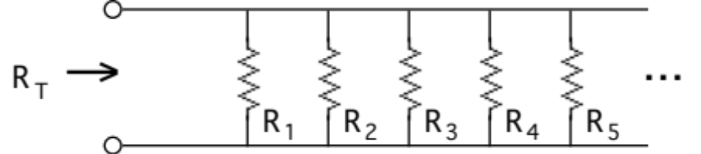
Figure 1. Shunt resistive network. No series resistors are allowed.
Resistive trimming is sometimes required in electronic ckt assembly to achieve prescribed voltages. Trimming is often automated, using a robotic controlled laser to burn away the connections of discrete, surface-mounted resistors one at a time until the net resistance is within the specified range. After trimming a resistor, it is gone forever and cannot be reconnected; thus, the network and trimming algorithm designs must be robust so that all units comply with the specs after trimming.
You and your partner should create your design and perform simulations and calculations before coming to the laboratory. The lab session itself will go quickly if you have done a good job in your design and preliminary testing.
III. Procedure
A. Before coming to the lab, design your network with shunt-connected resistors and develop the required trimming procedure using worst-case analysis. The trimming procedure consists of a set of instructions (a decision tree) that leads to a final value of the network resistance with the specification. It is hard to imagine developing your design without the use of some simple computational tool to help in calculating resistance values. A program in C, a simple routine programmed on a hand-held calculator, or an Excel spreadsheet would be appropriate. You may find it easier to use conductance values in your calculations.
- In the laboratory, collect enough resistors to make three prototypes and put them in a breadboard. Then proceed to your bench to conduct trials. Use the ohms scale of your multimeter, trimming your network by removing resistors according to your algorithm to get a value within the specifications. Repeat the trimming exercise several times. If you discover that your design is flawed, check the resistor values to diagnose the problem and then, if necessary, redesign your network and algorithm.
- When you are ready, inform the TA, who will collect a new set of resistors for you to assemble (with no prior measurements allowed). Then, with the TA observing, perform the test to see if you reach the specifications.
IV. Write-up
Your lab write-up should include a concise summary of all design specifications, i.e., network schematic with resistor values. It should also include the trimming algorithm, presented in the form of a decision tree that could be used as the basis for automated production. Follow this design summary with a worst-case analysis to show how well your design copes with values that are high or low. Describe computational tool developed to accomplish the analysis. Finally, summarize your results, describing any successes and acknowledging any failures or limitations.
On a separate page, submit a 100-word Executive Summary for the boss, describing the design and how well it works. If more effort is needed to complete the project, explain the problem and how you propose to fix it. Assume that the recipient of the report, while not intimately familiar with your project, is a well-trained EE with a good understanding of precision and tolerance.

