University of Rochester
Guidelines for ECE111 Lab Reports

Every report should include the following sections:

- Header (on both separate Executive Summary page and first page of report)
- Objective
  - Paragraph or two stating the purpose of the laboratory and what theories or laws are being tested
- Equipment list
  - Oscilloscope, multimeter, bread board, resistors, chips, etc
- Procedure
  - Describe the laboratory procedure in words. What is to be measured? Voltage, current, frequency? How will they be determined? Will calculations be necessary? If so, what formulae or what fundamental laws (e.g. KVL) will be required?
  - Include circuit diagrams with labels and descriptions. These should be either drawn in a computer program or copied and pasted from the lab website. They must be referred to in the write-up. An example is shown below:

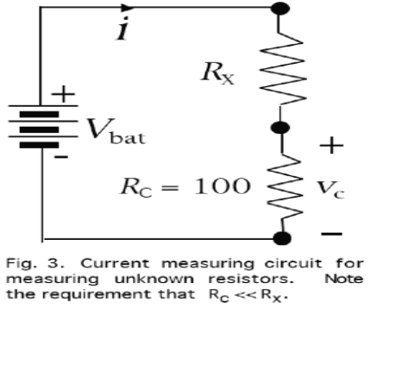
Figure 3: Circuit with unknown resistor (R_{x}) and known resistor
(R_{c}) and battery voltage (V_{bat}). Figure taken from ECE 111 Blackboard site.

- Results
  - Results should be presented in table or charts in a logical, professional format.
    - Units should be indicated on all charts and final answers.
    - Where appropriate, use prefixes such as mA and kΩ.
    - Values of resistors and other components used in circuits should be measured with the RLC meter, presented in the results, and used in all calculations.
  - All calculations and analyses should be shown starting with fundamental equations.
  - Estimated error should be included where appropriate (e.g., when comparing predicted and measured results).
  - Any necessary plots should be appropriately labeled and should include a title, description, and have appropriate axis labels.
    - Include data used to create a plot in tabular form in your write-up.
    - An example is shown below.
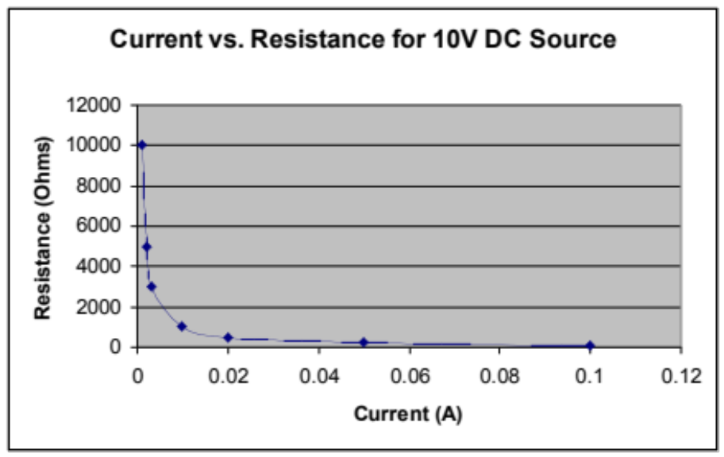
I (A) | R (Ω)
0.1 | 100
0.05 | 200
0.02 | 500
0.01 | 1000
0.003333 | 3000
0.002 | 5000
0.001 | 10000

Figure 5. Lab data for current vs. resistance for a 10 V source.

Figure 6: Plot of current vs. resistance for a 10 V DC source.

- Discussion
  - Explain the results of each section of the procedure. Did the results agree with your predictions? What can be concluded from your results? Explain the motivation for any calculations you performed.
- Conclusion
  - Start with a paragraph or two that discusses the important results of the lab and why, or why not, the lab was a success. Be sure to mention any concepts or theories that were tested in the lab.

NOTE: The Discussion and Conclusion are separate sections and have different purposes. The Conclusion is usually shorter and may restate some elements found the Discussion!

