Borja Rojo

Dan Waldman

ECE 221 Lab #6: BJT DC Biasing and common-emitter amplifier

Part 1

With the circuit built in the configuration of Figure 2, the following values were found.

|  |  |
| --- | --- |
| Current | Value |
| Ie | 2.345mA |
| Ib | .0143mA |
| β | 163 |

The value of β found fell well within the margin specified by the datasheet. The value was supposed to be a minimum β of 50 and a maximum of 300; 163 lies will in between.

Part 2

With the emitter grounded, VCE and VBE are equivalent to Vc and Vb respectively. Using this fact, and the target values of VCE and Ic, Rc was found as follows:

$$\frac{V_{cc}- V_{ce}}{R_{c}}=\frac{10V-5V}{2500Ω}=2mA$$

The expression Ib = Ic/β was then used to substitute for Ib in the equation

$$\frac{V_{cc}-V_{be}}{R_{b}}=I_{b}=\frac{I_{c}}{B};\frac{10-.7}{R_{b}}= \frac{2e^{-3}}{163}$$

and Rb was found to be 757,950Ω, or approximately 750kΩ.

Part 3

b) Ic = .535mA, VCE = 8.27V

c)

Vout­ : DC level looks to be in the middle, about 10V

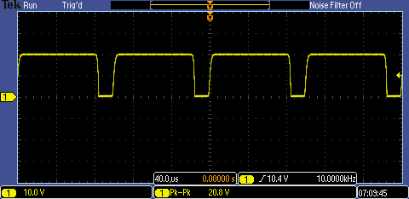

Vin: DC level looks to be at 0V

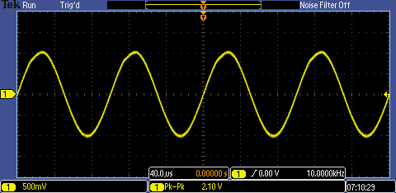

Vb: DC level looks to be about .25V

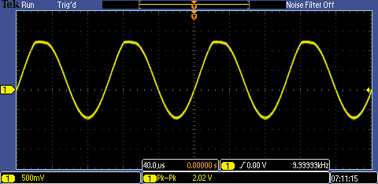

d)

Av = 9.9V. It should be noted that there is a large amount of clipping, so it can be said that the gain is much larger.

e) Rout = 23.07kΩ