**Post-Lab**

Part 1

The pre-lab determined that a reasonable peak-to-peak voltage to use in this circuit analysis is 10V. Setting the waveform to a 1Khz triangle wave, these plots were recorded.

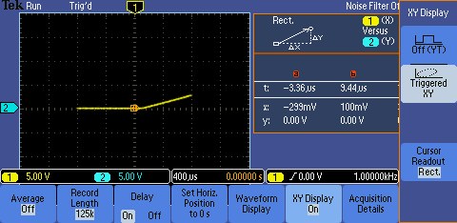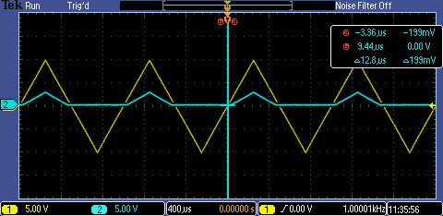Figure 1 Figure 2

Figure 1 represents the V­­in and Vout vs time and superimposed on each other. It is clear that Vout is half-rectified and with a lower positive peak voltage than Vin This is due to the open circuit nature of a diode in reverse bias and the voltage drop of a diode in forward bias, respectively.

Figure 2

Figure 2 is a V­in­­­ vs V­out plot. This represents the transfer function of the circuit. This shows that while Vin is negative, Vout is 0V, and while Vin increases positively, Vout increases with it a fraction of the rate (its slope is less than 1).

Part 2

a) Figure 1 (Figure 2 circuit in lab)

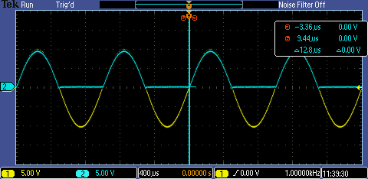This plot represents Vin, 1kHz 10Vpp and Vout vs time, where Yellow is Vin and Blue is Vout. The observed result match my calculations, where the negative Vin causes the diode to be reverse biased, tying Vout to ground, and the positive Vin to forward bias the diode and cause Vout to follow Vin.

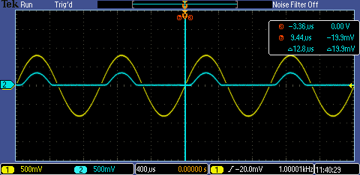b) Figure 2 (Figure 2 circuit in lab)

This plot represents Vin/Vout vs time for the same circuit as figure two, but Vpp for Vin is .8V. The results differ slightly than my calculated results. Unlike the previous plot, there is evidence of a voltage drop across the diode when forward biased here. This is evident by the small period of inactivation as Vin crosses 0V and by the peak amplitude drop of Vout compared to Vin.

c) Figure 3 (Figure 3 circuit in lab)

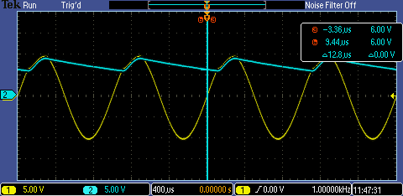This plot represents the Vin/Vout vs time for a new circuit, which adds a capacitor in parallel with the output of the last circuit. The observed results closely match my computed results. There is a ripple voltage created by the capacitor, which is caused by it charging and discharging as Vin oscillates. The observed ripple voltage was about 4V, while my calculated results point to a ripple voltage of about 2.5V.

Part 3

a) Figure 1 (Figure 4 in lab)

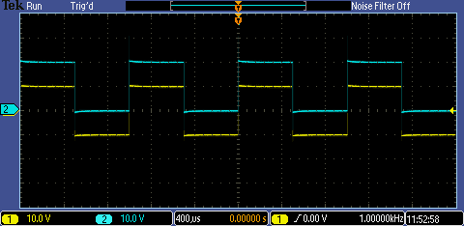

This plot represents Vout/Vin vs time. Vin is a 1kHz 10Vpp square wave. The circuit shows a clamping response, where the lower peak of the square wave is clamped to ground. This creates a Vout that is a square wave of the same amplitude that oscillates between 10V and 0V.

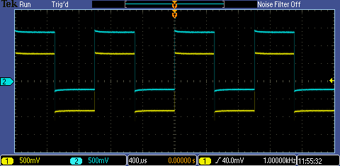b) Figure 2 (Figure 4 in lab)

This plot represents Vout/Vin vs time. Vin is a 1kHz .8Vpp square wave. The difference that is evident here from the previous input is that the diode just activates and does not clamp the waveform to 0V, but instead to something closer to -.1V. Because the diode is only just activated, there is an effective voltage drop, not allowing the capacitor to fully charge to the negative portion of Vin. This inability to fully charge causes the clamping effect to be diminished. This result matches my previous results. Higher voltages across the diode would show a smaller voltage drop across the diode, while smaller voltages would make the diode have a larger voltage drop. This is a curious result, as the voltage drop across the diode differs with the forward bias voltage across the diode.

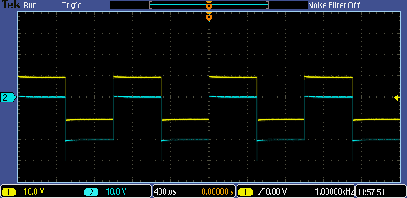c) Figure 3 (Figure 5 in lab)

This plot represents Vout/Vin vs time. Vin is a 1kHz 10Vpp square wave. The circuit shows a clamping response, where the upper peak of the square wave is clamped to ground. This creates a Vout that is a square wave of the same amplitude that oscillates between -10V and 0V.

Part 4

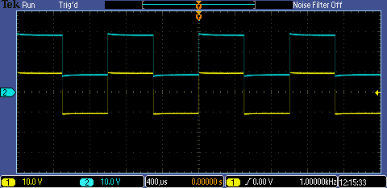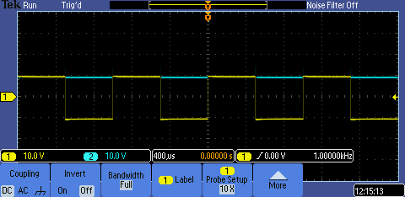Figure 1 Vin/V1 Figure 2 Vin/V2

V1 shows a rectified Vin V2 shows a clamped Vin

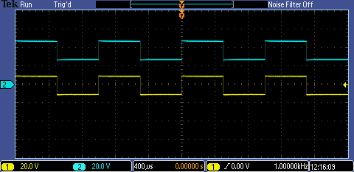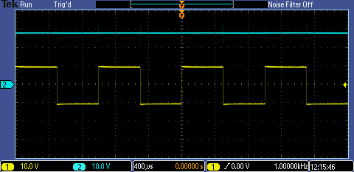Figure 3 Vin/V3 Figure 4 Vin/V4

V3 shows a rectified V2 V4 shows a clamped V2 to V1

Figure 5 Vin/Vout

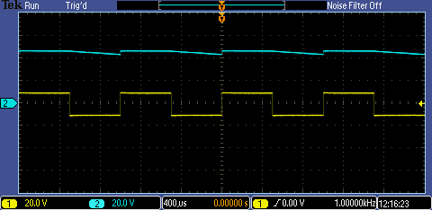Vout shows a rectified V4. The results for all the graphs match my predictions. The ripple voltage, caused by the 1MΩ load resistor in parallel with the .01µF was observed to be 3V.