Lab 4

Common Source (Circuit 1)

1. Figure 1: Transfer Function (Vout vs Vin)

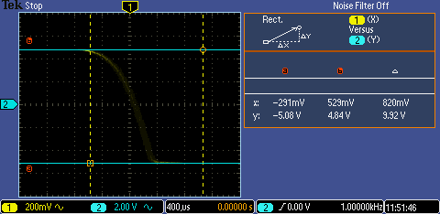

The display is very faint, but follows perfectly the expected shape of a FET transfer function.

3. Figure 2: AC Gain (Vout & Vin vs time)

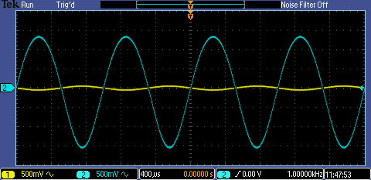

Measured gain = -9.603; Theoretical gain = -10. The two values are very close, and the difference is well within our margin of error considering the error of the resistors.

Vout = 4.92V

Iout = 4.81mA

4. Figure 3: Clipping (Vout & Vin vs time)

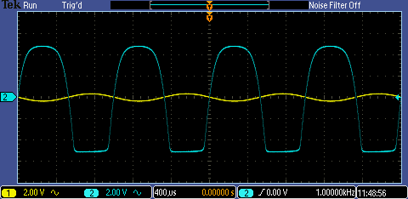

Vin at clipping = 410mV

Clipping occurred because the swing of the AC input shifted the bias of the transistor out of the saturation region, and into the cut-off/ triode regions, where the transfer characteristic no longer behaves linearly.

Common Source with Source Degeneration (Circuit 2)

1. Figure 4: Transfer characteristic of Circuit 2 (Vout vs Vin)

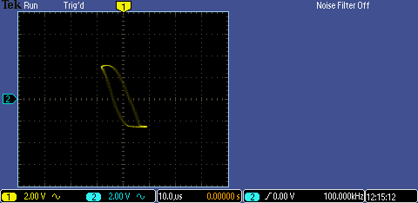

(Experiment section instructed us to view transfer characteristic, and did not mention to save the waveform)

2.

Comparing output of two circuits:

The split nature of the second circuit’s transfer characteristic is due to the charging and discharging of the capacitors. With this effect ignored, the transfer characteristics can be seen to have the same general shape. Note however the dramatically different vertical scaling in between Figures 1 and 4, due to differing gain values.

Comparing different Vg ‘s for Circuit 2:

As Vg was adjusted, the waveform clipped more or less on each side, until a point at which all linear response disappeared from the output. This was true for increasing and decreasing Vg .