Lab 3 Feedback Amplifiers

ECE 222 Spring 2016

University of Rochester

1. Analysis

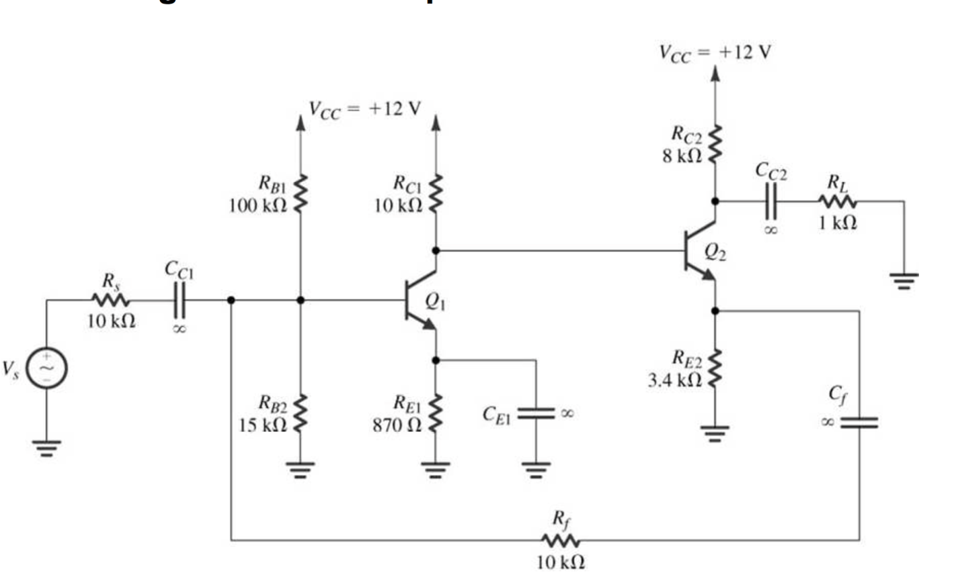

|  |  |  |
| --- | --- | --- |
| Values\Beta | 100 | 416.4 |
| ro1 | 75 kΩ | 75 kΩ |
| ro2 | 187.5 kΩ | 187.5 kΩ |
| gm2 | .016 S | .016 S |
| rπ2 | 6.25 kΩ | 26.025 kΩ |
| gm1 | .04 S | .04 S |
| rπ1 | 2.5 kΩ | 10.41 kΩ |
| Vπ1 | Vs \* .1535406 V | Vs \* .287889 V |
| Vb2 | Vs \* -52.4286 V | Vs \* -100.78832 V |
| Io | Vs \* -.020166 A | Vs \* -.038767 A |
| A | -201.66 | -387.675 |
| Ri | 1.535406 kΩ | 2.878899 kΩ |
| Ro | 2.687174 kΩ | 2.62096 kΩ |
| 1+A\*β | 52.22 | 99.47 |
| Rif | 29.402 Ω | 28.943 Ω |
| Rin | 29.489 Ω | 29.027 Ω |
| Af | -3.8617 | -3.8974 |
| Iout/Iin­ | -3.432 | -3.464 |
| Rof | 140.324 kΩ | 260.704 kΩ |
| Rout | 18.137980 MΩ | 71.176020 MΩ |

2. Netlist

An ideal capacitor causes there to be an ideal coupling through each stage of the amplifier. This means that the AC component of a signal passed through each stage is not affected by any impedance. When a real capacitor is replaced in a circuit, an impedance exists between each of the stages of the amplifier. This causes the AC component of a signal to have a phase shift.

Another effect of having real capacitors is their ability to track instantaneous averages of voltage. This means that the AC and DC signals being passed through have a slight effect on the DC bias parameters of the ideal circuit. This will cause the parameters to shift off of their ideal values.

3. DC Analysis

Look in folder for netlist. The graph clearly shows that any DC change from rail to rail causes minimal changes to the output. It also shows that the DC and small signal parameters of the simulated circuit with real capacitors closely matches that of the calculated results. Take note to read which nodes match the correct lines, using the netlist, and it will be evident that the changes due to the capacitors are as expected.

lab3_3_DCbias_graph.pdf

4. 2-Port Network Parameters

|  |  |
| --- | --- |
| 2-Port Parameters |  |
| Rif | 29.016 Ω – A little lower than before |
| Rof | 262.866 kΩ - A higher lower than before |
| Af | -3.92 – nearly the same |

5.

lab3_5_circuit.pdf