ECE 242 Lab 2: Frequency Modulations

Sophie(Xueqi) Zhang, Rebecca Van Dyke, Borja Rojo

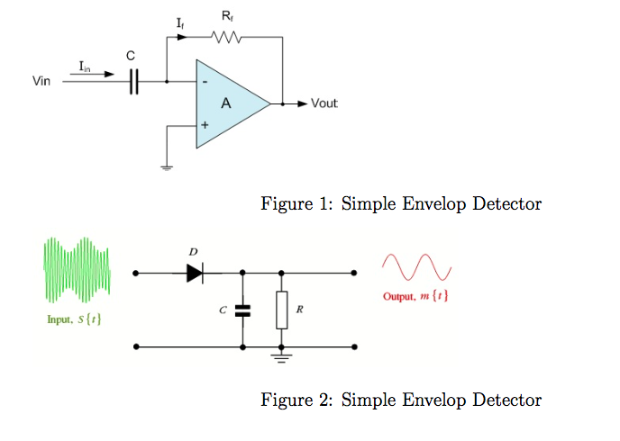

R1=1.2kOhm || C1=18nF || R2=5.1kohm || C2=10nF

**Abstract**

This lab is a demonstration of how frequency deviation in a frequency modulated signal affects the bandwidth and reconstruction of that signal. Frequency deviation represents the difference between the highest and lowest frequencies the FM signal varies between. A signal was modulated with a constant carrier and message frequency and the frequency deviation was varied on 5 different values. It was found that the bandwidth of the signal and the fidelity of the demodulated signal both increase as the frequency deviation increases.

**Materials**

* Function generator
* Oscilloscope
* Flash drive
* Breadboard
* Diode, capacitors, resistors

**Procedure**

1. Generate an FM signal with fc = 10 kHz, fm = 1 kHz, and frequency deviation of 500 Hz. View the resulting waveform on the oscilloscope. Obtain the magnitude spectrum and record the magnitude and frequency of each impulse in the frequency domain.
2. Increase the frequency deviation in increments of 100 Hz until Δf = 1 kHz. Record the magnitude and frequency of each impulse and calculate β for each frequency deviation.
3. Use MATLAB to compute the Bessel function for the first few values of n for each of the values found in the previous step.
4. Build the simple differentiator shown in figure 1 with R = 2 kΩ and C = 20 nF. Verify that the differentiator is working before proceeding.
5. Choose component values for and build the envelop detector in figure 2.
6. Connect the output of the signal generator to the input of the differentiator and the output of the differentiator to the input of the envelop detector. Connect channel 1 of the oscilloscope to the differentiator input and channel 2 to the envelop detector input. (*we also connected channel 2 to the envelop detector output)*
7. Generate an FM signal with fc = 10 kHz, fm = 5 kHz, and Δf = 500 Hz. Vary fm down to 100 Hz. For each value of fm,
   1. Compute the value of β.
   2. Compute the bandwidth of the FM signal.
   3. Record the waveform.

**Data/Analysis**

FM signal with fc 10kHz and fm 1kHz and frequency deviation 500 Hz.

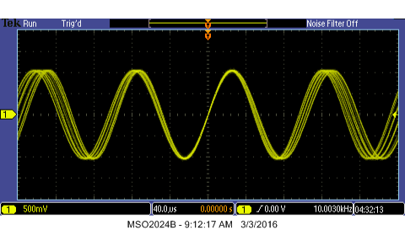

3. FM signal above with impulses using FFT

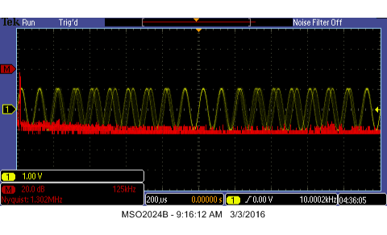

MATLAB

FM signal waveform in time & frequency domain

Deviation frequency = 500 Hz

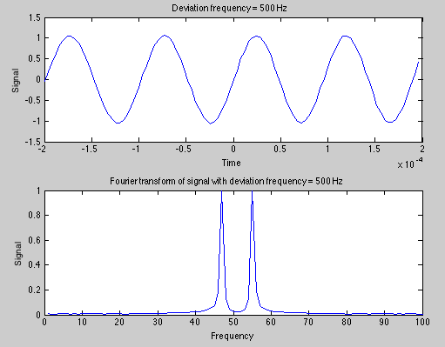

**Demodulator**

|  |  |
| --- | --- |
| fm | Waveform |
| 5 kHz | lab2_15.png |
| 2.5 kHz | lab2_16_2.5k.png |
| 1 kHz | lab2_16_1k.png |
| 500 Hz | lab2_16_500.png |
| 100 Hz | lab2_16_100.png |

The yellow signal is the input FM signal. The blue signal is the output of the differentiator. For all frequencies, the AM properties of this signal can be seen. This is a result of how the differentiator interacts with FM signals. The purple signal is the final output. This portion of the lab did not work exactly as expected - it should be smooth, without the choppy dips, but an overall periodic trend can still be discerned.

**FM signal magnitude and frequency spectrum**

Deviation frequency = 500 Hz



Deviation frequency = 600 Hz

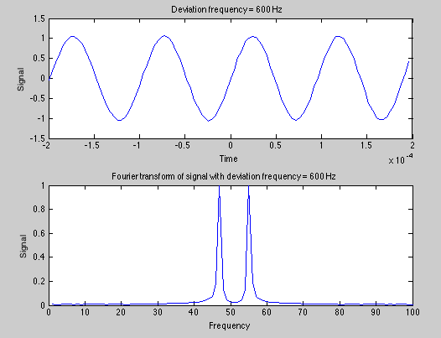

Deviation frequency = 700 Hz

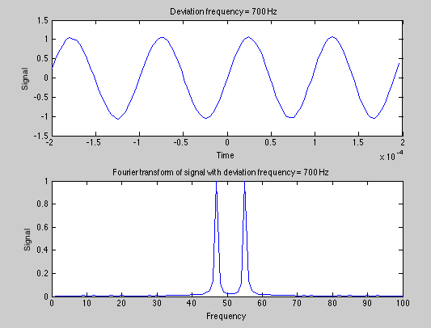

Deviation frequency = 800 Hz

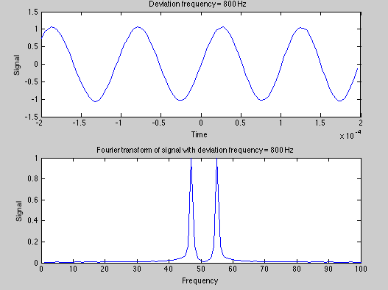

Deviation frequency = 900 Hz

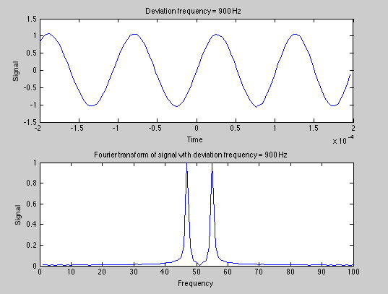

Deviation frequency = 1 kHz

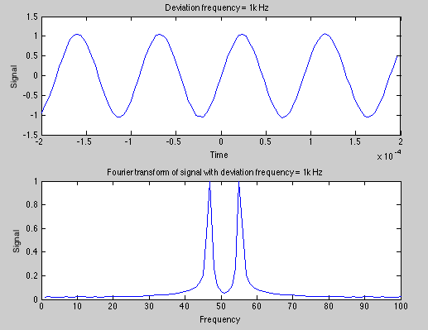

* MATLAB graphs are enlarged in order to see signal spectrum in frequency domain so despite their varying deviation frequency, they look similar despite the overall frequency is changing. Same goes for magnitude spectrum; the spectrums here only belong to part of the signal not the holistic picture.

**β for different frequency deviation during frequency modulation**

Frequency modulation index  =  ( fm = 1kHz )

|  |  |
| --- | --- |
| Frequency deviation ( Hz ) | β |
| 500 | 0.5 |
| 600 | 0.6 |
| 700 | 0.7 |
| 800 | 0.8 |
| 900 | 0.9 |
| 1000 | 1 |

**Bessel function values**

|  |  |  |  |
| --- | --- | --- | --- |
| β | J0(β) | J1(β) | J2(β) |
| 0.5 | 0.938 | 0.242 | 0.031 |
| 0.6 | 0.912 | 0.287 | 0.044 |
| 0.7 | 0.881 | 0.329 | 0.059 |
| 0.8 | 0.846 | 0.369 | 0.076 |
| 0.9 | 0.808 | 0.406 | 0.095 |
| 1 | 0.765 | 0.440 | 0.115 |

**β and bandwidth for different fm during demodulation**

∆f = 100 Hz Bandwidth = 2\*(β+1)\*fm (Carson’s rule)

|  |  |  |
| --- | --- | --- |
| Fm | β | Bandwidth |
| 5 kHz | 0.02 | 10.2 kHz |
| 2.5 kHz | 0.04 | 5.2 kHz |
| 1 kHz | 0.1 | 2.2 kHz |
| 500 Hz | 0.2 | 1.2 kHz |
| 100 Hz | 1 | 400 Hz |

Questions:

1. *What effect does the frequency deviation have on the spectrum?*

The frequency deviation is the difference between the largest and smallest instantaneous frequency that the modulated signal ever is. That is, if the FM signal varies between 90MHz and 92MHz, the frequency deviation is 2MHz. This would be the case if, for example, there was a carrier frequency of 91MHz being modulated with a 2MHz frequency deviation. The message signal then determines how fast the FM signal varies between those two frequencies. The frequency deviation, along with the message frequency, determines bandwidth. Greater frequency deviation means a wider band.

1. *How do computed Bessel function values compare with measured magnitudes?*

The MatLab plots representa an unexpected result. The corresponding Bessel function predicts that there is a carrier frequency present, while our data does not show that result. The bandwidth, though, seems accurate. The bandwidth increases with our frequency deviation which the Bessel function predicts.

**Conclusion**

The lab shows that a larger bandwidth is needed for a larger frequency deviation. This manifests itself with more sidebands being created as the modulation index increases, which is directly correlated with the frequency deviation. The demodulation of the signal is also affected by the modulation index, where a larger frequency deviation will create a higher fidelity demodulated signal. The modulation index is also inversely correlated with the message frequency, so picking the right modulation index for the current message is fundamental when evaluating how much bandwidth can be used in the channel and how clean the message is desired to be on the receiving end.