NAME: ________________________________________

**ECE 111**

**EXAM 1**

**Fall 2012**

FOR GRADERS’ USE ONLY.

|  |  |  |
| --- | --- | --- |
| PROBLEM # | GRADE | POINTS |
| 1 |  | 16 |
| 2 |  | 50 |
| 3 |  | 50 |
| 4 |  | 8 |
| 5 |  | 20 |
| TOTAL |  | 144 |

1. (16 points total)

Given simple circuit elements with voltages across and currents through them as shown below, what power are they dissipating? Be sure to follow the Passive Sign Convention.

A. (4 points)

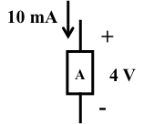 PA = _+(10mA)(4V)=+40mW___________

B. (4 points)

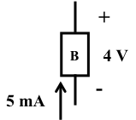 PB = _-(5mA)(4V)=-20mW____________

C. (4 points)

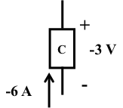 PC = __-(-6A)(-3V)=-18W_____________

1. (4 points)

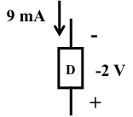 PD = _-(9mA)(-2V)=18mW_____________

2. (50 points total)

Given the circuit below, use Node Voltage Analysis to find the voltage across the 6Ω resistor, VO.

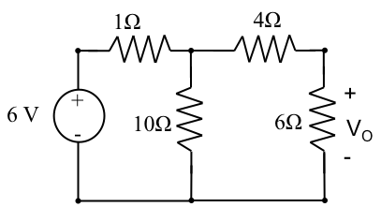

A.) (4 points) Label the nodes on the diagram and designate one as reference.

A (top left), B(top center), C(top right), D(bottom)

B.) (2 points) Write the desired result in terms of the Node Voltages.

V0=VC-0=VC

C.) (8 points) Can any node voltages be found by inspection?

VA=6V

D.) (16 points) Write the Node equations needed and reduce .

$$\frac{V_{B}-6V}{1Ω}+\frac{V_{B}}{10Ω}+\frac{V_{B}-V_{C}}{4Ω}=0$$

$$\left(\frac{1}{1Ω}+\frac{1}{10Ω}+\frac{1}{4Ω}\right)V_{B}-\left(\frac{1}{4Ω}\right)V_{C}=\frac{6V}{1Ω}=6A$$

$$\frac{V_{C}-V_{B}}{4Ω}+\frac{V_{C}}{6Ω}=0$$

$$-\left(\frac{1}{4Ω}\right)V_{B}+\left(\frac{1}{4Ω}+\frac{1}{6Ω}\right)V_{C}=0$$

E.) (20 points) Find VO. (Be sure to draw a box around your answer.)

$\left(\frac{1}{1Ω}+\frac{1}{10Ω}+\frac{1}{4Ω}\right)V_{B}-\left(\frac{1}{4Ω}\right)V_{C}=\frac{6V}{1Ω}=6A$

Multiply by 20Ω: $\left(20+2+5\right)V_{B}-\left(5\right)V_{C}=\frac{6V}{1Ω}20Ω=120V$

$$27V_{B}-\left(5\right)V_{C}=120V$$

$$27V_{B}=120V+\left(5\right)V_{C}$$

$$V_{B}=120V/27+\left(5/27\right)V_{C}$$

$$-\left(\frac{1}{4Ω}\right)V_{B}+\left(\frac{1}{4Ω}+\frac{1}{6Ω}\right)V_{C}=0$$

Multiply by 12Ω to get: $-\left(3\right)V_{B}+\left(3+2\right)V_{C}=0$

Or $-\left(3\right)V_{B}+5V_{C}=0$

Substitute:

3. (50 points total)

Given the same circuit below, use Mesh Analysis to find the voltage across the 6Ω resistor, VO.



A.) (4 points) Label the meshes on the diagram.

A (left) and B (right)

B.) (2 points) Write the desired result in terms of the Mesh Currents.

$$V_{0}=6Ω(I_{B})$$

C.) (8 points) Can any mesh currents be found by inspection?

No, there are no current sources.

D.) (16 points) Write the Mesh equations needed and reduce .

$$1ΩI_{A}+10Ω\left(I_{A}-I_{B}\right)-6V=0$$

$$11ΩI_{A}-10ΩI_{B}=6V$$

$$4ΩI_{B}+6ΩI_{B}+10Ω\left(I_{B}-I_{A}\right)=0$$

$$-10ΩI_{A}+20ΩI_{B}=0$$

E.) (20 points) Find VO. (Be sure to draw a box around your answer.)

4. (8 Points Total)

A.) (4 points) Given this Thevenin Equivalent Source:

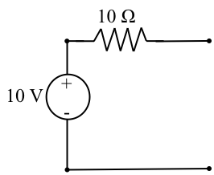 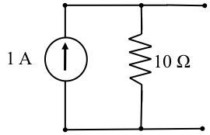

What is its Norton Equivalent Source?

B. (4 points) Given this Norton Equivalent Source:

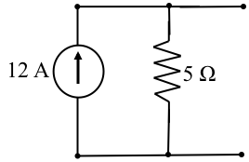 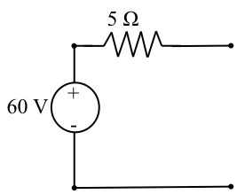

What is its Thevenin Equivalent Source?

5. (20 Points Total)

Given this circuit:

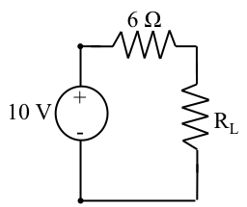

A.) (4 points) For what load resistance RL will the maximum power be dissipated in RL?

B.) (16 points) For the condition in part A, how much power is dissipated in each element (PL in the Load Resistor, PR in the Internal Resistor, and PS in the Voltage Source)?

PL = _______________________ PR = _______________________ PS = _______________________