Borja Rojo

3/15/2015

Digital Logic Circuit Simulation Using Multisim

Lab Project 4

Part 1

1)

Truth table

|  |  |  |  |  |  |
| --- | --- | --- | --- | --- | --- |
| X1 | X2 | X3 | X4 | X5 | f |
| 0 | 0 | 0 | 0 | 0 | 0 |
| 0 | 0 | 0 | 0 | 1 | 0 |
| 0 | 0 | 0 | 1 | 0 | 0 |
| 0 | 0 | 0 | 1 | 1 | 0 |
| 0 | 0 | 1 | 0 | 0 | 0 |
| 0 | 0 | 1 | 0 | 1 | 0 |
| 0 | 0 | 1 | 1 | 0 | 0 |
| 0 | 0 | 1 | 1 | 1 | 0 |
| 0 | 1 | 0 | 0 | 0 | 0 |
| 0 | 1 | 0 | 0 | 1 | 0 |
| 0 | 1 | 0 | 1 | 0 | 0 |
| 0 | 1 | 0 | 1 | 1 | 0 |
| 0 | 1 | 1 | 0 | 0 | 1 |
| 0 | 1 | 1 | 0 | 1 | 1 |
| 0 | 1 | 1 | 1 | 0 | 1 |
| 0 | 1 | 1 | 1 | 1 | 1 |
| 1 | 0 | 0 | 0 | 0 | 0 |
| 1 | 0 | 0 | 0 | 1 | 0 |
| 1 | 0 | 0 | 1 | 0 | 1 |
| 1 | 0 | 0 | 1 | 1 | 1 |
| 1 | 0 | 1 | 0 | 0 | 0 |
| 1 | 0 | 1 | 0 | 1 | 0 |
| 1 | 0 | 1 | 1 | 0 | 1 |
| 1 | 0 | 1 | 1 | 1 | 1 |
| 1 | 1 | 0 | 0 | 0 | 1 |
| 1 | 1 | 0 | 0 | 1 | 1 |
| 1 | 1 | 0 | 1 | 0 | 1 |
| 1 | 1 | 0 | 1 | 1 | 1 |
| 1 | 1 | 1 | 0 | 0 | 1 |
| 1 | 1 | 1 | 0 | 1 | 1 |
| 1 | 1 | 1 | 1 | 0 | 1 |
| 1 | 1 | 1 | 1 | 1 | 1 |

Modeled Circuit

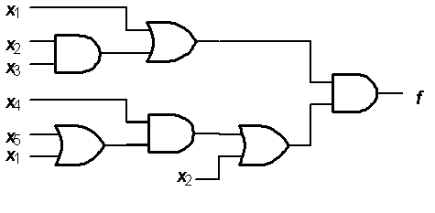

Karnaugh Maps

X1 = 0

|  |  |  |  |  |
| --- | --- | --- | --- | --- |
| \X4,X5  X2,X3\ | 00 | 01 | 11 | 10 |
| 00 | 0 | 0 | 0 | 0 |
| 01 | 0 | 0 | 0 | 0 |
| 11 | 1 | 1 | 1 | 1 |
| 10 | 0 | 0 | 0 | 0 |

|  |  |  |  |  |
| --- | --- | --- | --- | --- |
| \X4,X5  X2,X3\ | 00 | 01 | 11 | 10 |
| 00 | 0 | 0 | 1 | 1 |
| 01 | 0 | 0 | 1 | 1 |
| 11 | 1 | 1 | 1 | 1 |
| 10 | 1 | 1 | 1 | 1 |

X1 = 1

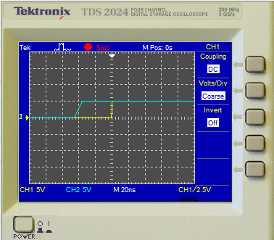

2) Both circuits have the same Truth Table, so that means their Sum of Products realization is the same. The original circuits have a cost of 18 and 33. A reduced circuit using the Karnaugh Map above gives a cost of 12. The sum-of-products realization of it is

ƒ = X2X3 + X1X2 + X1X4.

This can then be further reduced to

ƒ = X2(X3+X1) + X1X4

This requires 4 gates of cost 3 to implement, therefore, a cost of 12.

Part 2

1)

Figure 3 Propagation Delay for Figure 3

|  |  |  |  |  |  |
| --- | --- | --- | --- | --- | --- |
| X1 | X2 | X3 | X4 | F | G |
| 0 | 0 | 0 | 0 | 1 | 1 |
| 0 | 0 | 0 | 1 | 0 | 0 |
| 0 | 0 | 1 | 0 | 0 | 1 |
| 0 | 0 | 1 | 1 | 1 | 1 |
| 0 | 1 | 0 | 0 | 1 | 1 |
| 0 | 1 | 0 | 1 | 0 | 1 |
| 0 | 1 | 1 | 0 | 0 | 1 |
| 0 | 1 | 1 | 1 | 1 | 1 |
| 1 | 0 | 0 | 0 | 0 | 0 |
| 1 | 0 | 0 | 1 | 1 | 0 |
| 1 | 0 | 1 | 0 | 0 | 1 |
| 1 | 0 | 1 | 1 | 1 | 1 |
| 1 | 1 | 0 | 0 | 0 | 0 |
| 1 | 1 | 0 | 1 | 1 | 1 |
| 1 | 1 | 1 | 0 | 1 | 1 |
| 1 | 1 | 1 | 1 | 1 | 1 |

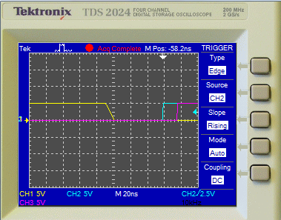

Figure 4

|  |  |  |  |  |  |
| --- | --- | --- | --- | --- | --- |
| X1 | X2 | X3 | X4 | F | G |
| 0 | 0 | 0 | 0 | 1 | 1 |
| 0 | 0 | 0 | 1 | 1 | 1 |
| 0 | 0 | 1 | 0 | 1 | 1 |
| 0 | 0 | 1 | 1 | 1 | 1 |
| 0 | 1 | 0 | 0 | 1 | 1 |
| 0 | 1 | 0 | 1 | 1 | 1 |
| 0 | 1 | 1 | 0 | 1 | 1 |
| 0 | 1 | 1 | 1 | 1 | 0 |
| 1 | 0 | 0 | 0 | 1 | 1 |
| 1 | 0 | 0 | 1 | 1 | 1 |
| 1 | 0 | 1 | 0 | 0 | 1 |
| 1 | 0 | 1 | 1 | 0 | 1 |
| 1 | 1 | 0 | 0 | 0 | 1 |
| 1 | 1 | 0 | 1 | 1 | 1 |
| 1 | 1 | 1 | 0 | 0 | 0 |
| 1 | 1 | 1 | 1 | 1 | 0 |

2) Both circuits have two outputs. They each have one subsircuit that affects their outputs, but their other subcircuits are isolated from each of their respective outputs. In Figure 3, f and g share an OR with (X1X2X3’X4’). The top half of Figure 3 can then be simplified to

(X1’ (X2 + X3)) + X4, making

F = (X1’ (X2 + X3)) + X4 + (X1X2X3’X4’)

The bottom half of Figure 3 cannot be simplified, making G the same as it is.

3) Yes there are. As described before, Figure 3 can be simplified, so its cost can be reduced to 32 from 41.

Part 3

Figure 5 Figure 6 Karnaugh Map

|  |  |  |  |
| --- | --- | --- | --- |
| X1 | X2 | X3 | Ƒ |
| 0 | 0 | 0 | 0 |
| 0 | 0 | 1 | 1 |
| 0 | 1 | 0 | 0 |
| 0 | 1 | 1 | 0 |
| 1 | 0 | 0 | 0 |
| 1 | 0 | 1 | 1 |
| 1 | 1 | 0 | 1 |
| 1 | 1 | 1 | 1 |

|  |  |  |  |
| --- | --- | --- | --- |
| X1 | X2 | X3 | Ƒ |
| 0 | 0 | 0 | 0 |
| 0 | 0 | 1 | 1 |
| 0 | 1 | 0 | 0 |
| 0 | 1 | 1 | 0 |
| 1 | 0 | 0 | 0 |
| 1 | 0 | 1 | 1 |
| 1 | 1 | 0 | 1 |
| 1 | 1 | 1 | 1 |

|  |  |  |  |  |
| --- | --- | --- | --- | --- |
| X3\X1X2 | 00 | 01 | 11 | 10 |
| 0 | 0 | 0 | 1 | 0 |
| 1 | 1 | 0 | 1 | 1 |

Timing Diagram

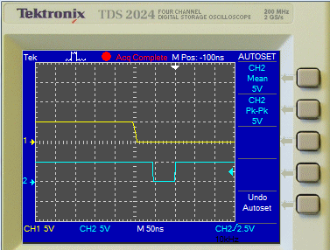

1) Figure 5: ƒ = X1X2 + X2’X3

Figure 6: ƒ = X1X2 + X2’X3

2) In order to eliminate the hazard, the circuit must represent the function

ƒ = X1X2 + X2’X3 + X1X3. This means that a gate that AND’s X1 and X3 must be implemented, which would then be OR’d with the rest of the circuit.

3) This is not a lower cost solution. It adds at least one more AND gate and, depending on if a 3 input or two 2 input OR’s are used, more cost on that side. In the best case, it increases the