**Instructions**

1.Insert the Chip ACROSS 2.Add the two similar 3. Add the capacitor.

the center of your resistors. This should go over the Chip

board The black line on YOUR capacitor

MUST match the white one below

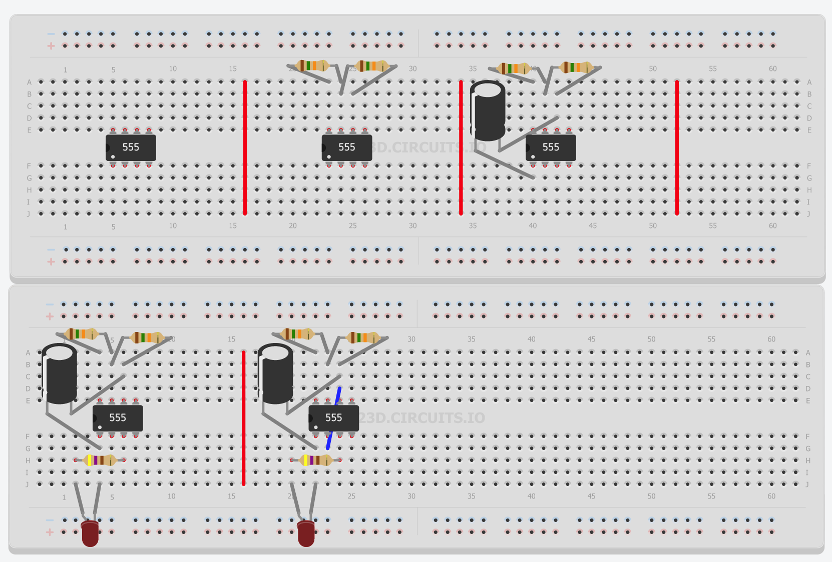

4.Connect the LED 5. Finally, connect the free wire

And Resistor. The over the chip. Now your circuit should work!

shorter wire on the LED

should be closest to the chip