1. Launch powershell as an admin.

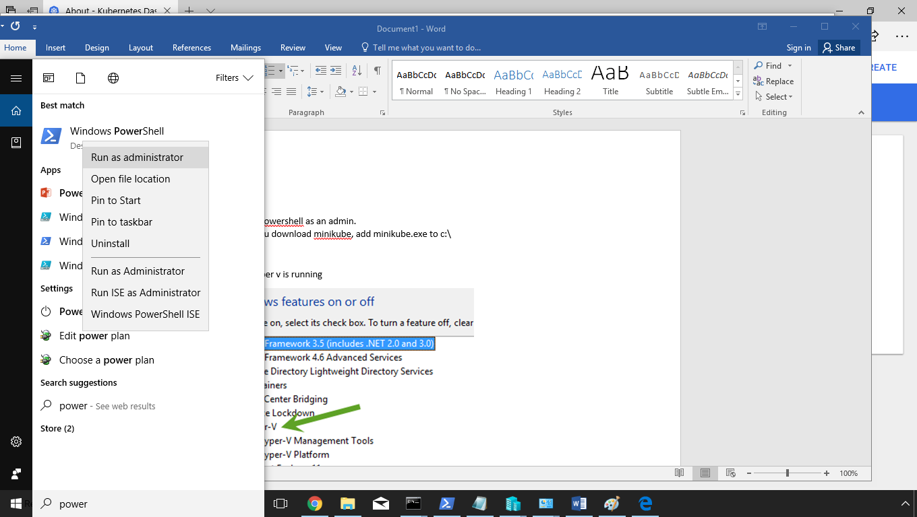

1. When you download minikube, add minikube.exe to c:\

2) Verify that hyper v is running

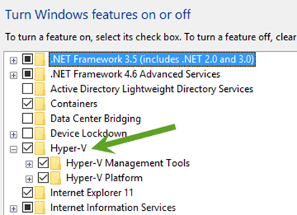

Alternatively, you can also run hyperv from powershell using this command below. Make sure you’re logged in as an admin:

Enable-WindowsOptionalFeature -Online -FeatureName Microsoft-Hyper-V -All

You can read more about enabling hyperv here: <https://docs.microsoft.com/en-us/virtualization/hyper-v-on-windows/quick-start/enable-hyper-v?redirectedfrom=MSDN>

3) Go to virtual switch manager

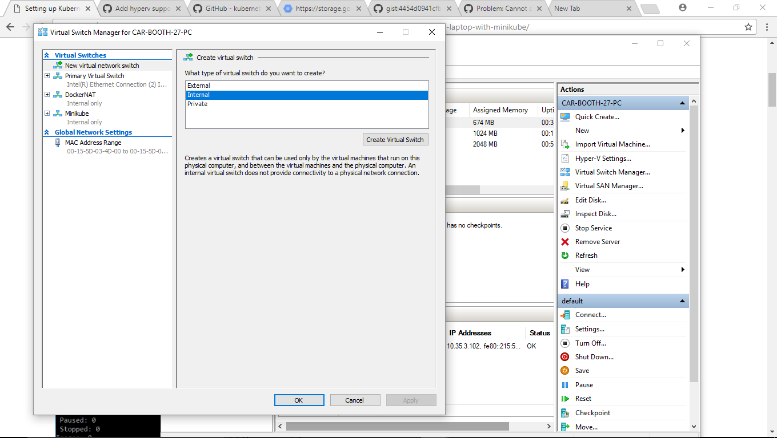

3) Create a New Virtual Network switch (Internal)

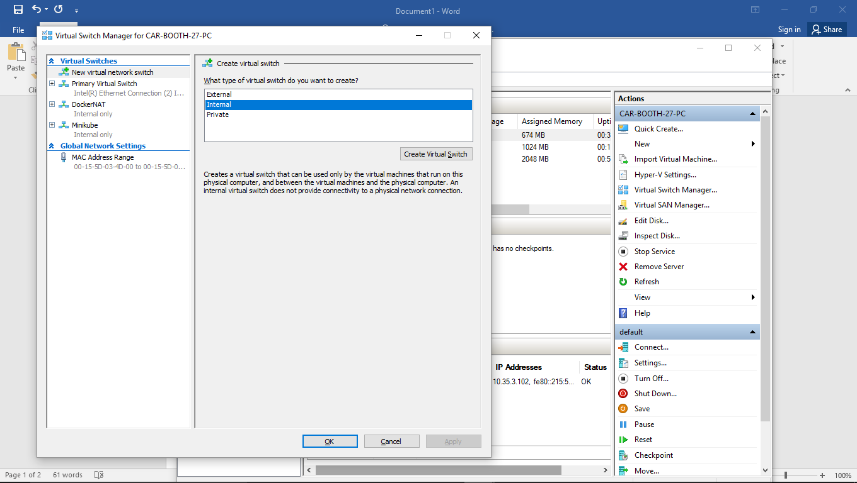

4) Call the switch "Minikube"

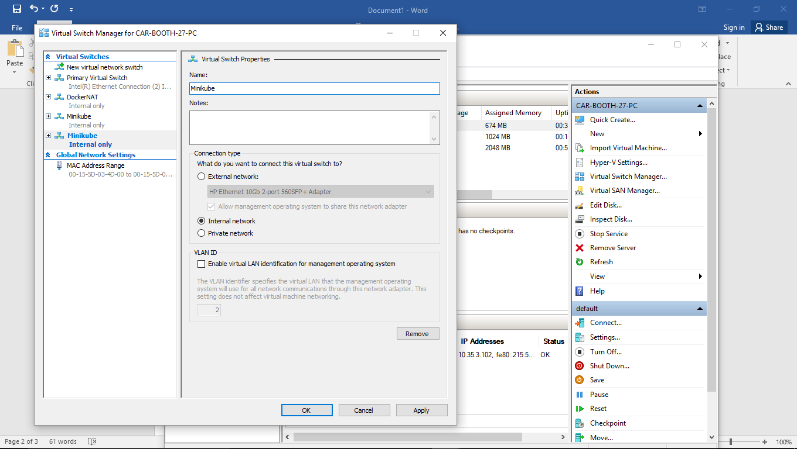

5) Go to Control Panel\Network and Internet\Network and Sharing Center

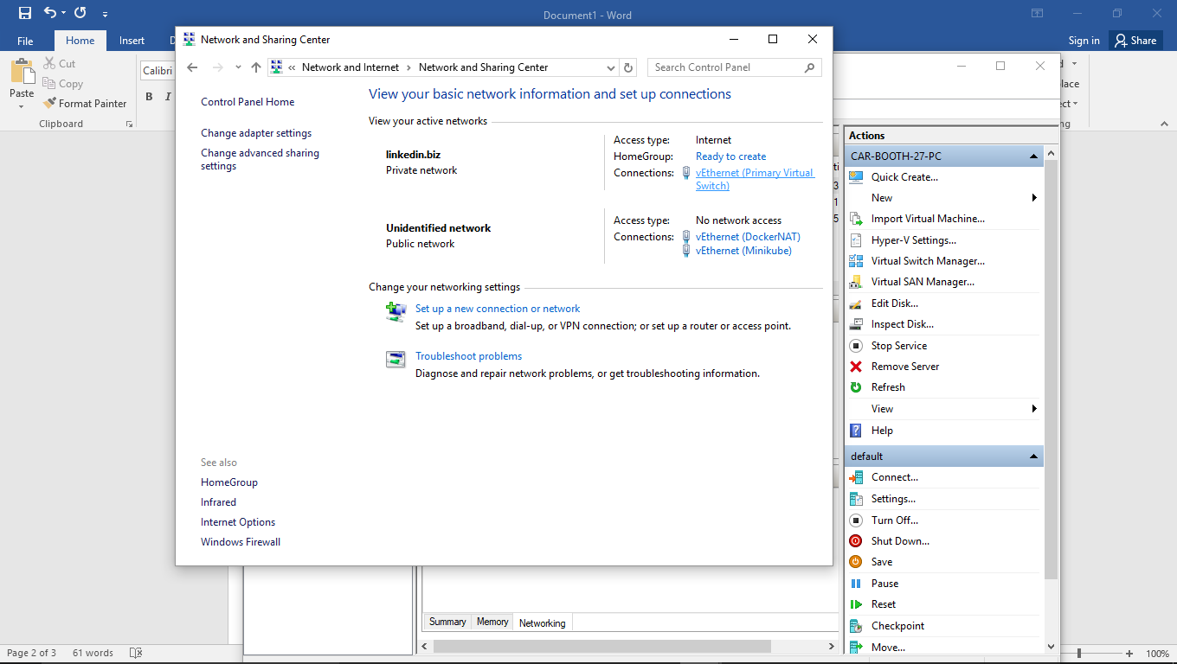

6) Go to your vEthernet status (will be on the right side underneath “Access type:” Internet, in the “Connections:” list

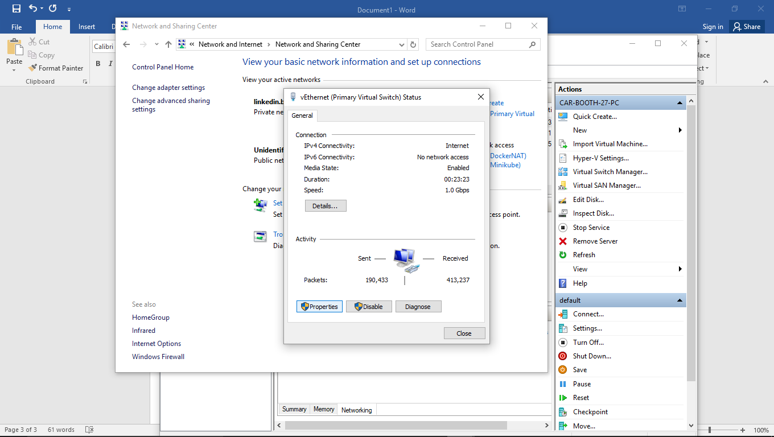

7) Go into properties, and then the sharing tab. Check that “Allow other network users to connect through the conputer’s Internet connection” and select “vEthernet (Minikube)” from the list.

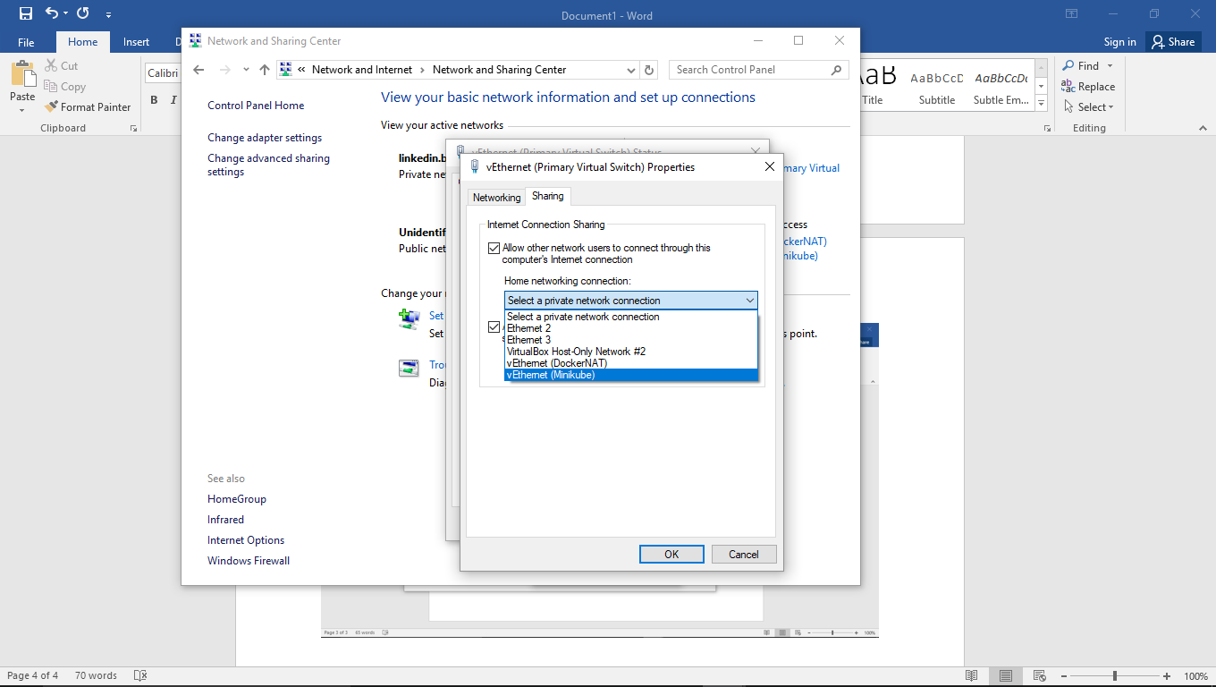

9) Run:

.\minikube.exe start --kubernetes-version="v1.8.0" --vm-driver="hyperv" --memory=1024 --hyperv-virtual-switch="Minikube" --v=7 –alsologtostderr

**.\minikube.exe start --vm-driver="hyperv" --memory=2048 --hyperv-virtual-switch="minikube" --v=7 --alsologtostderr**

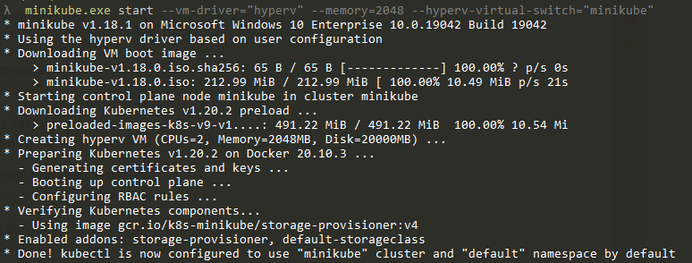

10) check the cluster:

**kubectl get nodes**

