GAME_DB Test game output –

Cow jumping over the moon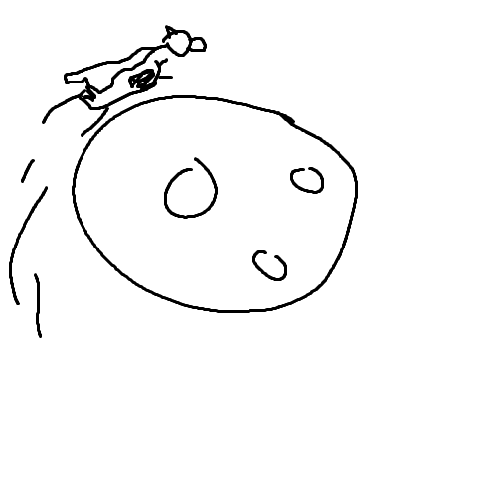

Super cow around the pond

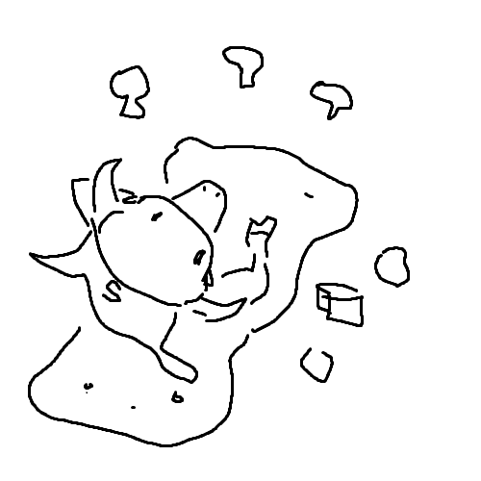

Cow having a picnic

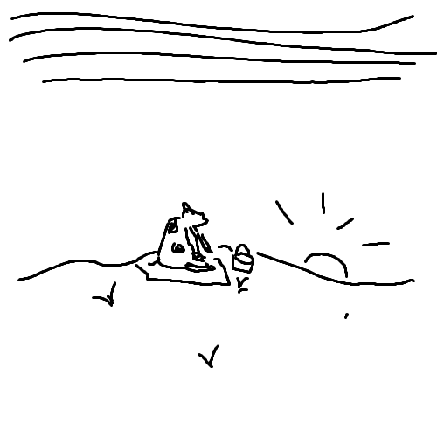

Cow watching the sun set

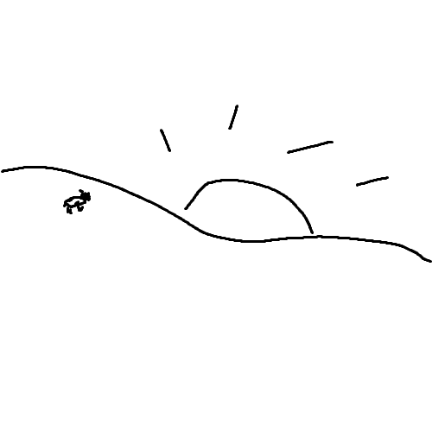

Lonely cow at sunrise