GAME_DB Test game output –

A zerg rush

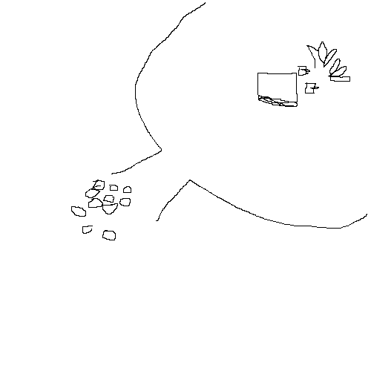

Air escaping a balloon

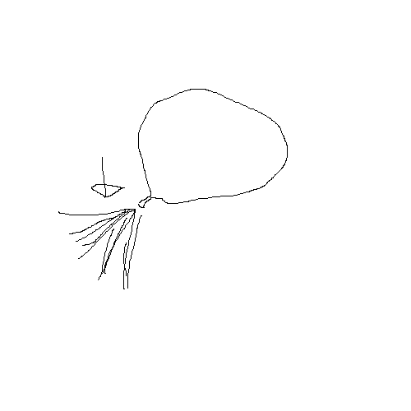

Onion power!!!

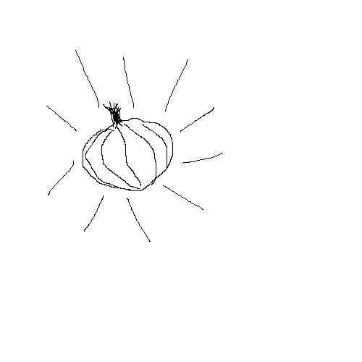

Exploding pumpkin. Look out!

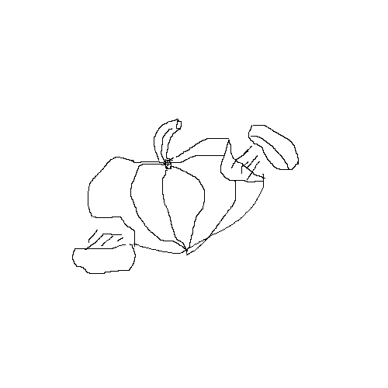

Tomato gone bad