Please conserve

water!

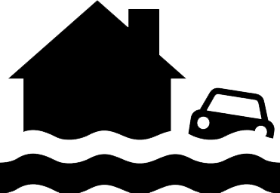
Plumbing can't keep up!

