Caution!

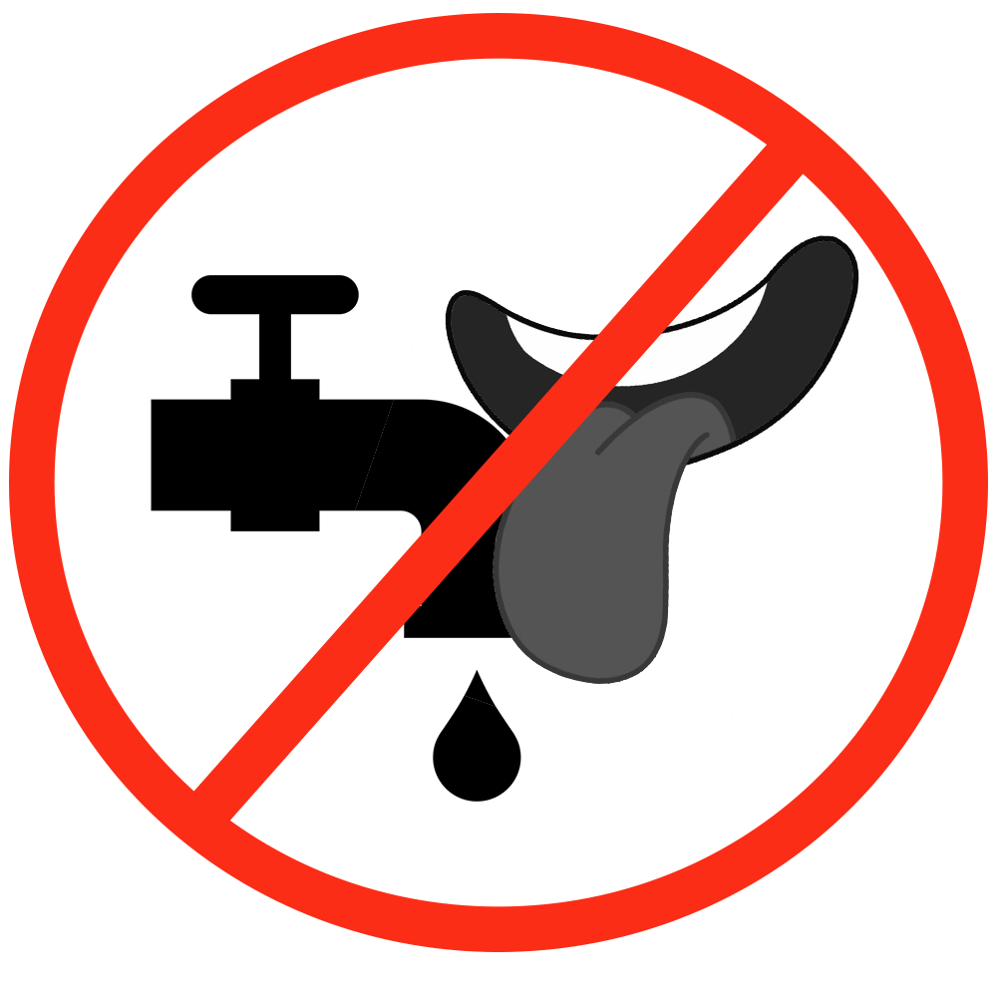
To reduce the spread of germs, please do not make contact with the tap and your bottle and/or mouth!

