Shared food

This area is for shared food

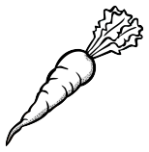
Feel free to share your food with others and make use of items in this area! :)

