TOUCHSTONE 3

Design Explanation
North Star Bakery Website
Student Name | Wesnel BORNO
Selected Client | North Star Bakery
Website Pages | Home, Products, About, Contact
PROJECT LINKS — REQUIRED FOR FINAL SUBMISSION
GitHub Repository Link: TO BE ADDED after the project is uploaded to a public GitHub repository.
Working Project/Preview Link: TO BE ADDED after GitHub Pages is enabled and the published website is tested.
Important: The project files and design explanation are prepared. A real repository URL and live preview URL cannot be created from this document; they must come from the student’s GitHub account after upload and publication. Do not submit invented or example URLs.

1. Client Alignment
The North Star Bakery website is designed to feel warm, friendly, and familiar to local customers looking for breads, pastries, and celebration cakes. Consistent navigation, clear headings, product imagery, and visible hours help visitors find information and reach the Contact page for questions or pre-orders.

2. Color Palette
The three main colors are cream (#FFF8ED), dark brown (#4B2E1F), and warm gold (#C78B36). Cream creates a light background, dark brown supports readable text and strong header/footer contrast, and gold highlights navigation and interactive states without making the design feel crowded.

3. Typography
The site uses Georgia for headings and Arial for body text and form controls. Georgia gives the bakery a traditional, handmade feeling, while Arial is easy to read in paragraphs, labels, and form fields; the difference between the two creates a clear visual hierarchy.

4. Responsive Design
The website follows a mobile-first approach: navigation links and content sections stack vertically on narrow screens. Flexbox and media queries at 600 px and 900 px arrange navigation and content cards in rows on wider screens; images, audio, video, and form controls stay within the available width.

5. Design Challenge
A key challenge was keeping four pages consistent even though each page has different content. One external style.css file defines shared colors, typography, spacing, navigation, content cards, and form styles, so updates remain consistent across Home, Products, About, and Contact.

6. Accessibility and Usability
The pages use meaningful image alt text, a skip link, visible keyboard focus, and a consistent heading structure. The Contact form has explicit labels, fieldset and legend elements, and required-field/email validation; the audio and video have fallback text for browsers that cannot play the media.

Website Design Screenshot
Home page preview showing the color palette, navigation, typography, spacing, and responsive content cards.
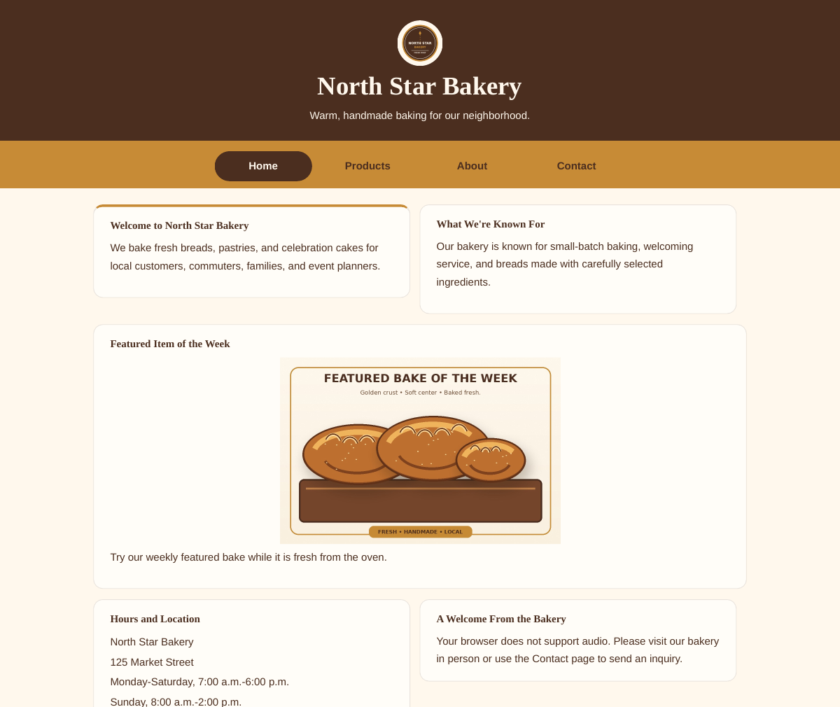
Figure 1. North Star Bakery home page visual design preview.

Final Submission Checklist
- Upload index.html, products.html, about.html, contact.html, style.css, the media folder, and README.md to a public GitHub repository. Submit this completed design explanation document together with the real repository and working preview links.
- Enable GitHub Pages and replace both URL fields on page 1 with real working links.
- Open the published site in a private/incognito browser window and test every navigation link and the Contact form.
- Submit this Word document and the published project link according to the course instructions.

