Exercise – stored procedure
Exercise 1 : Create a Stored Procedure
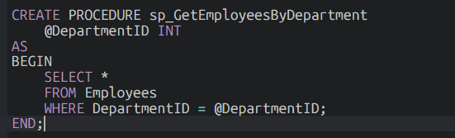
Sample Output:
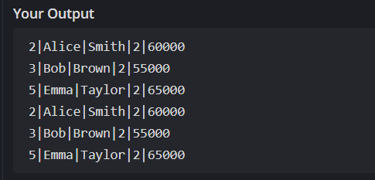
Exercise 5 : Return Data From Stored Procedure
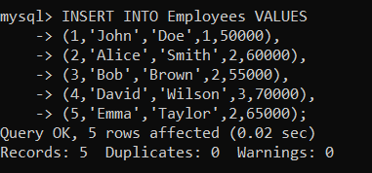
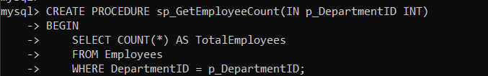
Output:
