

**Contact No.: 06064206228 or 088-3150357**

**PUROK 13 HAGKOL, VALENCIA CITY**

**Owned and Manage by: BABES GANGGA PEDUCHE**



**SPECIALTY**

**KAMBING FAVORITES**

**FREE**  1 PANCIT GUISADO IN EVERY 10 CHICKEN ATI-ATIHAN

**FREE 1 PANCIT GUISADO IN EVERY 10 CHICKEN ATI-ATIHAN**

**FREE 1 PANCIT GUISADO IN EVERY 10 CHICKEN ATI-ATIHAN**

**SIZZLING SQUID**

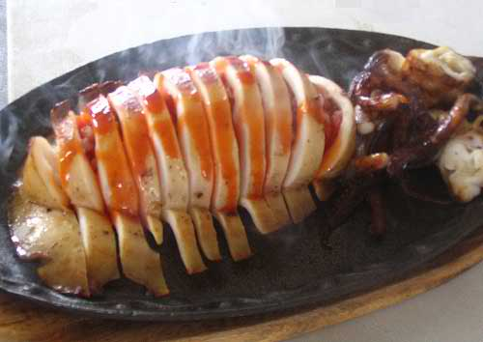

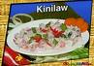

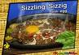

**FLAMMING SIZZIG**

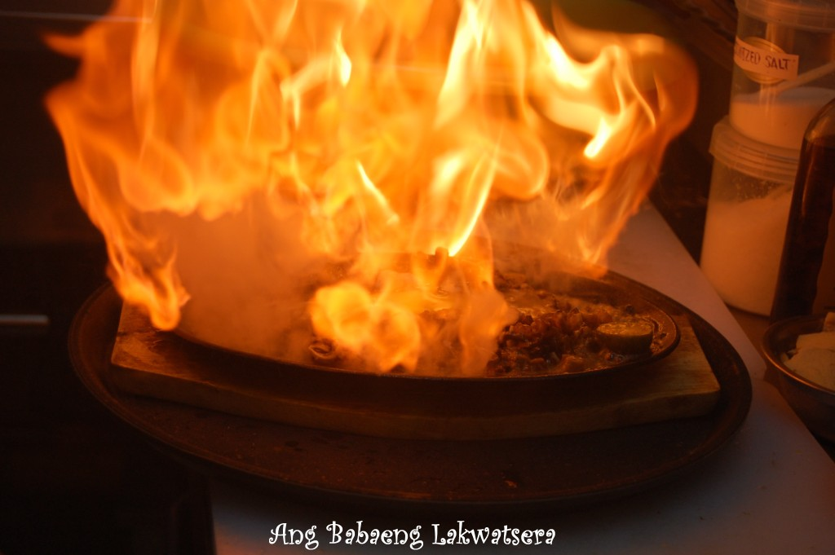

Figure Flamming Sizzig

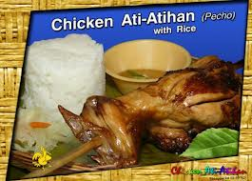

**KILAWIN KAMBING …………………………….. P100.00**

**ADOBONG KAMBING …………………………….. P120.00**

**KALDERERITA …………………………….. P120.00**

**PAPAIT SOUP …………………………….. P80.00**

**SINIGANG KAMBING …………………………….. P120.00**

**CHICKEN ATI-ATIHAN W/DRINKS&UNLIMITED RICE …………… P100.00**

**CHICKEN ATI-ATIHAN W/O DRINKS ………………………………P90.00**

**CHICKEN ATI-ATIHAN W/O RICE&DRINKS (GOOD FOR TAKE OUT)....P80.00**

**ATI-CRISPY FRIED CHICKEN W/RICE&DRINKS ………………………P110.00**

**ATI-CRISPY FRIED W/O RICE&DRINKS ………………………… ……..P90.00**

**FLAMMING PORK SIZZIG W/ EGG ……………………………….…….. P110.00**

**FLAMMING PORK SIZZIG W/O EGG ……………………..……… P105.00**

**SEAFOODS**

**KINILAW ……………………. P100.00**

**SINUGLAW ……………………. P160.00**

**SIZZLING MALASUGUE W/RICE …………………… P110.00**

**GRILLED MALASUGUE/RICE ……………………. P105.00**

**SIZZLING BANGUS ……………………. P100.00**

**GRILLED BANGUS ……………………. P95.00**

**SIZZLING SQUID ……………………. P100.00**

**CALAMARES ……………………. P100.00**

**FRIED TILAPIA ……………………. P80.00**

**GRILLED TILAPIA ……………………. P70.00**

**SWEET & SOUR FISH ……………………. P110.00**

**HITO -P40.00 PER 100grms-GRILLED OR FRIED**

**(HITO IS SEASONAL ONLY)**

**CHICKEN FAVORITES**

**CHICKEN HALANG – HALANG ……………………… P85.00**

**SIZZLING CHICKEN W/EGG ……………………… P100.00**

**SIZZLING CHICKEN W/O EGG ……………………… P95.00**

**CHICKEN ADOBO ……………………… P80.00**

**SIZZLING CHICKEN W/RICE, POTATOES & BEANS ……….. P110.00**

**PORK FAVORITES**

**SIZZLING PORK SIZZIG W/EGG & RICE …………………… P110.00**

**SIZZLING PORK SIZZIG W/O RICE …………………… P100.00**

**SIZZLING PORK SIZZIGW/O EGG&RICE …………………… P95.00**

**LECHON KAWALI …………………… P90.00**

**CRISPY PATA …………………… P255.00**

**PORK CHOP SINUGBA …………………… P70.00**

**PORK BARBECUE …………………… P25.00**

**PORK STEAK …………………… P80.00**

**PORK HUMBA …………………… P90.00**

**BEEF FAVORITES**

**BEEF STEAK WITH OYSTER SAUCE .…………… P100.00**

**BEEF STEAK W/OUT OYSTER SAUCE …………. P 90.00**

**OPENS DAILY FROM 8:00 AM TO 10:00 PM**



**PUROK 13 HAGKOL, VALENCIA CITY**

**Owned and Manage by: BABES GANGGA PEDUCHE**



**Contact No.: 09064206228 or088-3150357**



**FRENCH FRIES**

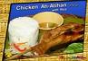

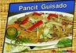

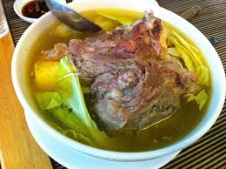

**POCHERO**

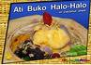

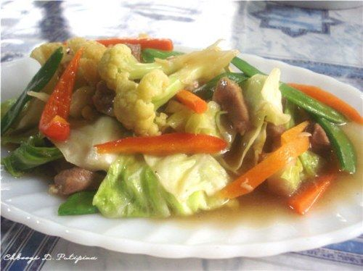

**CHOPSUEY GUISADO**

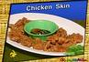

**PEPSI 8OZ ………………. P12.00**

**SEVEN UP 8OZ ………………. P12.00**

**PEPSI / 7UP 1 LTR. ………………. P30.00**

**PEPSI/7UP 1.5 ……………….. P55.00**

**CAN SOFTDRINKS ………………. P30.00**

**ICE TEA (GLASS) ………………. P25.00**

**MANGO JUICE (GLASS) ………………. P25.00**

**PINEAPPLE JUICE (GLASS) ………………. P25.00**

**STRAWBERRY JUICE (GLASS) ..…………. P25.00**

**GRAPE JUICE (GLASS) ………………. P25.00**

**PINEAPPLE JUICE CAN ………………. P38.00**

**FOUR SEASONS JUICE CAN ………….. P38.00**

**BUKO JUICE IN SHELL ………………. P30.00**

**CALAMANSI JUICE (HOT&COLD) ………. P35.00**

**COFFEE ( 3n1,CREAMY LATTE, BROWN, BLACK) .. P20.00**

**DRINKS /JUICES & COFFEE**

**POCHERO ESPESYAL ……….………... P170.00**

**CHICKEN TINOLA …………………. P100.00**

**SOTANGHON SOUP …………………. P80.00**

**PANCIT LUMI …………………. P90.00**

**FISH TINOLA …………………. P105.00**

**FISH SINIGANG …………………. P105.00**

**PORK SINIGANG …………………. P110.00**

**SHRIMP SINIGANG …………………. P110.00**

**PORK TINOLA …………………. P105.00**

**BANGUS TINOLA …………………. P100.00**

**BANGUS SINIGANG …………………. P100.00**

**TINOLA MANOK BISAYA..……………. P160.00**

**SOUP**

**BM #1 P75.00 BM#2 P60.00**

**2 PORK BBQ 1 PC. FRIED CHICKEN**

**1 PLAIN RICE 1 PLAIN RICE**

**1 PEPSI 8OZ 1 PEPSI 8OZ**

**BM #3 P85.00 BM#3 P80.00**

**1 PC. FRIED CHICKEN 1 PC. FRIED CHICKEN**

**1 PORK BBQ 2 PCS. LUMPIA SHANGHAI**

**1 PLAIN RICE 1 PLAIN RICE**

**1 PEPSI 8OZ 1 PEPSI 8OZ**

**BUDGET MEALS**

**NOODLES & VEGETABLES**

**PANCIT GUISADO ……………… P75.00**

**BIHON GUISADO ……………… P70.00**

**SOTANGHON ……………… P70.00**

**BAM-I GUISADO ……………… P75.00**

**CHOPSUEY GUISADO ……………… P95.00**

**VEGETABLE LUMPIA …………………… P60.00**

**MORNING Special w/Coffee or Ice Tea**

**LONGSILOG ……………… P75.00**

**CORNSILOG ……………… P75.00**

**HOTSILOG ……………… P75.00**

**HAMSILOG ……………… P75.00**

**CHICKEN SKIN W/BUNTOT (SEASONAL ONLY) ..P60.00**

**FISH IN CHIPS …………………….. P80.00**

**FRENCH FRIES …………………….. P60.00**

**HAMBURGER …………………….. P35.00**

**CHEESE BURGER …………………….. P45.00**

**EGG SANDWICH …………………….. P25.00**

**HAM & EGG SANDWICH ……..…………… P35.00**

**SPAGHETTI …………………….. P50.00**

**CHEESE FRITTERS W/HOTDOG ………… P60.00**

**PICA-PICA & SNACKS**

**RICE**

**PLAIN RICE ………………. P15.00**

**FRIED RICE (3 PERSONS) ………………. P80.00**

**GARLIC RICE (3 PERSONS) …………….. P70.00**

**SHAKES & DESSERTS**

**MANGO SHAKE ……………… P40.00**

**COOKIES & CREAM SHAKE ………. P40.00**

**BUKO SHAKE ……………… P40.00**

**BUKO PANDAN SHAKE ……………. P40.00**

**DURIAN SHAKE (SEASONAL ONLY)…….… P50.00**

**BUKO HALO-HALO ……………… P85.00**

**HALO-HALO REGULAR ……………. P70.00**

**MAIS CON YELO W/ GOLDEN BANANA ……. P40.00**

**OPENS DAILY FROM 8:00 AM TO 10:00 PM**