https://inversive-daughters.000webhostapp.com/index.html

https://inversive-daughters.000webhostapp.com/about.html

https://inversive-daughters.000webhostapp.com/contact.html

https://inversive-daughters.000webhostapp.com/services.html

https://inversive-daughters.000webhostapp.com/gallery.html

Browsers used: Internet Explorer and Firefox

Validation snapshot capture:

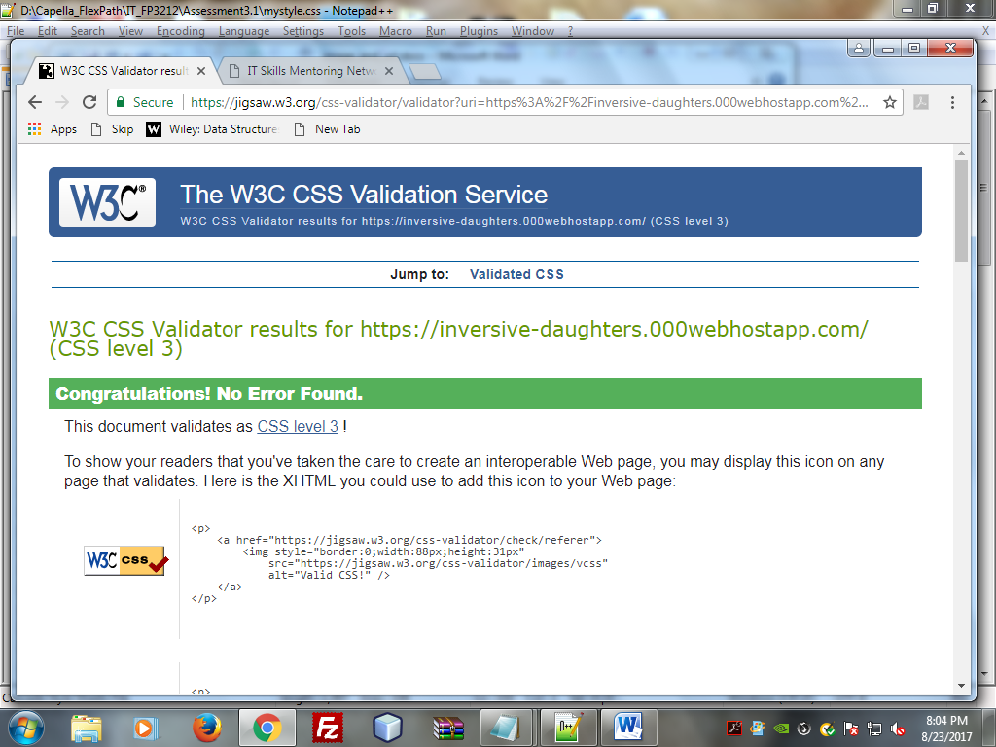

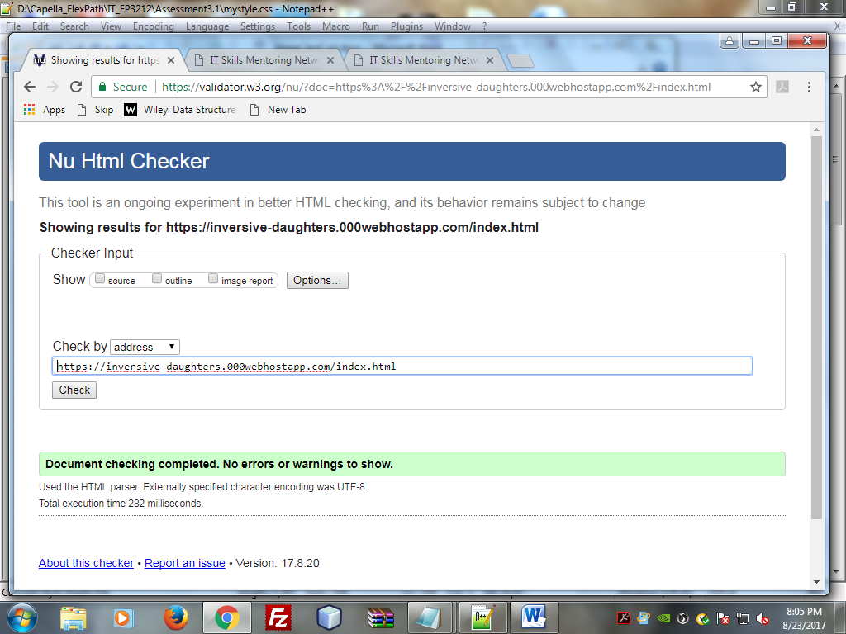

Pictures

