# Home Work #6 Schematic Tree and Decision Tree Analysis by Hand

## Q1

The goal is to *maximize* the *End Result*: the portfolio value after the investment.

1. 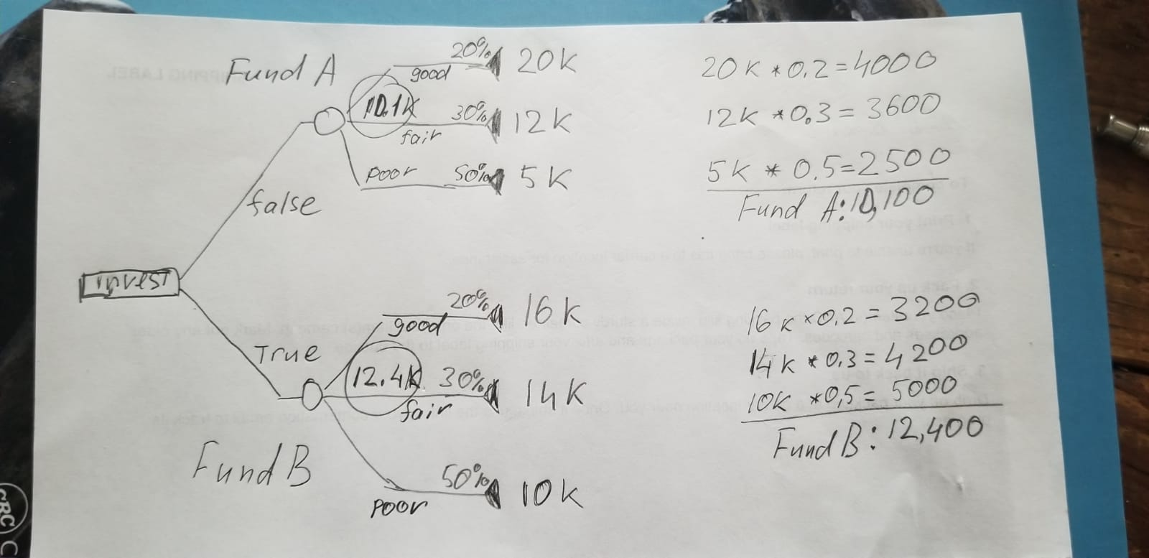
2. Q1
3. The better choice is the Fund B - the expected value ot this branch 12.4K vs 11.1K for the Fund A branch.
4. For the branches to be equal in case of *fund A in a good economy* the amount of 2.3K has to come from Fund A -> Good Economy branch. The value must be 2.3K more then 4K or 6.3K. Given the branch has 20% probability ahe absolute value must be 6.3K * 5 or 31.5K so the return must be at least 21.5K vs 10K as originally stated.

## Q2

The goal is to maximize the EMV of Winings Taken Home

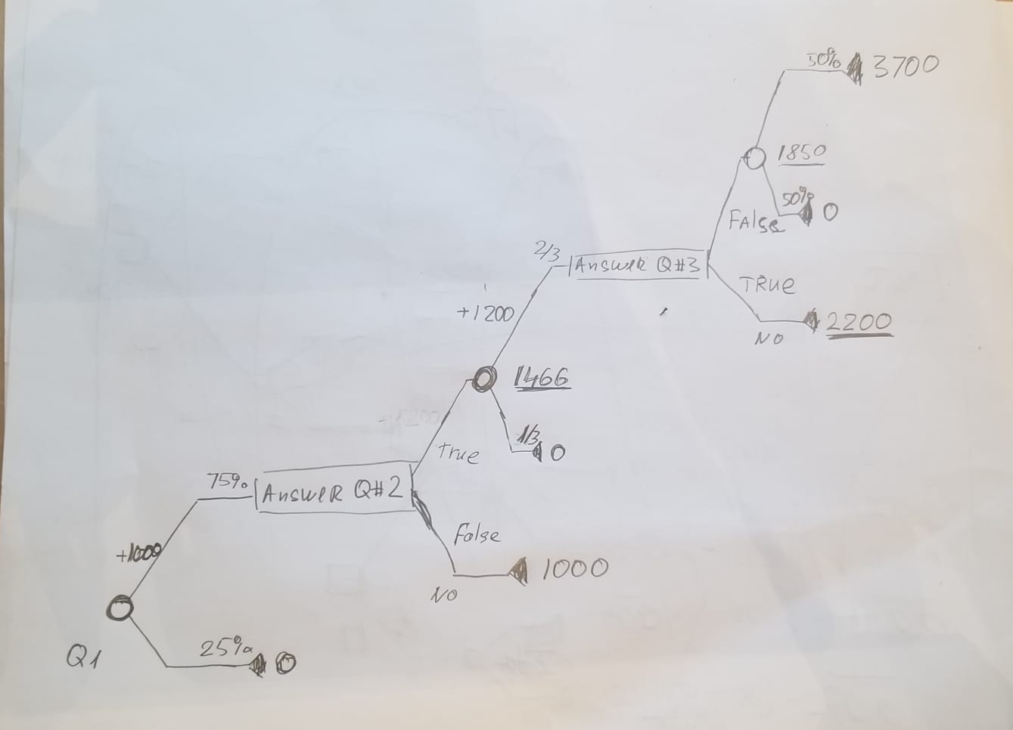

Q2

1. The full tree starts from Q1 and there is 75% chance of having $1000 after the first question. After the decision of Answering the Question #2 the EMV is $1000 for NO. The EMV is 1446 after applying the 2/3 probability of having 2200 = 1000 + 1200 in winings. To deside on Answering the Question #3 or not let’s compare NO that gives 2200 and 50% chance of having 3700: 2200 > 1850 hence by denying the answering the Q3 we have 2200 of EMV. *If first two qiestions answered correctly there is no point in answering the Q3*

## Q3

The goal is to minmize the EMV of Support cost per episode

1. 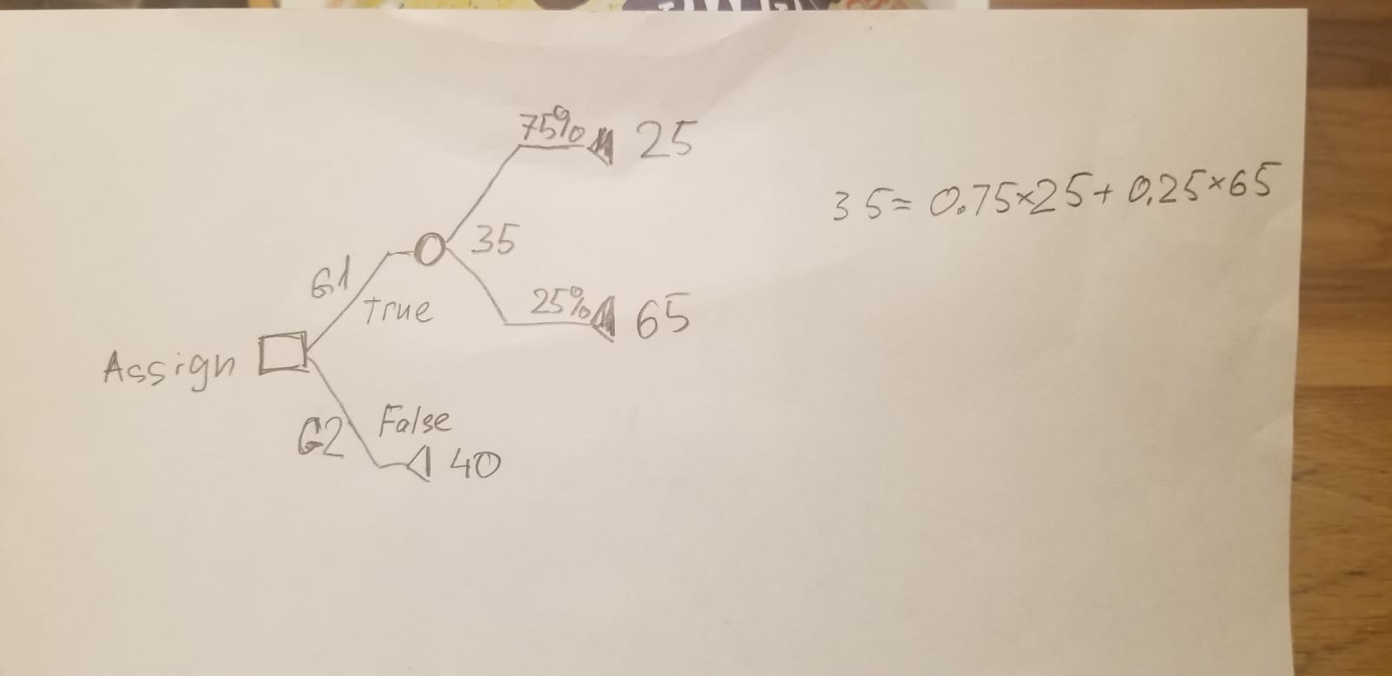
2. Q3-a
3. The assigment of Group 1 specialist in the case where probability of him solving the problem is 75% have EMV of $35 vs $40 if the Group 1 takes it first. The Group 1 has to handle this request.
4. 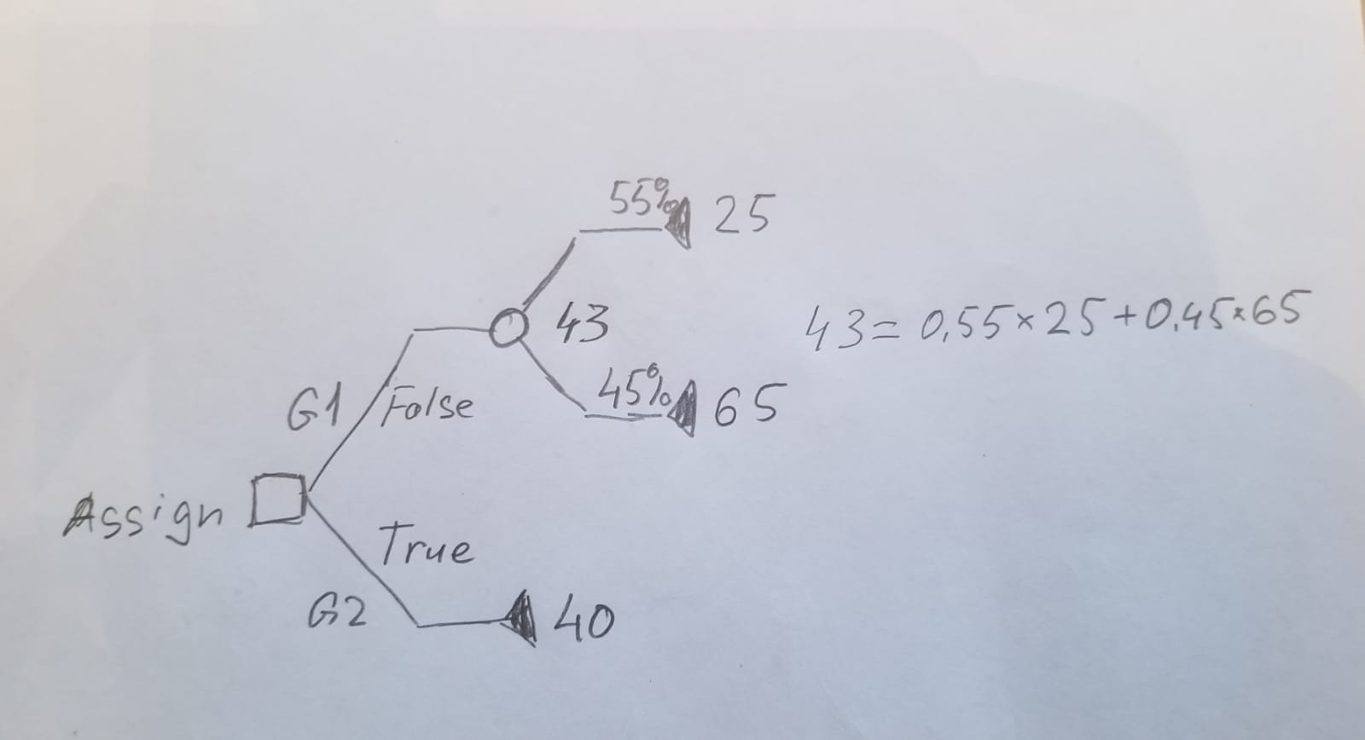
5. Q3-c
6. The assigment of Group 2 specialist in the case where probability of the Group 1 specialist solving the problem is 55% gives EMV of $40 vs $43 if done the other way. The Group 2 has to handle this request.

## Q4

1. The Probability of part to be scrapped is the same no matter what order the operations are performed. What is the probability that a part is ruined?

* Probability of Success (1 – 0.1)(1 – 0.2) = %72   
* Probability of Failure %100 - %72 = %28

1. The EMV has the value of -10 when Lathe #2 starts and -15 otherwise: Lathe #2 has to start first.

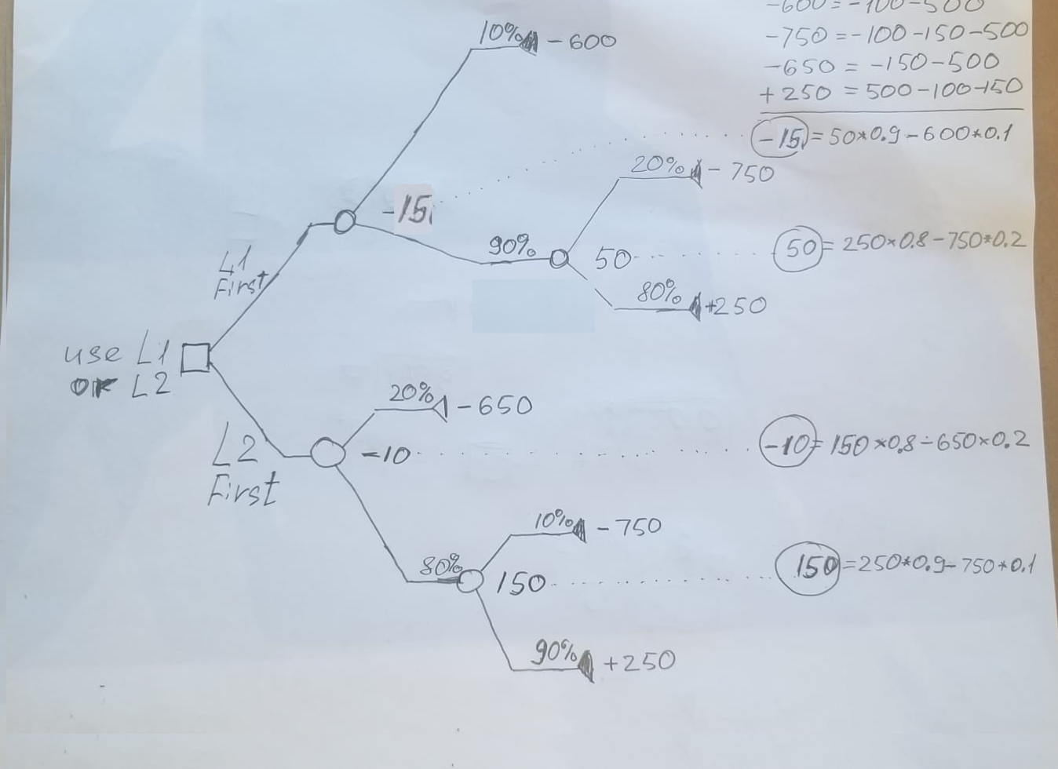

Q4

My hand drawings had incorrect calculations: I have assumed the loss of $500 in cost of material per scrapped part is incurred and Value is -10 - I got some suspitions but maybe this is *subsidised* business. Here is the proper tree:

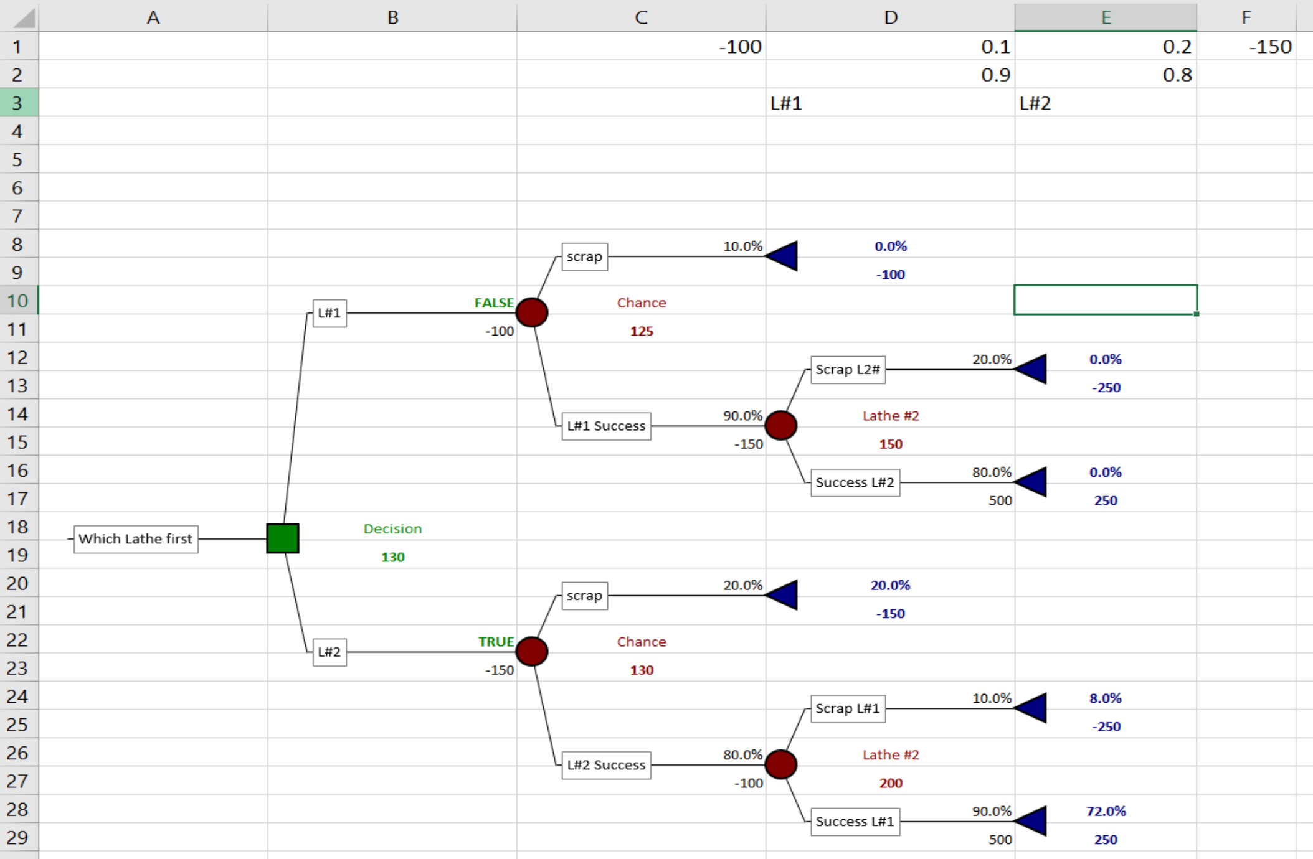

Q4

1. The Lathe #2 has to start first.