

**DSA6200(Section – 001): Operations Research - 3 Credits**

**Course Syllabus - Fall 2017**

|  |  |
| --- | --- |
| **Instructor:** | Saravanan (Saran) Venkatachalam, Ph.D.  Assistant Professor, Industrial & Systems Engineering Department  Saravanan.V@wayne.edu | Tel: 313.577.1821 |
| **Classroom:** | MANO 0120 |
| **Office:** | Room 2155, 4815 Fourth Street (MEB), Wayne State University, Detroit, MI 48202 |
| **Office Hours:**  **TA:** | MW : 3-4pm or by Appointment  Saied Haidarian ([saied.haidarian@gmail.com](mailto:saied.haidarian@gmail.com)) Office Hours: xxx |
| **Web Sites[1]:** | <http://blackboard.wayne.edu> |
| **Description:** | Introduction to prescriptive analytics with focus on modelling skills, algorithm development and practical implementations. Solution methods using optimization techniques and heuristics development will be covered. Applications, theory and practical algorithm implementation and computational experimentation using state of art softwares will be emphasized. Encouragement for the usage of grid and cloud computing architectures. |
| **Course Learning Outcomes:** | At the end of the course, the successful student will be able to:   * Develop skills in recognizing & formulating deterministic and stochastic optimization models including: constraints, objective functions and decision variables. * Develop an appreciation for the role of sensitivity analysis in analyzing a system. * Build a broader understanding of the types of mathematical models and their appropriate context in the data science and analytics. * Acquire hands-on experience in the application of exact methods and meta-heuristics for developing analytics solutions and decision support systems with *prescriptive models* for significant problems in practice * Work as a team member to put operations research into practice: identify, analyze, formulate and solve a business case problem and effectively justify your model and solution in a written and oral report |
| **Prerequisites:** | Familiarity with a programming language; Graduate standing and good mathematics background. |
| **Textbook:** | Hillier, F. S. and Lieberman, G. J. Introduction to Operations Research, 10th ed. |
| **References:** | Model building in mathematical programming, 5th edition, H. Paul Williams. (E-book available at library.wayne.edu)  Wayne L. Winston, Operations Research: Applications and Algorithms, 4th ed., Duxbury Press.  Additional tutorials and journal papers will be distributed in the class as needed to complement the material from the textbooks. |
| **Software:** | CPLEX, OPL, AMPL, Gurobi. Students are encouraged to use grid computing (<https://www.grid.wayne.edu/>) and cluster computing facilities for term project. |
| **Grading:** | Semester Project @ 10 x 1 10 pts  Two Exams @ 10, 15 25 pts  Assignments @ 5 x 4 20 pts  Case Study @ 7 x 5 35 pts  In-Class Quiz 10 pts  ___________________  Total 100 pts  Individual projects, exams, and special assignments might be curved and changed with regard to importance (i.e., in points), at the discretion of the instructor. Project reports and assignment reports have to be typed, and when feasible, results have to be justified and thoroughly summarized (without appending lots of pages of output). Reports have to be submitted at the beginning of the class on the due date. Late reports will NOT be accepted.  Guidelines for assigning grades: A = 95%+, A– = 90%+, B+ = 87%+, B = 83%+, B– = 80%+, C+ = 77%+, C =73%+, C– = 70%+, D+ = 65%+, D = 60%+, D– = 55%+, E = less than 55%. |
|  |  |
| **Semester  Project:** | This is a team assignment. Students are encouraged to pursue a practical topic and use an exact method and meta-heuristic approach for the project.  You may download IBM ILOG CPLEX Optimizer (free for academic use) at http://www-01.ibm.com/software/integration/optimization/cplex-optimizer/ |
| **Attendance Policy:** | Students attending any given class are required to join the class within the first five minutes to minimize any class disruptions. |
| **Religious Holidays:** | Because of the extraordinary variety of religious affiliations of the University student body and staff, the Academic Calendar makes no provisions for religious holidays. However, it is University policy to respect the faith and religious obligations of the individual. Students with classes or examinations that conflict with their religious observances are expected to notify their instructors well in advance so that mutually agreeable alternatives may be worked out. |
| **Student  Services:** | * *The Academic Success Center* (1600 Undergraduate Library) assists students with content in select courses and in strengthening study skills. Visit <http://success.wayne.edu> for schedules and information on study skills workshops, tutoring and supplemental instruction (primarily in 1000 and 2000 level courses). * *The Writing Center* is located on the 2nd floor of the Undergraduate Library and provides individual tutoring consultations free of charge. Visit <http://clasweb.clas.wayne.edu/writing> to obtain information on tutors, appointments, and the type of help they can provide. |
| **Class  Recordings:** | Students need prior written permission from the instructor before recording any portion of this class. If permission is granted, the audio and/or video recording is to be used only for the student’s personal instructional use. Such recordings are not intended for a wider public audience, such as postings to the internet or sharing with others. Students registered with Student Disabilities Services (SDS) who wish to record class materials must present their specific accommodation to the instructor, who will subsequently comply with the request unless there is some specific reason why s/he cannot, such as discussion of confidential or protected information. |
| **Academic Dishonesty – Plagiarism and Cheating:** | Academic misbehavior means any activity that tends to compromise the academic integrity of the institution or subvert the education process. All forms of academic misbehavior are prohibited at Wayne State University, as outlined in the Student Code of Conduct (<http://www.doso.wayne.edu/student-conduct-services.html>). Students who commit or assist in committing dishonest acts are subject to downgrading (to a failing grade for the test, paper, or other course-related activity in question, or for the entire course) and/or additional sanctions as described in the Student Code of Conduct.   * *Cheating*: Intentionally using or attempting to use, or intentionally providing or attempting to provide, unauthorized materials, information or assistance in any academic exercise. Examples include: (a) copying from another student’s test paper; (b) allowing another student to copy from a test paper; (c) using unauthorized material such as a "cheat sheet" during an exam. * *Fabrication*: Intentional and unauthorized falsification of any information or citation. Examples include: (a) citation of information not taken from the source indicated; (b) listing sources in a bibliography not used in a research paper. * *Plagiarism*: To take and use another’s words or ideas as one’s own. Examples include: (a) failure to use appropriate referencing when using the words or ideas of other persons; (b) altering the language, paraphrasing, omitting, rearranging, or forming new combinations of words in an attempt to make the thoughts of another appear as your own. * *Other* forms of academic misbehavior include, but are not limited to: (a) unauthorized use of resources, or any attempt to limit another student’s access to educational resources, or any attempt to alter equipment so as to lead to an incorrect answer for subsequent users; (b) enlisting the assistance of a substitute in the taking of examinations; (c) violating course rules as defined in the course syllabus or other written information provided to the student; (d) selling, buying or stealing all or part of an un-administered test or answers to the test; (e) changing or altering a grade on a test or other academic grade records. |
| **Student Disability Services:** | If you have a documented disability that requires accommodations, you will need to register with Student Disability Services for coordination of your academic accommodations. The Student Disability Services (SDS) office is located at 1600 David Adamany Undergraduate Library in the Student Academic Success Services department. SDS telephone number is 313-577-1851 or 313-577-3365 (TTD only). Once you have your accommodations in place, I will be glad to meet with you privately during my office hours or at another agreed upon time to discuss your needs. Student Disability Services' mission is to assist the university in creating an accessible community where students with disabilities have an equal opportunity to fully participate in their educational experience at Wayne State University. Please refer to the SDS website for further information about students with disabilities and the services we provide for faculty and students: <http://studentdisability.wayne.edu/>  Students who are registered with Student Disability Services and who are eligible for alternate testing accommodations such as extended test time and/or a distraction-reduced environment should present the required test permit to the professor at least one week in advance of the exam. Federal law requires that a student registered with SDS is entitled to the reasonable accommodations specified in the student’s accommodation letter, which might include allowing the student to take the final exam on a day different than the rest of the class. |
| **Course Drops and Withdrawals:** | In the first two weeks of the (full) term, students can drop this class and receive 100% tuition and course fee cancellation. After the end of the second week there is no tuition or fee cancellation. Students who wish to withdraw from the class can initiate a withdrawal request on Pipeline. You will receive a transcript notation of WP (passing), WF (failing), or WN (no graded work) at the time of withdrawal. No withdrawals can be initiated after the end of the tenth week. Students enrolled in the 10th week and beyond will receive a grade. Because withdrawing from courses may have negative academic and financial consequences, students considering course withdrawal should make sure they fully understand all the consequences before taking this step. More information on this can be found at: <http://reg.wayne.edu/pdf-policies/students.pdf> |
| **Deferred  Grade:** | A grade of 'I' can only be assigned if all of the following criteria are met:   1. the student IS NOT currently failing the class and, 2. there is NOT a substantial quantity of work yet to be completed, 3. there is no extra work required of the instructor beyond the normal duties of grading the paper/exam, 4. there is no need for the student to attend the class in subsequent terms.   The final decision to assign an incomplete grade rests with the instructor. An 'I' grade MUST be made up within one year of assignment of the grade. |

**Tentative Course Schedule:**

1. Introduction to MS/OR Modelling ***(introduction)***
   1. Decision-making in real-world applications, decision-making models
   2. Linear Programing (LP) formulation
   3. LP Graphical method
   4. OR Modeling software and solution technologies, Introduction to OPL, AMPL
2. LP Solution Methods ***(fundamentals, LP basic theory)***
   1. LP Simplex Method
   2. Sensitivity Analysis, and Duality
   3. Introduction to Multi-objective LPs, Goal Programming
   4. OPL and AMPL Examples and modelling exercises
3. Integer Programming ***(introduction, modelling, and solution methods)***
   1. Integer programming (IP) models
   2. Exact solution method IP – Branch and Bound
   3. Heuristic for IP
   4. Introduction to CPLEX, more modelling exercises
4. LP and IP Models in Applications ***(use cases, case studies, and papers)***
   1. Supply Chain Management
   2. Revenue Management
   3. Health Care
   4. Miscellaneous applications
   5. Transportation and Assignment Problems
   6. Network Optimization Models
5. LP and IP Extensions ***(introduction)***
   1. Transportation Problems
   2. Assignment Problems
   3. Network Optimization Models
6. Meta-Heuristics ***(introduction, methods, and application)***
   1. Tabu Search
   2. Simulated Annealing
   3. Genetic Algorithm
7. Dynamic Programming ***(introduction, methods, and application)***
   1. Prototype and characteristics
   2. Deterministic DP
   3. Probabilistic DP
8. Decision Making Under Uncertainty
   1. Introduction to Robust Optimization
   2. Introduction to Stochastic Programming
   3. Introduction to Probabilistic Constrained Programming

**Tentative Course Schedule – Last Update Aug 28th.**

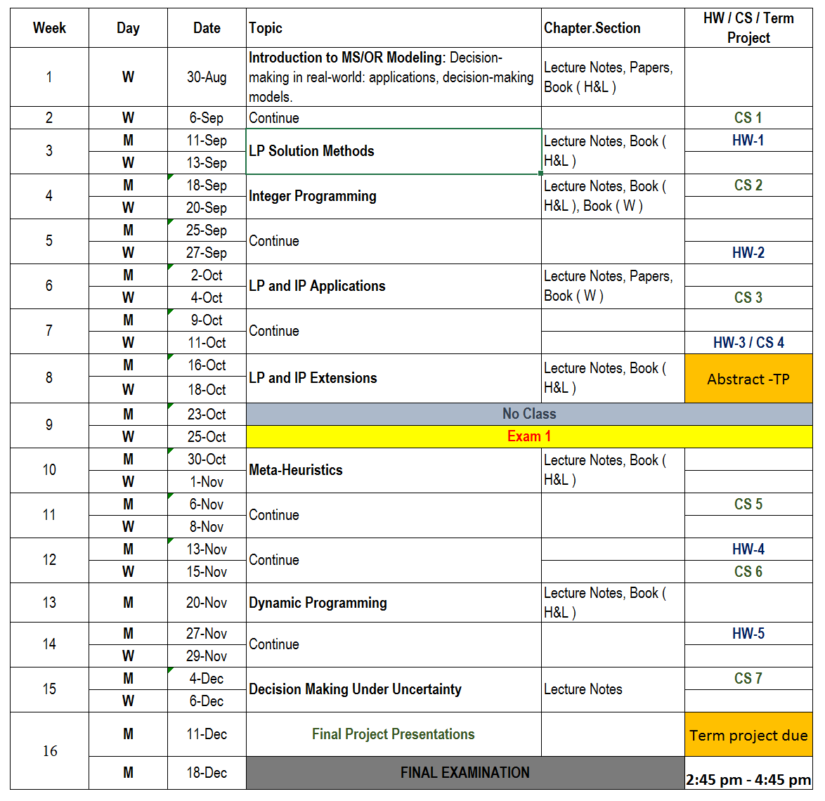

1. Blackboard website is protected by individual user login names and passwords. The username is the uniquely assigned WSU AccessID. To activate your WSU AccessID or change the password or set an alternate forwarding e-mail address, visit <https://computing.wayne.edu/accessid>. Call the WSU Computing & Information Technology (C&IT) Help Desk at 313-577-4778 for any difficulties.