Importing OO-stuff to WXT

Limitations
This mechanism is not complete and free from faults. We can only deal with text, tables, images, lists and to some extent formulas.
Formulas are at the present represented by MathML, which not all browsers are too happy with.
The concept of «dpath» for selecting material from a flat documentstructure is not waterproof, but it works on simple constructs.
WXT also assume that headings are style as Heading1, Heading2 etc

Purpose
The idea is to give authors not familiar to XML and HTML a way of producing material for a website, or importing material from reports written in Open Office, or even material written in Microsoft Office, and converted to Open Office.

Illustrations
Here are some images

and


Portraits
It also contain some portraits of the author
samples
 | 
 | 

El Classico
These are the facts
- Barcelona – Real Madrid
- Camp Nou
- 29.11.2010
- 5 -0


Bezier

Math

Line
Let us look a straight line in a plane as a simple first example.
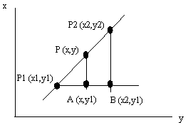
The triangles P1,A,P and P1,B,P2 are similar and we can set up the following:

and find for example y expressed by coordinates for the two known points and x.

As an alternative we could set up a parametric equation for the line. Parametric means that the expression contains a parameter, t, that changes when we run along the line. For a line in the plane we get two parametric expressions, one for x and one for y. Since we have a line, both are linear.

