Testing ODT
This document contains headings, textparagraphs,
tables, images and formulas.
It is a demopage for ODT-import from WXT.

Formula
Bezier function

Table
A 2X2 table
Square 1,1 | Square 1,2
Square 2,1 | Square 2,2

List
We can handle
- images
- lists
- tables
- references
- headings
- textparagraphs

Image
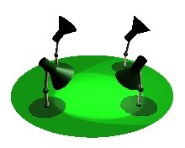
And another:



