The Bezier function

A polynom of degree 3
We will use a situation quite similar to the one we had when we developed the Hermit curve.
We want to find the coefficients in an expression of third degree:

We want geometrical guidelines that state that the curve should start and stop in two points: P0 and P3.
Consequently:

We want a polynomial of third degree and need two more guidelines.
We use two points that indirect state the derivative in the endpoints:
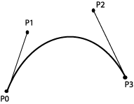 | We decide that:

The derivative is:

We have to find a,b,c and d in this set of equations:

We solve and find:

and we set up the expression for B(t):

We rearrange and we get:

This has given us a form that resembles the one we had for the Hermit curve and we can set up the expression in a matrix form:

where
, and

The blending functions are described like this:
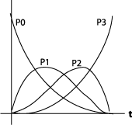

Note that we can rewrite:

to

which is the normal description of the Bezier curve.

de Casteljau
The starting point is the parametrical form for a line:

According to de Casteljaus algorithm we may consider this as special case of a Bezier curve, a linear Bezier curve.
The algorithm can be described after the following scheme, where we imagine that t runs from 0 to 1:
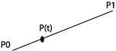
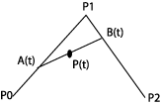 | and  giving
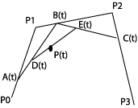 | and  and  giving:

The last expression is the same as the one we reached above, when we used a general polynomial of third degree and constraints for the endpoints and the derivative in the endpoints as a starting point.
It is easy to convince oneself that we can repeat the de Casteljau algorithm with further control points, P4, P5 etc.

The formula
The expression for the Bezier function is in general:

where n states the number of control points.
The description of the curve becomes:

Coefficients,are the same as the ones in Pascals triangle:
 |  |  |  | 1
 |  |  | 1 |  | 1
 |  | 1 |  | 2 |  | 1
 | 1 |  | 3 |  | 3 |  | 1
1 |  | 4 |  | 6 |  | 4 |  | 1

We have used n=4, and used the coefficients 1, 3, 3, 1.

Segments
The general shape of the Bezier curve gives us the possibility to specify more control points. We can for example let n=5 and get:

We will not develop this reasoning to handle longer curves. We will in stead regard a curve as put together by several curve segments.
We want to look at how we can join curves and gain different degrees of smoothness. We will concentrate on what conditions that has to be fulfilled if two segments are going to hang together in a "smooth" way. We'll look at four degrees of geometric continuity. We'll regard Bezier curves and represent them as they are represented in drawing programs. The lines between the control points is represented as "handles" that we can use to change the shape of the curve.
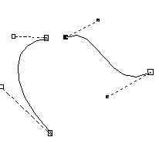 | No continuity. The two curve segments don't have a common point.
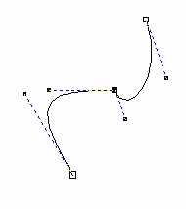 | The two curve segments have a common point. The curves are connected, but with an obvious break in direction. The derivatives (for right and left segment) are different both in direction and size in this point.
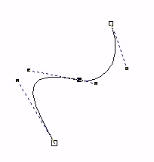 | The two curve segments have a common point, and the joint is quite smooth. The derivatives in this point have the same direction, but not the same size.
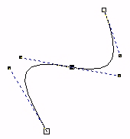 | The two curve segments have a common point, and the joint is smooth. The derivatives in this point have the same direction and size.

