Understanding topological properties of network connectivity in Resting-State fMRI   
Jaime Gomez-Ramirez, Yuzie Li, Qiong Wu, Xiaoyu Tang, Jinglong Wu

Universidad Politécnica de Madrid, José Gutiérrez Abascal,2 Madrid 28006, Spain

Okayma University, Japan

Abstract

Network theory approaches to brain connectivity in Resting-State fMRI have been mainly focused on the study of topological properties and network motifs that characterize the network structure. Small world architectures –highly clustered nodes connected thorough relatively short paths- have been identified in healthy and functional brain networks. It has been suggested that the disruption of normal brain function in diseases such as Schizophrenia and AD, can be observed and measured in terms of variations in the network topology. For example, the reshaping of small-worldness into randomness in functional connectivity networks. This posits new venues to the study of brain disease prognosis in terms of network-based biomarkers. However, a formal understanding of the interplay between brain disease and network connectivity is still missing. Here we build a information based theory of robustness, in which rather than quantify how global graph properties –efficiency, global cost etc.- are modified upon node removal, we study how network connectedness is altered by biased random walks, that is random walks that follow a given strategy, for example, favor the visit of nodes with high betweenness centrality. Thus, each strategy –a vector containing nodes weights- produces a new network adjacency matrix that can be used by biased random walkers. We calculate the entropy of probability distributions such as first time passage, and we build on this results to study the network *b-Robustness* for different strategies. A quantitative analysis of our approach and how it compares to traditional vulnerability-based studies of network robustness in Resting-State fMRI functional is provided.

© 2001 Elsevier Science. All rights reserved

1. Introduction

It has been suggested that fluctuations in the BOLD signal measured in humans in resting state, represent the neuronal activity baseline and shape spatially consistent patterns (Raichle and Gusnard, 2005), (Fransson, 2006) (Y. Li More refs here). The systematic study of those patterns using correlation analysis techniques, has identified a number of resting state networks, which are functionally relevant networks found in subjects in the absence of either goal directed-task or external stimuli. The visual identification of the overall connectivity patters in resting state functional magnetic resonance imaging (R-fMRI), has been assessed using either model-based and model-free approaches. In the former, statistical parametric maps of brain activation are built upon voxel-wise analysis location. This approach has been successful in the identification of motor networks, but it shows important limitations when the seed voxel cannot be easily identified. For example, in brain areas with unclear boundaries; i.e. cognitive networks involved for instance, in language or memory. Independent Component Analysis (ICA), on the other hand, is a model-free approach that allows separating resting fluctuations from other signal variations, resulting on a collection of spatial maps, one for each independent component, that represent functionally relevant networks in the brain. While ICA has the advantage over model-free methods that it is unbiased, (that is, it does not need to posit a specific temporal model of correlation between ROIs), the functional relevance of the different components is, however, computed relative to their resemblance to a number of networks based on criteria that are not easily formalized.

More recently, researchers using graph-theory based methods have been able to not only visualize brain networks, but to quantify their topological properties. Large-scale anatomical connectivity analysis in the mammalian brain, shows that brain topology is neither random nor regular. Instead, it is organized in small world architectures (Watts & Strogatz, 1998), (Vaessen et al., 2010), characterized by high clustering and short path lengths. Small world networks are not solely structural, functional networks with a small world organization have been identified in the mammal brain (Basset & Bullmore, 2006). In addition to this, disruptions in the small world organization can give clues about normal development and pathological conditions. For example, Spekar and colleagues (Spekar et a., 2008) have shown that the deterioration of small world properties such as the lowering of the cluster coefficient, affect local network connectivity which in turn may work as a network biomarker for Alzheimer’s disease. Abnormalities in small-worldness may also have a significant positive correlation in for example, schizophrenia (Liu et al. 2008) and epilepsy (Liao, 2010) ) (Y. Li More refs here. While network-based studies have been successful in delineating generic network properties, such as path length or clustering, additional work is needed in order to come to grips with the internal working of the systems underlying the network.

Robustness in brain connectivity has been typically approached in terms of the impact that the complete disruption and/or removal of a network component has in the network topology (Kaiser at al.,2007). However, by focusing on the topology of the network, factors that may play a key role in the network’s vulnerability to failures can be neglected. For example, it has been suggested that patients with Alzheimer’s disease show an increment in brain activity in certain areas relative to healthy subjects that compensates for the disease related atrophy of other regions (Sanz-Arigita,2010).

In this paper we explore the network degeneration hypothesis, which states that neurological diseases target functional neural networks modifying its topological properties, using a methodology that combining graph theoretic tools and information theory may rigorously address robustness and its interplay in aging and pathological conditions. This approach posits a new theoretical framework to investigate network robustness and how it is affected by “internal perturbations” such as aging and neurological disorders.

**Network Robustness**

(Y.Li) Provide bibliography on study of network robustness and it is related to brain disorders. Find papers (e.g. (Kaiser at al.,2007)) that study this with node removal i.e. delete a node and all its links and calculate the cost, efficiency or other relevant parameter of the new network.

**b-Robustness**

A stochastic process is an indexed sequence of random variables and a random walk on a graph G(N,E) is an instance of a stochastic process characterized by a sequence of nodes {N1, … Nn} that are visited according to a probabilistic rule. A fair random walk in an undirected graph is defined by an uniform probability distribution Pij=1/ki, where ki is the connectivity of the node i. For example, if node i is connected to nodes j,k and m, Pij=Pik=Pim=1/3. Pij=0 if the nodes i and j are not adjacent (Figure). Note that this can be directly extended for directed graphs with Pij=Wij/sum(Wik).

Now, a biased random walk on undirected graphs is defined by a biased transition operator such that the probability to visit node j from node is factored by a bias bj:

Pij= bj*Aij/sumk(Aik*bk) (Aij is the original adjacency matrix of the graph)

The vector b represents a strategy follow by the walkers on the graph. For example, if the bias b is the betweeness centrality c, the network dynamics is shaped by a strategy that favours the visit of nodes with a high occurrence in the shortest paths of the graph. Thus, for a given graph we can simulate different walks that follow a strategy given by a bias b. It ought to be noted that there is both an unlimited number of strategies and walks. The rationale behind this approach is that we can study global properties of the network –connectedness, robustness- based on probability distributions that result form the biased random walks. Using Shannon’s definition of entropy we can quantify the uncertainty of certain probability distributions e.g., first time passage, and the uncertainty between two or more probability distributions, for example local connectivity and global path length. Network robustness is here addressed in terms of a particular strategy or bias b followed by a number of walker or network instances. Here, each biased random walk can be interpreted as a network response to a perturbation. The strategy or bias b suggests a strategy adopted by the network in response to an unknown perturbation. Thus, the graph and the random walks defined in it constitute a stochastic dynamical system which can be characterized by certain probability distributions P(t) of the walking times. The uncertainty of those distributions is calculated thorough the entropy rates which at its turn provides a measure of network robustness.

**Entropy**

The entropy H(p) is the functional on the graph G with respect to the probability distribution p. A network in order to be robust needs to be able to deploy some sort of “rational” strategy which can always be randomized as a biased random walk. For example, the transition from i node to node j is more likely to occur than to node k which is also adjacent to node i but with less betweeness centrality than node j. Thus, we can now define a bias or strategy as a function that maps the set V into the real positives. Accordingly the adjacency matrix is now:

1. Methods

(Y.Li)

**Data Acquisition and Preprocessing**

Twenty-four healthy volunteers ( ?21–? years) were scanned on a 3.0 Tesla ? scanner (?). All subjects had no history of neurological or psychiatric disorders BLA BLA BLA

**Construction of Brain Functional Networks**

Functional brain networks at the temporal scale.

To construct large-scale brain functional networks at the temporal scale, a X-step process was undertaken. (i) BLA BLA

Functional brain networks at the spatial scale

1. Results (working progress section just draft)
   1. Study of network robustness with orthodox approach (no b-robustness

Connectivity distribution

We can exclude the possibility that the connectivity distribution follows a power law as the figure clearly represents. (the log-log plot of the nodes connectivity and the cumulative probability distribution is a totally unoptimal fit with a straight line (solid line) ).

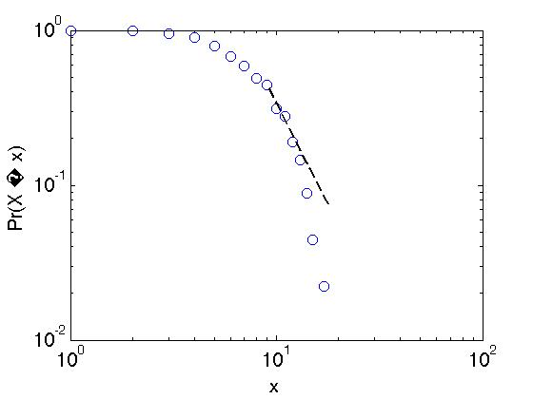

The next step is to study whether the connectivity network is scale free or a small world network. Note that in small world networks degree distributions other than power law are possible. For example, a power law can be cut-off by a Gaussian or exponential distribution, which apparently is the above scenario for the tail (). However, the figure shows that only in the middle of the distribution we may have something like a power law, in the extremes, other candidates such as exponential or Gaussian should be investigated.

The figure 2 depicts a good fit between the experimental data and a normal distrubtion, note that in both extremes the fit is not optimal, but for values in the number of connections between 5 to 15 the experimental depicts a straight line.

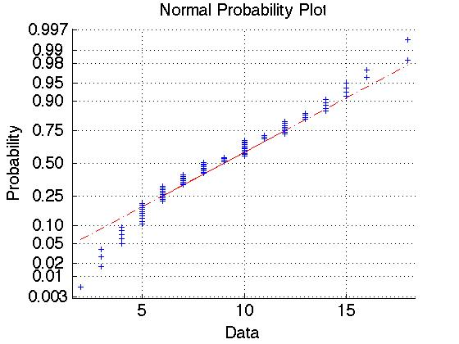

The Kolmogorov-Smirnov test (p=1). BUT The Kolmogorov-Smirnov is only valid for continuous cumulative distribution functions, and the test requires that CDF be predetermined. WHICH IS NOT THE CASE HERE as the figure 3 shows.

Using Matlab *lillietest* we can rule out the null hypothesis of normality and it does also with the exponential distribution.

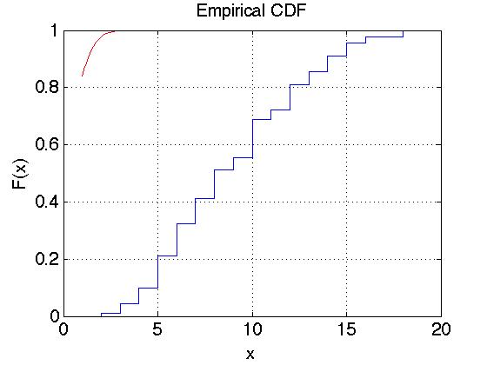

**Network Identification**

In order to asses the network topology of the given network we need first to adopt a metric to which will be applied to either the empirical network and a randomly generated set of synthetic networks. Thus, the randomized counterpart will give us the null model that we need in order to identify whether the relevant properties given by the adopted metric in the real network are over represented or under represented in relation with the synthetic networks.

Here we explain how the generate a pool of randomly generated random network, then we compare the metric for the real network with this pool. There are a number of different algorithms that may generate a pool opf random network that maintain specific characteristics that we wish the random network hold, such as connectivity degree, number of nodes, number of edges etc. rirst, we use the Renyi-Erdos model to provide a population of random networks with the same number of nodes and edges than the brain network. The Matlab code is as follows:

*%library: http://strategic.mit.edu/downloads.php?page=matlab_networks*

%%% Reny-Erdos model

% number of random matrix to be generated

M=100;

randomgraphs=zeros(90,90,M);

RZnumnodes =numnodes(RZcor);

RZnumedges =numedges(RZcor);

% number of random matrix to be generated

for i= 1:M

randomgraphs(:,:,i)=random_graph(RZnumnodes,[ ],RZnumedges);

end

Now we have to calculate the clustering and path length parameters referred to either the real network and the synthetic ones.

*Cprd=zeros(90,1,M);*

*cprdi_mean=zeros;*

*Lpran=zeros;*

*cprdglob_mean=0;*

*for i= 1:M*

*Cprd(:,:,i)= clustering_coef_bu(randomgraphs(:,:,i));*

*cprdi_mean(i)=mean(Cprd(:,:,i));*

*Lpran(i)=charpath(randomgraphs(:,:,i));*

*end*

*cprdglob_mean= mean(cprdi_mean);*

*lpranmean=mean(Lpran);*

*%%% gamma, local clustering, if mygamma >1 higher clustering than in random network*

*mygamma=cpsw/cprdglob_mean;*

*%%% lambda, global path distance*

*mylambda= Lp/lpranmean;*

*% if smallw > 1 likely small world*

*mysmallw=mygamma/mylambda*

We obtain the global path length ( $λ{}_{real}$ = $0.0881)/ (λ{}_{random}=0.0993)$ = 0.8881 and the local clustering coefficient ($γ{}_{real}=0.7790$)/($γ{}_{random}$ = 0.1005)=7.7527. Thus, $σ=\frac{γ}{λ}=8.7299$, which indicates that the clustering tin the real network is much higher than in the counterpart random networks and the distance in the characteristic path length is near (close to 1).

A different alternative to create random networks is using the Maslov’s algorithm () in which the degrees of each node is preserved, that is, each node in the generated random network will have the same number of immediate neighbors.

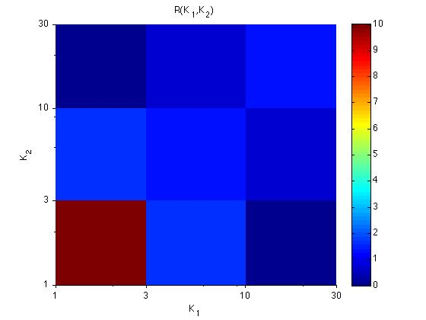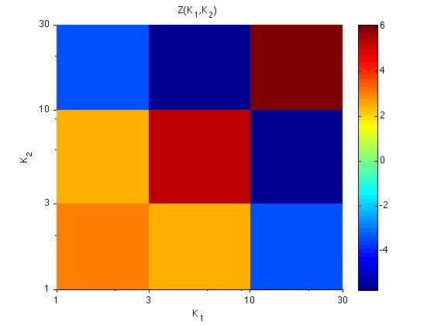

In the left side we calculate the systematic deviations of the ratio P(K0,K1)/Pr(K0,K1)) from 1 and on the right side is depicted the statistical significance of the deviations. Both plots combined reveals regions on the plane were connections between brain regions are significantly enhanced or supressed compared to the null model. The red region in the left side plot indicates the tendency of poorly connected nodes to associate with other poorly connected nodes (less than four neighbors), blue regions in the upper left and lower right shows the reduced likelihood that highly connected nodes are directly linked with poorly connected nodes and viceversa. The Z scores plot on the right Z(K0,K1) = (P(K0,K1) − Pr(K0,K1))/ $σ$_r (K0,K1) where $σ$_r(K0,K1) is the standard deviation of Pr(K0,K1) in 100 realizations of a randomized network.)

Distance related measures (Network Efficiency and Network Vulnerability)

3.2 b-Robustness

Conclusions

The precise way in which network properties are modified during normal development, aging or pathological conditions is still under debate. For example, it is unclear whether Alzheimer’s disease affects local or global connectivity, or if connectivity is attenuated as in the Default Mode Network (DMN) (Greicius et al., 2004) or on the contrary, Alzheimer’s disease may induce an increase in functional connectivity that compensates for the disease related atrophy of affected regions (Sanz-Arigita,2010). We have presented here a new approach to network robustness –b-robustness- that makes use of stochastic processes –biased random walks- to simulate the network response to unknown perturbations. Our study shows that … compared to traditional studies of network robustness based on node removal …RESULTS HERE

Acknowledgments

References

1. Kaiser M, Robert M, Andras P, Young MP. (2007). Simulation of robustness against lesions of cortical networks. Eur J Neurosci 25: 31 85-3 1 92.
2. Liao, W., et al. (2010). Altered func¬tional connectivity and small-world in mesial temporal lobe epilepsy. PLoS ONE 5, e8525.
3. Liu, Y., et al. (2008). Disrupted small-world networks in schizophrenia. Brain 131, 945–961.