Hands-On Data Lab Implementation
Data Analyst Virtual Internship Report
Nayan Deepak Borse

1. Objective
The goal of this lab was to build a working data analysis environment and to complete practical exercises in data manipulation, visualization and basic analysis. I used a logistics shipments dataset of 1,000 records so the work connects to my earlier internship tasks.

2. Environment Setup
I installed Python 3 with Jupyter Notebook and the core libraries needed for analysis. Installation was done with pip:
pip install jupyter pandas numpy matplotlib seaborn
jupyter notebook

Library | Purpose
pandas | Tables, cleaning, filtering, groupby and merge
NumPy | Numeric arrays and random data generation
Matplotlib | Base plotting
Seaborn | Statistical charts such as histogram and heatmap
Jupyter | Interactive notebook to run code and view results

A version check cell confirmed the setup worked: Python 3.12, NumPy, pandas, Matplotlib and Seaborn all imported without errors.

3. Dataset
The dataset has 1,000 shipments with these columns: shipment_id, order_date, region, carrier, distance_km, weight_kg, delivery_days and cost_inr. It was generated with a fixed random seed so results are reproducible. I added 40 missing weight values and 25 missing delivery day values to practise cleaning.

4. Data Manipulation Exercises
- Inspection: used info() and isnull().sum() to find the missing values.
- Cleaning: filled weight_kg with the column median and delivery_days with the median of each carrier. No missing values remained.
- Filtering: found 58 heavy long distance shipments (weight above 800 kg and distance above 1,000 km).
- New columns: created cost_per_km, month and an on_time flag (delivery in 4 days or less).
- Groupby: built a carrier summary of shipment count, average cost and average delivery days.
- Merge: joined a carrier information table (fleet size) to the shipments with a left join.

Carrier summary result:
Carrier | Shipments | Avg cost (INR) | Avg days
RoadKing | 258 | 7,993 | 4.46
FastTrack | 248 | 7,982 | 4.49
CargoPlus | 234 | 8,403 | 4.59
SwiftMove | 260 | 8,267 | 4.65

Sample code used for cleaning and grouping:
df["weight_kg"] = df["weight_kg"].fillna(df["weight_kg"].median())
summary = df.groupby("carrier").agg(
shipments=("shipment_id", "count"),
avg_cost=("cost_inr", "mean"),
avg_days=("delivery_days", "mean"))

5. Visualization Exercises
Four charts were created and saved from the notebook.
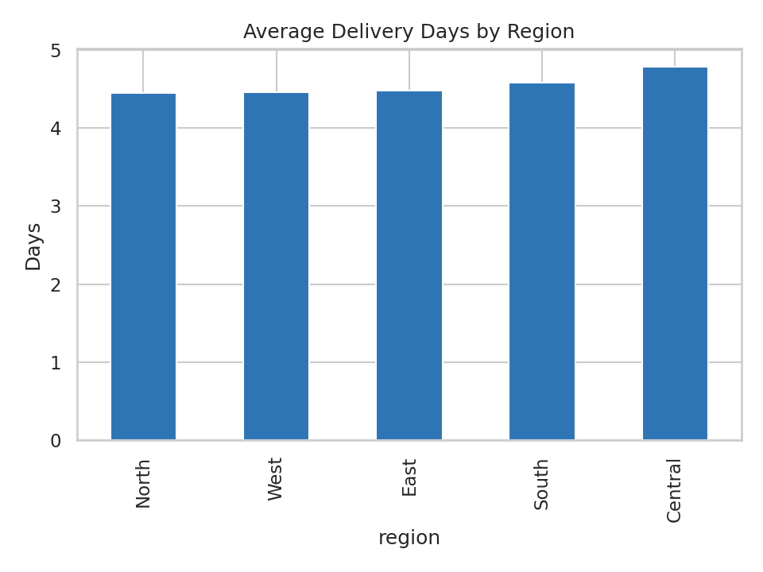
Figure 1: Average delivery days by region
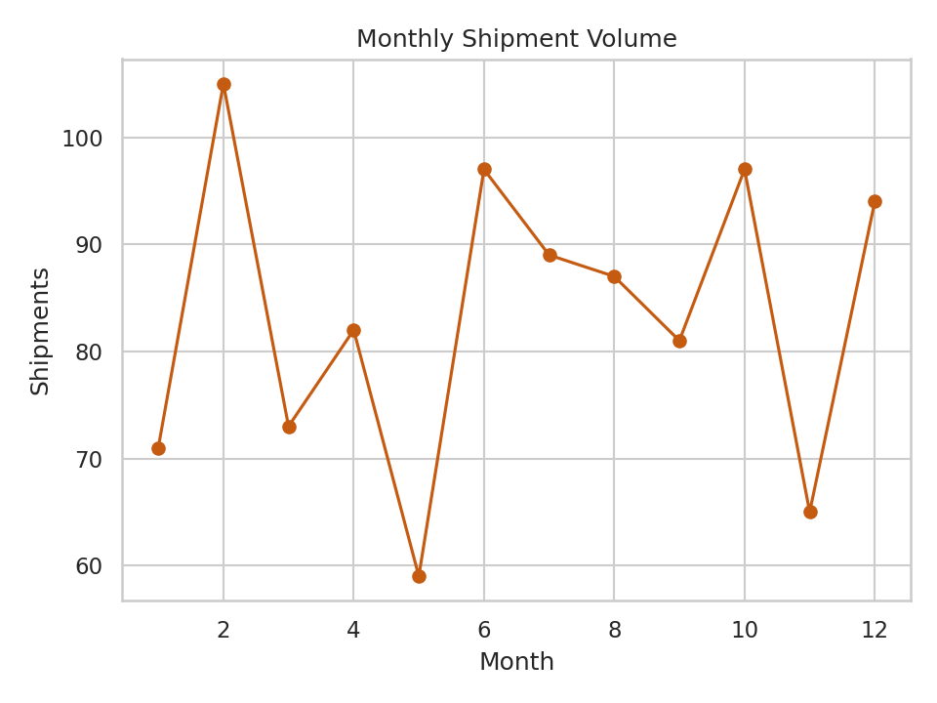
Figure 2: Monthly shipment volume
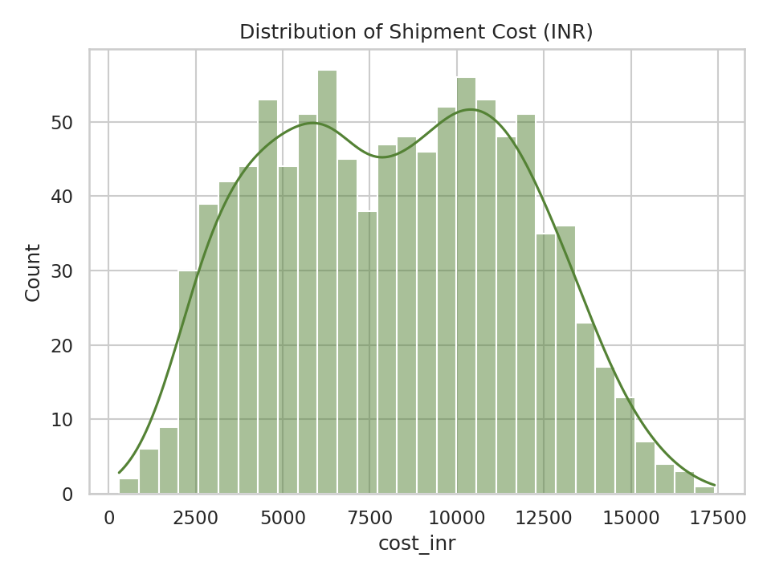
Figure 3: Distribution of shipment cost
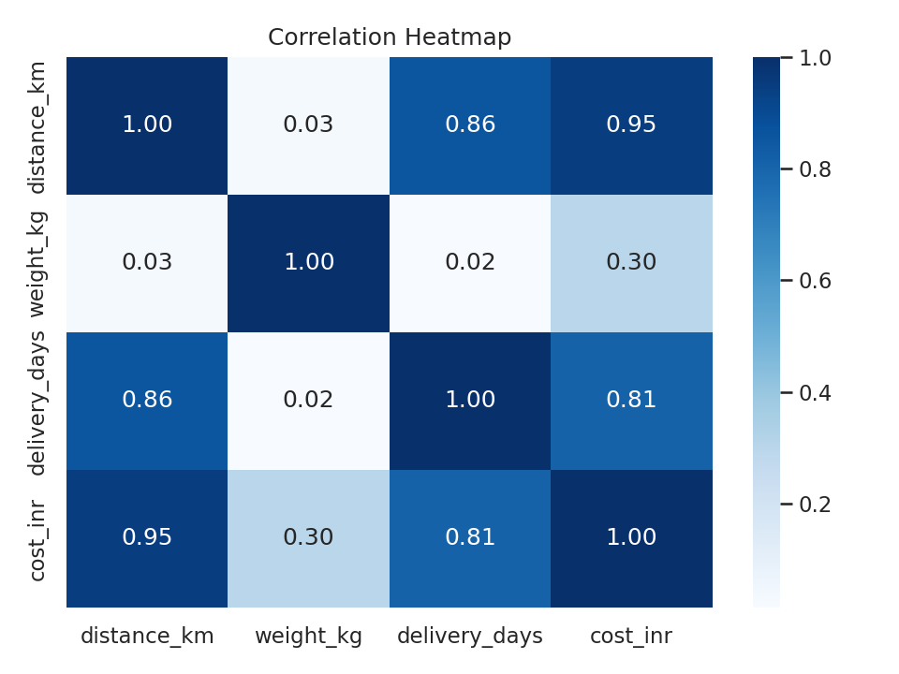
Figure 4: Correlation heatmap

6. Basic Analysis and Findings
- Average shipment cost is about 8,158 INR with an average delivery time of 4.55 days.
- Distance has a very strong positive correlation with cost (0.95) and a strong one with delivery days (0.86).
- On time rate (4 days or less) was highest for FastTrack at 43.5 percent and lowest for CargoPlus at 34.2 percent.
- RoadKing and FastTrack had the lowest average cost and delivery time among the four carriers.
Note: the data is synthetic so these findings demonstrate the method and are not real business conclusions.

7. Conclusion
This lab gave me a complete working workflow in Jupyter: setting up the environment, cleaning data, transforming it, visualizing it and summarising results. The same steps can be applied to real datasets in later tasks.

8. GitHub Repository
Notebook, charts and README: https://github.com/borsenayan/data-lab-implementation

