**IOT & Cyber Security - Week 2 - Scanning Activity**

1. **How many hops from your machine to your assigned website?**

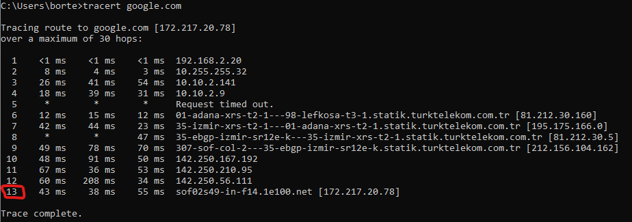We use the “tracert” command on google.com and we have 13 hops.

1. **Which step causes the biggest delay in the route? What is the average duration of that delay?**

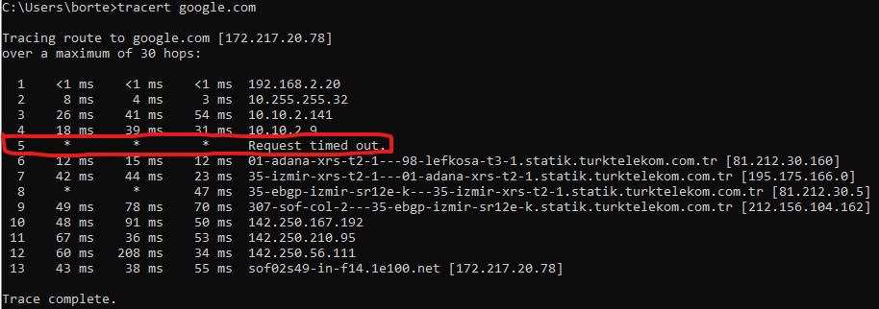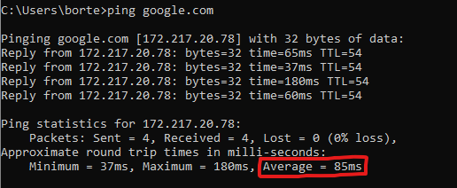In 5th line because there is a time out and the average duration is 85ms.

1. **What are the main nameservers for the website?**

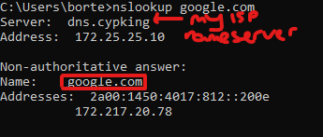The main nameserver is a google.com

1. **Who is the registered contact?**

We can see this with the “whois” command. I did this in linux terminal because windows cmd doesn't support it.

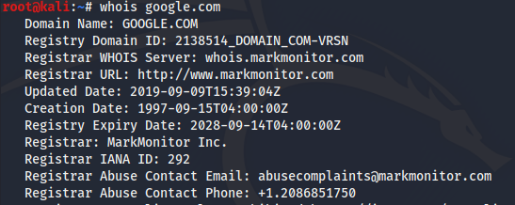

1. **What is the MX Record for the website?**

MX Record command is nslookup. I show you from linux terminal.

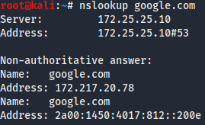

1. **Where is the website hosted?**

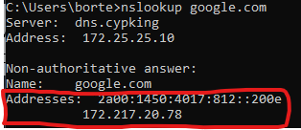

**Reflection Part:**

1. **Did you have any issues or challenges with the scans?**

I have only one issue. I couldn't run the mx record command fully.

1. **How did you overcome them?**

I got over it with what we saw in class and research I did on the internet.

1. **How will they affect your final report?**

It was a very fun part for me. Learning about windows cmd commands and linux commands showed me how things work in the background. With the Scanning activity, I learned how the threads in the network reach us and how I can examine them.