'''program 1'''

def factorial(*n*):

if *n*==0 or *n*==1:

return 1

else:

return *n*\*factorial(*n*-1)

try:

num=int(input("enter a number to find its factorial: - "))

if num<0:

print("please write a non negative number ")

else:

result=factorial(num)

print(f"The factorial of {num} is: {result}")

except ValueError:

print("invalid input.please enter a integer not a character")

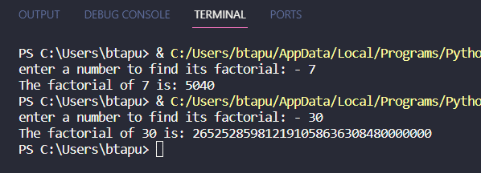

'''program 2'''

p = int(input("Enter a number to check whether it's prime or composite: "))

if p < 2:

print("It's neither prime nor composite.")

elif p == 2:

print("It's a prime number.")

elif p % 2 == 0:

print("It's a composite number.")

else:

is_prime = True

for i in range(3, int(p**0.5) + 1, 2):

if p % i == 0:

is_prime = False

break

if is_prime:

print("It's a prime number.")

else:

print("It's a composite number.")

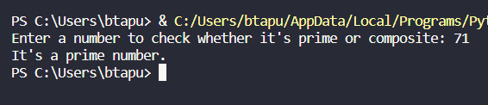

'''program 3'''

def fibonacci(*n*):

if *n* <= 0:

return "Invalid input. Please enter a positive integer."

fib_sequence = [0, 1]

while len(fib_sequence) <= *n*:

next_term = fib_sequence[-1] + fib_sequence[-2]

fib_sequence.append(next_term)

return fib_sequence[*n*]

user_input = int(input("Enter the value of n to find the nth term in Fibonacci series: "))

result = fibonacci(user_input)

print(f"The {user_input}th term in the Fibonacci series is: {result}")

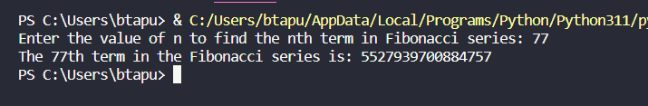

'''program 4'''

import random

def random_no():

return print(random.randint(1,6))

while True:

random_no()

break

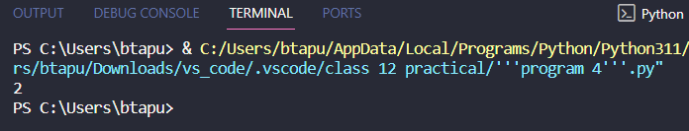

'''program 5'''

def calculate_product_and_square(\**ar*):

    product = 1

    square = []

    for num in *ar*:

        product *= num

        square.append(num**2)

    return product, square

m=int(input("input no to the list: "))

n=int(input("input no to the list: "))

o=int(input("input no to the list: "))

p=int(input("input no to the list: "))

x=int(input("input no to the list: "))

y=int(input("input no to the list: "))

numbers = [m,n,o,p,x,y]

result_product, result_squares = calculate_product_and_square(*numbers)

print(f"Product of the numbers: {result_product}")

print("Square of each number:")

for i, square in enumerate(result_squares):

    print(f"Number {numbers[i]}: {square}")

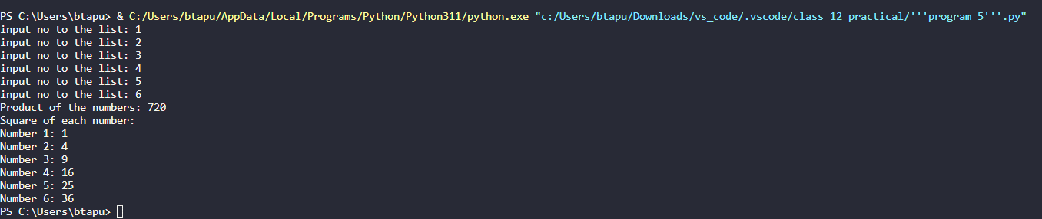

'''program 6'''

def days_to_weeks(*days*):

try:

*days* = int(*days*)

weeks = *days* // 7

print(f"{*days*} days is approximately {weeks} weeks.")

except ValueError:

print("Error: Input is not an integer.")

finally:

print("Program executed.")

days = input("Enter the number of days: ")

days_to_weeks(days)

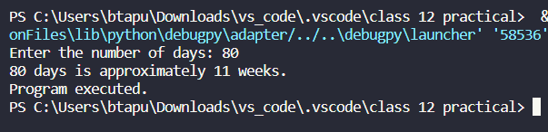

'''program 7'''

def search_word_in_sentence(*sentence*, *search_word*):

words = *sentence*.split()

if *search_word* in words:

return f"The word '{*search_word*}' is found in the sentence."

else:

return f"The word '{*search_word*}' is not found in the sentence."

user_sentence = input("Enter a sentence: ")

user_search_word = input("Enter the word to search: ")

print(search_word_in_sentence(user_sentence, user_search_word))

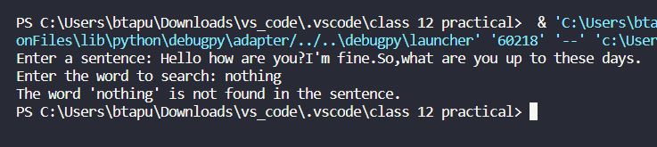

'''program 8'''

def display(*file_path*):

try:

with open("{0}.txt".format(*file_path*), "r") as file:

for line in file:

words = line.strip().split()

formatted_line = '*'.join(words)

print(formatted_line)

except FileNotFoundError:

print(f"Error: File '{0}' not found.")

except Exception as e:

print(f"An error occurred: {e}")

file_PATH = input("Enter the name of the file: ")

display(file_PATH)

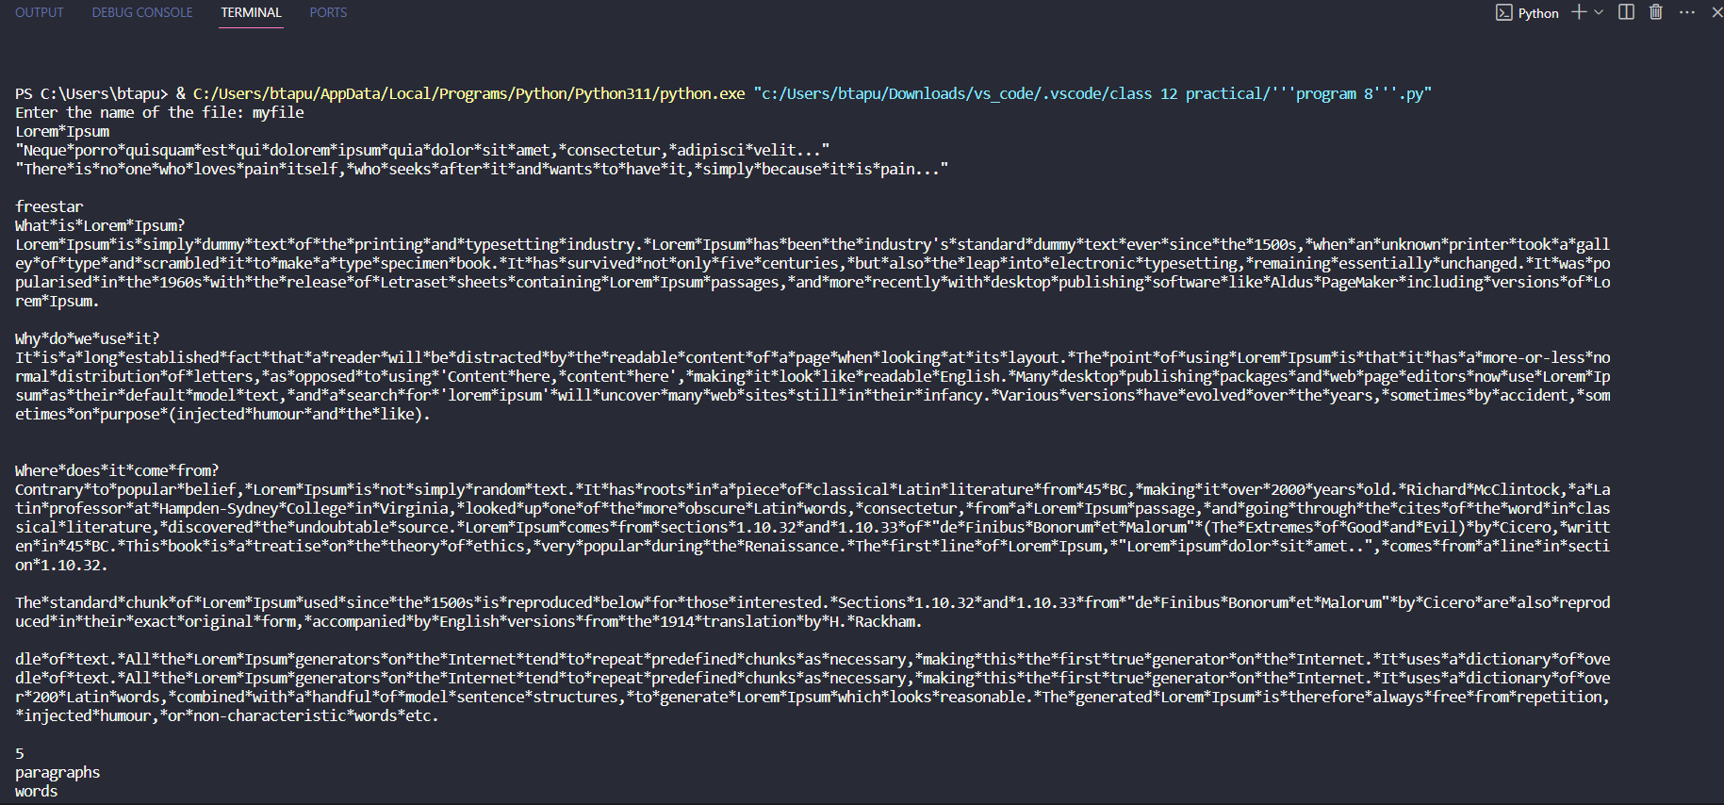

'''program 9'''

def countul(*file_path*):

    try:

        with open("{0}.txt".format(*file_path*), 'r') as file:

            content = file.read()

            upper_count = 0

            lower_count = 0

            for char in content:

                if char.isupper():

                    upper_count += 1

                elif char.islower():

                    lower_count += 1

            print(f"Total uppercase characters: {upper_count}")

            print(f"Total lowercase characters: {lower_count}")

    except FileNotFoundError:

        print(f"Error: File '{*file_path*}' not found.")

    except Exception as e:

        print(f"An error occurred: {e}")

file_route = input("Enter the name of the file: ")

countul(file_route)



'''program 10'''

import pickle

def write_employee_data(*file_data*, *employee_data*):

    with open(*file_data*, 'wb') as file:

        pickle.dump(*employee_data*, file)

def find_employee_by_code(*file_data*, *search_code*):

    try:

        with open(*file_data*, 'rb') as file:

            employee_data = pickle.load(file)

        for employee in employee_data:

            if employee['EmployeeCode'] == *search_code*:

                return employee['EmployeeName']

        return None

    except FileNotFoundError:

        print(f"Error: File '{*file_data*}' not found.")

    except Exception as e:

        print(f"An error occurred: {e}")

# Example data

employee_data = [

    {'EmployeeCode': 101, 'EmployeeName': "Supratik"},

    {'EmployeeCode': 102, 'EmployeeName': "Debojit"},

    {'EmployeeCode': 103, 'EmployeeName': "Tapubrat"},

    {'EmployeeCode': 104, 'EmployeeName': "Ronald"},

    {'EmployeeCode': 105, 'EmployeeName': "Puneet Babua"}

]

# File path

file_route = "employee_data.pkl"

# Write employee data to the binary file using pickle

write_employee_data(file_route, employee_data)

# Get input from the user to search for an employee by code

search = int(input("Enter the employee code to search: "))

# Find and display the employee name or "Employee not found"

result = find_employee_by_code(file_route, search)

if result:

    print(f"Employee found: {result}")

else:

    print("Employee not found")

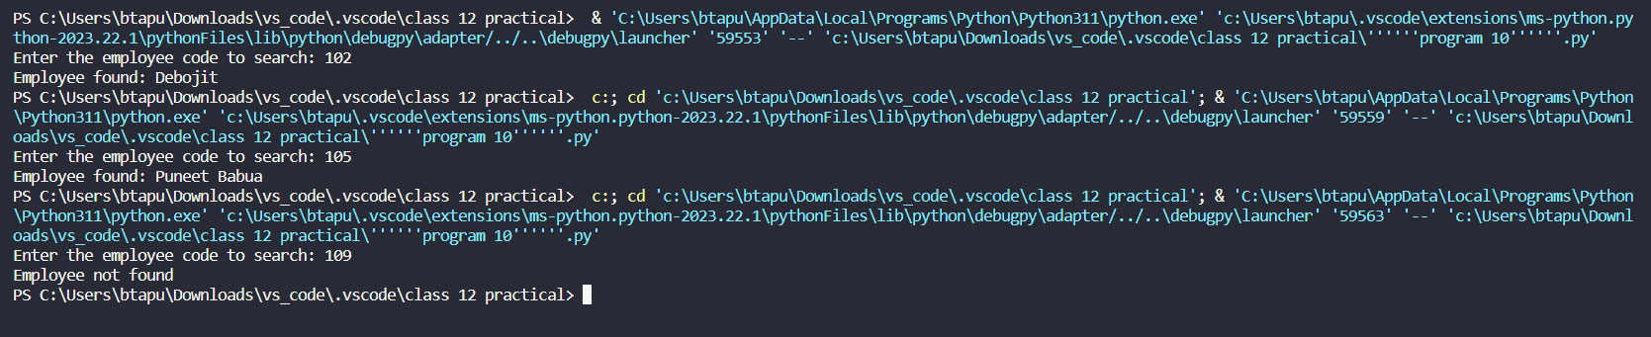

'''program 11'''

import pickle

def write_student_data(*file_data*, *student_data*):

    with open(*file_data*, 'wb') as file:

        pickle.dump(*student_data*, file)

def update_marks(*file_data*, *roll_no*, *new_marks*):

    try:

        with open(*file_data*, 'rb') as file:

            student_data = pickle.load(file)

        for student in student_data:

            if student['RollNo'] == *roll_no*:

                student['Marks'] = *new_marks*

        with open(*file_data*, 'wb') as file:

            pickle.dump(student_data, file)

    except FileNotFoundError:

        print(f"Error: File '{*file_data*}' not found.")

    except Exception as e:

        print(f"An error occurred: {e}")

student_data = [

    {'RollNo': 1, 'Name': "Superman", 'Marks': 85},

    {'RollNo': 2, 'Name': "Batman", 'Marks': 90},

    {'RollNo': 3, 'Name': "The Flash", 'Marks': 78}

]

file_route = "student_data.pkl"

write_student_data(file_route, student_data)

roll_no_to_update = int(input("Enter the RollNo to update marks: "))

new_marks = float(input("Enter the new marks: "))

update_marks(file_route, roll_no_to_update, new_marks)

with open(file_route, 'rb') as file:

    updated_student_data = pickle.load(file)

print("\nUpdated Student Data:")

for student in updated_student_data:

    print(f"RollNo: {student['RollNo']}, Name: {student['Name']}, Marks: {student['Marks']}")

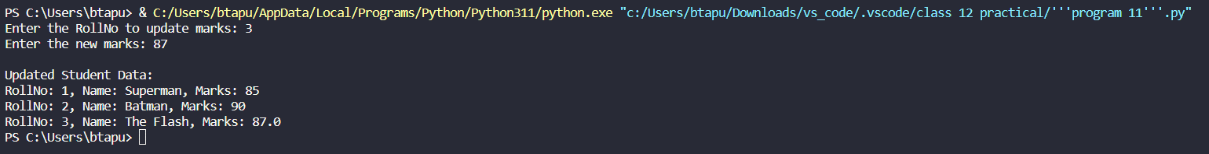

'''program 12'''

input_file_name = 'input_file.txt'

output_file_name = 'output_file.txt'

try:

with open(input_file_name, 'r') as input_file, open(output_file_name, 'w') as output_file:

for line in input_file:

if 'o' not in line.lower():  # Case-insensitive check for 'o'

output_file.write(line)

print("Processing complete. Output written to", output_file_name)

except FileNotFoundError:

print(f"Error: The file '{input_file_name}' does not exist.")

except Exception as e:

print("An error occurred:", str(e))



'''program 13'''

import pickle

def write_employee_data(*employee_data*, *filename*):

with open(*filename*, 'wb') as file:

pickle.dump(*employee_data*, file)

def read_employee_data(*filename*):

try:

with open(*filename*, 'rb') as file:

return pickle.load(file)

except FileNotFoundError:

return {}

def update_salary(*emp_id*, *new_salary*, *employee_data*):

if *emp_id* in *employee_data*:

*employee_data*[*emp_id*]['salary'] = *new_salary*

print(f"Salary for Employee ID {*emp_id*} updated successfully.")

else:

print(f"Employee ID {*emp_id*} not found.")

employee_data = {

101: {'name': 'John Doe', 'salary': 50000},

102: {'name': 'Jane Smith', 'salary': 60000},

}

file_name = 'Employee.dat'

write_employee_data(employee_data, file_name)

def update_salary_function():

try:

emp_id = int(input("Enter Employee ID to update salary: "))

new_salary = float(input("Enter the new salary: "))

update_salary(emp_id, new_salary, employee_data)

write_employee_data(employee_data, file_name)

except ValueError:

print("Invalid input. Please enter a valid employee ID and salary.")

update_salary_function()



'''program 14'''

with open("myfile.txt","r") as fh:

    fh.read()

    initial_position=fh.tell()

    print(f"the initial position of the pointer is: {initial_position}")

    fh.seek(3)

    position_now=fh.tell()

    print(f"the pointer after the cursor is moved to 4th position: {position_now}")

    text=fh.read(5)

    print(f"the next 5 characters after 4th position are: {text}")

    tell=fh.tell()

    fh.seek(tell+10,0)

    final=fh.tell()

    print(f"file pointer at 10th character after displaying 5 characters: {final}")

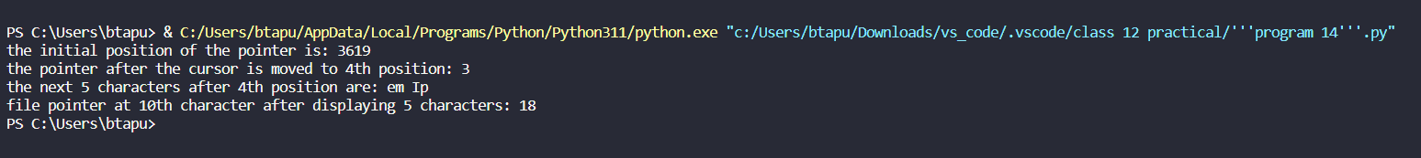

'''program 15'''

class Stack:

    def __init__(*self*):

*self*.stack = []

    def push(*self*, *item*):

*self*.stack.append(*item*)

        print(f"Pushed: {*item*}")

    def pop(*self*):

        if not *self*.is_empty():

            item = *self*.stack.pop()

            print(f"Popped: {item}")

            return item

        else:

            print("Stack is empty. Cannot pop.")

    def is_empty(*self*):

        return len(*self*.stack) == 0

    def display(*self*):

        if not *self*.is_empty():

            print("Stack contents:")

            for item in reversed(*self*.stack):

                print(item)

        else:

            print("Stack is empty.")

my_stack = Stack()

while True:

    print("\nStack Operations:")

    print("1. Push")

    print("2. Pop")

    print("3. Display")

    print("4. Quit")

    choice = input("Enter your choice (1/2/3/4): ")

    if choice == '1':

        item = input("Enter the item to push: ")

        my_stack.push(item)

    elif choice == '2':

        my_stack.pop()

    elif choice == '3':

        my_stack.display()

    elif choice == '4':

        print("Exiting the program.")

        break

    else:

        print("Invalid choice. Please enter 1, 2, 3, or 4.")

