**11)**

SELECT line.OrderID,

line.ItemID,

line.Price,

line.Quantity,

ISNULL(SUM(ship.QtyShipped), 0) AS TotalQuantityShipped,

line.Quantity - ISNULL(SUM(ship.QtyShipped), 0) AS LeftToShip

FROM tblOrderLine as line

LEFT OUTER JOIN tblShipLine as ship

ON line.OrderID = ship.OrderId AND

line.ItemID = ship.ItemID

GROUP BY line.OrderID,

line.ItemID,

line.Price,

line.Quantity;

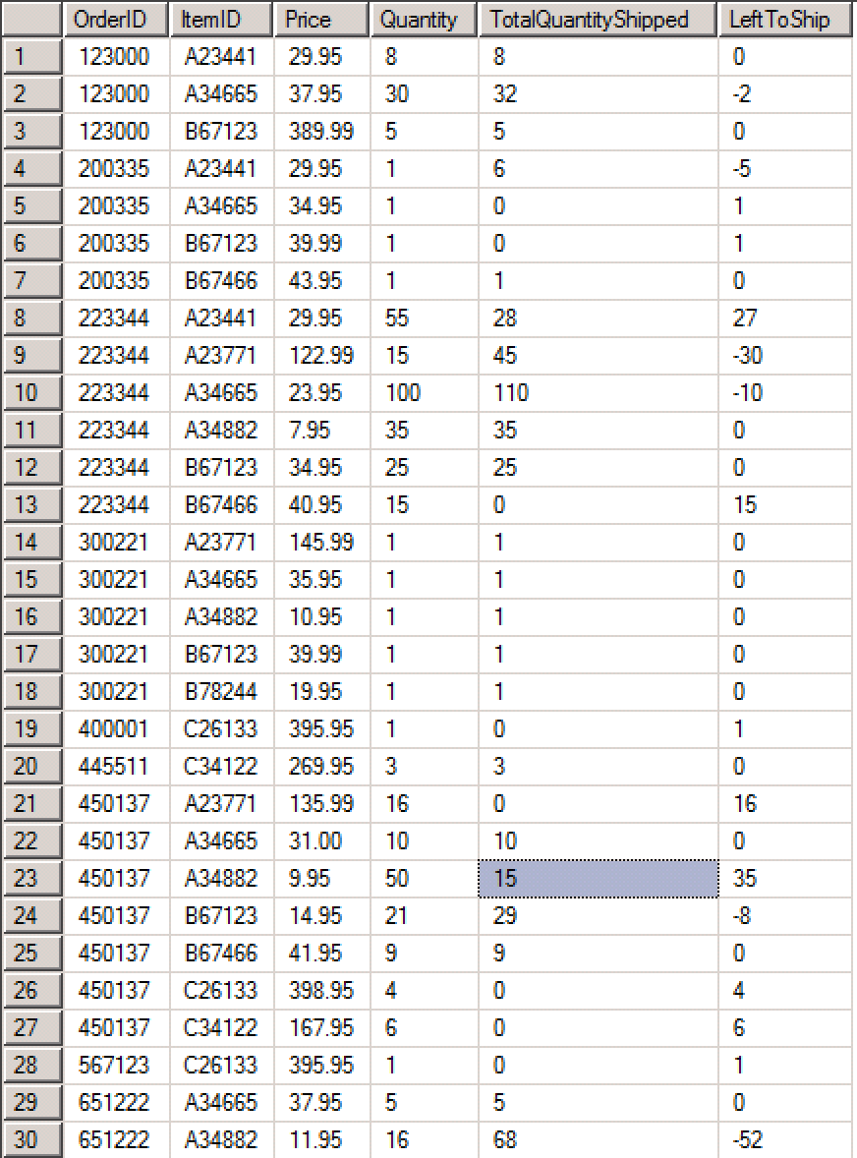

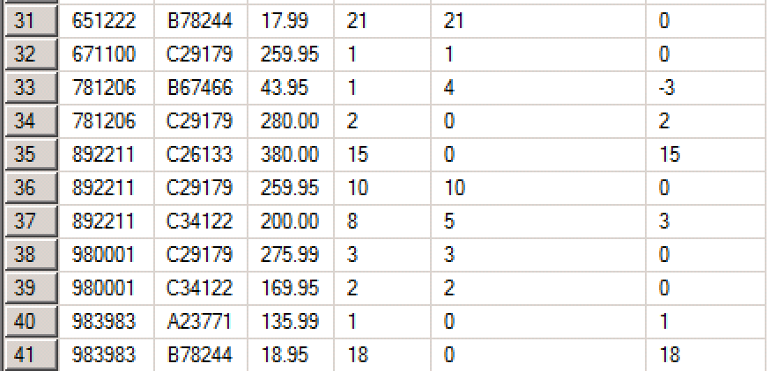

**12)**

SELECT line.OrderID,

cust.LastName + ', ' + cust.FirstName,

line.ItemID,

line.Price,

line.Quantity,

ISNULL(SUM(ship.QtyShipped), 0) AS TotalQuantityShipped,

line.Quantity - ISNULL(SUM(ship.QtyShipped), 0) AS LeftToShip

FROM tblOrderLine AS line

LEFT OUTER JOIN tblShipLine AS ship

ON line.OrderID = ship.OrderId AND

line.ItemID = ship.ItemID

LEFT OUTER JOIN tblOrder AS ord

ON line.OrderID = ord.OrderID

LEFT OUTER JOIN tblCustomer AS cust

ON ord.CustomerID = cust.CustomerID

GROUP BY line.OrderID,

cust.LastName,

cust.FirstName,

line.ItemID,

line.Price,

line.Quantity;

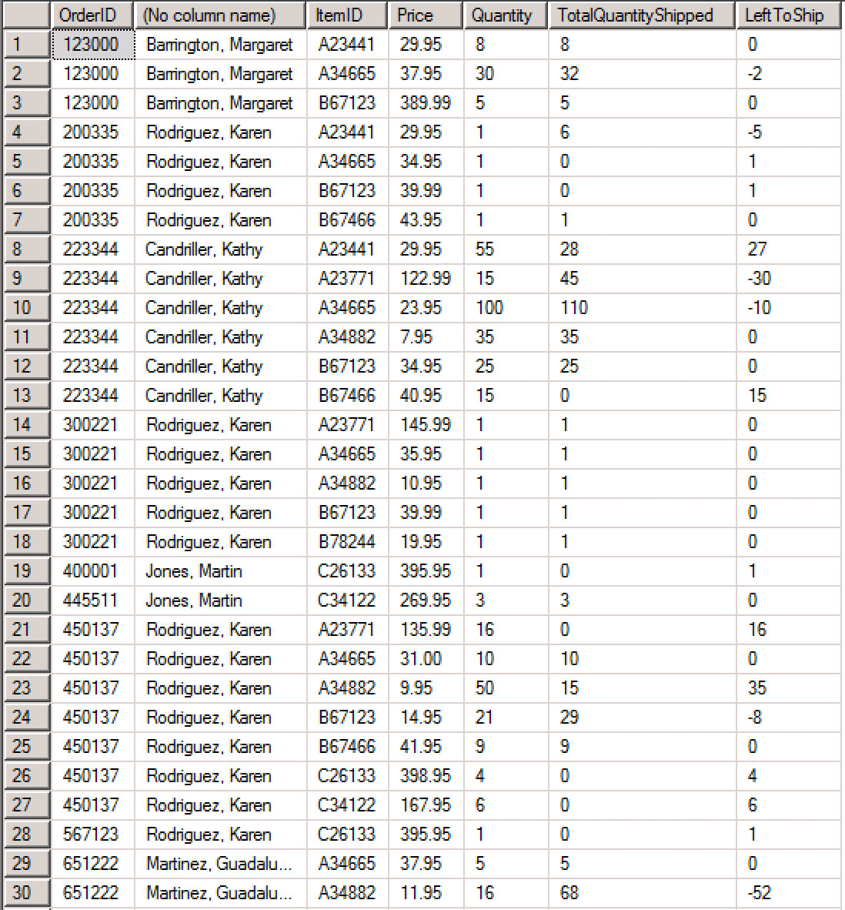

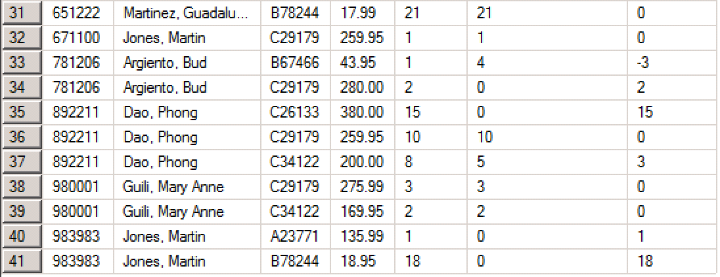

**13)**

SELECT line.OrderID,

cust.LastName + ', ' + cust.FirstName,

line.ItemID,

item.Description,

type.CategoryDescription,

item.ListPrice,

line.Price,

line.Quantity,

ISNULL(SUM(ship.QtyShipped), 0) AS TotalQuantityShipped,

line.Quantity - ISNULL(SUM(ship.QtyShipped), 0) AS LeftToShip

FROM tblOrderLine AS line

LEFT OUTER JOIN tblShipLine AS ship

ON line.OrderID = ship.OrderId AND

line.ItemID = ship.ItemID

LEFT OUTER JOIN tblOrder AS ord

ON line.OrderID = ord.OrderID

LEFT OUTER JOIN tblCustomer AS cust

ON ord.CustomerID = cust.CustomerID

LEFT OUTER JOIN tblItem AS item

ON line.ItemID = item.ItemID

LEFT OUTER JOIN tblItemType AS type

ON item.TypeID = type.TypeID

GROUP BY line.OrderID,

cust.LastName,

cust.FirstName,

line.ItemID,

item.Description,

type.CategoryDescription,

item.ListPrice,

line.Price,

line.Quantity;

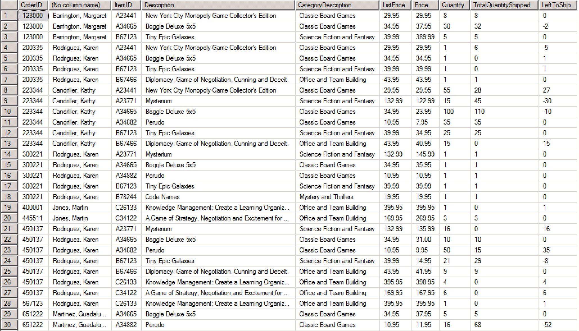

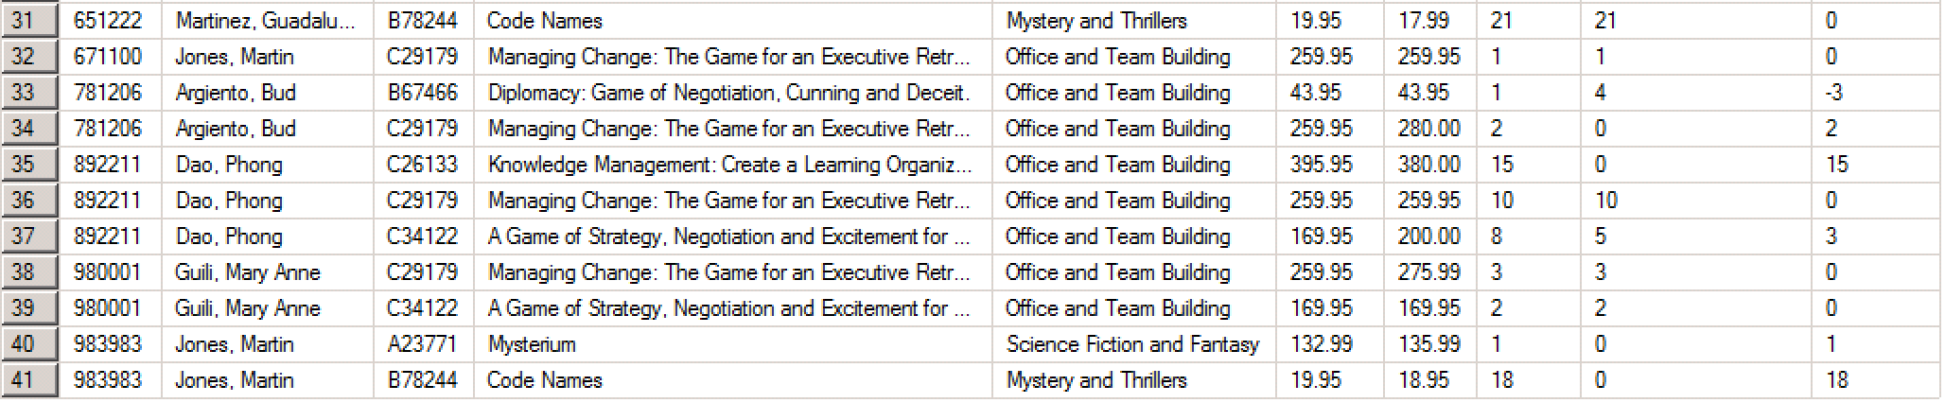

**14)**

SELECT line.OrderID,

cust.LastName + ', ' + cust.FirstName,

line.ItemID,

item.Description,

type.CategoryDescription,

item.ListPrice,

line.Price,

line.Quantity,

ISNULL(SUM(ship.QtyShipped), 0) AS TotalQuantityShipped,

line.Quantity - ISNULL(SUM(ship.QtyShipped), 0) AS LeftToShip

FROM tblOrderLine AS line

LEFT OUTER JOIN tblShipLine AS ship

ON line.OrderID = ship.OrderId AND

line.ItemID = ship.ItemID

LEFT OUTER JOIN tblOrder AS ord

ON line.OrderID = ord.OrderID

LEFT OUTER JOIN tblCustomer AS cust

ON ord.CustomerID = cust.CustomerID

LEFT OUTER JOIN tblItem AS item

ON line.ItemID = item.ItemID

LEFT OUTER JOIN tblItemType AS type

ON item.TypeID = type.TypeID

GROUP BY line.OrderID,

cust.LastName,

cust.FirstName,

line.ItemID,

item.Description,

type.CategoryDescription,

item.ListPrice,

line.Price,

line.Quantity

HAVING line.Quantity - ISNULL(SUM(ship.QtyShipped), 0) < 0

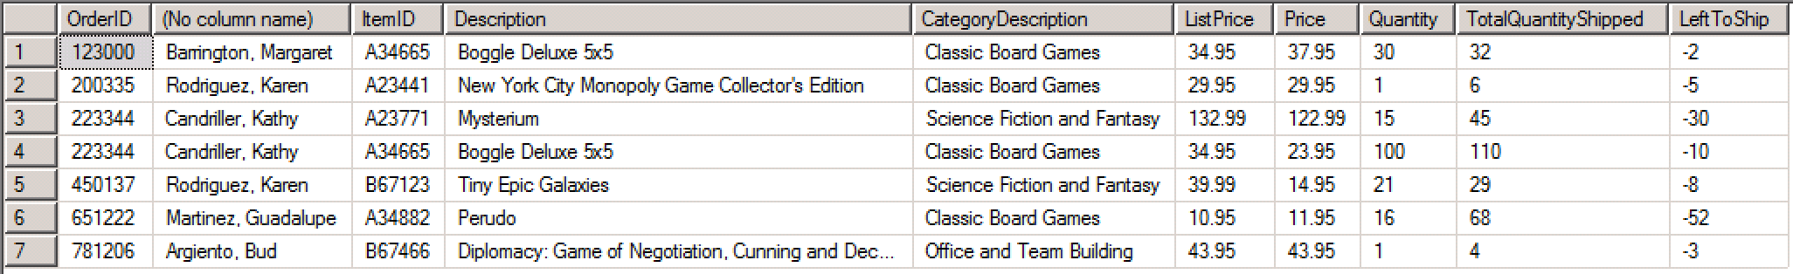

**15)**

SELECT cust.LastName + ', ' + cust.FirstName CustomerName,

line.OrderID,

line.ItemID,

item.Description

FROM tblOrderLine AS line

LEFT OUTER JOIN tblItem AS item

ON line.itemID = item.itemID

LEFT OUTER JOIN tblOrder AS ord

ON line.OrderID = ord.OrderID

LEFT OUTER JOIN tblCustomer AS cust

ON ord.CustomerID = cust.CustomerID

LEFT OUTER JOIN tblShipLine AS ship

ON line.OrderID = ship.OrderID AND

line.ItemID = ship.ItemID

WHERE ship.MethodShipped = 'FedEx'

