**Table Create Statements**

/* CUSTOMER TABLE */

CREATE TABLE Customer(

CustomerID char(7) NOT NULL,

CustomerName varchar(20) NOT NULL,

Email varchar(60),

Phone char(15) NOT NULL

CONSTRAINT pkCust PRIMARY KEY (CustomerID));

/* MODEL TABLE */

CREATE TABLE Model(

ModelNumber char(11) NOT NULL,

ModelDescription varchar(60) NOT NULL,

CONSTRAINT pkModelNumber PRIMARY KEY (ModelNumber));

/* DISTIBUTOR TABLE */

CREATE TABLE Distributor(

DistributorID char(7) NOT NULL,

DistributorName varchar(40) NOT NULL,

CONSTRAINT pkDistributorID PRIMARY KEY (DistributorID));

/* TOY TABLE */

CREATE TABLE Toy(

SerialNumber char(13) NOT NULL,

ModelNumber char(11) NOT NULL,

DistributorID char(7),

DateOfReturn date,

ReturnNotes varchar(200)

CONSTRAINT pkSerialNumber PRIMARY KEY (SerialNumber),

CONSTRAINT fkModelNumber FOREIGN KEY (ModelNumber) REFERENCES Model (ModelNumber),

CONSTRAINT fkDistributorID FOREIGN KEY (DistributorID) REFERENCES Distributor (DistributorID));

/* REGISTRATION TABLE */

CREATE TABLE Registration(

RegistrationID char(8) NOT NULL,

CustomerID char(7) NOT NULL,

SerialNumber char(13) NOT NULL,

DateOfPurchase date NOT NULL,

Price money NOT NULL CHECK (Price > 0),

WhereFirstLearn varchar(30) NOT NULL CHECK ( WhereFirstLearn = 'Advertisement in print' OR

WhereFirstLearn = 'Advertisement on the web' OR

WhereFirstLearn = 'Advertisement on TV' OR

WhereFirstLearn = 'Friend’s recommendation' OR

WhereFirstLearn = 'In-store display' OR

WhereFirstLearn = 'Catalog' OR

WhereFirstLearn = 'Other' ),

RelationshipToUser varchar(15) NOT NULL CHECK ( RelationshipToUser = 'Parent' OR

RelationshipToUser = 'Grandparent' OR

RelationshipToUser = 'Aunt/Uncle' OR

RelationshipToUser = 'Friend' OR

RelationshipToUser = 'Other Relative' OR

RelationshipToUser = 'Other' ),

UserAge int NOT NULL CHECK (UserAge > 0),

UserGender varchar(1) NOT NULL CHECK (UserGender = 'F' OR UserGender = 'M'),

FutureBuy varchar(10) NOT NULL CHECK (FutureBuy = 'Yes' OR

FutureBuy = 'No' OR

FutureBuy = 'Don''t know')

CONSTRAINT pkRegistrationID PRIMARY KEY (RegistrationID),

CONSTRAINT fkCustomerID FOREIGN KEY (CustomerID) REFERENCES Customer (CustomerID),

CONSTRAINT fkSerialNumber FOREIGN KEY (SerialNumber) REFERENCES Toy (SerialNumber));

/* FEATURE TABLE */

CREATE TABLE Feature(

FeatureID char(5) NOT NULL,

FeatureDescription varchar(40) NOT NULL,

CONSTRAINT pkFeatureID PRIMARY KEY (FeatureID));

/* REGISTRATION FEATURE TABLE */

CREATE TABLE RegistrationFeature(

RegFeatureID char(5) NOT NULL,

FeatureID char(5) NOT NULL,

RegistrationID char(8) NOT NULL,

CONSTRAINT pkRegFeatureID PRIMARY KEY (RegFeatureID),

CONSTRAINT fkRegistrationID FOREIGN KEY (RegistrationID) REFERENCES Registration (RegistrationID),

CONSTRAINT fkFeatureID FOREIGN KEY (FeatureID) REFERENCES Feature (FeatureID));

**Select Statements**

SELECT *

FROM Customer



SELECT *

FROM Model

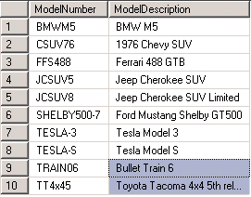

SELECT *

FROM Distributor

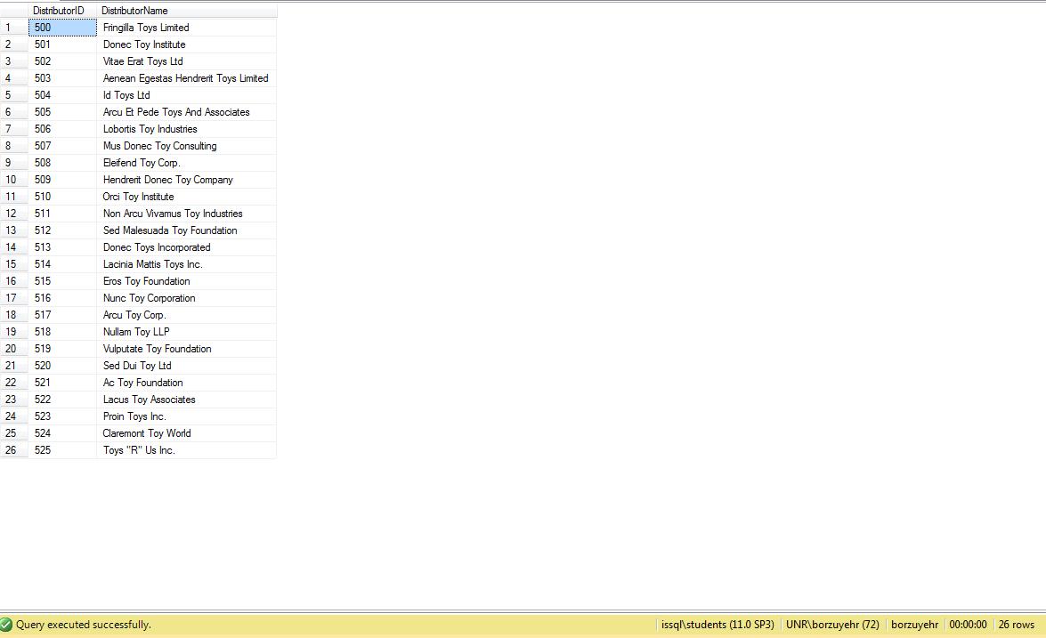

SELECT *

FROM Toy

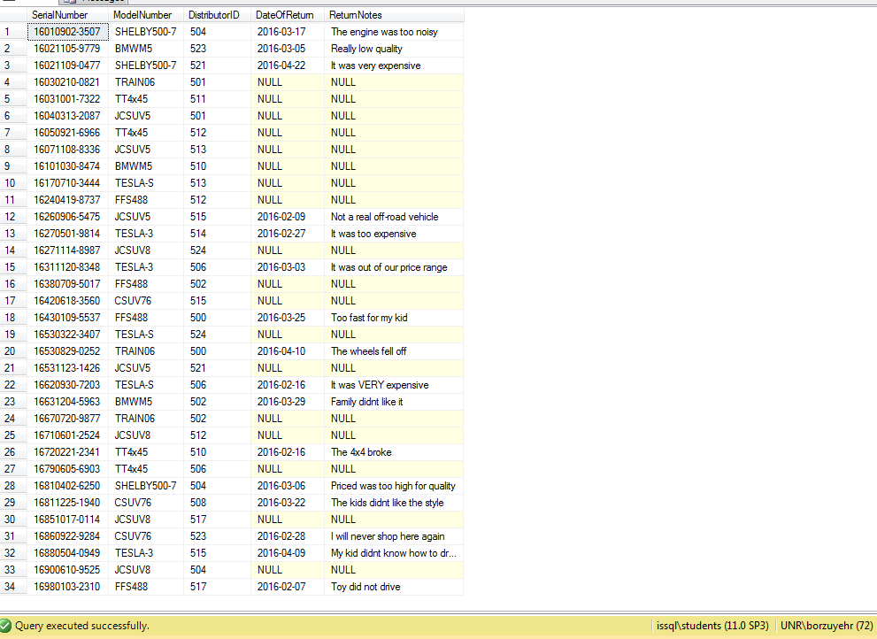

SELECT *

FROM registration

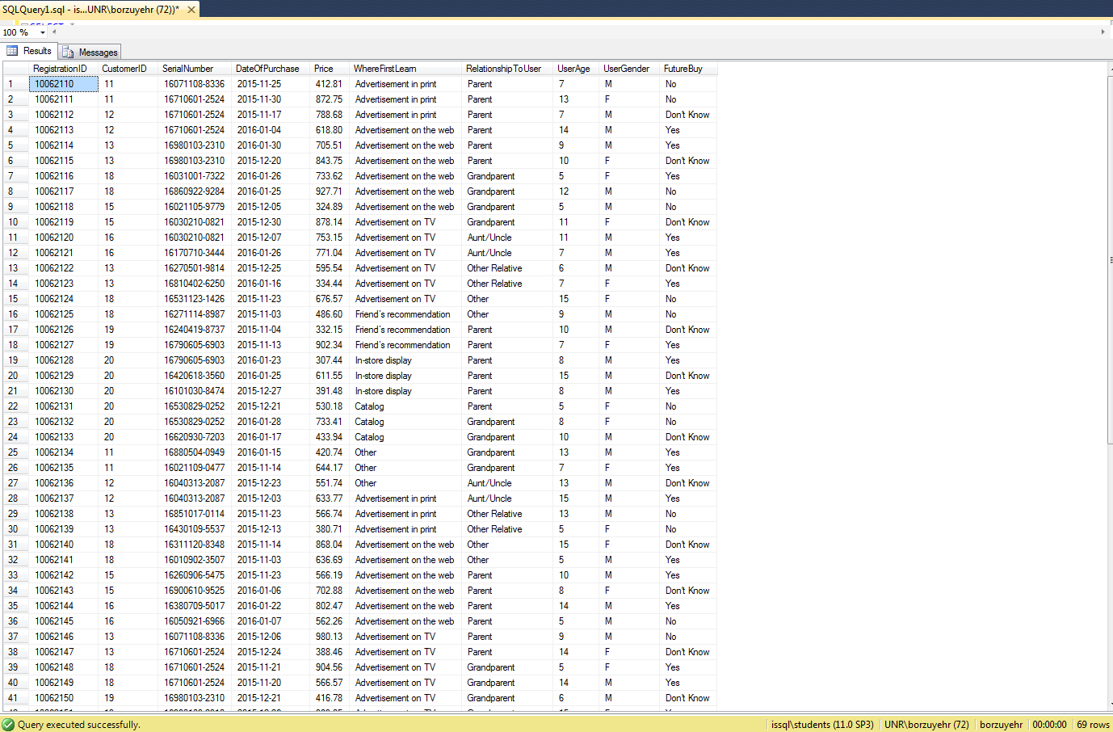

SELECT *

FROM feature

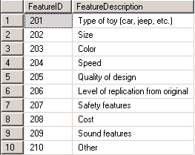

SELECT *

FROM registrationfeature

