To: Professor Dana Edberg

From: Eric Adorno, Ryan Swain, Peter Rahmanifar

Date: 04/26/2016

Subject: Logical Data Model Modifications

The original logical data model that we built had a lot more tables than the modified model. We modified our data model so that it has 7 tables now instead of the vast amount of tables we had before. Some of the changes we made are in the following:

1. The first change we made was to split the purchase table into Toy and Registration tables with a 1:1 relationship. The reasoning for this is that toys can be returned or have a report filed on them without having a registration filled out.
2. The second change was to disconnected the Registration from Question and Answer tables. The Registration will now store single-answer questions in WhereFirstLearn, RelationshipToUser and FutureBuy attributes. For the multiple-answer feature question, a Feature table was created. Answers to that question will be stored in an intersection with Feature and Registration.
3. We simplified the Survey tables. Now Question and Answer tables are linked directly to a Survey table with a single intersection.
4. We removed the Reporter type entity as a reporter can be identified by the ID that is associated with a single report.
5. We added an Employee table and linked it to the Report table because it was missing before.
6. Finally, we created a unary relationship in the Test entity. TestDate was added to the concatenated Primary Key, and ParentTestDate was added as a foreign key.

All of the modifications that were made should make the data model easier to work with that will give us the most out of our data.

**2) Revised Logical Data Model**

Macintosh HD:Users:ryanswain:Downloads:ProjectERD-swain4.pdf

**2) Revised Logical Data Model**

**3) Copy of Original Logical Data Model (With Comments Part 1 & 2)**

**4) Physical Data Model**

Macintosh HD:Users:ryanswain:Downloads:TestERDPeter.pdf

**5) Prototype Database: Create Statements**

/* CUSTOMER TABLE */

CREATE TABLE Customer(

CustomerID char(7) NOT NULL,

CustomerName varchar(20) NOT NULL,

Email varchar(60),

Phone char(15) NOT NULL

CONSTRAINT pkCust PRIMARY KEY (CustomerID));

/* MODEL TABLE */

CREATE TABLE Model(

ModelNumber char(11) NOT NULL,

ModelDescription varchar(60) NOT NULL,

CONSTRAINT pkModelNumber PRIMARY KEY (ModelNumber));

/* DISTIBUTOR TABLE */

CREATE TABLE Distributor(

DistributorID char(7) NOT NULL,

DistributorName varchar(40) NOT NULL,

CONSTRAINT pkDistributorID PRIMARY KEY (DistributorID));

/* TOY TABLE */

CREATE TABLE Toy(

SerialNumber char(13) NOT NULL,

ModelNumber char(11) NOT NULL,

DistributorID char(7),

DateOfReturn date,

ReturnNotes varchar(200)

CONSTRAINT pkSerialNumber PRIMARY KEY (SerialNumber),

CONSTRAINT fkModelNumber FOREIGN KEY (ModelNumber) REFERENCES Model (ModelNumber),

CONSTRAINT fkDistributorID FOREIGN KEY (DistributorID) REFERENCES Distributor (DistributorID));

/* REGISTRATION TABLE */

CREATE TABLE Registration(

RegistrationID char(8) NOT NULL,

CustomerID char(7) NOT NULL,

SerialNumber char(13) NOT NULL,

DateOfPurchase date NOT NULL,

Price money NOT NULL CHECK (Price > 0),

WhereFirstLearn varchar(30) NOT NULL CHECK ( WhereFirstLearn = 'Advertisement in print' OR

WhereFirstLearn = 'Advertisement on the web' OR

WhereFirstLearn = 'Advertisement on TV' OR

WhereFirstLearn = 'Friend’s recommendation' OR

WhereFirstLearn = 'In-store display' OR

WhereFirstLearn = 'Catalog' OR

WhereFirstLearn = 'Other' ),

RelationshipToUser varchar(15) NOT NULL CHECK ( RelationshipToUser = 'Parent' OR

RelationshipToUser = 'Grandparent' OR

RelationshipToUser = 'Aunt/Uncle' OR

RelationshipToUser = 'Friend' OR

RelationshipToUser = 'Other Relative' OR

RelationshipToUser = 'Other' ),

UserAge int NOT NULL CHECK (UserAge > 0),

UserGender varchar(1) NOT NULL CHECK (UserGender = 'F' OR UserGender = 'M'),

FutureBuy varchar(10) NOT NULL CHECK (FutureBuy = 'Yes' OR

FutureBuy = 'No' OR

FutureBuy = 'Don''t know')

CONSTRAINT pkRegistrationID PRIMARY KEY (RegistrationID),

CONSTRAINT fkCustomerID FOREIGN KEY (CustomerID) REFERENCES Customer (CustomerID),

CONSTRAINT fkSerialNumber FOREIGN KEY (SerialNumber) REFERENCES Toy (SerialNumber));

/* FEATURE TABLE */

CREATE TABLE Feature(

FeatureID char(5) NOT NULL,

FeatureDescription varchar(40) NOT NULL,

CONSTRAINT pkFeatureID PRIMARY KEY (FeatureID));

/* REGISTRATION FEATURE TABLE */

CREATE TABLE RegistrationFeature(

RegFeatureID char(5) NOT NULL,

FeatureID char(5) NOT NULL,

RegistrationID char(8) NOT NULL,

CONSTRAINT pkRegFeatureID PRIMARY KEY (RegFeatureID),

CONSTRAINT fkRegistrationID FOREIGN KEY (RegistrationID) REFERENCES Registration (RegistrationID),

CONSTRAINT fkFeatureID FOREIGN KEY (FeatureID) REFERENCES Feature (FeatureID));

**5) Prototype Database: Create Statements**

SELECT *

FROM Customer

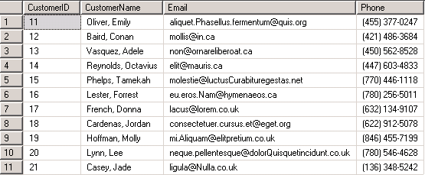

SELECT *

FROM Model

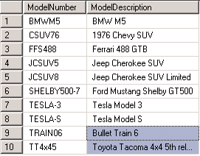

SELECT *

FROM Distributor

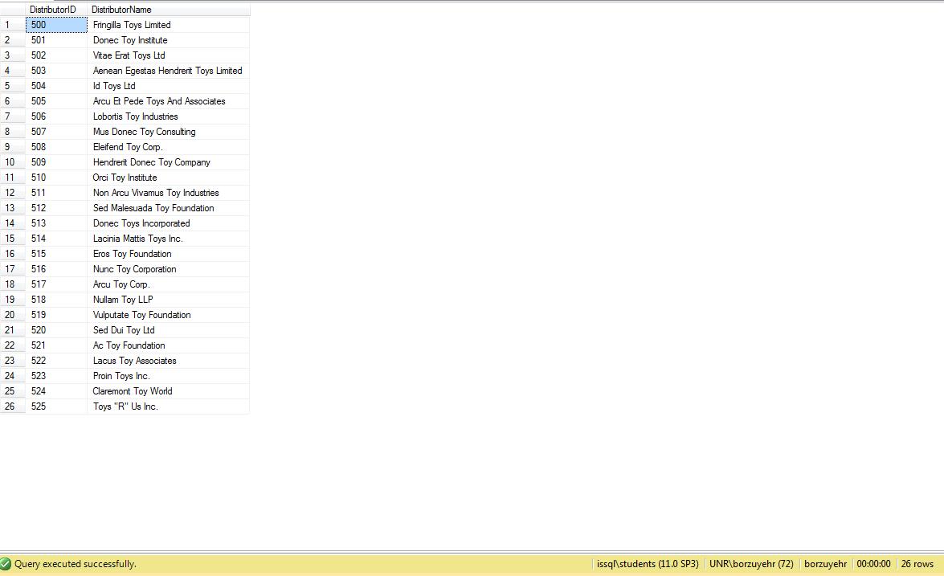

SELECT *

FROM Toy

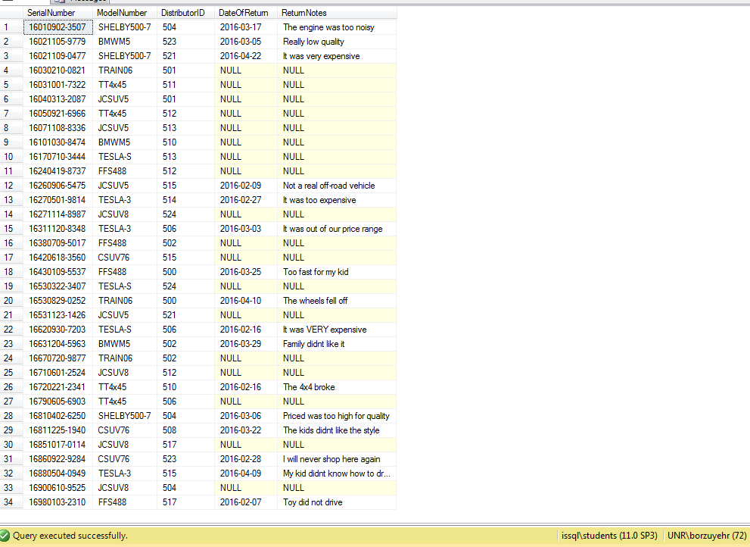

SELECT *

FROM registration

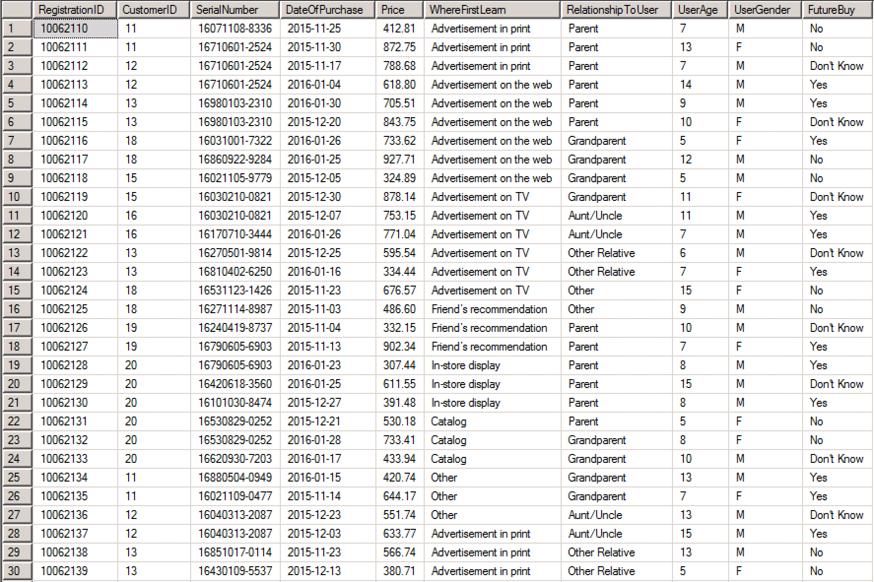

(CONTINUED ON NEXT PAGE)

SELECT *

FROM registration; (CONTINUED FROM PREVIOUS PAGE)

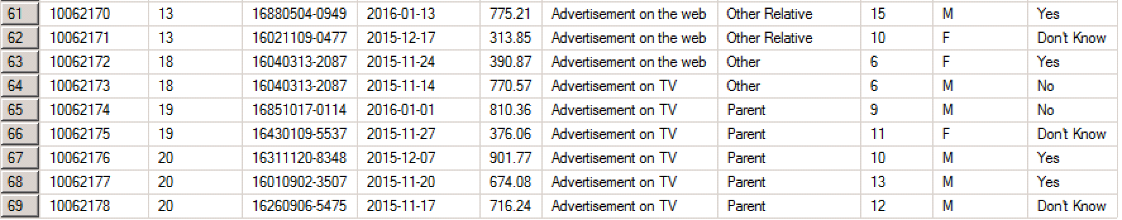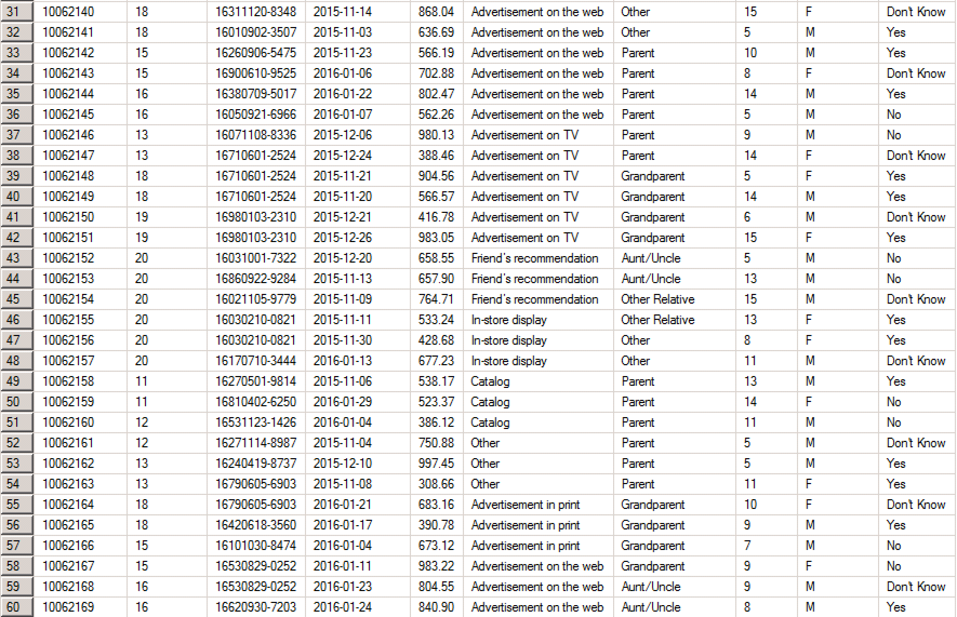

SELECT *

FROM feature

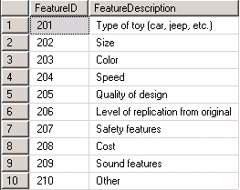

SELECT *

FROM registrationfeature

