Mass-Spectrometer connection to MyTardis

Introduction
Building 77, floor 2’s new Orbitrap Mass Spectrometer (ThermoFisher Scientific, Q-Exactive Benchtop HRAM Orbitrap mass spectromter) is expected to produce at least 500gb of data a month. This rate of data production overwhelms the capacity of the current storage system. Data produced needs to be archived for current and future analysis, shared with collaborators and potentially made public for citation in scientific publications. A connection to the data repository MyTardis is proposed as the long-term solution to these aims.

Current System
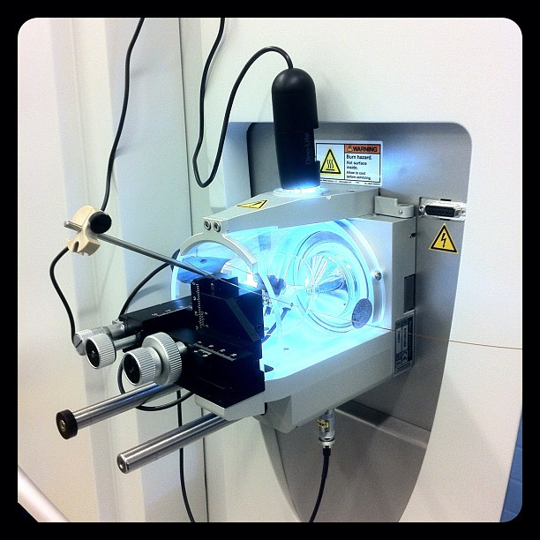
The instrument is connected to networked file storage. Once an experiment has been completed, the scientist responsible must manually copy data across to this storage so it is accessible on their desktop machines. Copying data to the researcher’s machine for analysis requires a second manual copy. The networked file storage is only accessible within the Monash University network and only by a pre-defined access list of users. Those outside the Monash network and/or not on the access list have no access to the file store. Sharing data with collaborators often requires transporting external hard drives.

The networked file storage is also limited in size at 12TB. This is unsuitable as a long-term data archive given the volumes of data being produced.

(current system diagram shown below)

Proposed System
An automated data transport system is proposed in order to remove the requirement to manually copy data. MyTardis will also allow researchers to access and share data anywhere and have it stored in a sustainable manner.

Data would be handled from the time it’s produced by the instrument to its final storage location in MyTardis and backed by the LaRDS’ >2 petabyte store. Once data resides in MyTardis it’s privately accessible those who own it, and shareable with internal and external collaborators alike. Data can also be opened up to the outside world for citation in papers.

(proposed system diagram shown below)

Technical Requirements
- Rsync script between instrument computer and networked storage box (to be coded)
- Linux virtual machine that mounts the networked storage box and produces a metadata feed using the MyTardis’ Atom Feed Provider service (to be deployed)
- MyTardis installation that mounts LaRDS storage for long term archival (exists)
- MyTardis Harvester Plugin to receive data from networked storage (to be deployed)
- File handlers for detailed display of x data within the web (optional, to be coded)

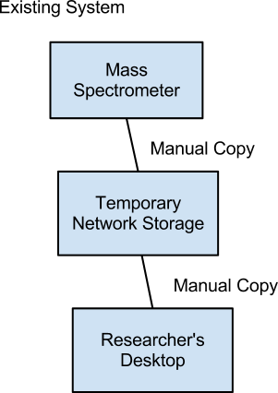

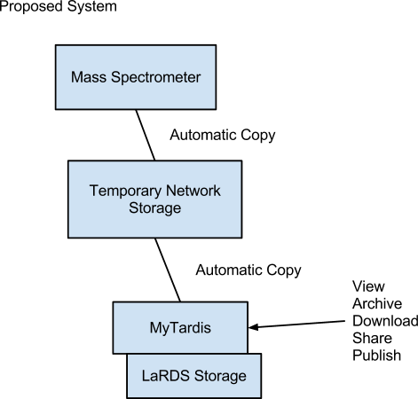

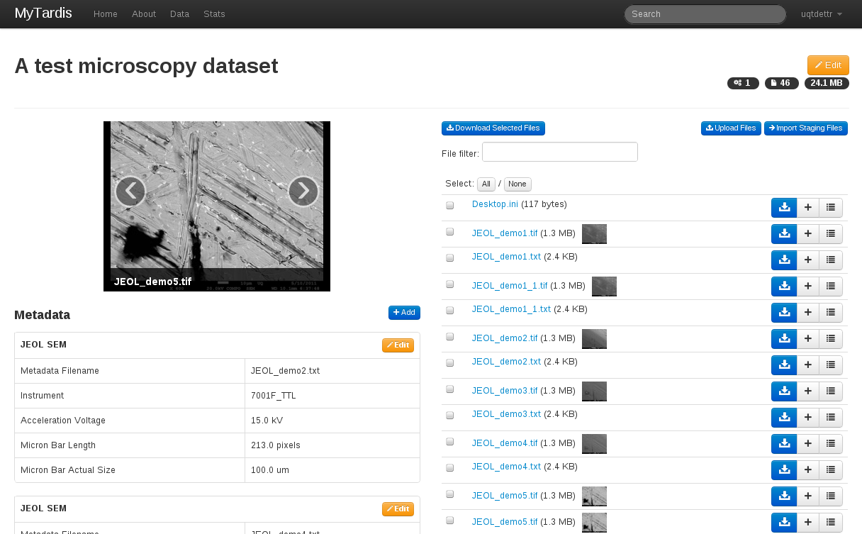

MyTardis Screenshot (with Microscopy Data Shown)

