Enhancing RETFound for Diabetic Retinopathy Grading:
Baseline vs Clinically Adapted Fine-Tuning
Thesis Experimental Report

Abstract
We compare RETFound Baseline (full fine-tuning + cross-entropy) with Enhanced RETFound (LoRA, multi-scale fusion, and focal/ordinal/referable losses) for five-class DR grading. On APTOS 2019 (test N = 550), Enhanced RETFound slightly improved QWK (0.893 vs 0.888) and referable AUROC (0.987 vs 0.981), while the baseline kept higher accuracy (0.831 vs 0.811). On external Messidor-2, Enhanced RETFound improved QWK (0.505 vs 0.488) and referable AUROC (0.778 vs 0.725). Ablation A2 (LoRA + multi-scale + focal) achieved the best APTOS QWK (0.895). Enhanced RETFound is comparable internally and stronger on external referable discrimination.

1. Introduction
Diabetic retinopathy grading is ordinal and class-imbalanced. This study asks whether a clinically motivated adaptation of RETFound improves severity grading over standard fine-tuning, including under external domain shift to Messidor-2.

2. Methods
Dataset | Role
APTOS 2019 | Train/val/test; test N = 550
Messidor-2 | External test only

Model | Description
RETFound Baseline | Full fine-tuning + weighted CE
Enhanced RETFound | LoRA + multi-scale + focal/ordinal/referable
A1 / A2 / A3 | Ablations of Enhanced components (15 epochs)

- Primary metric: Quadratic Weighted Kappa (QWK).
- Secondary: accuracy, macro-F1, referable DR accuracy/AUROC.

3. Results

3.1 Main comparison
Model | Set | Acc | Macro-F1 | QWK | Ref Acc | Ref AUROC
RETFound Baseline | APTOS | 0.831 | 0.671 | 0.888 | 0.929 | 0.981
Enhanced RETFound | APTOS | 0.811 | 0.683 | 0.893 | 0.935 | 0.987
RETFound Baseline | Messidor-2 | 0.612 | 0.330 | 0.488 | 0.807 | 0.725
Enhanced RETFound | Messidor-2 | 0.593 | 0.349 | 0.505 | 0.802 | 0.778

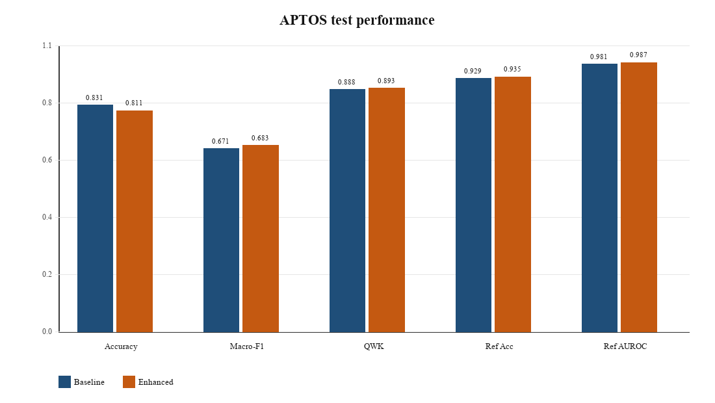
Figure 1. APTOS test metrics: RETFound Baseline vs Enhanced RETFound.
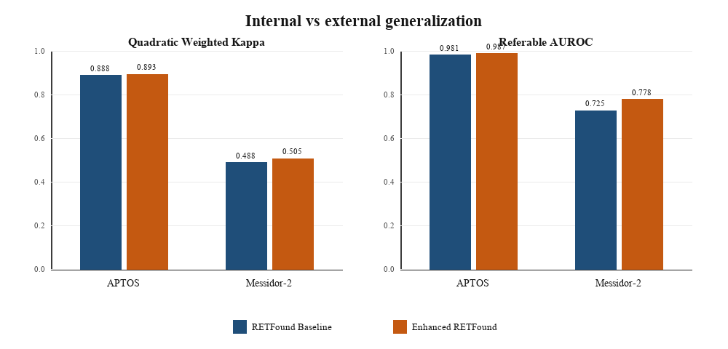
Figure 2. Internal vs external generalization (QWK and referable AUROC). Enhanced RETFound shows a clearer Messidor-2 gain in referable AUROC (0.725 → 0.778).

3.2 Confusion matrices
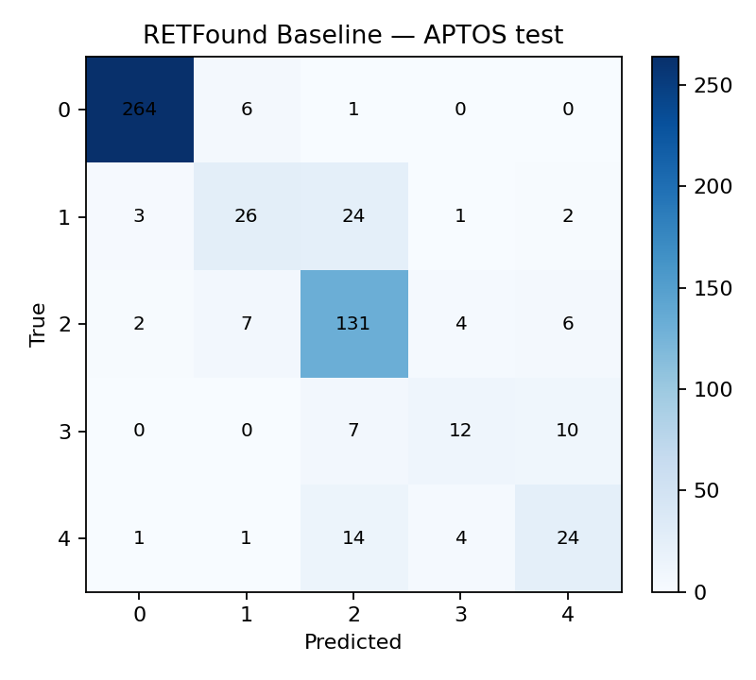 | 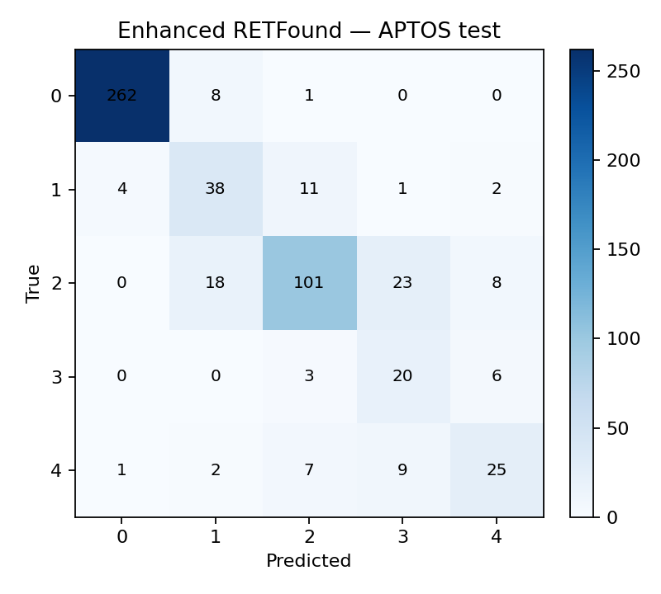
Figure 3a. Baseline — APTOS | Figure 3b. Enhanced — APTOS

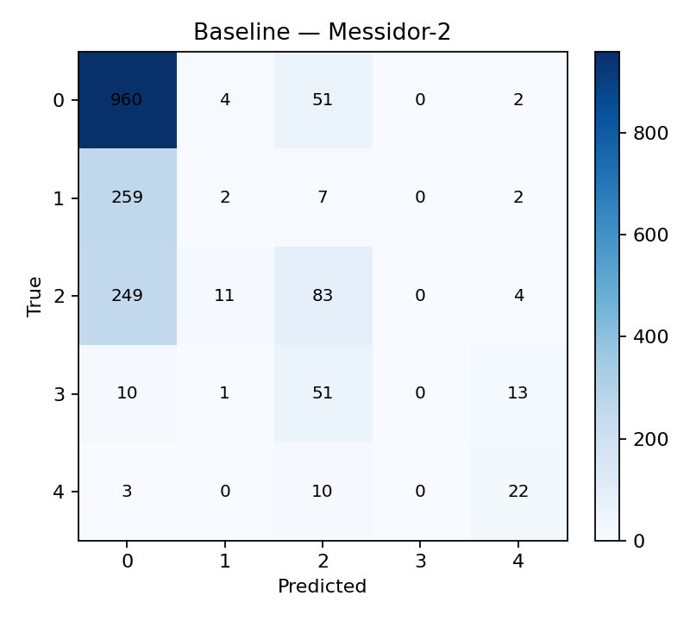 | 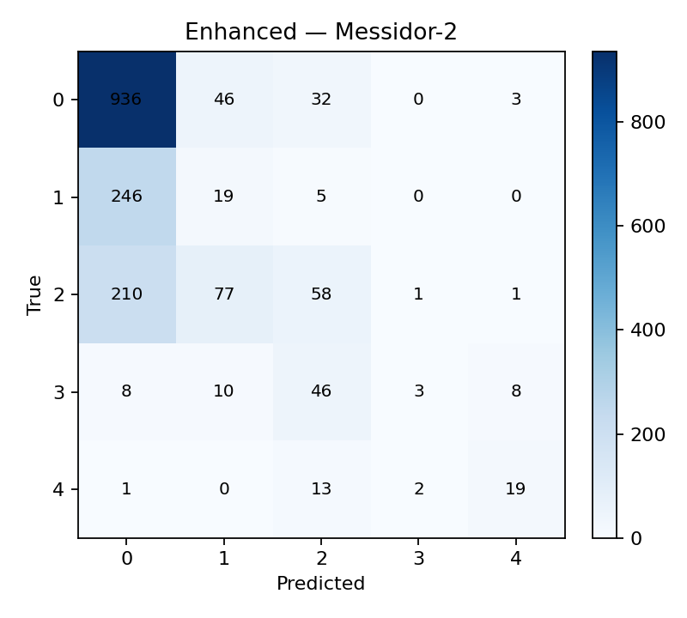
Figure 4a. Baseline — Messidor-2 | Figure 4b. Enhanced — Messidor-2

3.3 Referable-DR ROC
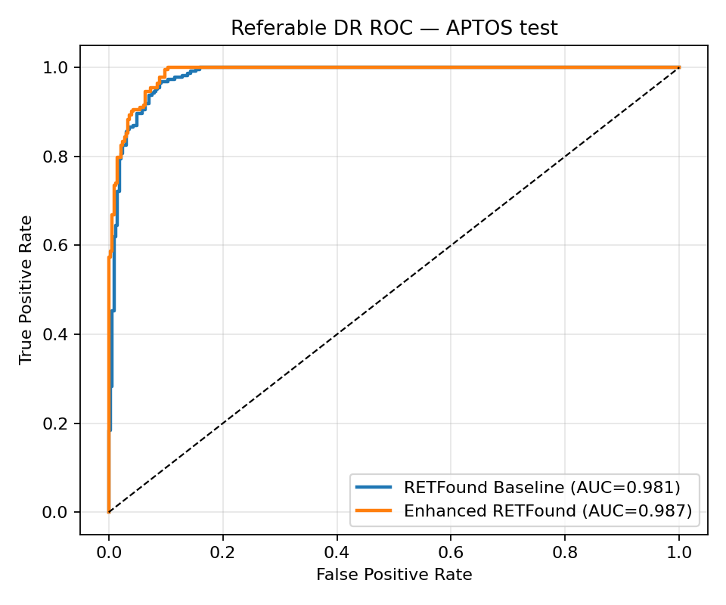 | 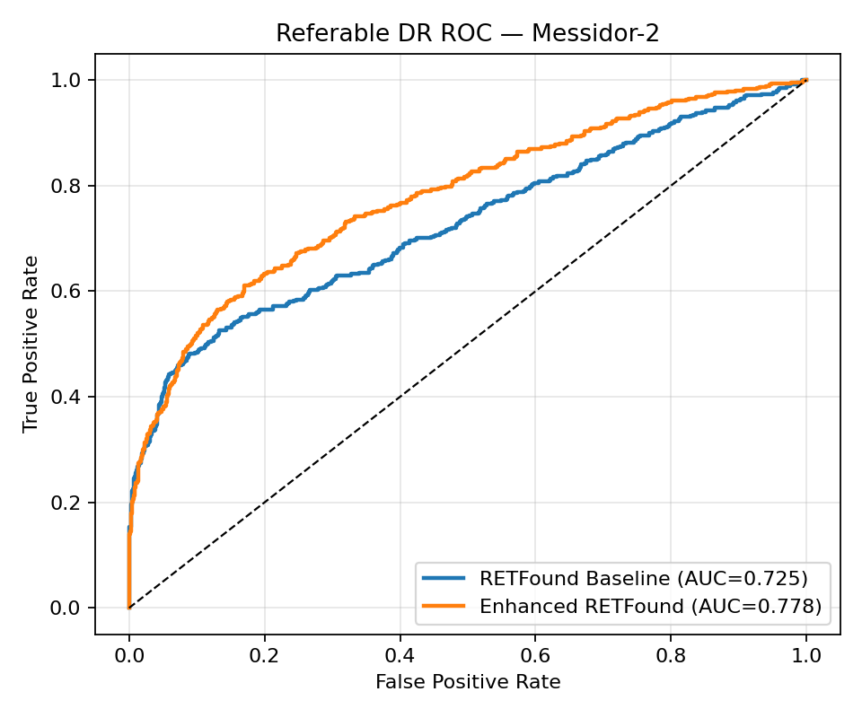
Figure 5a. Referable ROC — APTOS | Figure 5b. Referable ROC — Messidor-2

3.4 Ablations
Variant | Acc | QWK | Ref AUROC
RETFound Baseline | 0.831 | 0.888 | 0.981
Enhanced RETFound | 0.811 | 0.893 | 0.987
A1 LoRA + focal | 0.738 | 0.892 | 0.985
A2 + multi-scale | 0.765 | 0.895 | 0.987
A3 + ordinal/referable | 0.764 | 0.881 | 0.988

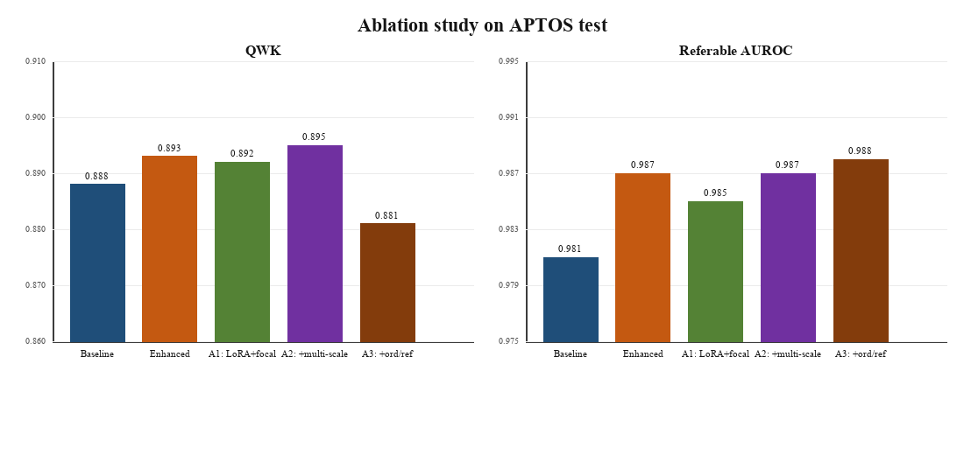
Figure 6. Ablation summary on APTOS: QWK (left) and referable AUROC (right). A2 best QWK; A3 best referable AUROC.

4. Discussion
1. Baseline is already strong on APTOS; Enhanced is comparable in-domain.
2. Under Messidor-2 shift, Enhanced improves QWK and especially referable AUROC.
3. A2 (LoRA + multi-scale + focal) is the strongest grading configuration among ablations.
4. Accuracy favours Baseline; ordinal/screening metrics favour Enhanced/A2 — report both.

5. Conclusion
Enhanced RETFound does not dominate APTOS accuracy, but improves ordinal/screening behaviour and generalises better to Messidor-2 referable detection. Multi-scale LoRA fine-tuning is the main useful enhancement.

