**Design Template**

|  |
| --- |
| [Company] |
| Software Project Template |
| [Name of Project] |

|  |
| --- |
| [Student Name]  [Date]  [Version x.x] |

Contents

A. Introduction 3

A1. Introduction and Purpose Statement 3

A2. Overview of the Problems 3

A3. Goals and Objectives 3

A4. Prerequisites 3

A5. Scope 3

A6. Environment 3

B. Requirements 4

Business Requirements 4

User Requirements 4

Functional Requirements 4

Non-Functional Requirements 4

C. Software Development Methodology 4

C1. Advantages and Disadvantages 4

Advantages of the Agile Method 4

Disadvantages of the Agile Method 4

Advantages of {A Different Method} 4

Disadvantages of {A Different Method} 4

C2. Best suited 5

D. Create Two Representations of the Software Solution 5

Representation 1 5

Representation 2 5

E. Testing 6

Test Name 1 6

Test Name 2 7

Test Name 3 8

F. Sources 8

# Introduction

# A1. Introduction and Purpose Statement

Provide a brief introduction and explain the purpose of the proposed system.

# A2. Overview of the Problems

Describe the problems the company is currently facing and how the proposed solution will solve those problems.

# A3. Goals and Objectives

Provide the goals and objectives for the project and solution.

# A4. Prerequisites

List the prerequisites, their descriptions, and future completion dates. Be sure to be clear and concise for all listed prerequisites. (You may add lines for additional prerequisites if needed.)

|  |  |  |  |
| --- | --- | --- | --- |
| Number | Prerequisite | Description | Completion Date |
|  |  |  |  |
|  |  |  |  |
|  |  |  |  |
|  |  |  |  |

# A5. Scope

Provide a brief overview of what the proposed solution will cover and what the proposed solution will not cover. It is important to set clear boundaries for the project.

# A6. Environment

Describe the front-end and back-end environments that the solution will be deployed in.

# Requirements

In the subsections below, explain your four distinct requirements, one for each subsection.

*Note: All requirements must be in your own words and must interpret the requirements found in the “CRM Requirements” supporting document. Please do not copy and paste word for word from the requirements in the “CRM Requirements” supporting document.*

## Business Requirements

Explain how your software solution addresses a distinct business requirement.

## User Requirements

Explain how your software solution addresses a distinct user requirement.

## Functional Requirements

Explain how your software solution addresses a distinct functional requirement.

## Non-Functional Requirements

Explain how your software solution addresses a distinct non-functional requirement.

# Software Development Methodology

Examine the Agile methodology and compare it to other software development methodologies.

*Note: All subsections are required. Refer to the requirements section and rubric section of the assessment for additional information.*

# C1. Advantages and Disadvantages

## Advantages of the Agile Method

Describe at least three advantages of the Agile methodology and how they will benefit this project.

## Disadvantages of the Agile Method

Describe at least three disadvantages of the Agile methodology and how they may hinder this project.

## Advantages of {A Different Method}

Describe at least three advantages of a different methodology and how they will benefit this project.

## Disadvantages of {A Different Method}

Describe three disadvantages of a different methodology and how they may hinder this project.

# C2. Best suited

Describe why the Agile methodology is the best software development methodology for this project, including specific examples to justify your claims.

**Or**

Provide the details of a different development process and outline why you have selected it and how it is better suited for this project, including specific examples to justify your claims.

# Create Two Representations of the Software Solution

*Note: You may add subsections here to fit the needs of the solution. At least two different representations of your design need to be present.*

## Representation 1

Provide the first representation of the application (e.g., storyboard, flowchart, UML diagram, ERD, GUI, etc.) and a brief description of the representation.

## Representation 2

Provide the second representation of the application (e.g., storyboard, flowchart, UML diagram, ERD, etc.) and a brief description of the representation.

# Testing

# Test Name 1

|  |
| --- |
| Requirement to be tested: |
| Preconditions: Conditions that must be present before the test case can successfully run. |
| Steps: The steps the tester must execute to test the feature. |
| Expected results: Expected results and any side effects such as updating a database, writing to a file, etc. |
| Pass/Fail: Explain why the test case passed or failed. The results can be compiled and used to determine if the application is ready for delivery or release. |

# Test Name 2

|  |
| --- |
| Requirement to be tested: |
| Preconditions: Conditions that must be present before the test case can successfully run. |
| Steps: The steps the tester must execute to test the feature. |
| Expected results: Expected results and any side effects such as updating a database, writing to a file, etc. |
| Pass/Fail: Explain why the test case passed or failed. The results can be compiled and used to determine if the application is ready for delivery or release. |

# Test Name 3

|  |
| --- |
| Requirement to be tested: |
| Preconditions: Conditions that must be present before the test case can successfully run. |
| Steps: The steps the tester must execute to test the feature. |
| Expected results: Expected results and any side effects such as updating a database, writing to a file, etc. |
| Pass/Fail: Explain why the test case passed or failed. The results can be compiled and used to determine if the application is ready for delivery or release. |

# Sources

Place the sources that you used here.

*Note: See the sources section in the requirements and rubric. If you did not use any outside sources, you may delete this section.*

**MJ Logistics Gaming Company**

**BPN1: Software Solution**

Thomas Boshans

04/15/25

Version 1.0

# A. Introduction

## A1. Introduction and Purpose Statement

The purpose of this proposal is to present a software solution for the MJ Logistics Gaming Company, that addresses current customer relationship management (CRM) challenges. The project, titled BPN1: Software Solution, outlines the design of a centralized, web-based CRM system aimed at improving business process efficiency, data integration, and user experience. This system will replace fragmented legacy tools, offering a scalable and secure platform that enhances reporting, customer tracking, and activity management capabilities.

## A2. Overview of the Problems

MJ Logistics currently operates with a mix of disconnected tools, including spreadsheets and legacy databases spread across multiple departments and locations. This approach leads to inefficiencies in communication, limited visibility into customer interactions, inconsistent data, and a lack of scalable solutions to support a growing team. As the company has seen a 42% increase in sales over the last two years, it is essential to streamline operations and centralize client data to maintain growth and competitive edge.

## A3. Goals and Objectives

- Centralize all customer and business contact information into a unified CRM platform.  
- Enable customizable reporting and dashboards for stakeholders across departments.  
- Support secure, role-based access controls for on-site and remote employees.  
- Improve sales tracking, order management, and communication workflows.  
- Provide integration with Microsoft Outlook for meeting and activity tracking.  
- Ensure system scalability and security in accordance with data protection laws.

## A4. Prerequisites

1. Stakeholder Approval – Final approval from executive leadership and department heads. (Deadline: May 2025)  
2. Product Evaluation – Analysis of COTS and custom-built options. (Deadline: May 2025)  
3. Infrastructure Setup – Prepare hosting environment and security protocols. (Deadline: June 2025)  
4. Training Program – Develop training guides for end-users and admins. (Deadline: June 2025)

## A5. Scope

The proposed CRM system will support contact management, sales tracking, ticketing, activity logging, order processing, and reporting. It will include features such as role-based access, real-time updates, and integration with Microsoft Outlook. The solution does not cover marketing automation tools, customer-facing mobile app development, or storefront functionalities at this stage.

## A6. Environment

The system will utilize a web-based front-end accessible from modern browsers (Chrome, Firefox, Edge, Safari) and mobile devices (Android/iOS). The back-end will support RESTful APIs and integrate with Microsoft Active Directory and Exchange. The infrastructure will be hosted either on-premises or on a secure cloud platform, depending on vendor evaluation.

# B. Requirements

## Business Requirements

The CRM solution must support robust reporting features that allow users to generate, filter, and export both predefined and custom reports. These reports should accommodate executive-level summaries as well as detailed views filtered by department, date range, and user-defined parameters. This business requirement addresses MJ Logistics’ need for real-time insight into sales performance, stakeholder engagement, and operational efficiency.

## User Requirements

The system must provide seamless access for users operating across various platforms and devices. This includes support for major browsers such as Chrome, Firefox, Safari, and Edge, as well as mobile operating systems like Android and iOS. Given MJ Logistics' distributed workforce and increasing remote operations, this user requirement ensures consistent access to the CRM across all user environments.

## Functional Requirements

The CRM must include a comprehensive ticketing module that tracks all interactions with clients or partners. Each ticket should log contact information, the nature of the inquiry, timestamps, assigned staff, and a history of follow-ups. The system must automatically associate these records with relevant contacts and generate audit trails to support accountability and service quality.

## Non-Functional Requirements

The system must enforce strong data governance through permissions and audit logging. It should support both soft and hard delete functions, where soft deletes hide records from standard views and hard deletes permanently remove data with appropriate authorization. The system must also maintain version control and allow for rollback of entries where needed, supporting long-term record accuracy and regulatory compliance.

# C. Software Development Methodology

## C1. Advantages and Disadvantages

Advantages of the Agile Method:

• Agile supports frequent stakeholder feedback through sprints and iteration reviews, helping align the CRM development with evolving company needs.

• Agile reduces the risk of project failure by delivering working features early, allowing issues to be caught before major investment.

• Agile allows teams to adapt to changing priorities, which is essential for MJ Logistics as its CRM needs may grow or shift during development.

Disadvantages of the Agile Method:

• Agile requires active and ongoing participation from stakeholders, which can be difficult for busy departments.

• Without strict boundaries, Agile can lead to scope creep as new feature requests emerge mid-development.

• Agile's flexibility may make it harder to forecast budgets and delivery timelines, especially early in the project.

Advantages of the Waterfall Method:

• Waterfall offers a linear and structured process, making it easier to track project milestones and deadlines.

• Budgets and timelines are easier to estimate and manage with fixed requirements.

• Waterfall encourages thorough documentation, which benefits long-term maintenance and onboarding.

Disadvantages of the Waterfall Method:

• Waterfall is inflexible; once requirements are defined, changes are costly and difficult to implement.

• Testing is delayed until after development, which increases the risk of discovering critical flaws too late.

• Limited user feedback during development may result in a product that doesn’t meet actual business needs.

## C2. Best Suited

Agile is the most suitable development methodology for MJ Logistics’ CRM project. The company's evolving business processes and need for real-time input from stakeholders make Agile’s iterative approach ideal. Agile allows MJ Logistics to prioritize modules such as contact management, ticketing, and reporting, implementing them incrementally and adjusting based on feedback. This also supports future integrations and scalability more effectively than a fixed-scope Waterfall model.

# D. Create Two Representations of the Software Solution

## Representation 1: UML Class Diagram

This UML class diagram depicts core CRM entities such as Business, Contact, Ticket, and Order. It illustrates the relationships between these entities, which are critical to the CRM’s data model. The structure allows for efficient data management and supports one-to-many relationships, making it easier to associate contacts with multiple orders or support tickets.

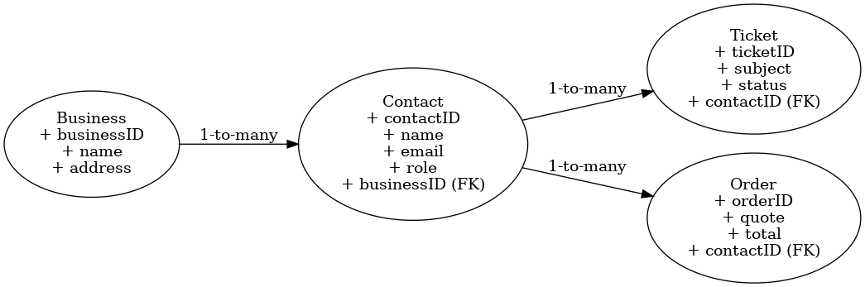

## Representation 2: Ticket Lifecycle Flowchart

This process flowchart outlines the full lifecycle of a customer support ticket. It begins with receiving a customer inquiry and ends with resolution and closure. The flow ensures the system supports essential steps such as assignment, response, follow-up, and escalation when needed. This representation provides clarity on business logic and system flow for developers and stakeholders alike.

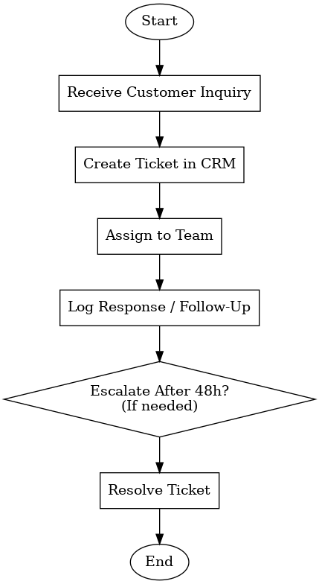

# F. Sources

MJ Logistics Gaming Company. *CRM Requirements Document*. Provided by Course Instructor, 2025.

Agile Alliance. “What Is Agile Software Development?” *Agile Alliance*, www.agilealliance.org. Accessed 15 Apr. 2025.

Lucidchart. “How to Build a UML Diagram.” *Lucid Software Inc.*, www.lucidchart.com/pages/uml-diagram. Accessed 15 Apr. 2025.