MJ Logistics Gaming - CRM Software Design

# A. Introduction

## A1. Introduction and Purpose Statement

The purpose of this project is to propose a scalable and robust Customer Relationship Management (CRM) system for MJ Logistics Gaming. The proposed solution will replace the company’s current disjointed tools with a centralized web-based system for managing client contacts, sales tracking, activity records, and reporting.

## A2. Overview of the Problems

MJ Logistics Gaming is facing issues with its current fragmented system of spreadsheets and databases. These tools are spread across different locations and hinder collaboration, data consistency, and workflow efficiency. A unified CRM system will solve these issues by integrating all functionalities into one accessible platform.

## A3. Goals and Objectives

- Centralize customer and partner data  
- Enable dynamic sales reporting and dashboards  
- Provide ticketing and order management  
- Implement robust security and role-based access  
- Integrate with Microsoft Exchange/Outlook  
- Ensure scalability for future growth

## A4. Prerequisites

1. Stakeholder Approval – May 2025  
2. Vendor/Product Evaluation – May 2025  
3. Infrastructure Readiness – June 2025  
4. Staff Training Plan – June 2025

## A5. Scope

In Scope: Contact management, sales tracking, ticketing, reporting, Outlook integration.  
Out of Scope: Marketing automation, native mobile app development, game distribution functions.

## A6. Environment

Front-end: Web interface compatible with modern browsers and mobile devices.  
Back-end: Hosted either on internal infrastructure or a scalable cloud platform, with RESTful API support and Active Directory integration.

# B. Requirements

## Business Requirements

The CRM will provide advanced reporting tools for users to create custom dashboards and generate meaningful reports from company data.

## User Requirements

The system will be accessible from any modern browser or device, supporting a remote and diverse user base of over 2,000 employees.

## Functional Requirements

The system will feature a built-in ticketing module to manage customer inquiries, automatically capture communication, and maintain an audit trail.

## Non-Functional Requirements

The CRM will support soft/hard deletes, access control based on roles, user activity logging, and the ability to restore previous versions of records.

# C. Software Development Methodology

## C1. Advantages and Disadvantages

### Advantages of the Agile Method

1. Frequent feedback cycles improve alignment with evolving business needs.  
2. Early delivery of usable features reduces project risk.  
3. Flexibility allows for adapting scope during development.

### Disadvantages of the Agile Method

1. Requires continuous user involvement.  
2. Risk of scope creep without strong sprint planning.  
3. Uncertainty in budget and timelines.

### Advantages of Waterfall

1. Waterfall allows full documentation before coding.  
2. Predictable project scope and cost.  
3. Easier to manage fixed-scope contracts.

### Disadvantages of Waterfall

1. Harder to change requirements late in the process.  
2. Bugs found late due to delayed testing.  
3. Less stakeholder engagement throughout development.

## C2. Best Suited

Agile is best suited for this CRM project as it allows iterative delivery, continuous input from stakeholders, and flexibility to adapt as MJ Logistics grows and scales.

# D. Create Two Representations of the Software Solution

## Representation 1

This UML diagram illustrates relationships between entities like Business, Contact, Ticket, and Order in the CRM system.

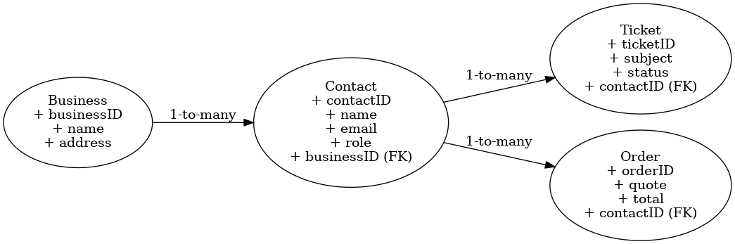

## Representation 2

This flowchart shows the lifecycle of a ticket from customer inquiry through assignment, response, and resolution.

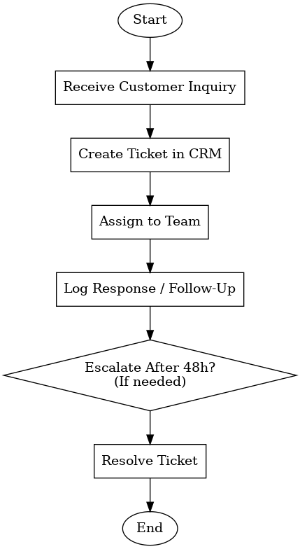

# E. Testing

## Test Name 1: Create and Assign Ticket

Requirement to be tested:  
The system must allow users to create a ticket for a customer inquiry and assign it to the appropriate department team within the CRM system.

Preconditions:  
- The user must be logged into the CRM system with appropriate permissions.  
- The customer contact profile must already exist within the database.  
- The user must have access to the 'Ticketing' module of the CRM.

Steps:  
1. Navigate to the 'Contacts' section of the CRM.  
2. Select an existing contact profile.  
3. Click on 'New Ticket'.  
4. Fill out the required fields: subject, inquiry description, and select the appropriate department from the dropdown.  
5. Click 'Submit' to finalize the ticket.  
6. Navigate to the 'Tickets' dashboard to verify ticket assignment and visibility.

Expected Results:  
- A new ticket should be saved with a unique ticket ID.  
- The ticket should automatically appear in the queue for the selected department.  
- The system should link the ticket to the correct contact and update the contact's activity history.  
- A confirmation message should display to the user indicating successful creation.

Pass/Fail Criteria:  
Pass if all of the following are met: the ticket is created, saved to the database, assigned to the correct team, appears in the dashboard, and is associated with the contact.  
Fail if the ticket is not saved, incorrectly assigned, missing fields, or does not appear in the contact’s activity log.

## Test Name 2: View and Export Reports

Requirement to be tested:  
The system must support custom report generation with filtering, formatting, and exporting capabilities.

Preconditions:  
- The user must be logged into the system with a Manager role.  
- The CRM must contain populated data such as tickets, contacts, and orders across multiple departments.  
- The report module must be enabled and accessible.

Steps:  
1. Navigate to the 'Reports' section in the CRM.  
2. Choose the 'Ticket Activity' report template.  
3. Apply filters for a specific department and a date range of the past 30 days.  
4. Click 'Generate Report' to view filtered results.  
5. Review the data, then click 'Export' to download the report in CSV format.  
6. Open the CSV file and verify the accuracy of exported data.

Expected Results:  
- The CRM should generate a report with the filtered criteria applied.  
- The displayed report should include accurate fields such as ticket ID, subject, assigned department, and timestamps.  
- The exported CSV file should exactly match the on-screen data with proper formatting.

Pass/Fail Criteria:  
Pass if the report filters function correctly, data is complete and correct, and the export matches the on-screen report.  
Fail if the export is incorrect, filters are not applied properly, or if the file is unreadable or missing fields.

## Test Name 3: Contact Preferences Management

Requirement to be tested:  
The system must allow contacts to update their own communication preferences, including opting in or out of specific marketing channels.

Preconditions:  
- A user must be logged in as a contact with access to account settings.  
- The contact must have existing preferences stored in the system.  
- The contact preference system must be active and integrated with the main contact profile.

Steps:  
1. Navigate to the 'Account Settings' section of the CRM.  
2. Select the 'Marketing Preferences' tab.  
3. Modify selections such as opting out of email or SMS communications.  
4. Click 'Save Preferences'.  
5. Refresh the page or log out and back in.  
6. Revisit the preferences to ensure changes were stored.  
7. Simulate or verify suppression of outbound marketing to this contact.

Expected Results:  
- The updated preferences should be saved to the database immediately.  
- The UI should reflect the new settings even after logout or refresh.  
- The system must prevent outbound marketing messages to opted-out channels.  
- A timestamp or audit log should be associated with the change.

Pass/Fail Criteria:  
Pass if preferences are accurately updated, persist through user session changes, and reflect in communication filters.  
Fail if preferences reset, changes are not saved, or the system continues to send communications against user preferences.