Script Programming:
Charcuterie Board
Stefan Bosheski ISVMA 1362

Gathering the knowledge about script programing has helped me write this program about the creation of a charcuterie board, using various techniques such as creation and manipulation of objects like lists, strings, tuples, dictionaries… And with the usage of algorithms and functions I have perfected this script.
The code starts off with settlement of the text constrictions, using the import of regular expressions.
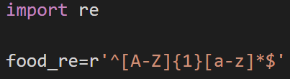

Next in line are the two most important objects in this code, the list that contains all the items and the total calculated price.
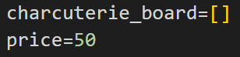

Afterwards I have created four dictionaries containing food items in different categories all with their unique prices.
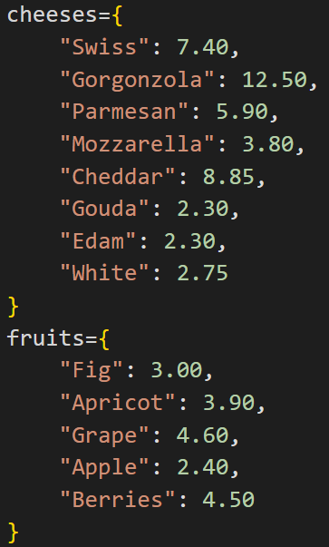
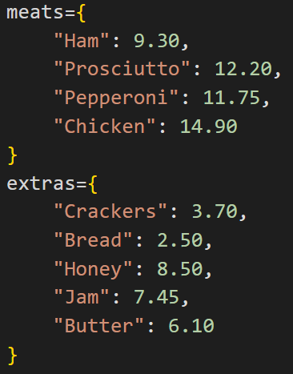

At last, we begin with the main function used for creating the charcuterie board. The ‘add_board’ function is divided in four identical sections covering the four types of food you can add to the board.
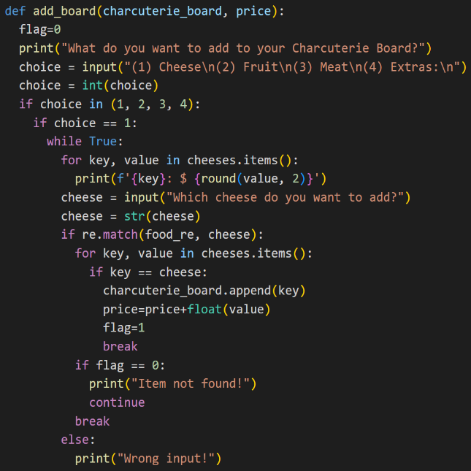
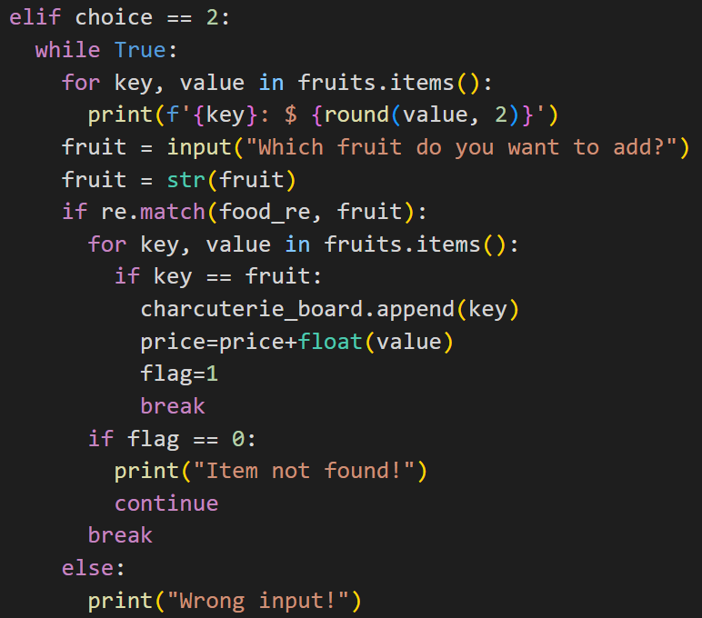

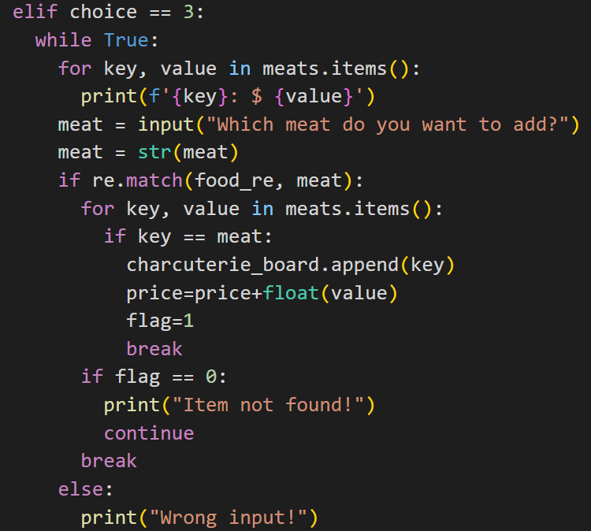
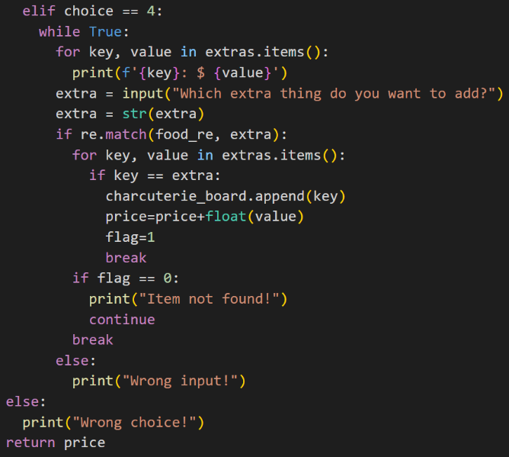

These snippets of code show how I have created the function with a built in menu that allows the user to choose the type of the food followed by which specific item you want on the board. If the user enters incorrect inputs by chance, the program informs the user and allows for a redo. At the end it returns the price which is calculated with each step.
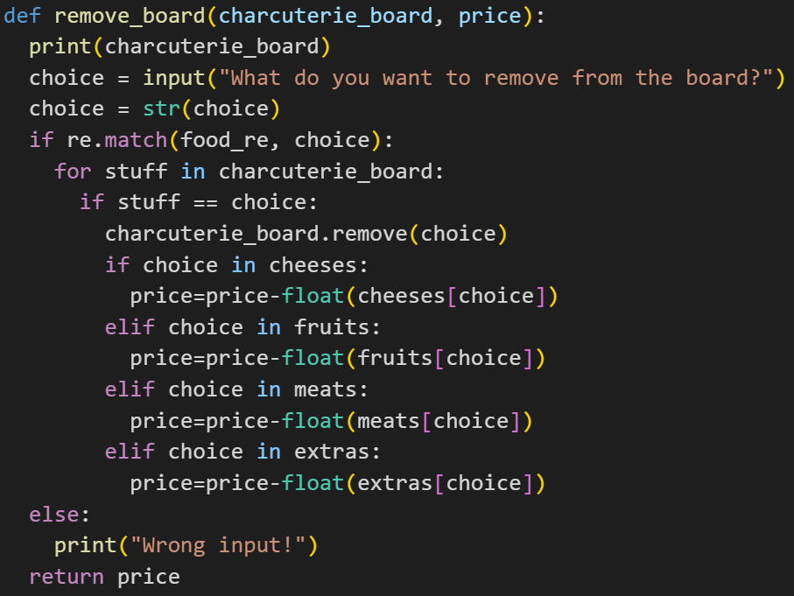

The second function is for removing a previously added item from the board. It works by allowing the user to enter the name of the food they want to remove and it removes it via the prebuilt list function. It also keeps track of where the item originates and removes the price accordingly.
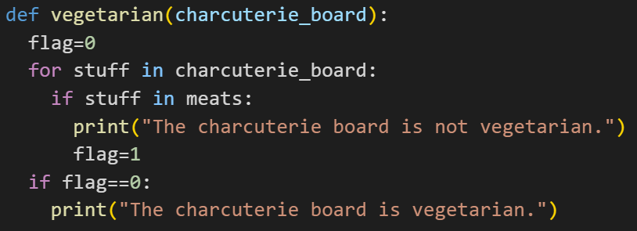

The third function only returns if the charcuterie board is vegetarian by checking if it contains an item from the ‘meats’ dictionary.
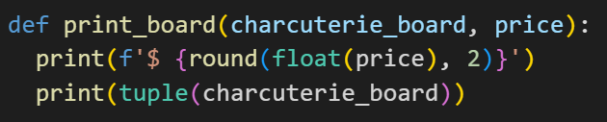

The final function shows the created charcuterie board and the total price. It makes the list ‘charcuterie_board’ into a tuple to save on memory and forces the price to round to two decimal places.
And at the end for the user to use this code, I have created an interface that shows all the possible options and calls individual functions accordingly. This is done via a ‘while True’ loop and ‘if-else’ statements.

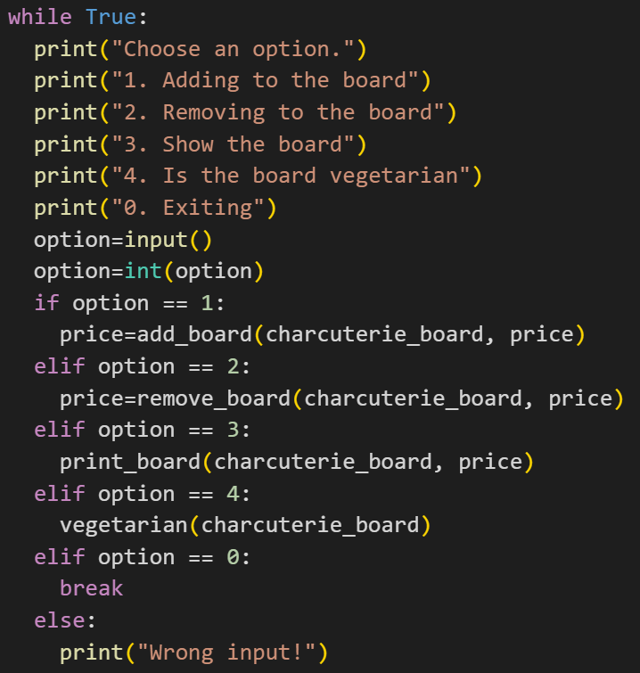

To conclude the explanation of my code, I have discovered that this code can be still worked on with more functions and improvements to the already added ones, but also it can be as it is, simple and efficient, which further proves the power and versatility of Python and scripts.

