CST8911 Midterm Project

Course: CST8911 Introduction to Cloud Computing
Name: Bosi Chen
Student Number: 041040774
GitHub Link: https://github.com/bosichen-ac/CST8911-Midterm

Scenario Overview
In this project, an Azure Virtual Machine using the most cost-effective instance is created to act as a secure management station and testing hub.
A Cosmos DB is created and an Azure Function App is used to interact with the database using RESTful API functions.
The Azure Key Vault is used for storing the access keys to the Cosmos DB and Function App.

Security Architecture using Key Vault
When trying to call the Function App
1. The Function App authenticates Key Vault using its System-Assigned Managed Identity.
2. Azure verifies the identity.
3. The Function App requests access to secrets in Key Vault.
4. Key Vault checks permissions using Role-Based Access Control (RBAC).
5. The secret values are sent back to the Function App for further actions.

Workflow

1. Create Resource Group
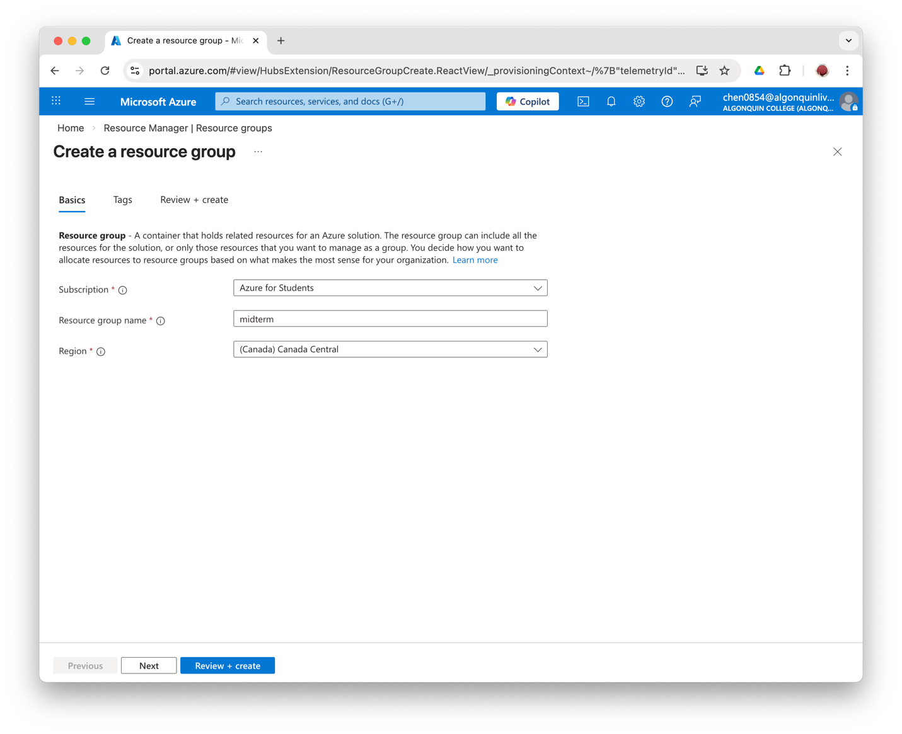

2. Create a Virtual Machine and Save the SSH key
Create a virtual machine
Save the key pair file in ~/.ssh and use chmod 400 cst8911-vm_key.pem to secure the key. This removes all access permissions so that only the owner can read it.

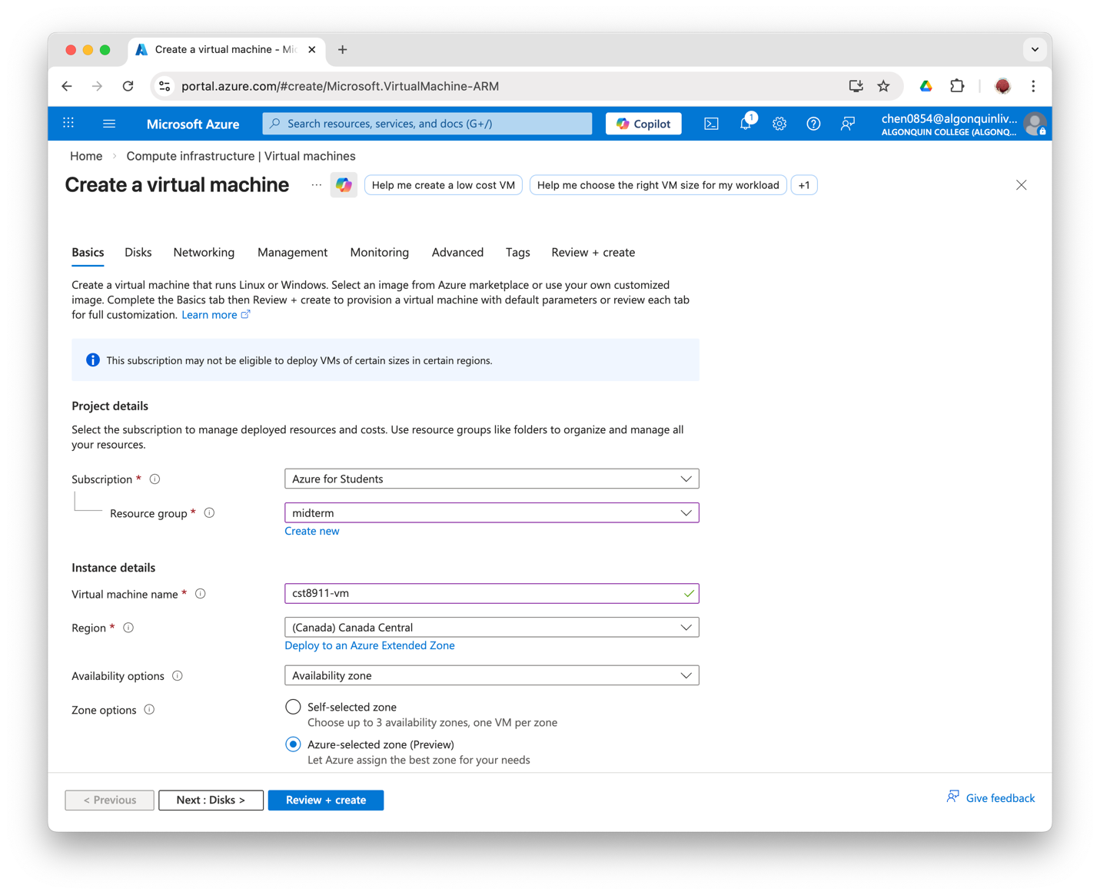
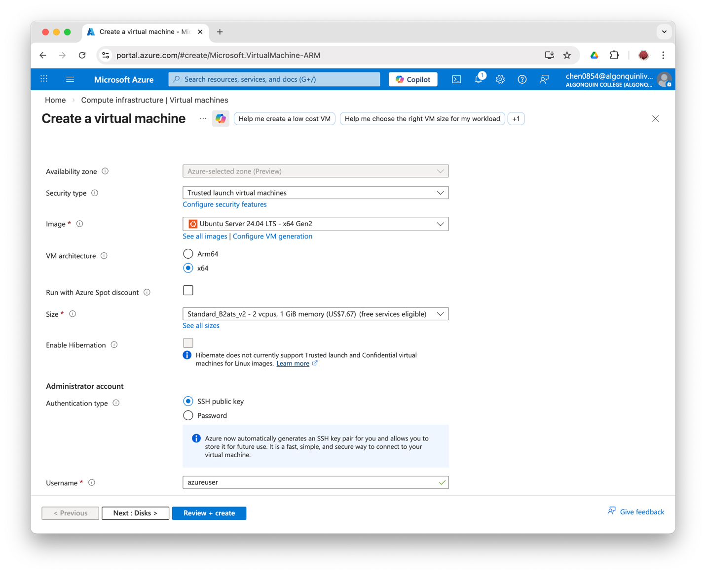
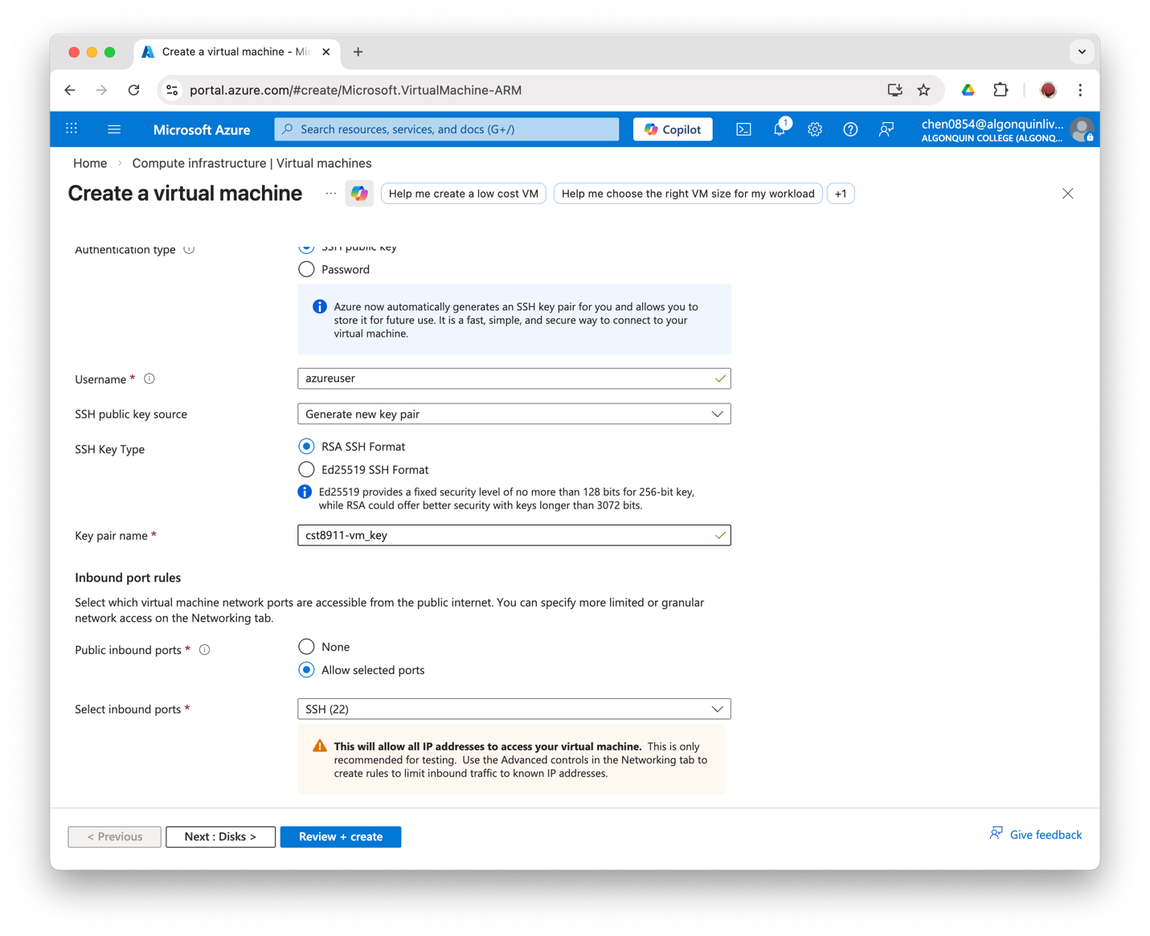

The B2ats (2vcpus, 1GB memory) provides the lowest cost of computing for Canada Central location and is enough for development and testing.

3. Create Cosmos DB (NoSQL option)

Create account
Create a serverless account for NoSQL named cosmos-midterm.

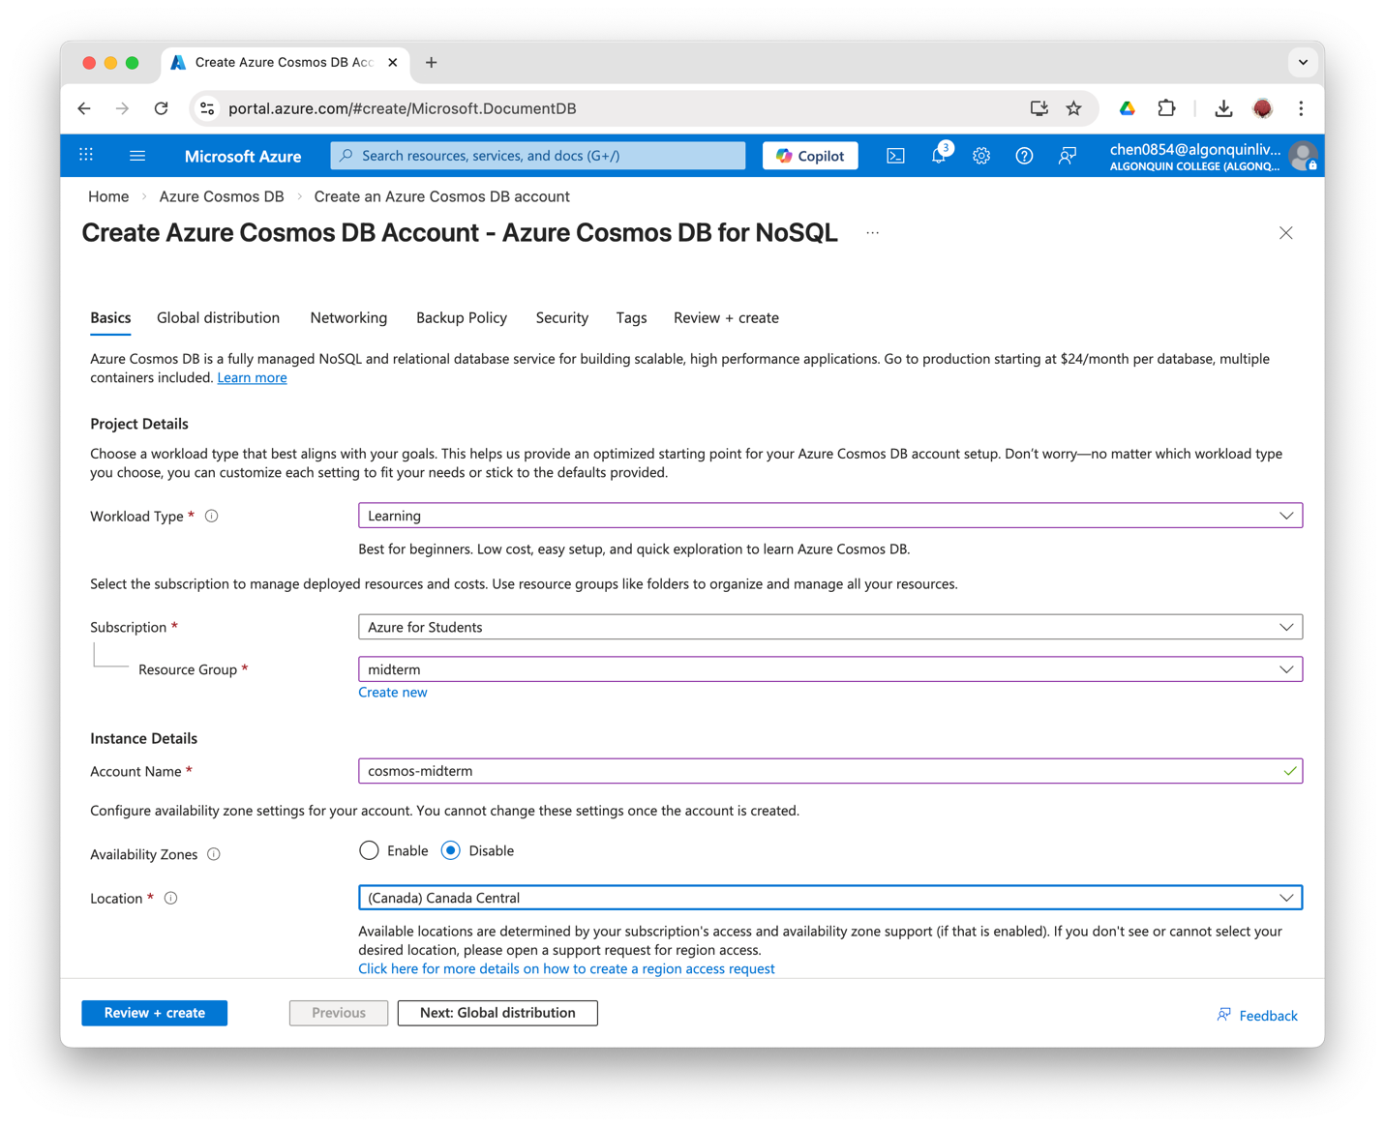
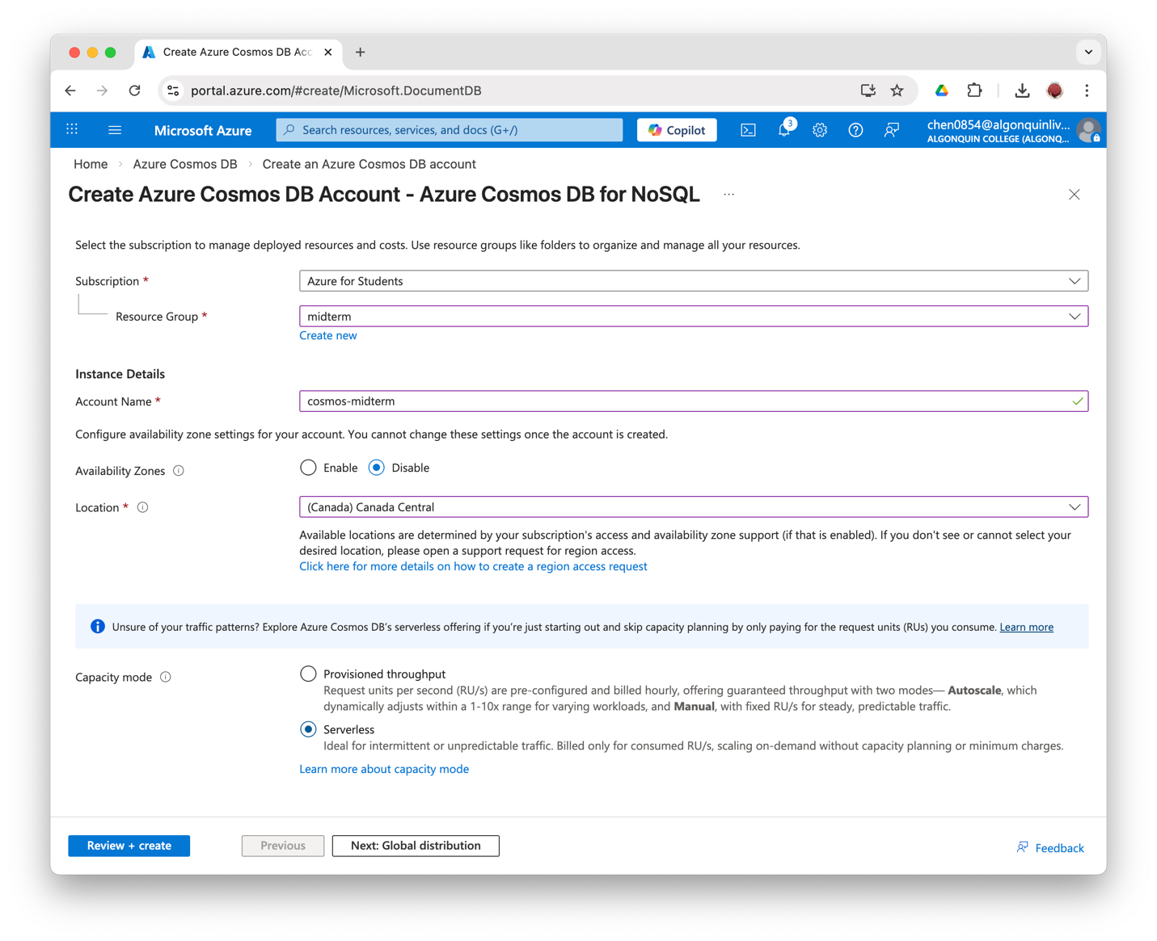

Serverless mode is selected because it charges only for request units consumed, and is the ideal for development and testing purposes.

Create database
Create database midterm-db.
Create a container items within the database, with /id as the partition key.

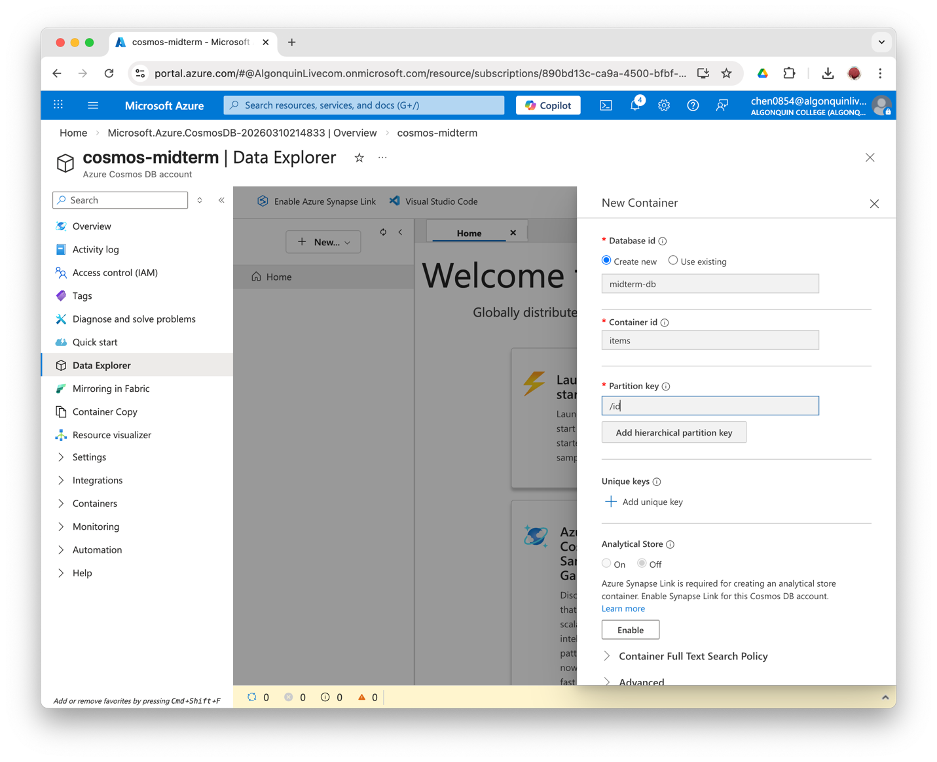

4. Create Function App
Create the Function App under Consumption Plan, named function-midterm.
Runtime stack: Node.js, 22LTS
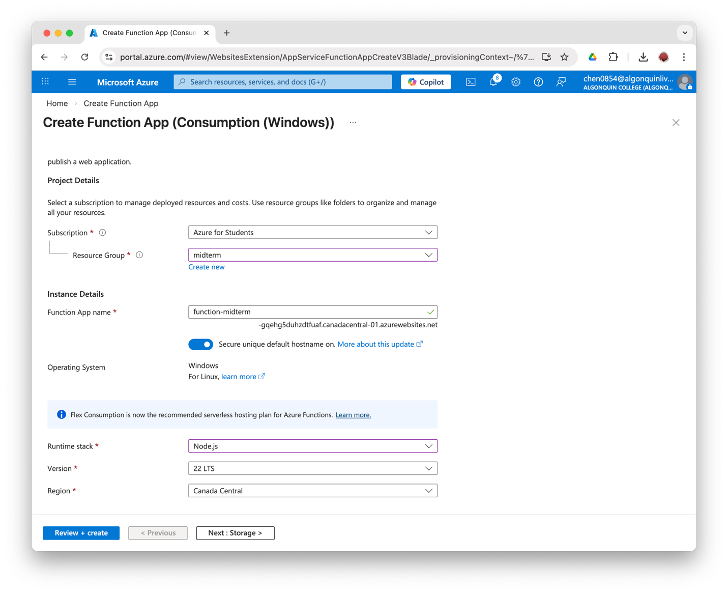
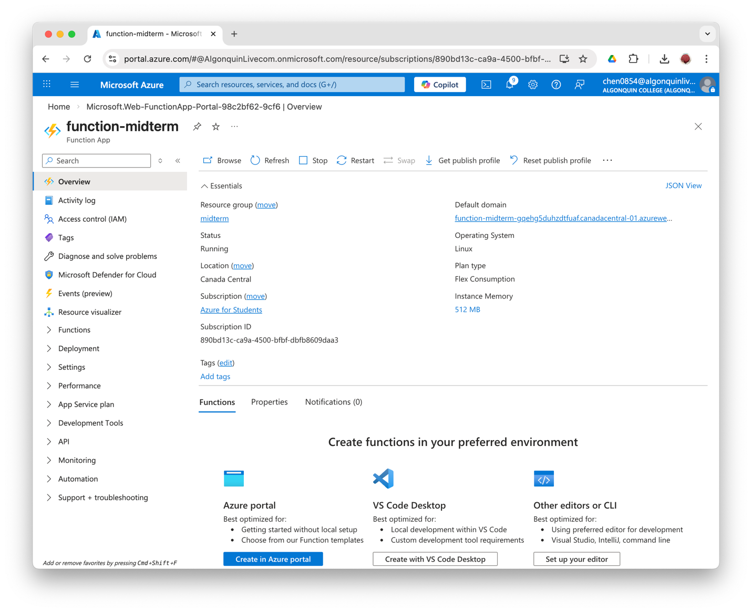
The Consumption plan is a serverless option and charges only when the function is executing. It is the most cost-effective choice for event-driven but low-traffic functions.

5. Create Key Vault
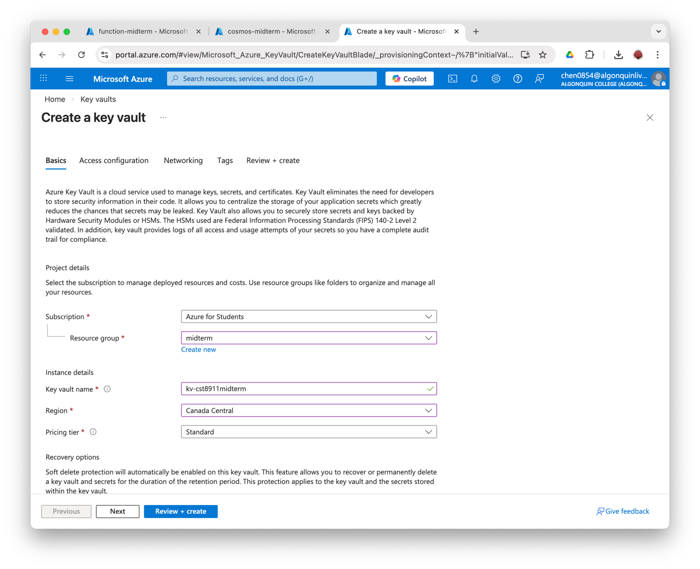
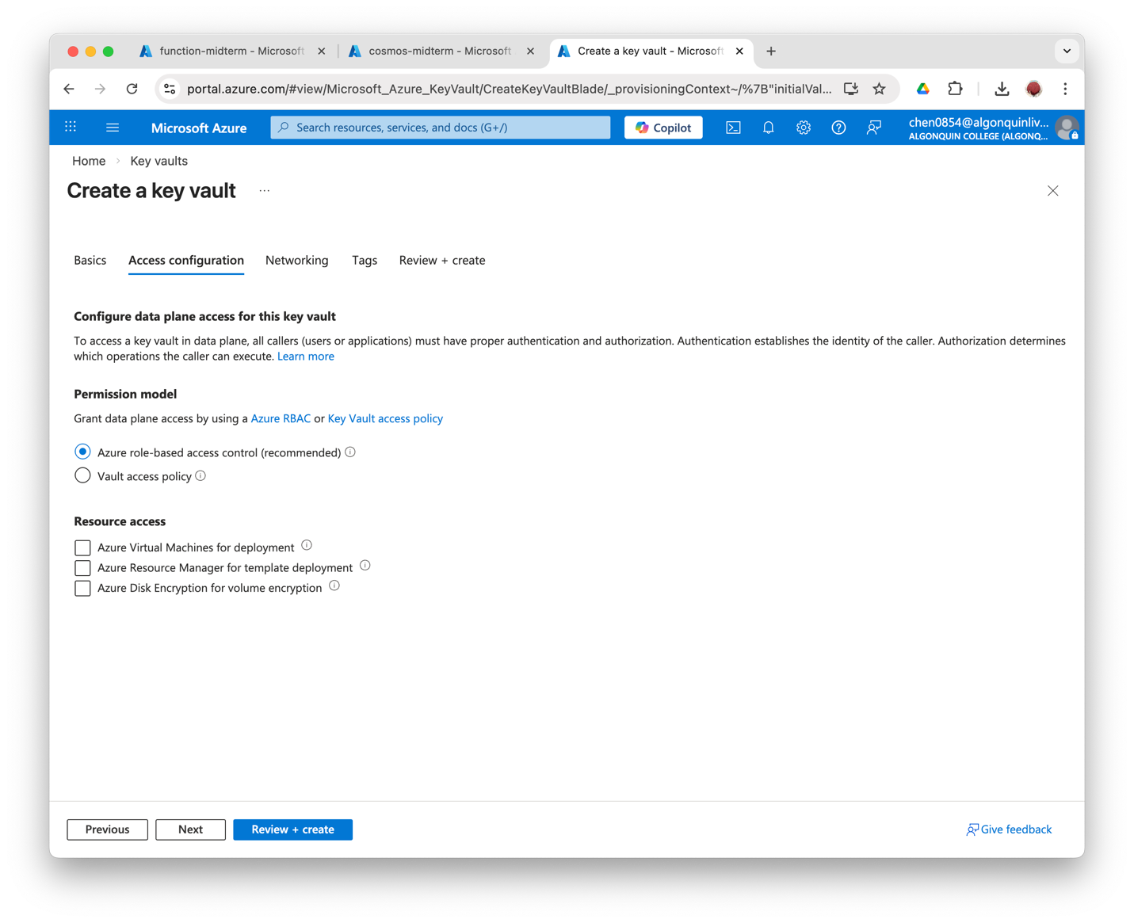
Selecting the Azure role-based access control can grant access by using the RBAC.
Azure Key Vault is used to store sensitive configuration values such as API access keys. It prevents secrets from being stored directly in code or configuration files.
The standard pricing tier is the most cost-effective choice for the Key Vault.

6. Store Keys in Key Vault
First, grant the user the Key Vault Secret Officer Role in the Access control(IAM) of the Key Vault.
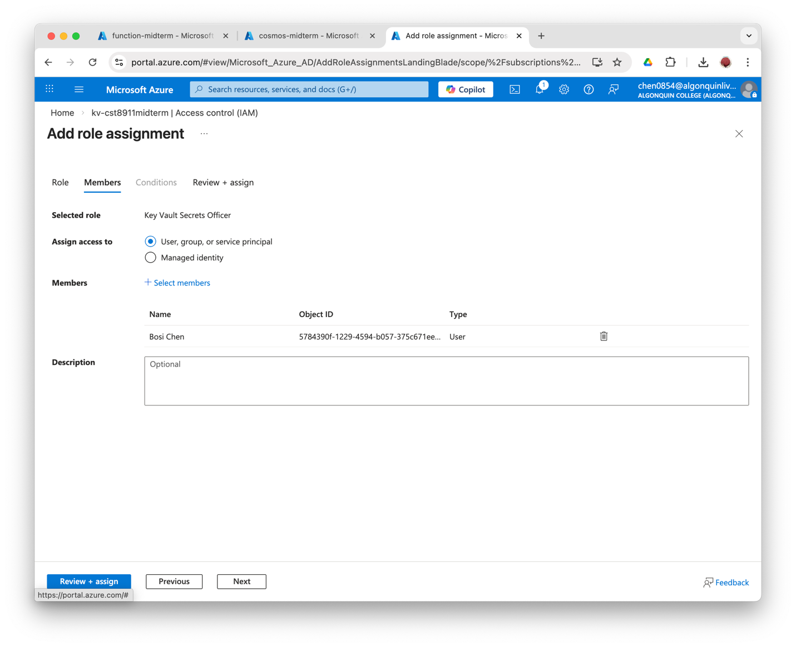

Store Cosmos DB Primary Key in Key Vault.
Generate a Secret in Key Vault named cosmos-key with the Cosmos DB key as value.
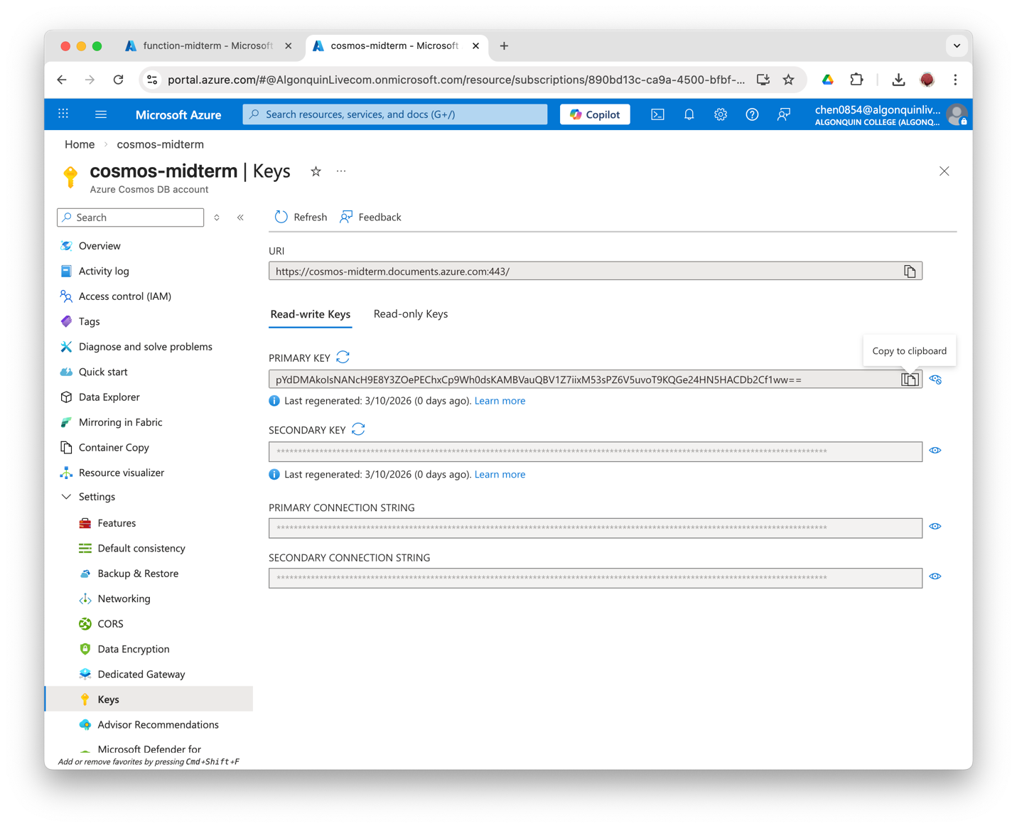
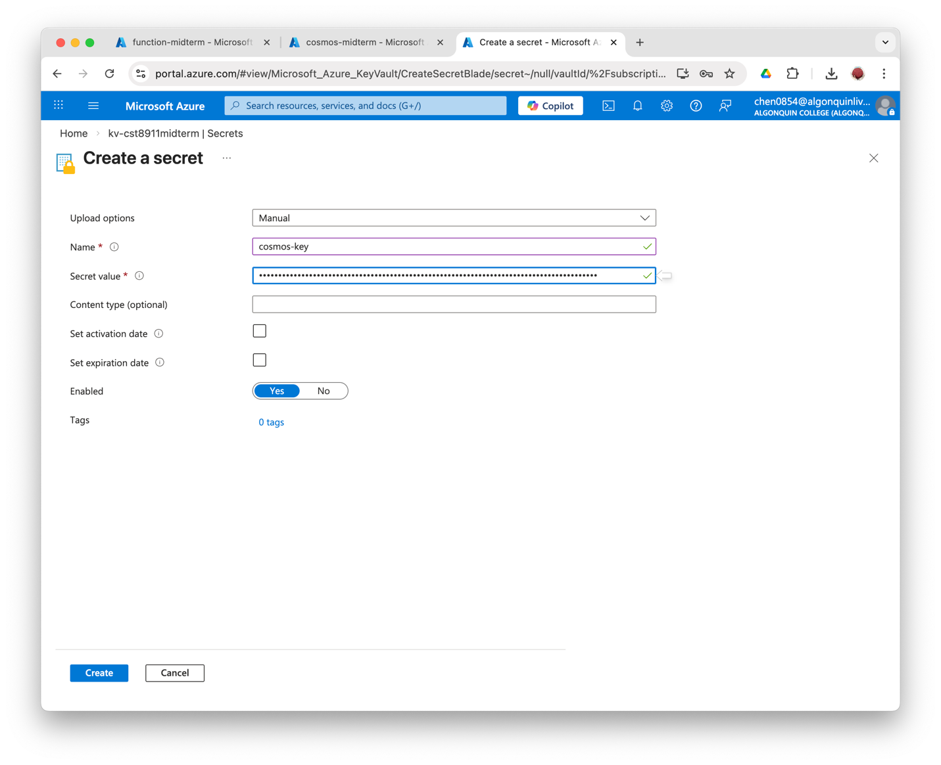

Add function access key to Key Vault.
Generate a Secret in Key Vault named function-default-key with the default function app key as value.
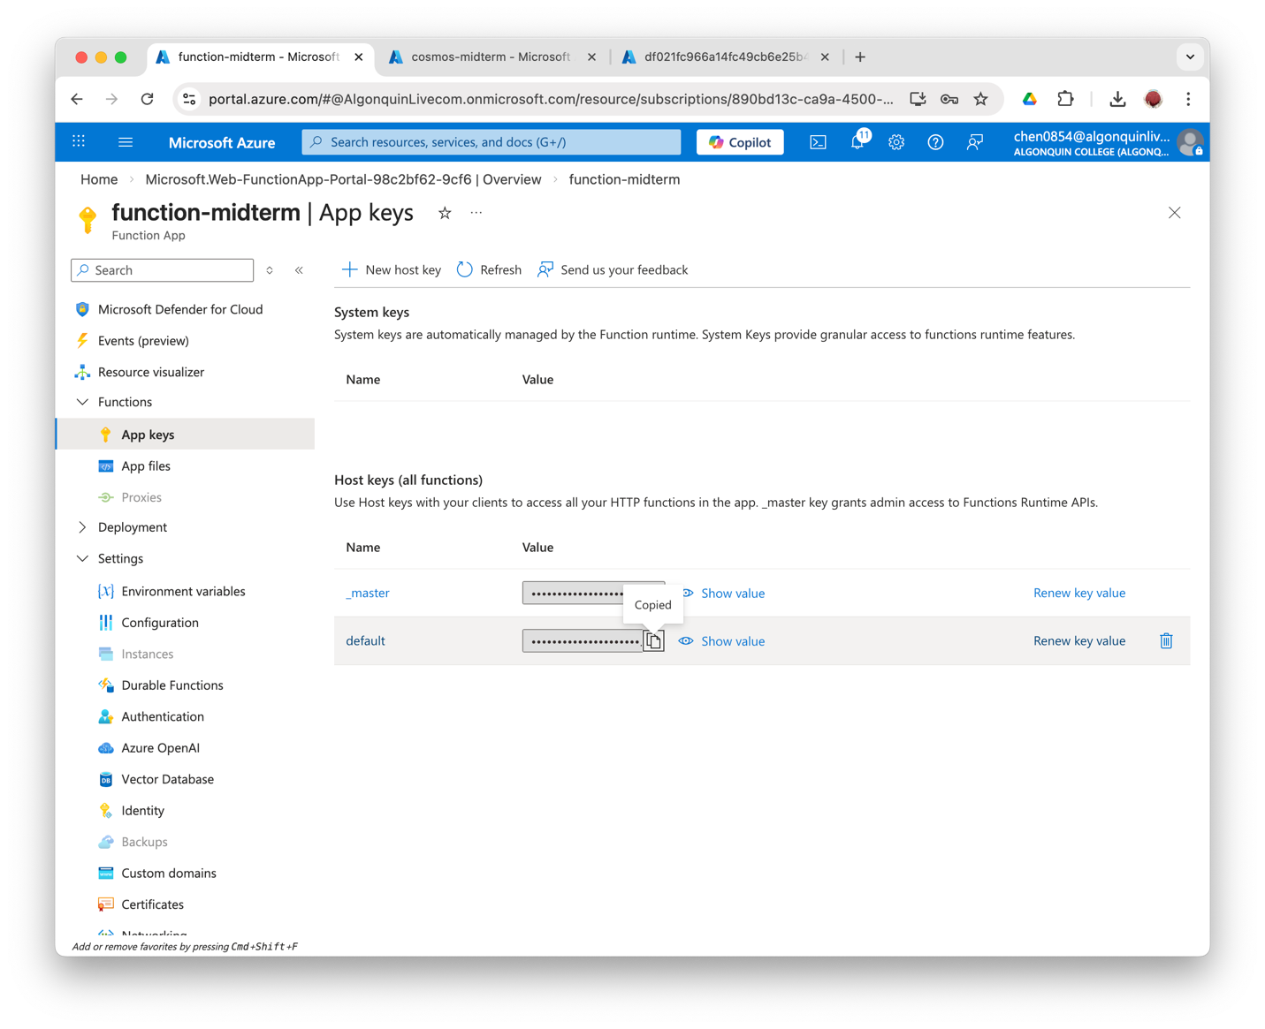
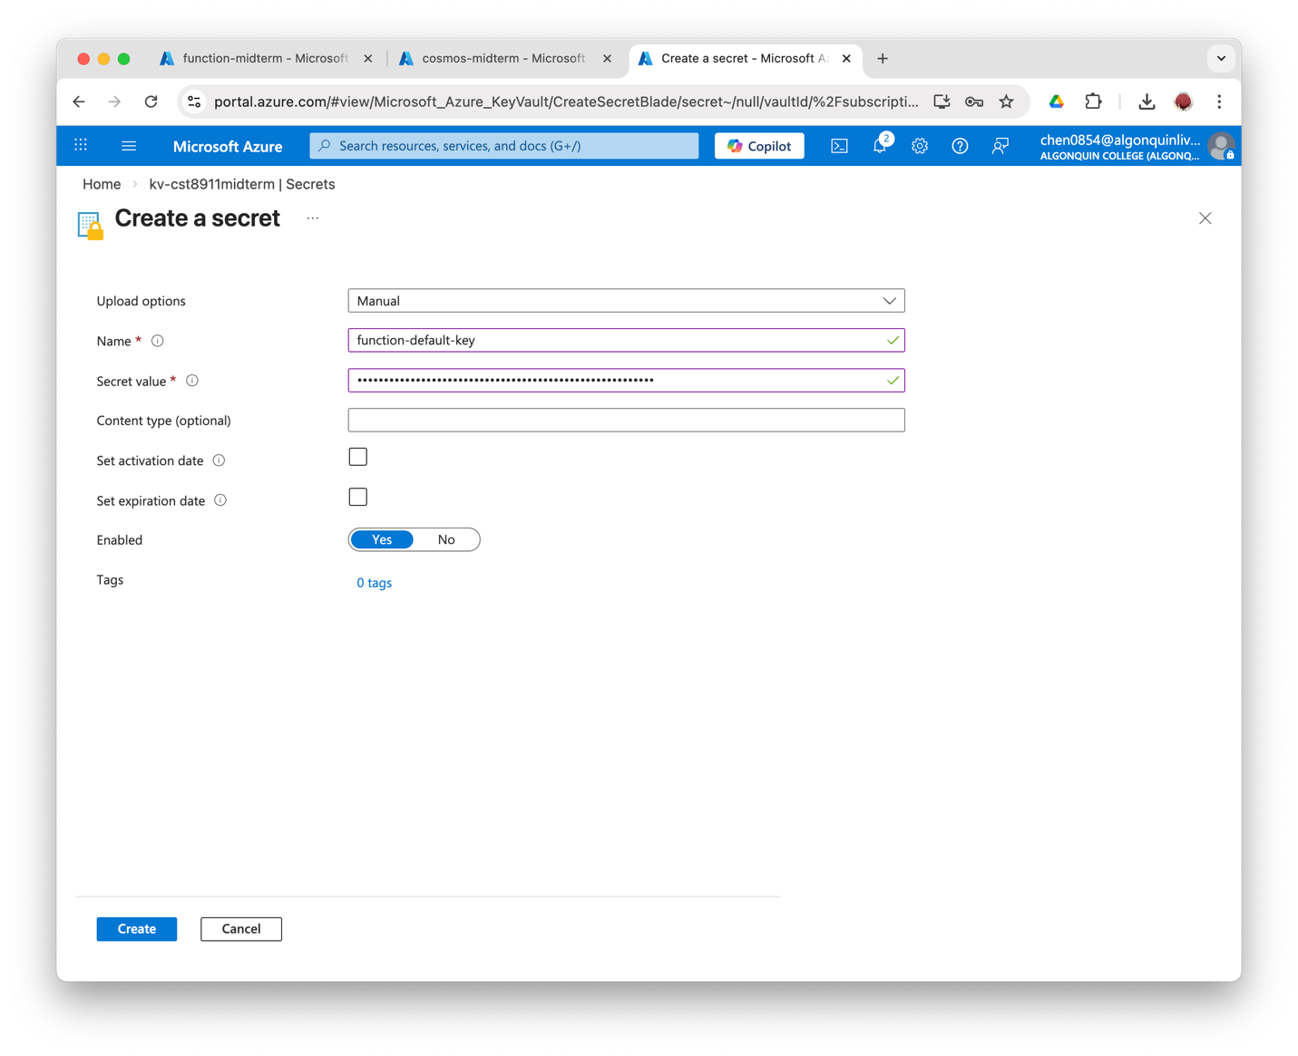

Final Overview
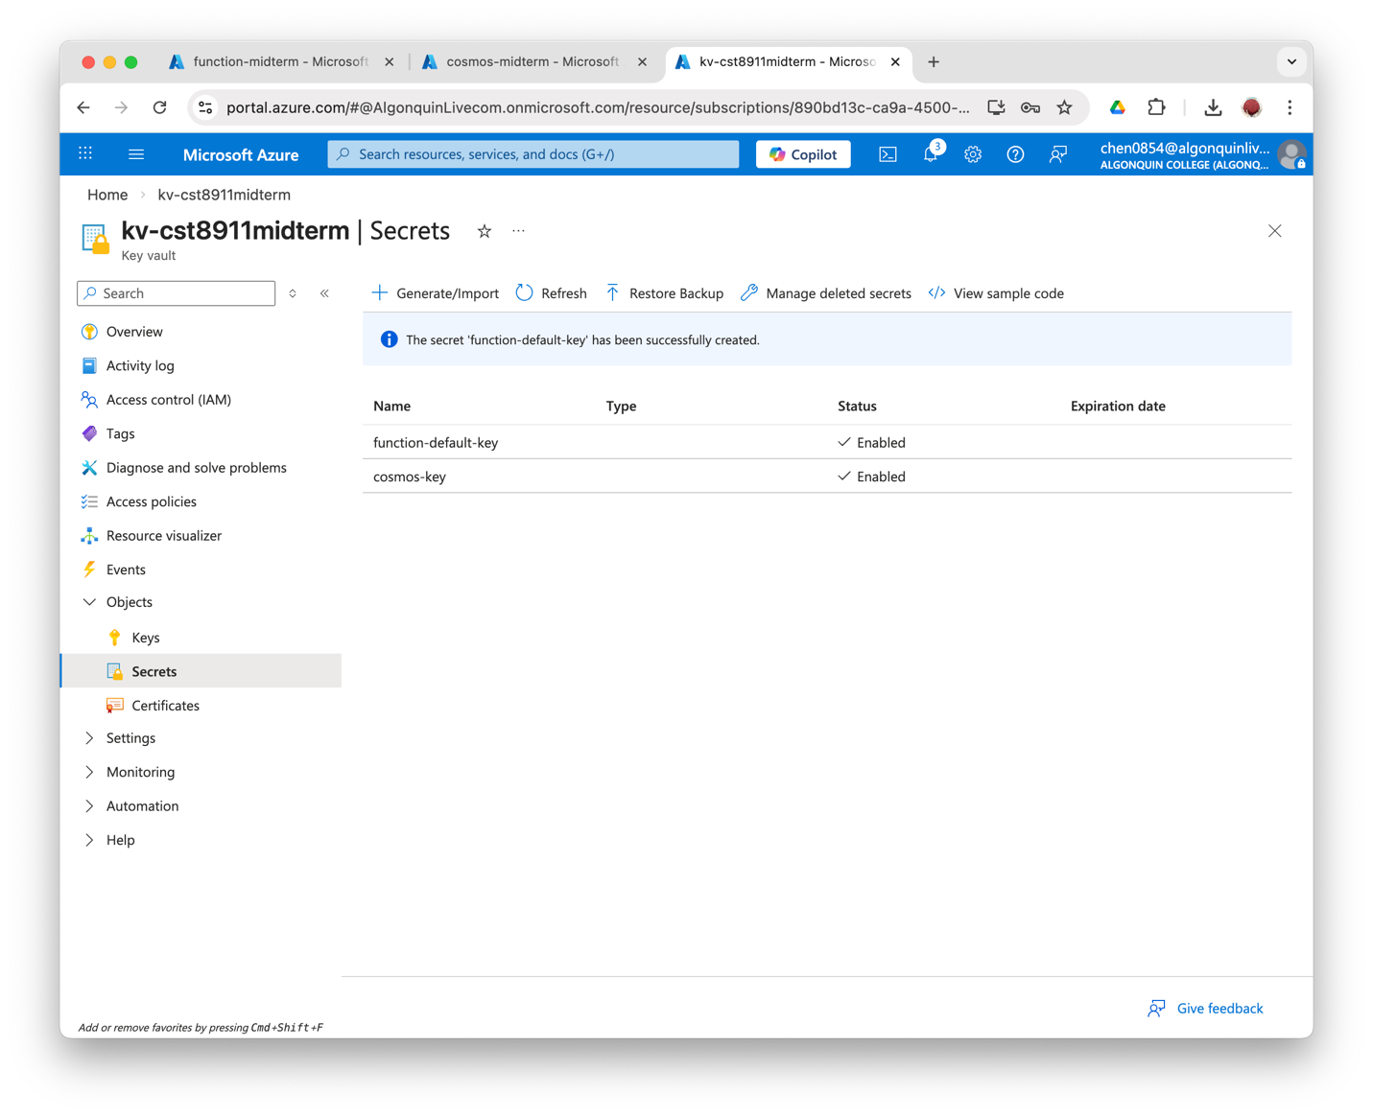

7. Give Function App access to only this secret
Turn on the System-Assigned Managed Identity.
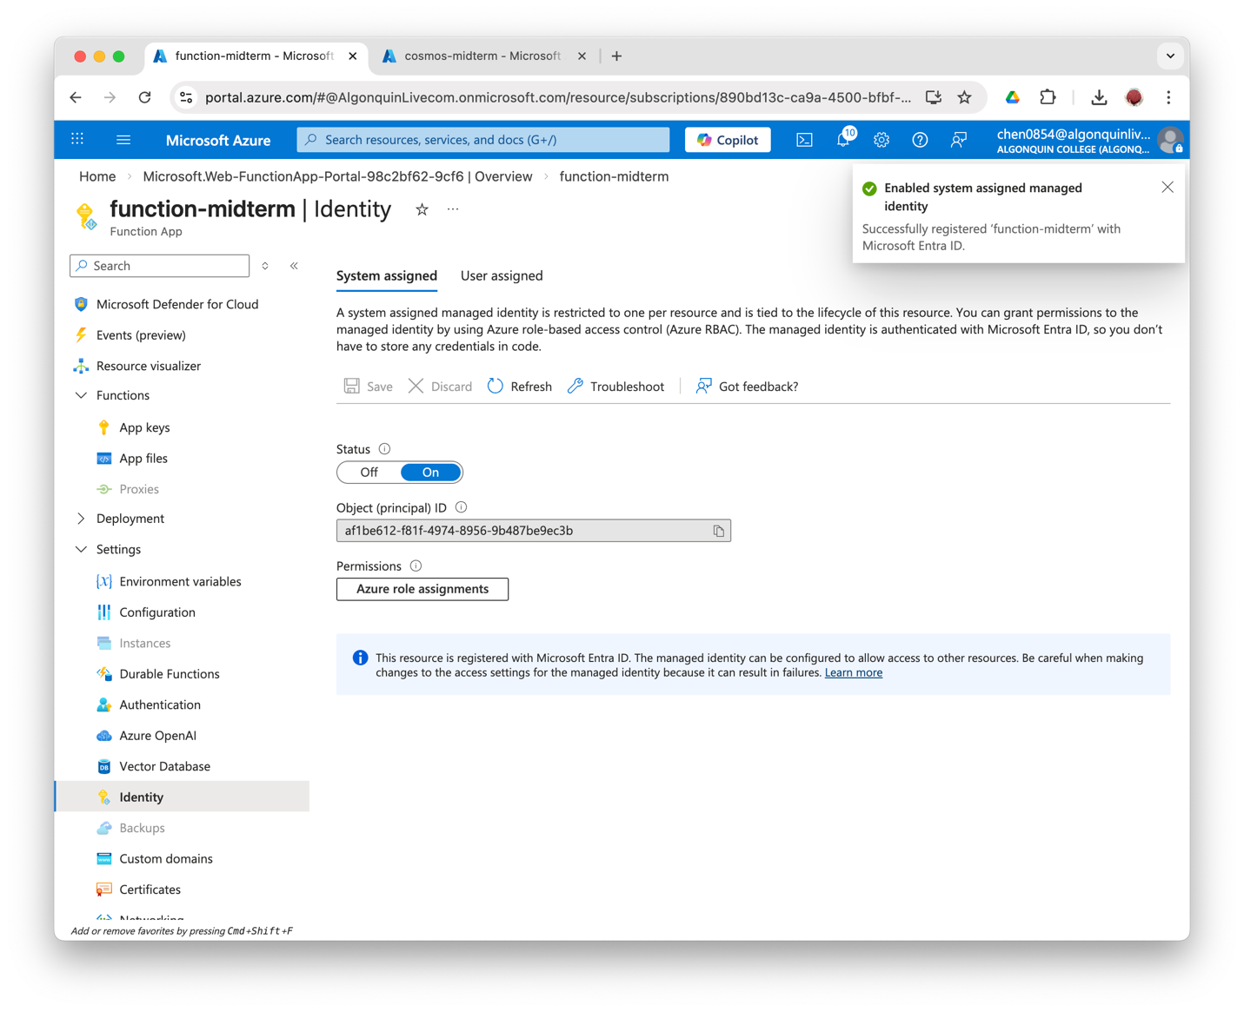
Then, in the Access Control IAM, assign Key Vault Secrets User role to the Function App's Managed Identity.
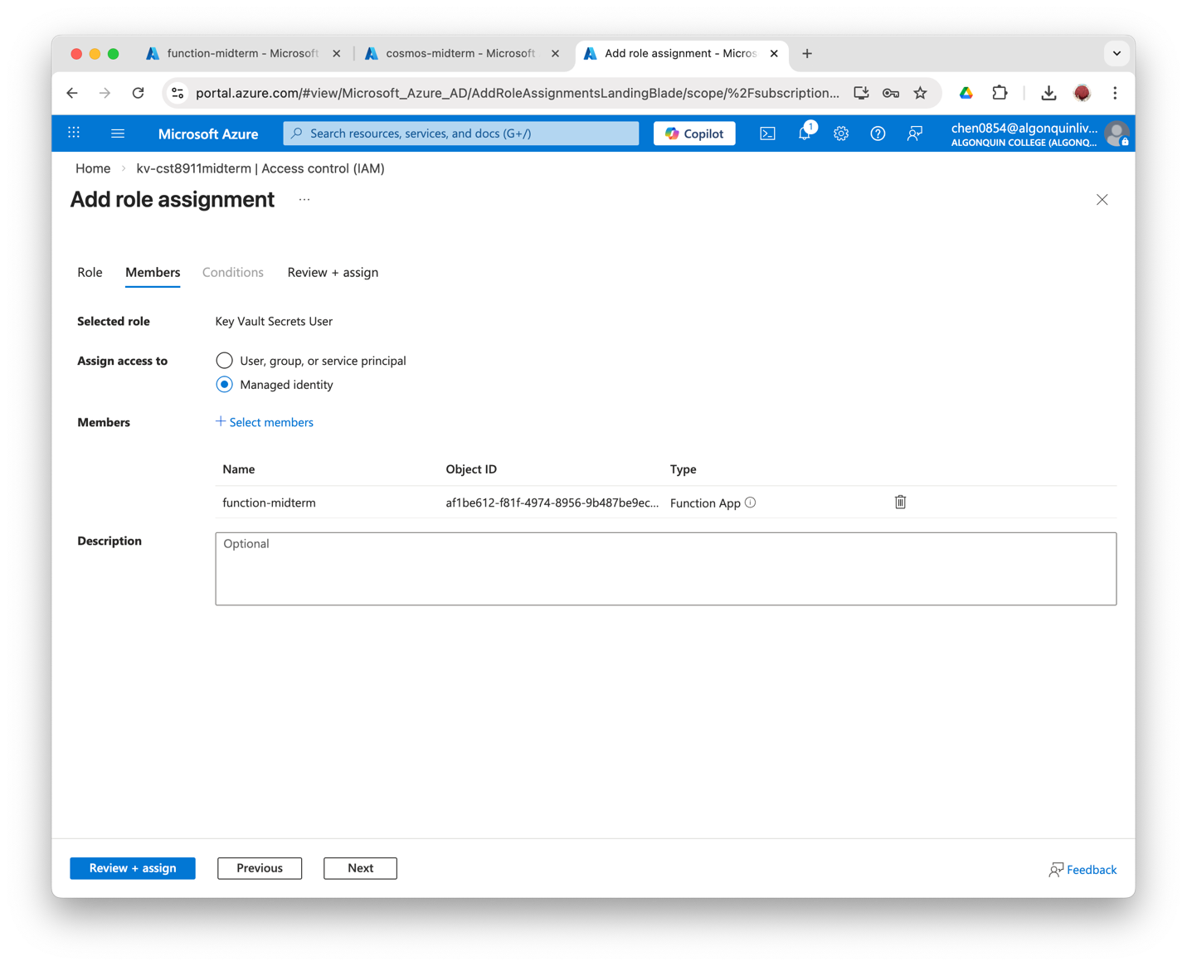
The Function App uses the System-Assigned Managed Identity to allow it to be authorized by Azure-managed services. It improves security by eliminating the direct storing of secret values in application services and thus reduces the risk of leaks.
The Function App's System-Assigned Managed Identity is granted the Key Vault Secrets User role, allowing it to only read and write data according to the least-privilege principle.

8. Set Up the Function App Environments
Name | Value
COSMOS_KEY_SECRET_URI | Secret Identifier of cosmos-key
COSMOS_ENDPOINT | Cosmos DB URI (from Overview Page)
COSMOS_DB_NAME | midterm-db
COSMOS_CONTAINER_NAME | items

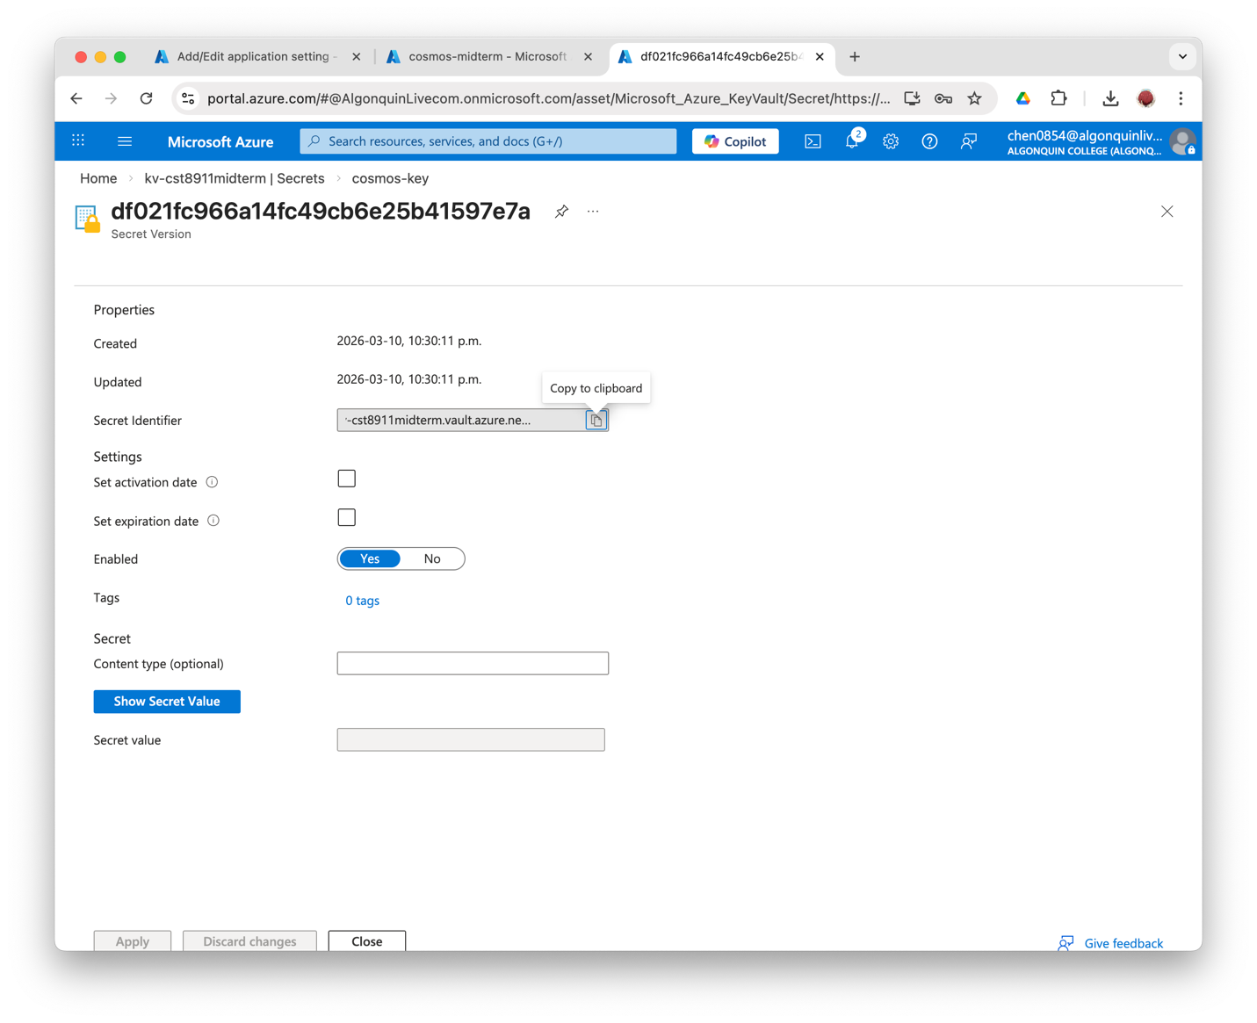
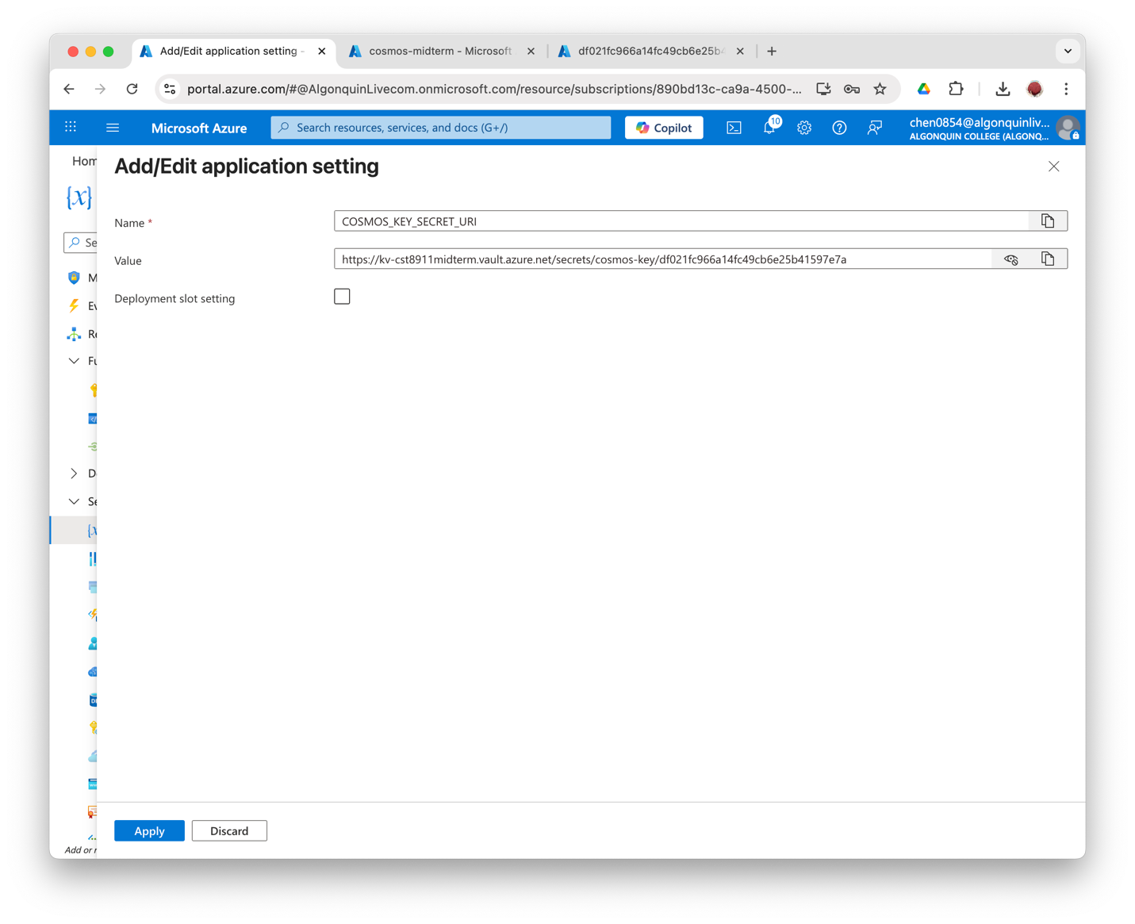
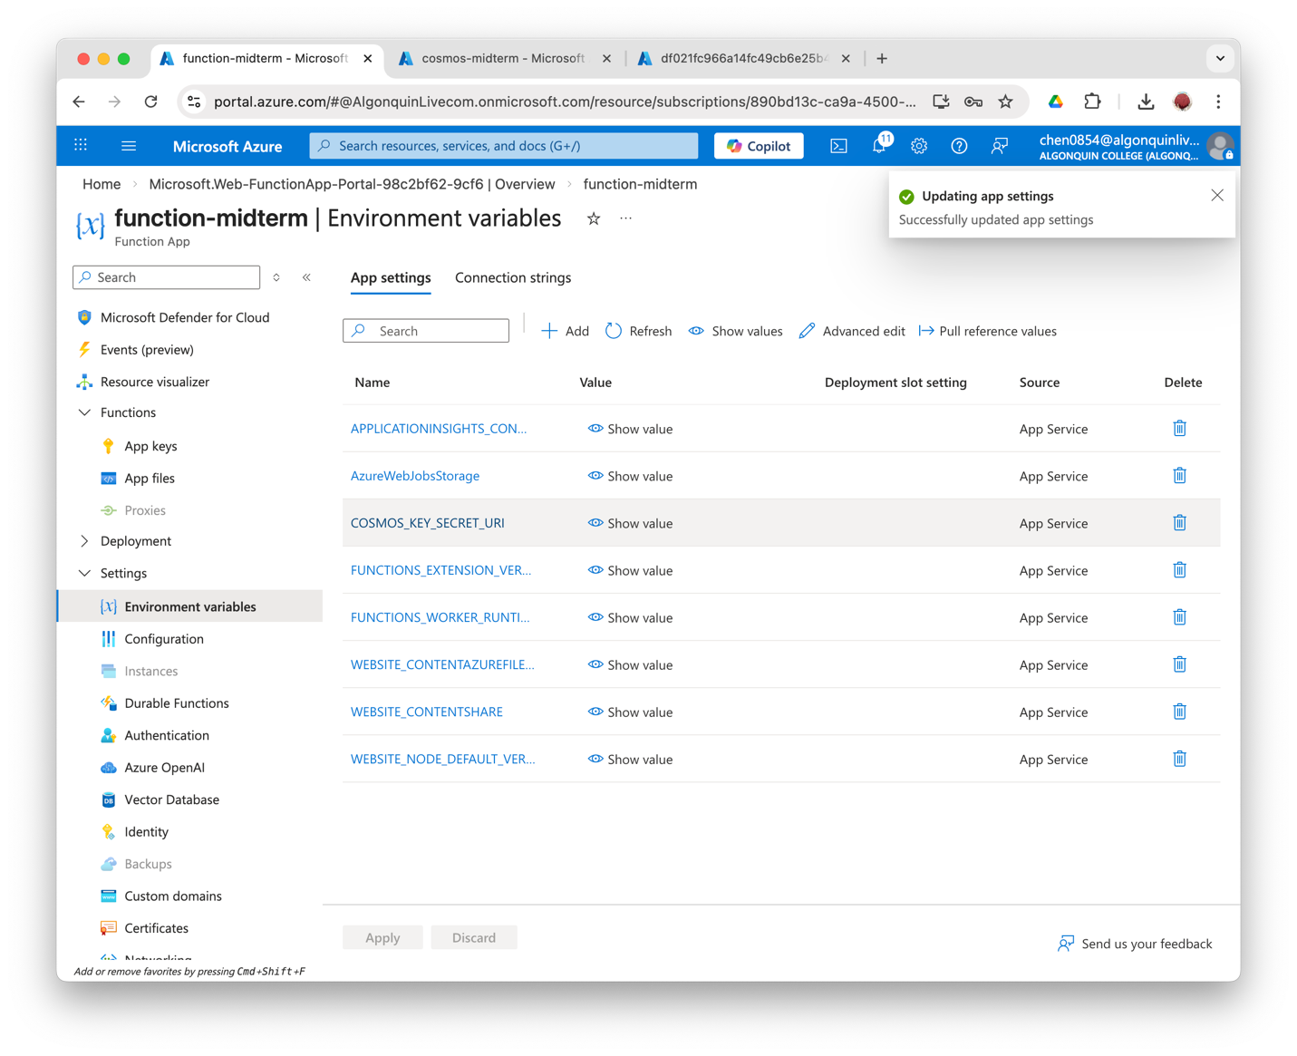
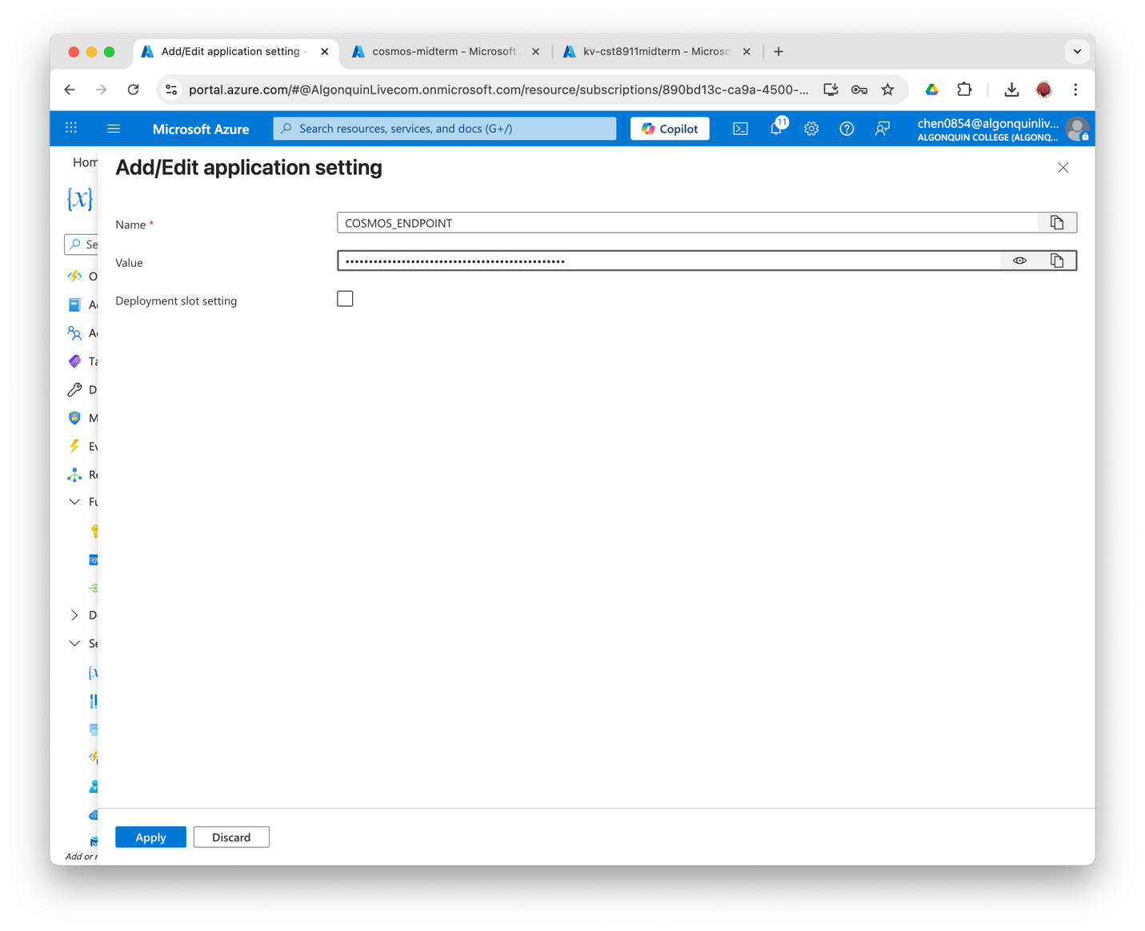
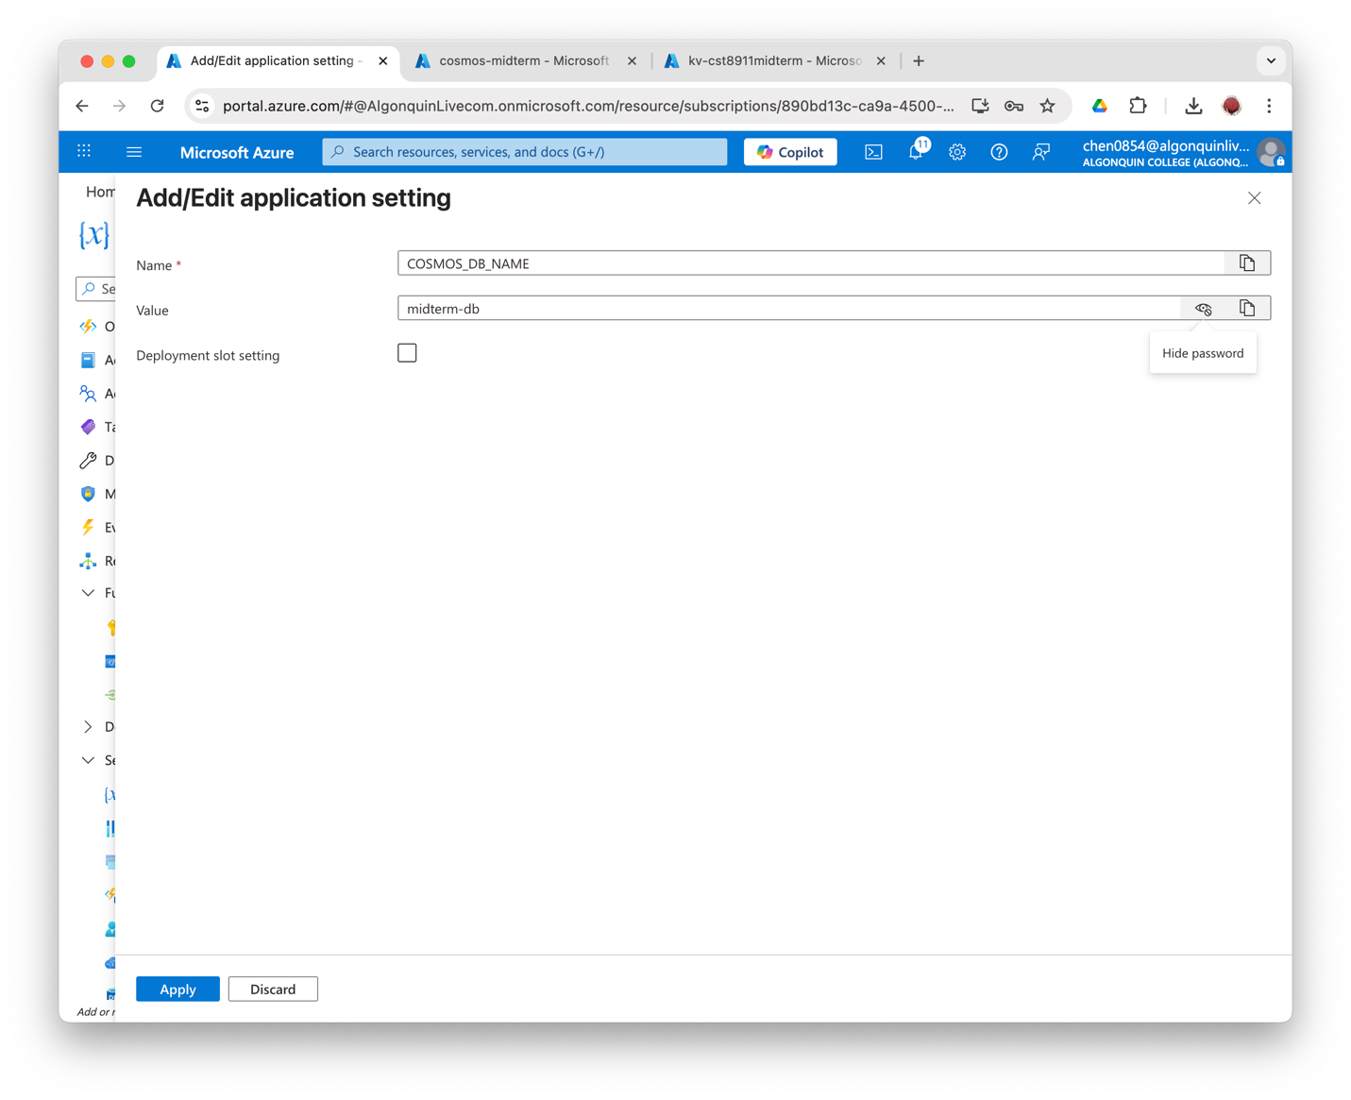
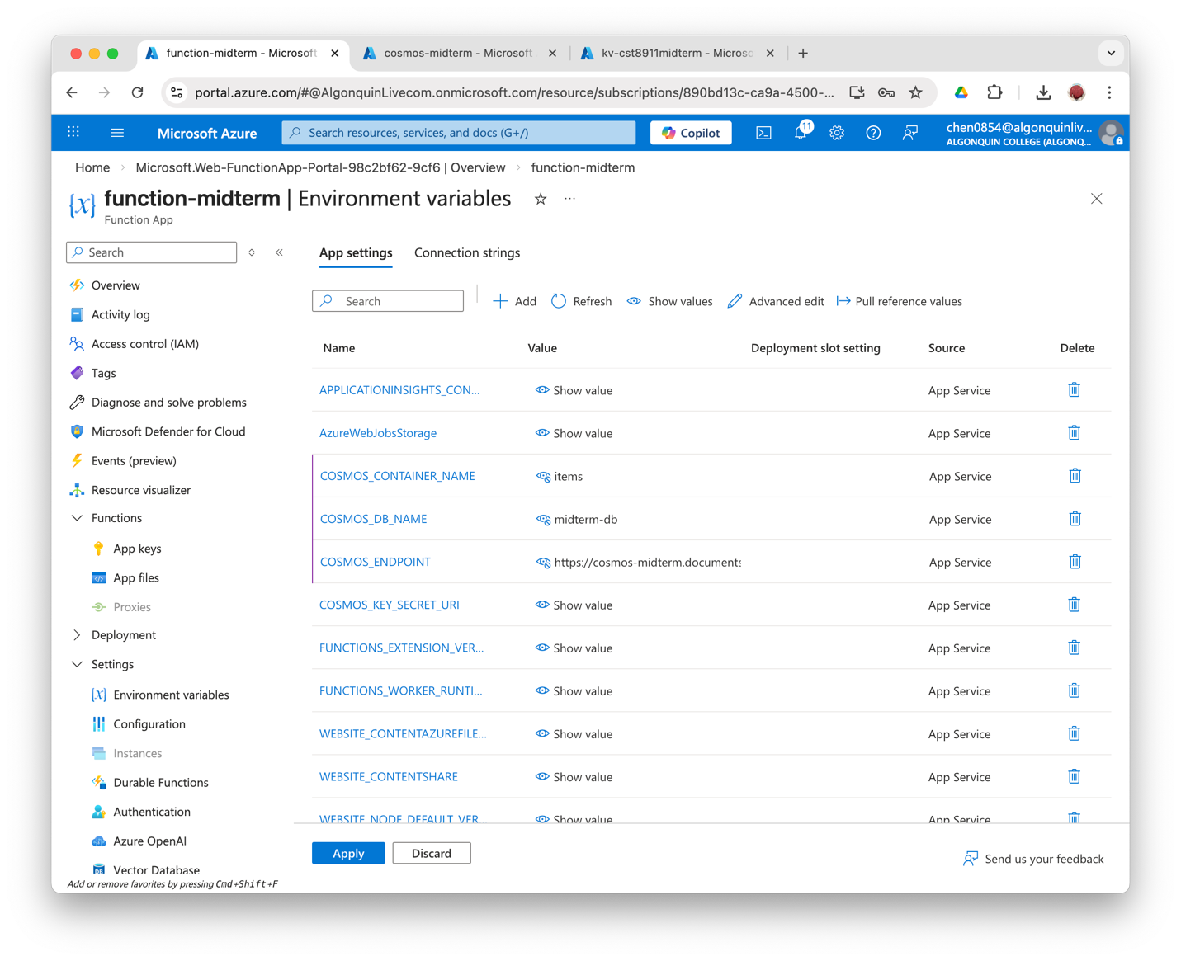
Store all the secret configuration strings in the App Environments to make sure that all the sensitive configuration data is kept secret separately instead of being hard-coded.

9. Create the functions in the Function App and Test/Run
Use Microsoft Copilot to generate 3 HTTP-triggered Functions, with Authorization level Function:
Function name | API end | What it does
GetItems (GET) | GET /items | Get all items from midterm-db
AddItem (POST) | POST /items | Insert a new item to midterm-db
DeleteItem (DELETE) | DELETE /items/{id} | Remove an item by ID

The API communicates with Cosmos DB using Node.js. An API key is required for accessing the Authorization level Function to ensure that only requests with a valid function access key can touch the API endpoints.

Create the three functions
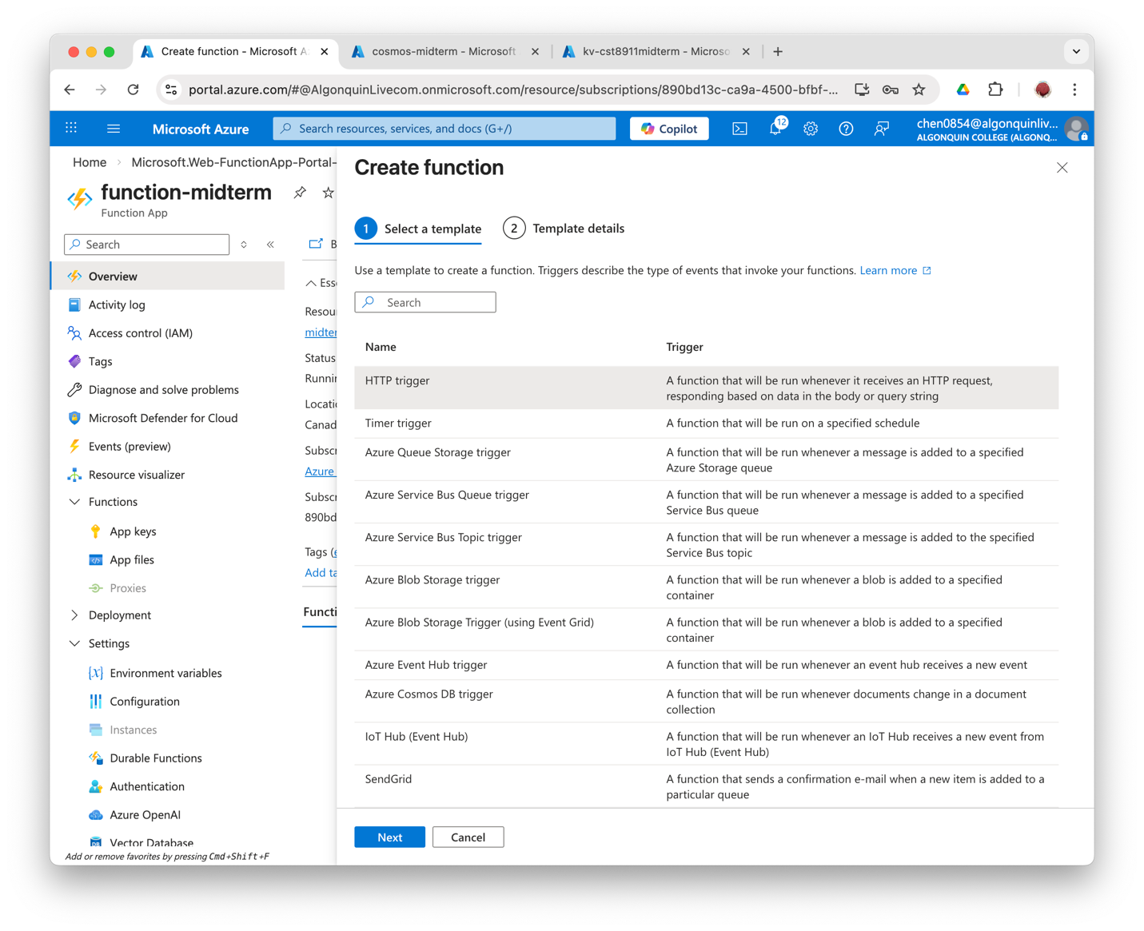
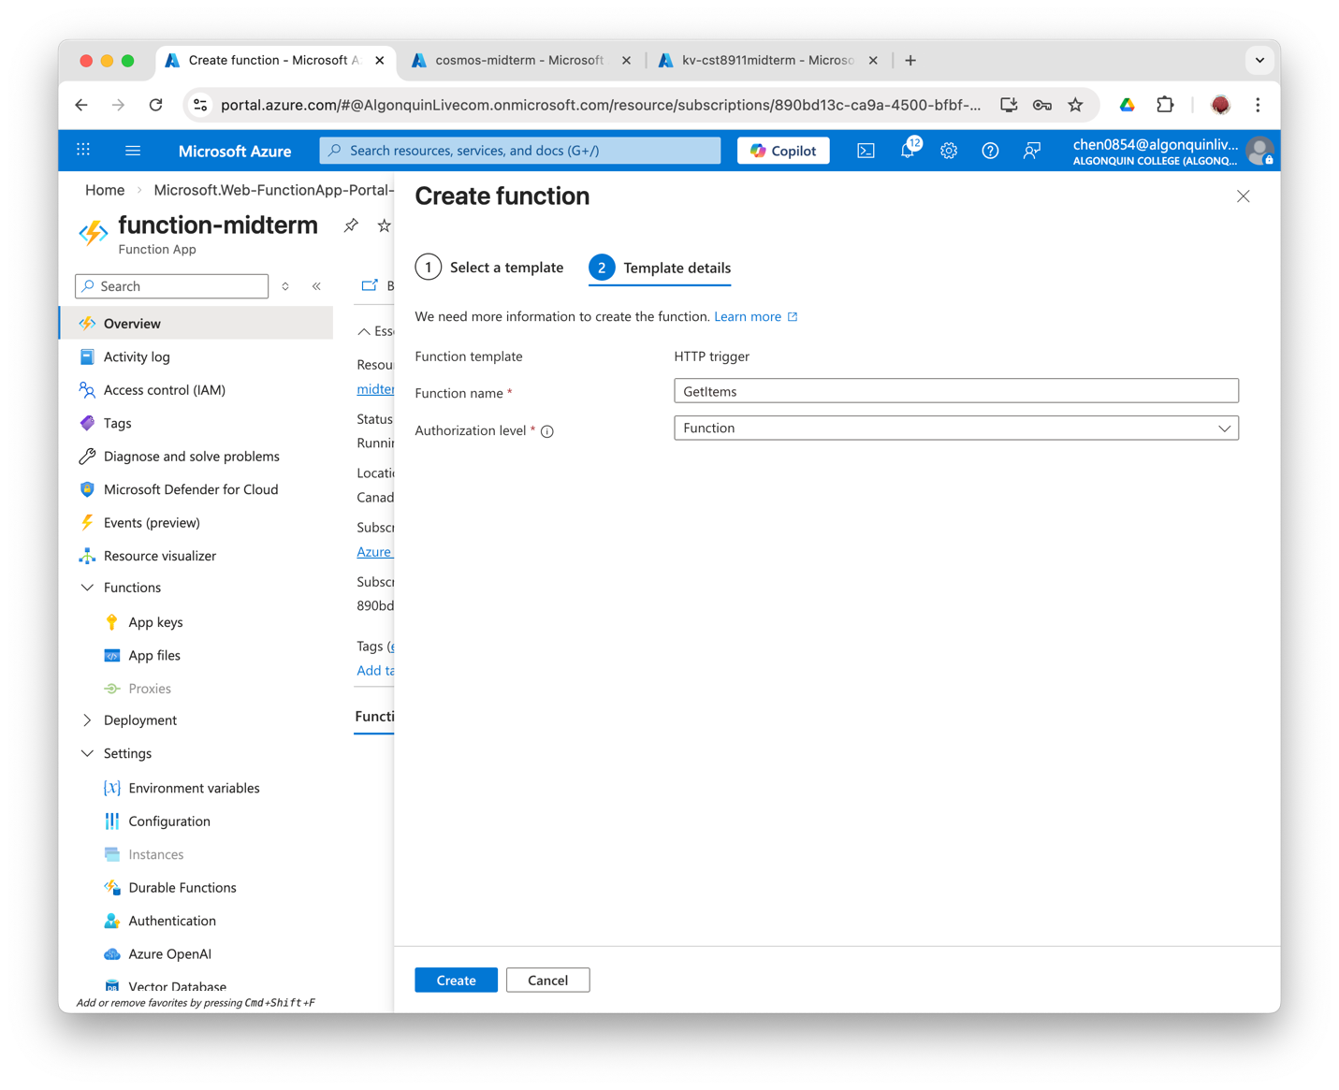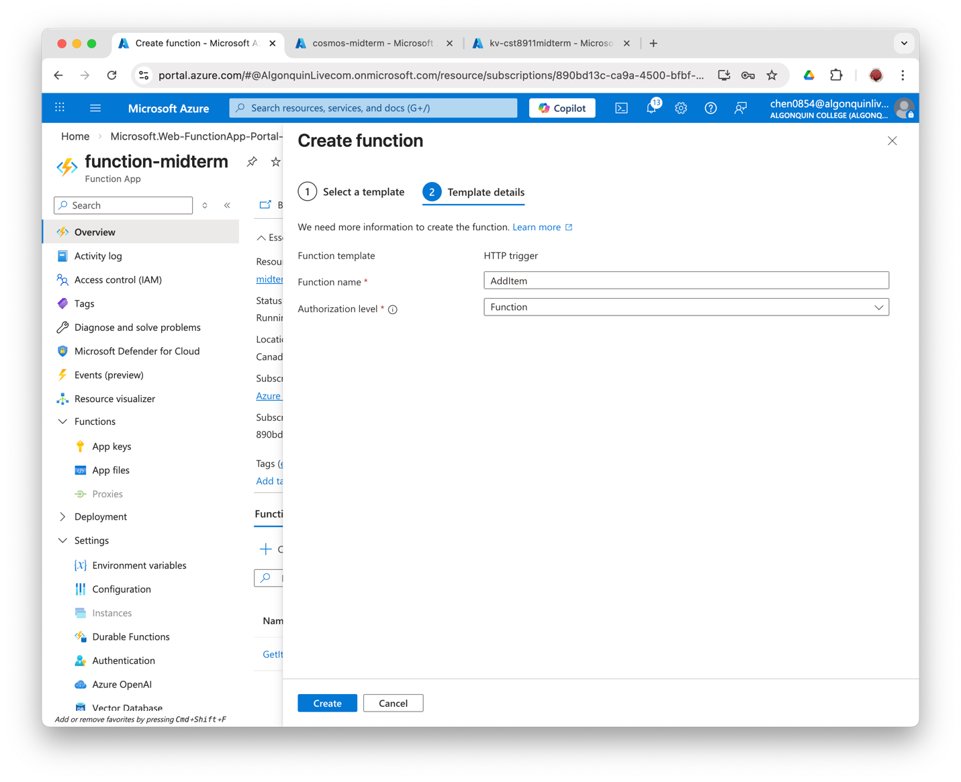
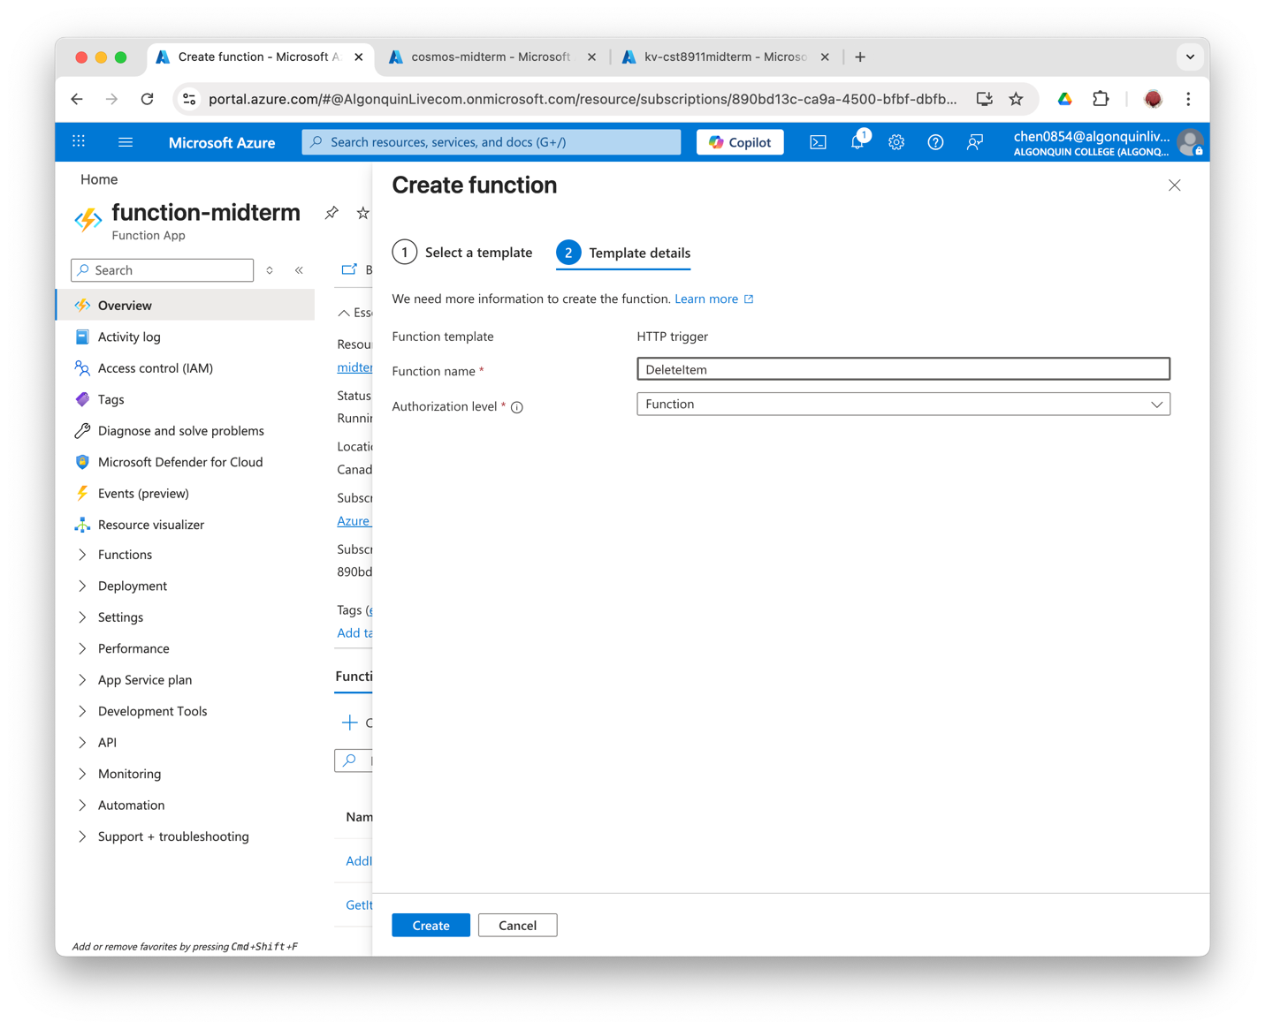

Add dependencies
Go to Development Tools --> Advanced Tools --> Go --> Debug Console --> PowerShell, create a package.json file.
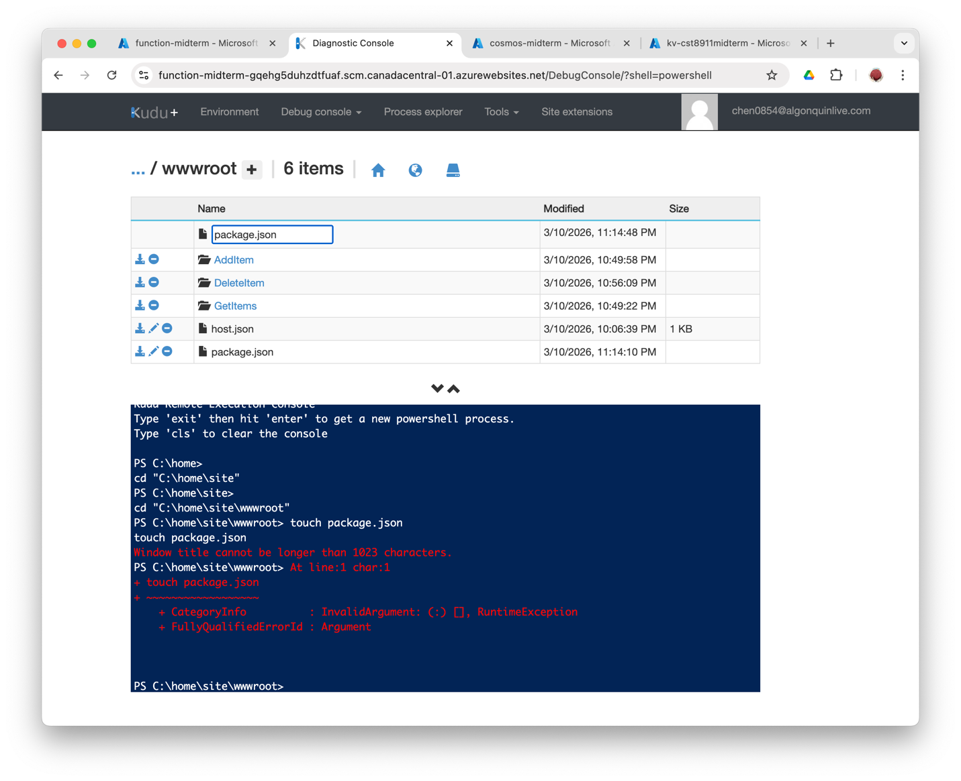
Go to App Files and add the dependencies code into package.json.
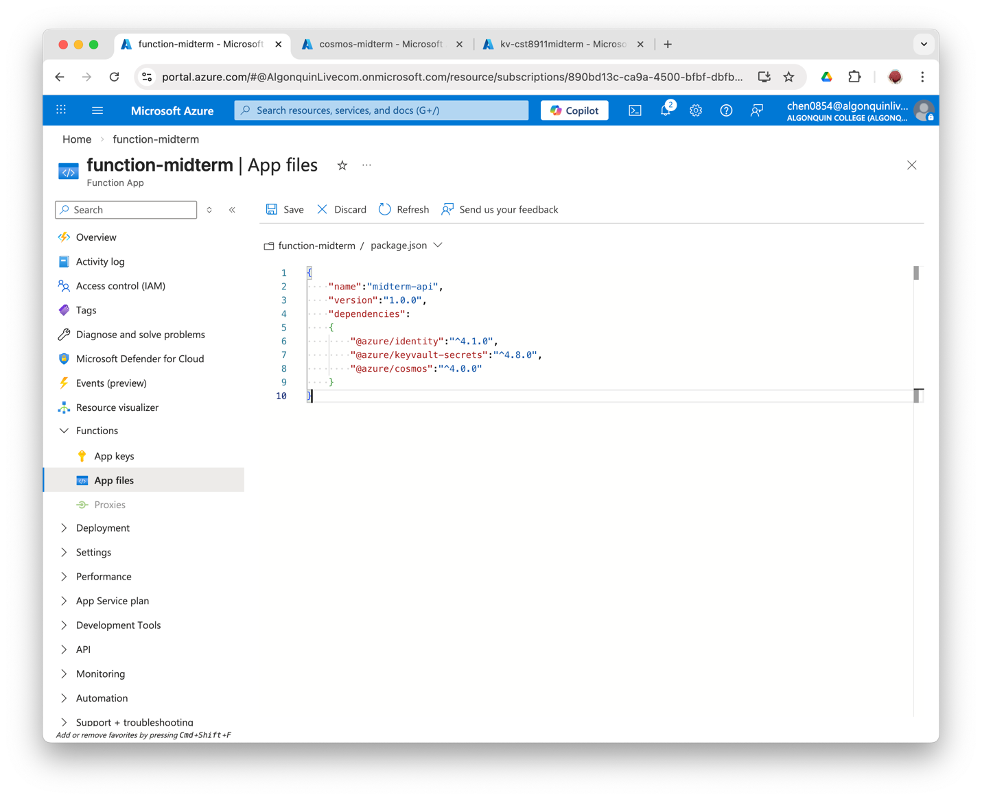

Test/Run the three functions to make sure it works.
GetItems (GET)
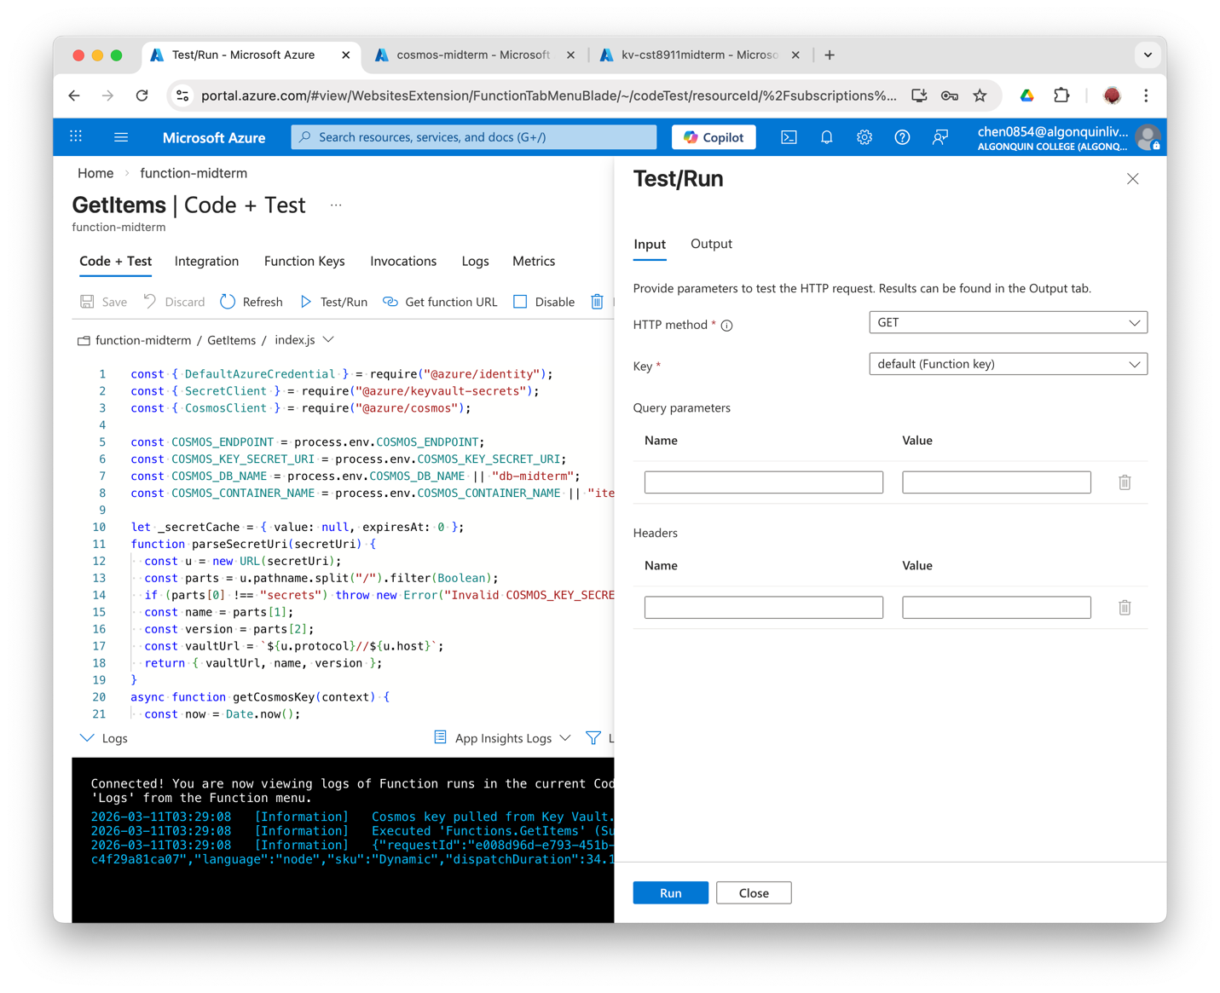
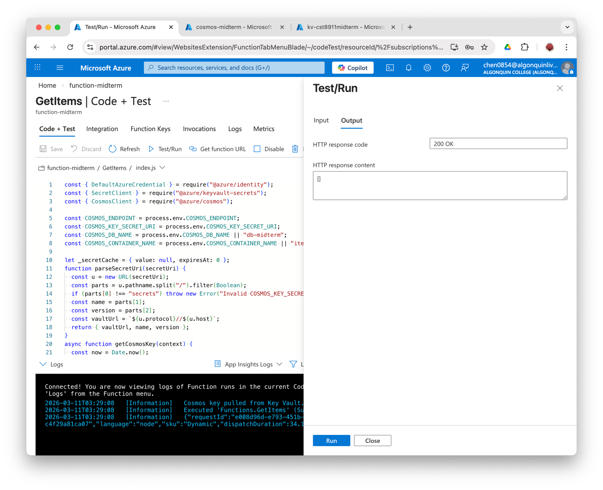

AddItem (POST)
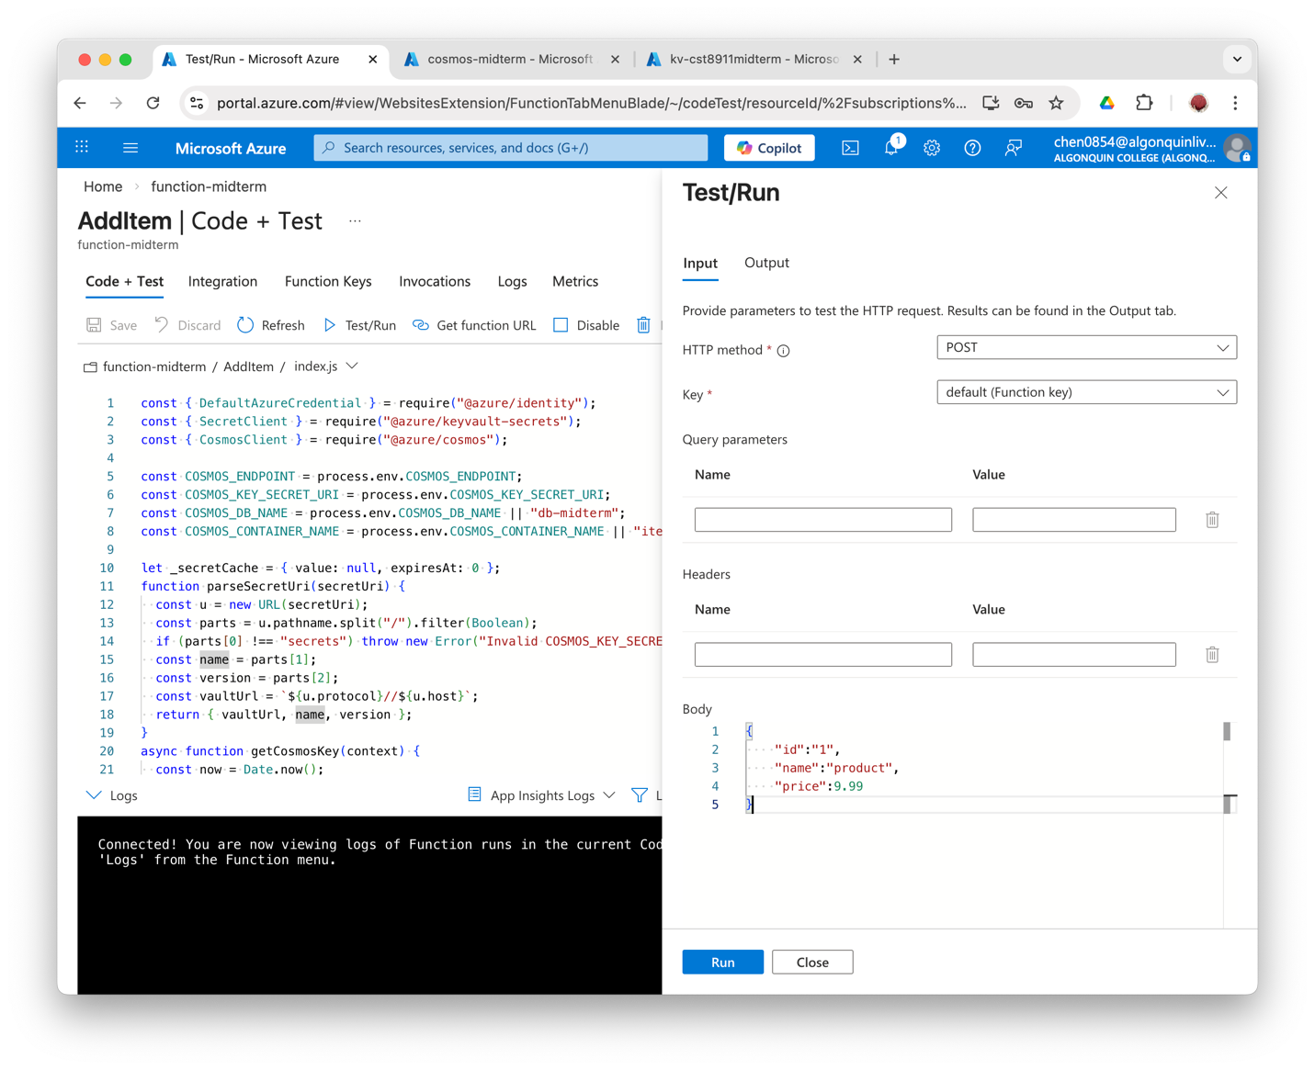
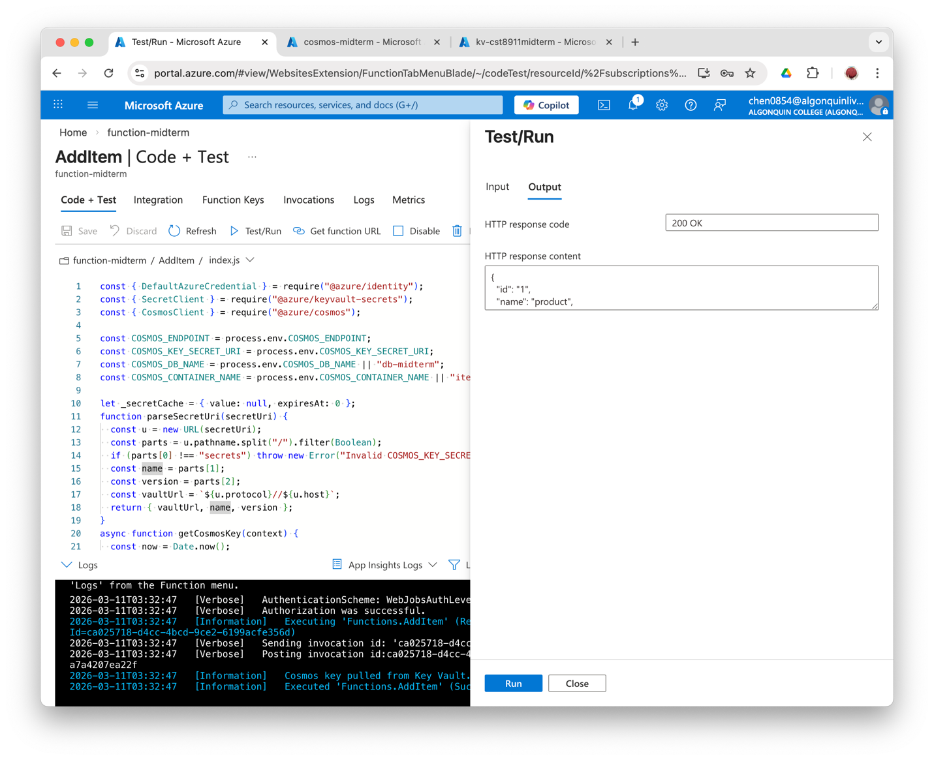
DeleteItem (DELETE)
Edit the Trigger of DeleteItem first to have the correct HTTP method and route, and then Test/Run.
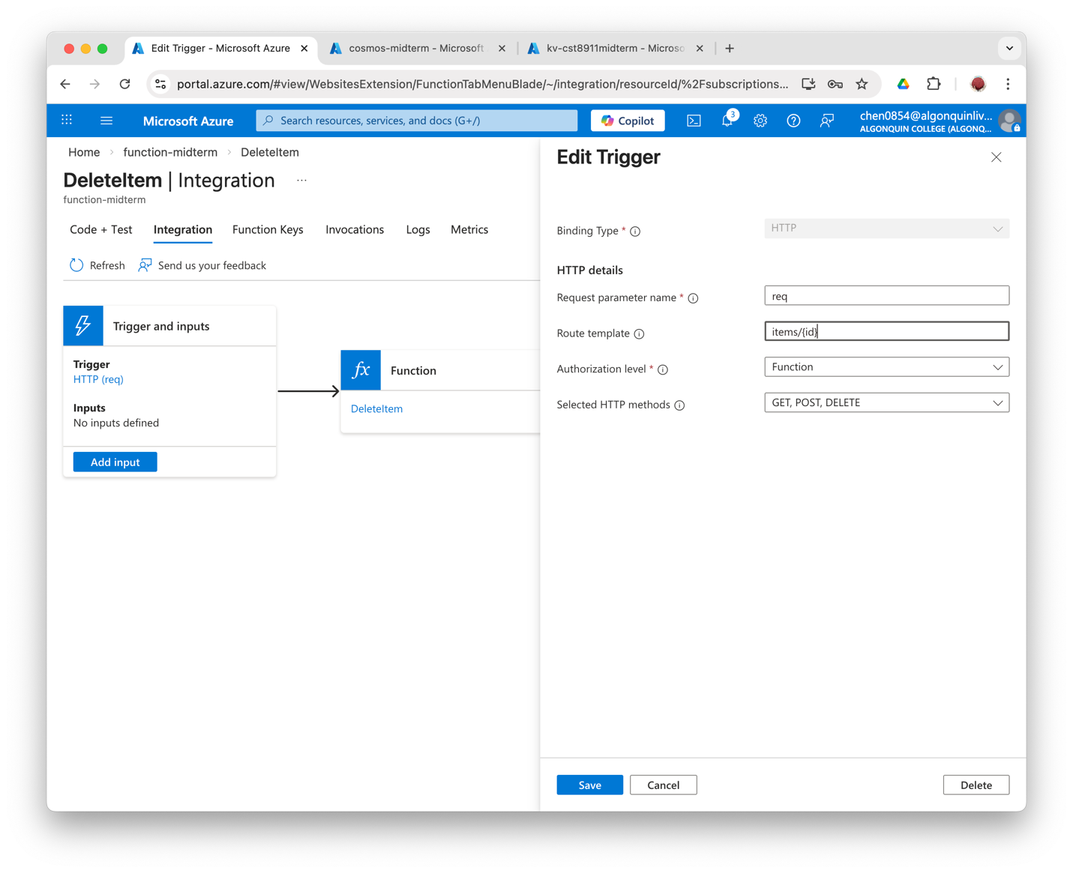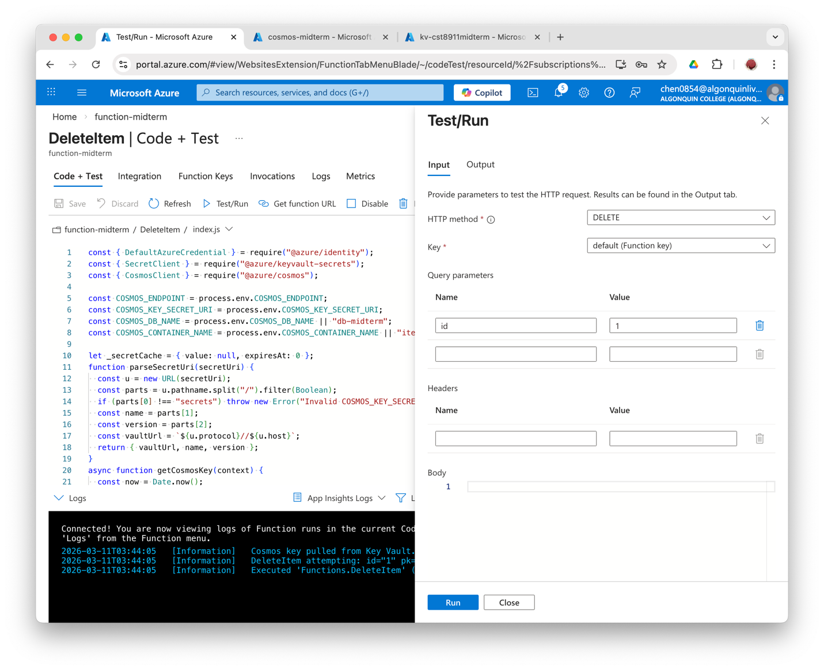
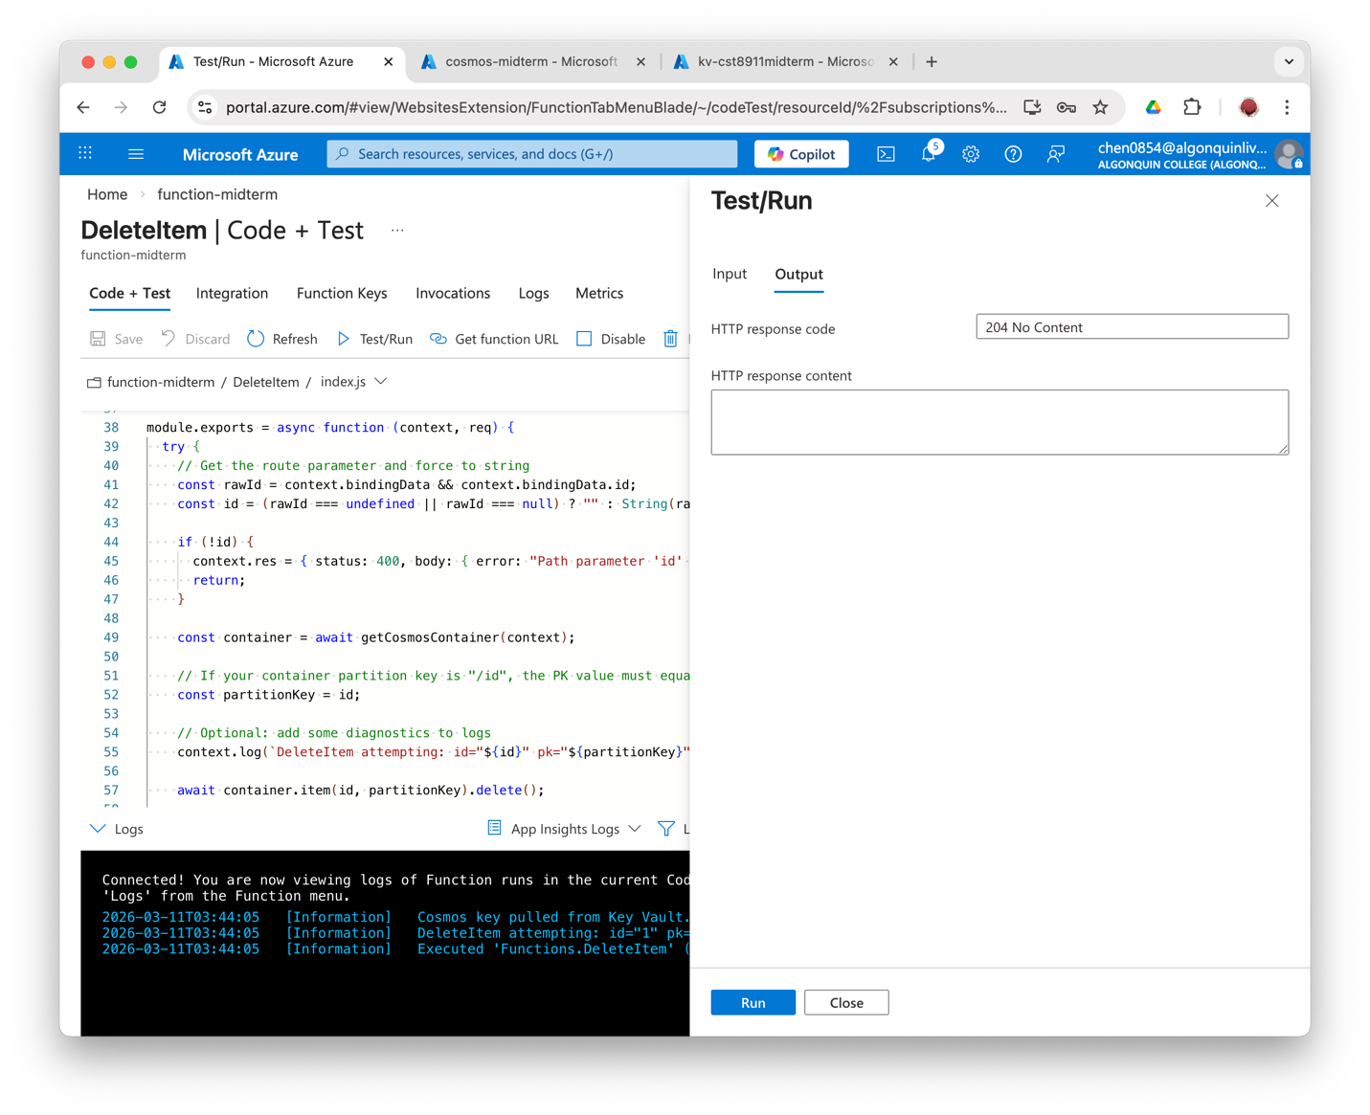

10. Test the functions from virtual machines
Use VSCode to SSH into the VM created in the previous steps.
Command Palette --> Connect to Host --> Add New SSH Host --> ssh -i ~/.ssh/cst8911-vm_key.pem azureuser@4.206.218.39 --> save it to the ssh config file and change the Host to cst8911midterm-vm
Then the new Host will show up when opening the Command Palette again. Select Connect to Host --> click to connect.
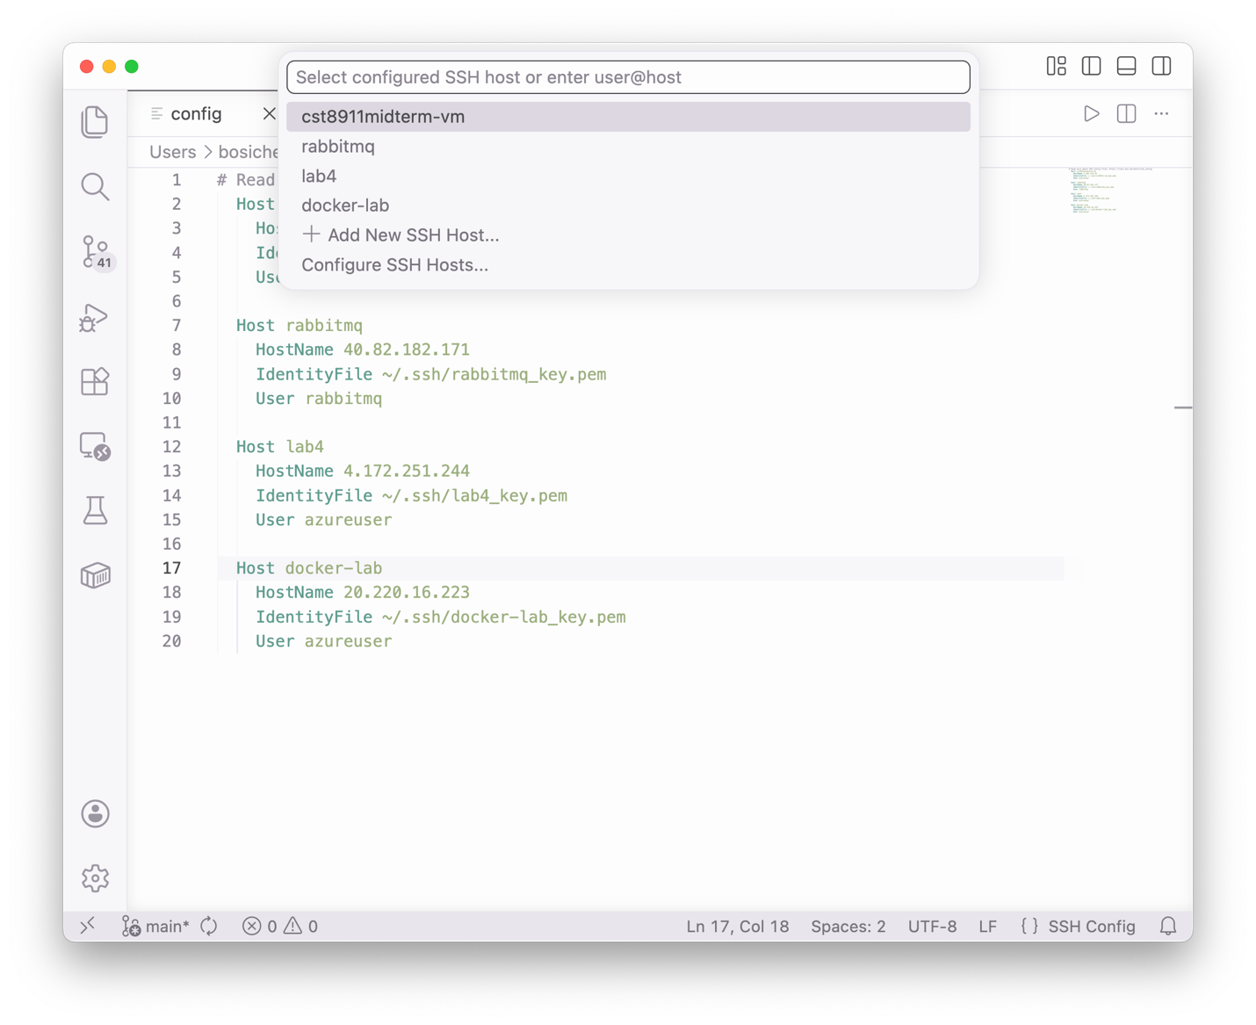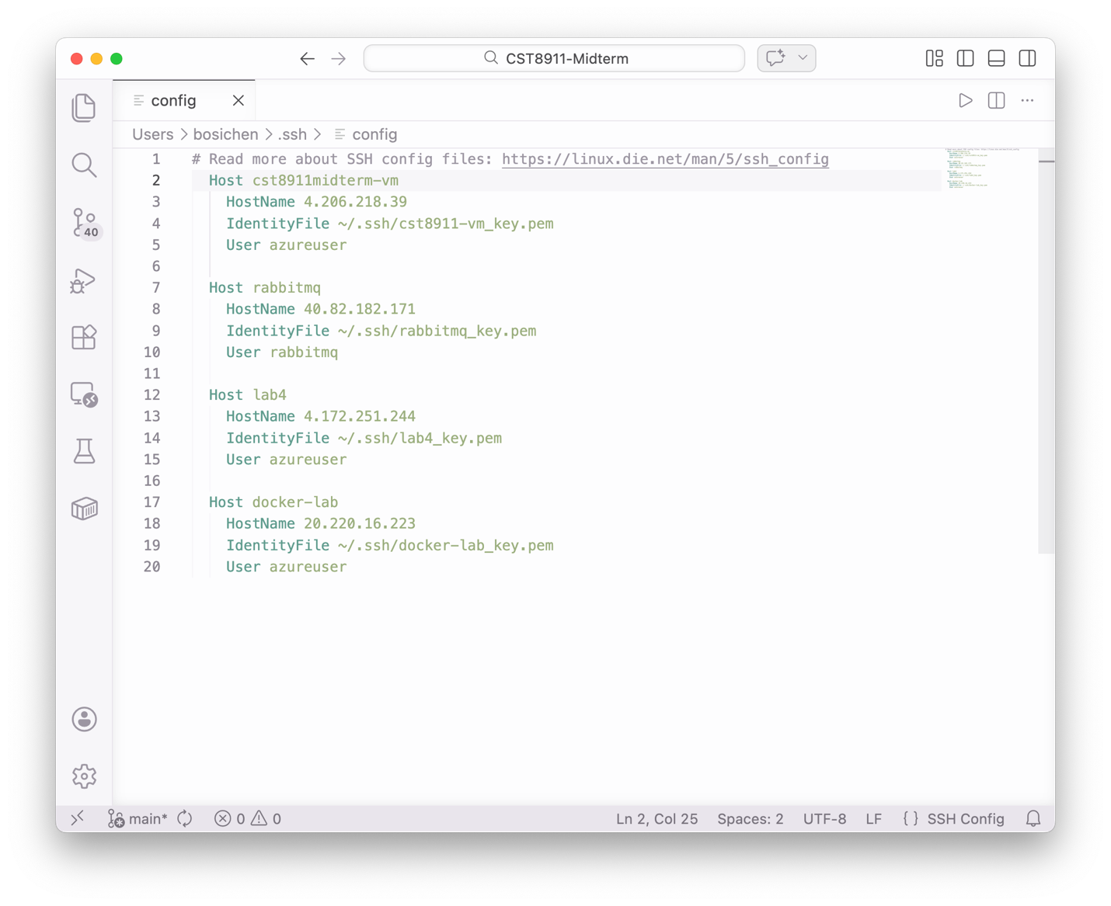
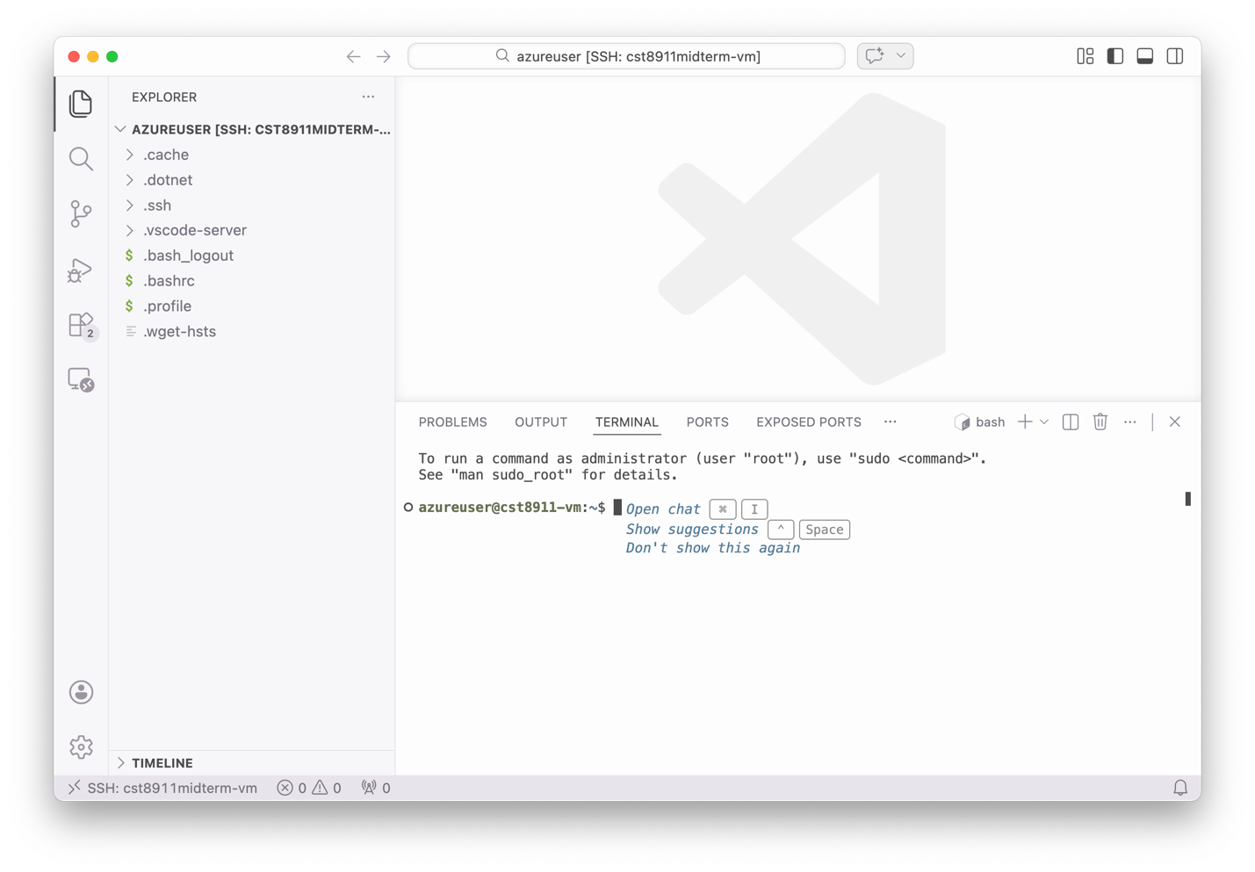
Copy the function url from the Code + Test page
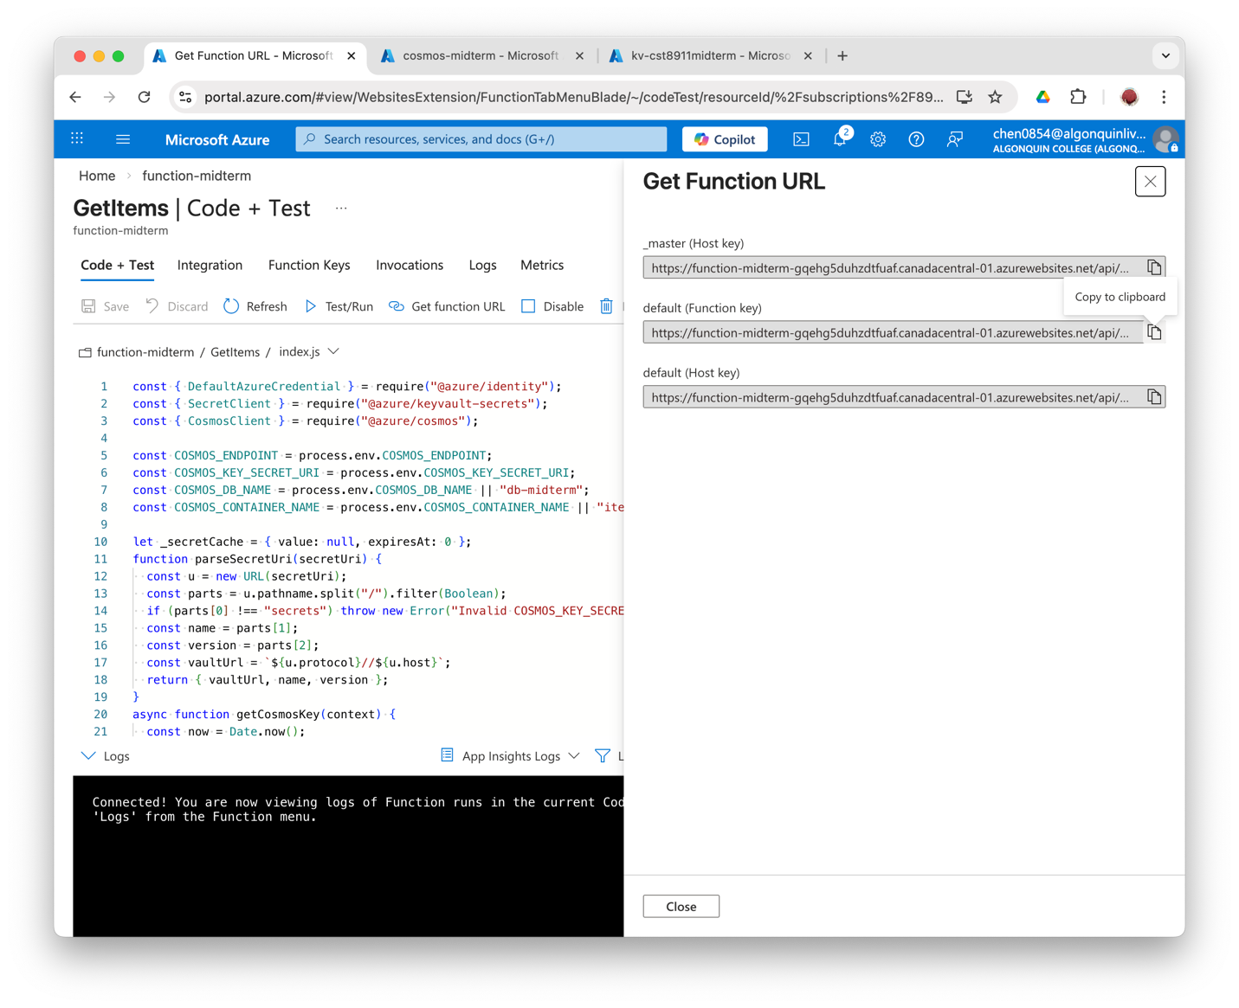

curl to test the GetItems function:
Returned [] initially since the container is empty.
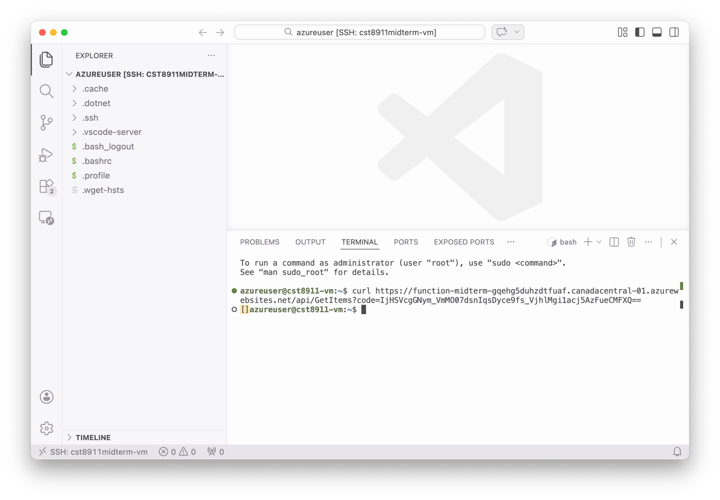
curl to test the AddItem function:
Returned the inserted JSON item
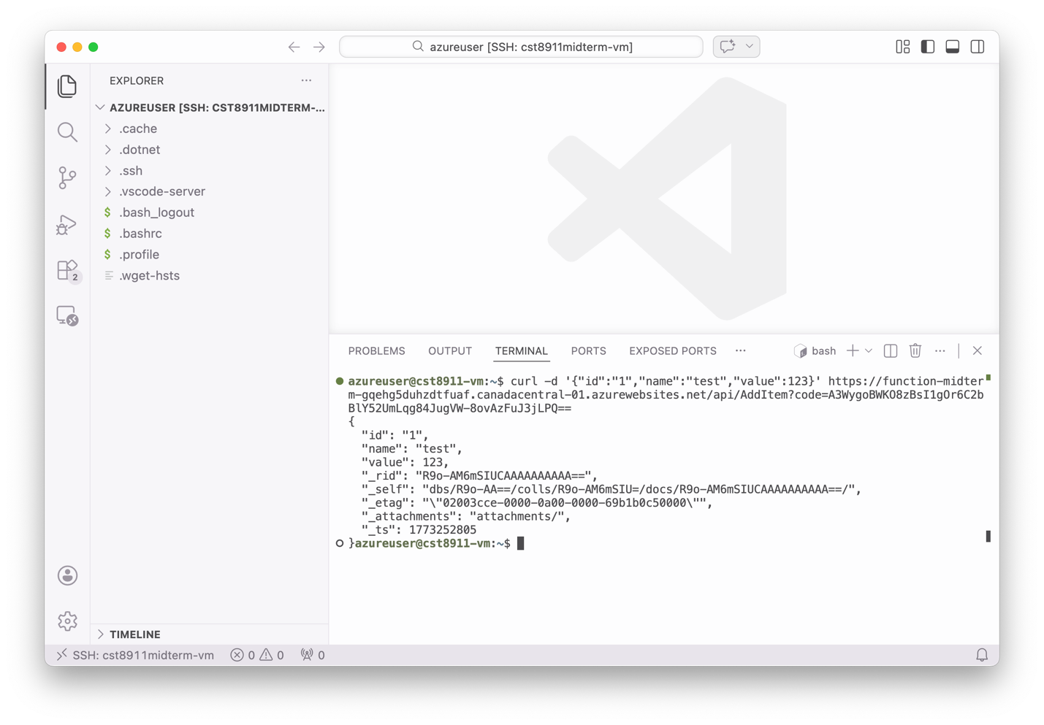
Call the GetItems function again to see if the new item is successfully added:
Returned the container with the newly added item.
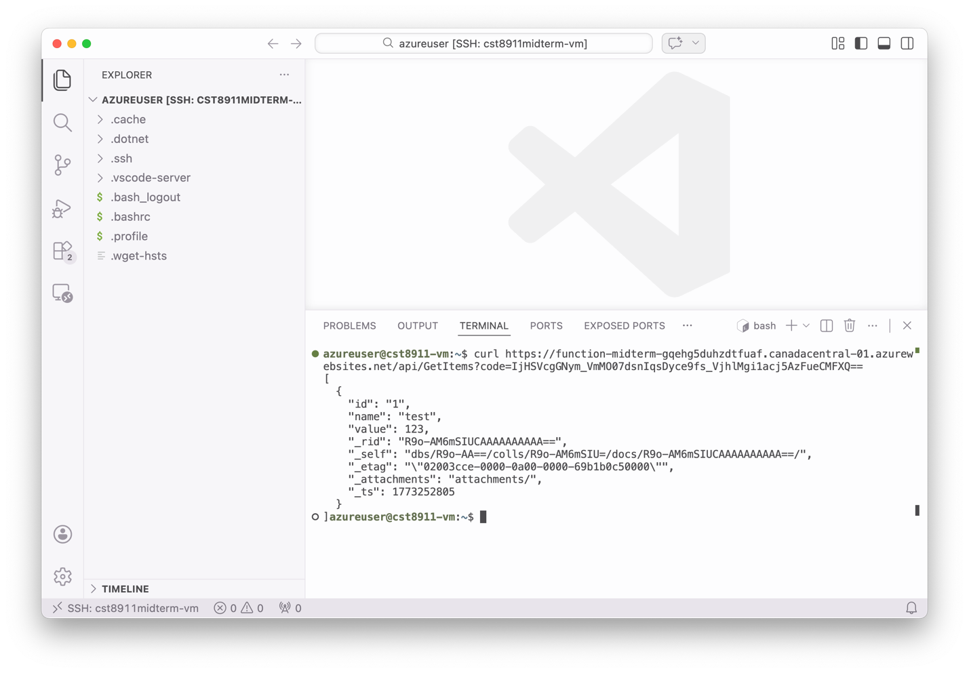
curl to test the DeleteItem function:
Should return (204) no content
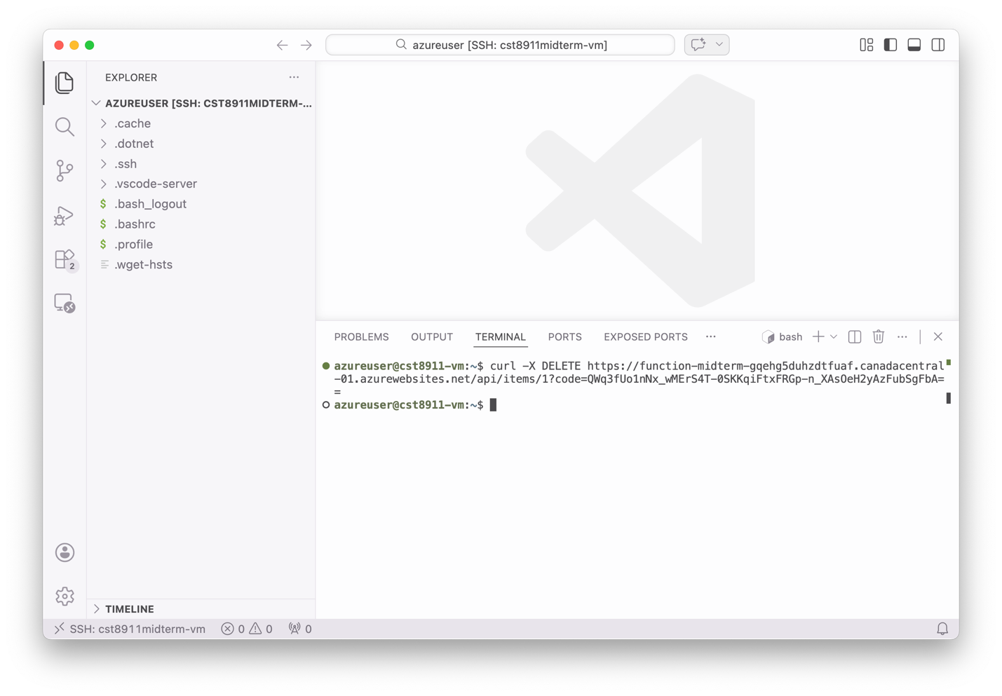
Call the GetItems function again to see if the new item is successfully deleted:
Returned [] again
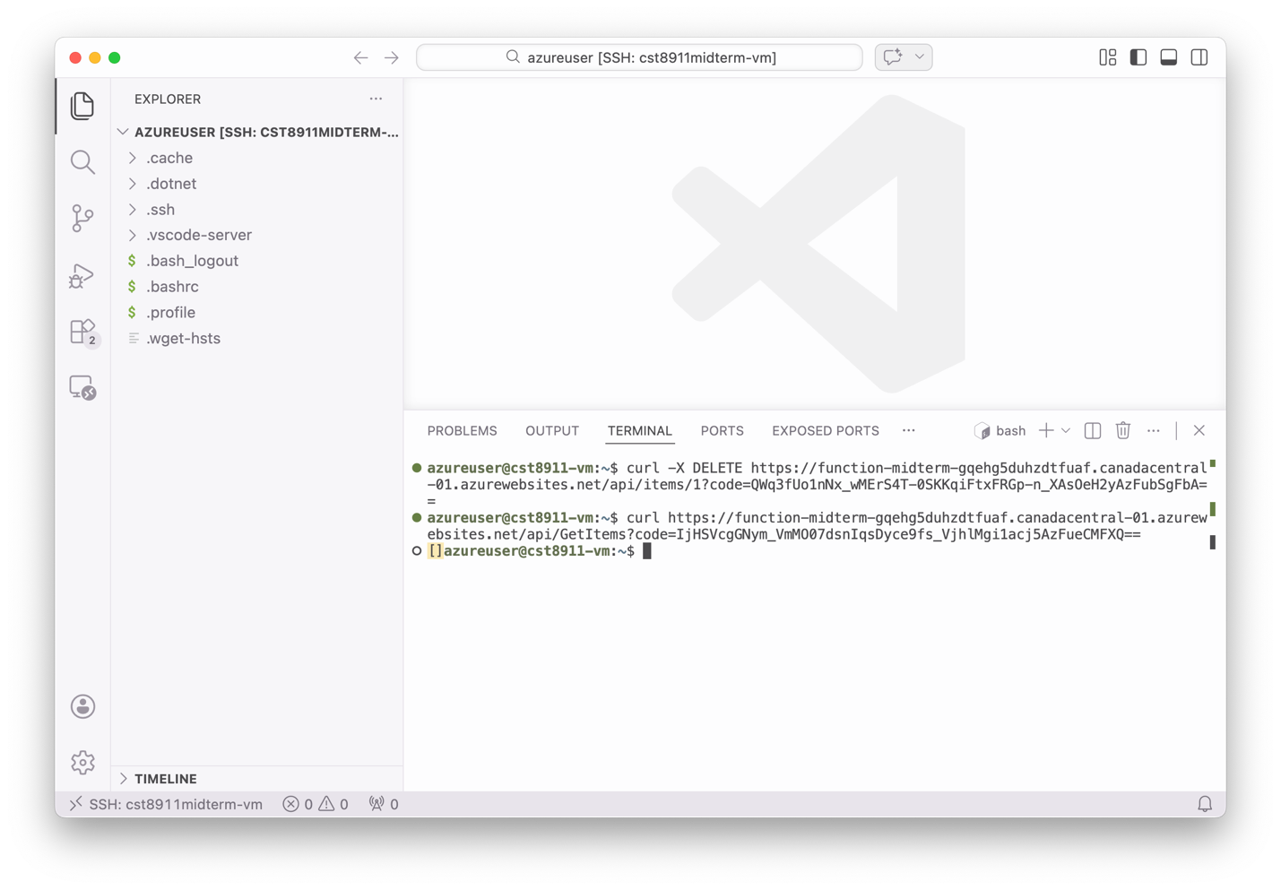

11. Delete all the resources
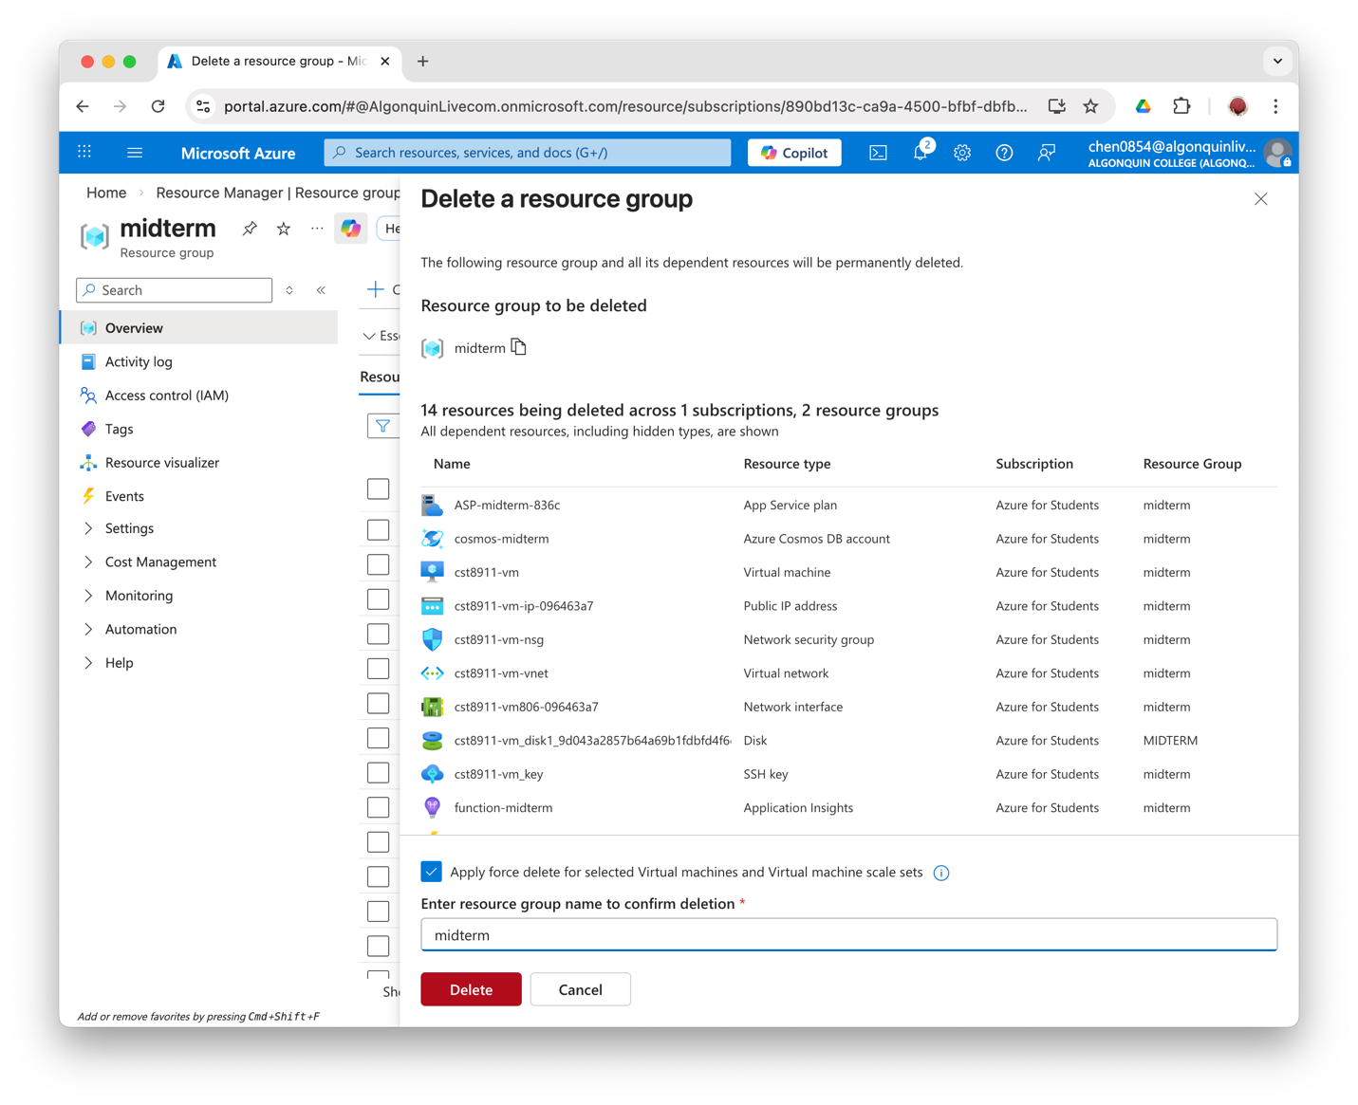
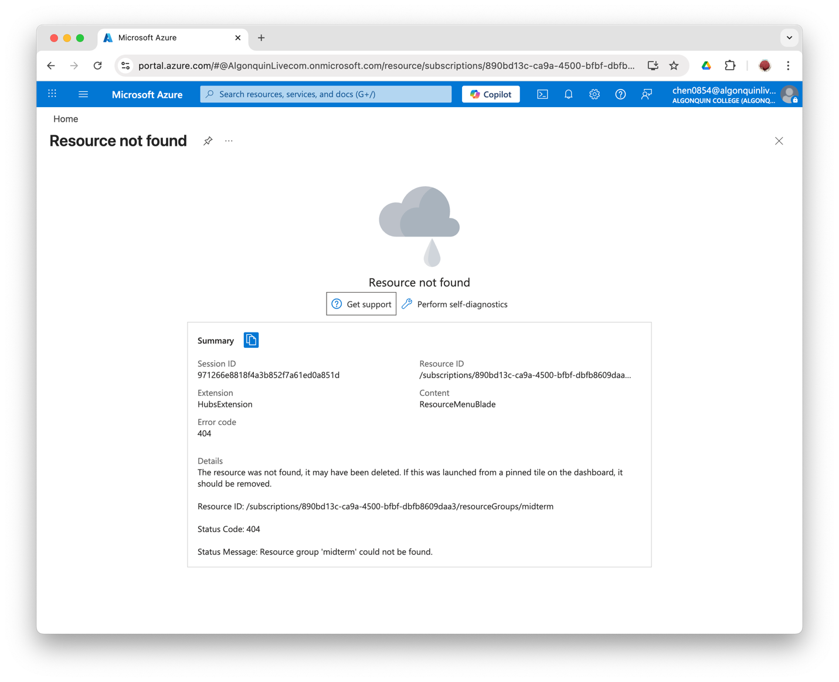

Conclusion
This project shows how a secured, scalable serverless RESTful API function app is created in Azure in a cost-effective way. The Key Vault can help storing secret values securely and the Managed Identity can reduce the complexity of security management.

