Bosi Cheng

A53271697

The author comes up with a system design principle for end-to-end systems, which is the underlying network design should focus on the implementation of the core transport function, rather than on other functions. He points out that technical implementations such as error recovery, secure encryption, duplicate message restriction and so on support the establishment of an end-to-end view. At the bottom of the network, the structure should be simplified, and more functions such as data confirmation and retransmission, and security encryption should be implemented in the high-level network, and the efficiency will be higher.

There are many uncontrollable risks involved in the transmission process, so the author discusses several ways to solve file transmission errors:

1. Perform multiple file copies, ensure the correctness of data writing through multiple simple transmissions;

2. End-to-end data validation and request retransmission

3. Perform error detection.

The cost of establishing a reliable file transfer at the bottom is too high, so it is better to do it on a higher layer network. Applied to practical problems, end-to-end perspective analysis requires a subtle distinction. For example, in voice transmission, people pay more attention to the requirement of sound synchronization rather than the correct rate. Excessive time delay can cause people to resent. Therefore, the author points out that the end-to-end view is not a rigid absolute rule, but a guide to designing the design of applications and protocols.

All in all, the end-to-end view is like Occam's Razor, which means that if the underlying design has more than the core business it can provide, consider designing it at other levels. The change is to design an end-to-end system responsible for reliable data transmission.

I agree on the end-to-end argument. I will take the part of the argument that the structure at the bottom of the network should be simplified and more functions should be implemented in higher levels. Considering the end-to-end argument, the OSI Model we are applying do implement higher layers and solve file transmissions errors in them. For example, the transport layer implements the function to make sure the information to an end is correct and enables session layer not bothered by the hardware changing.

Performance:

The communication subnet is different among the world but in OSI Model, the session layer demands stable connection. So, the transport layer carries the function. It provides services such as [connection-oriented communication](https://en.wikipedia.org/wiki/Connection-oriented_communication), [reliability](https://en.wikipedia.org/wiki/Reliability_(computer_networking)), [flow control](https://en.wikipedia.org/wiki/Flow_control_(data)), and [multiplexing](https://en.wikipedia.org/wiki/Multiplexing).

Correctness:

For example, the data transporting on physical layer produces errors inevitably due to many unreliable factors. To eliminate the errors, the data link layer detects errors and possibly corrects them.

Security:

All OSI layers obey and coordinates the standards for security telecommunications such as ITU-T.

When it comes to a situation or circumstance where the low-level function by itself is insufficient and an end-to-end solution is needed, the solution will possibly build up higher layers and make them realize some functions such as error recovery, secure encryption, duplicate message restriction. From the argument, the cost of implementing these functions at the bottom is too high, so it is better to do it on a higher layer network.

1.3

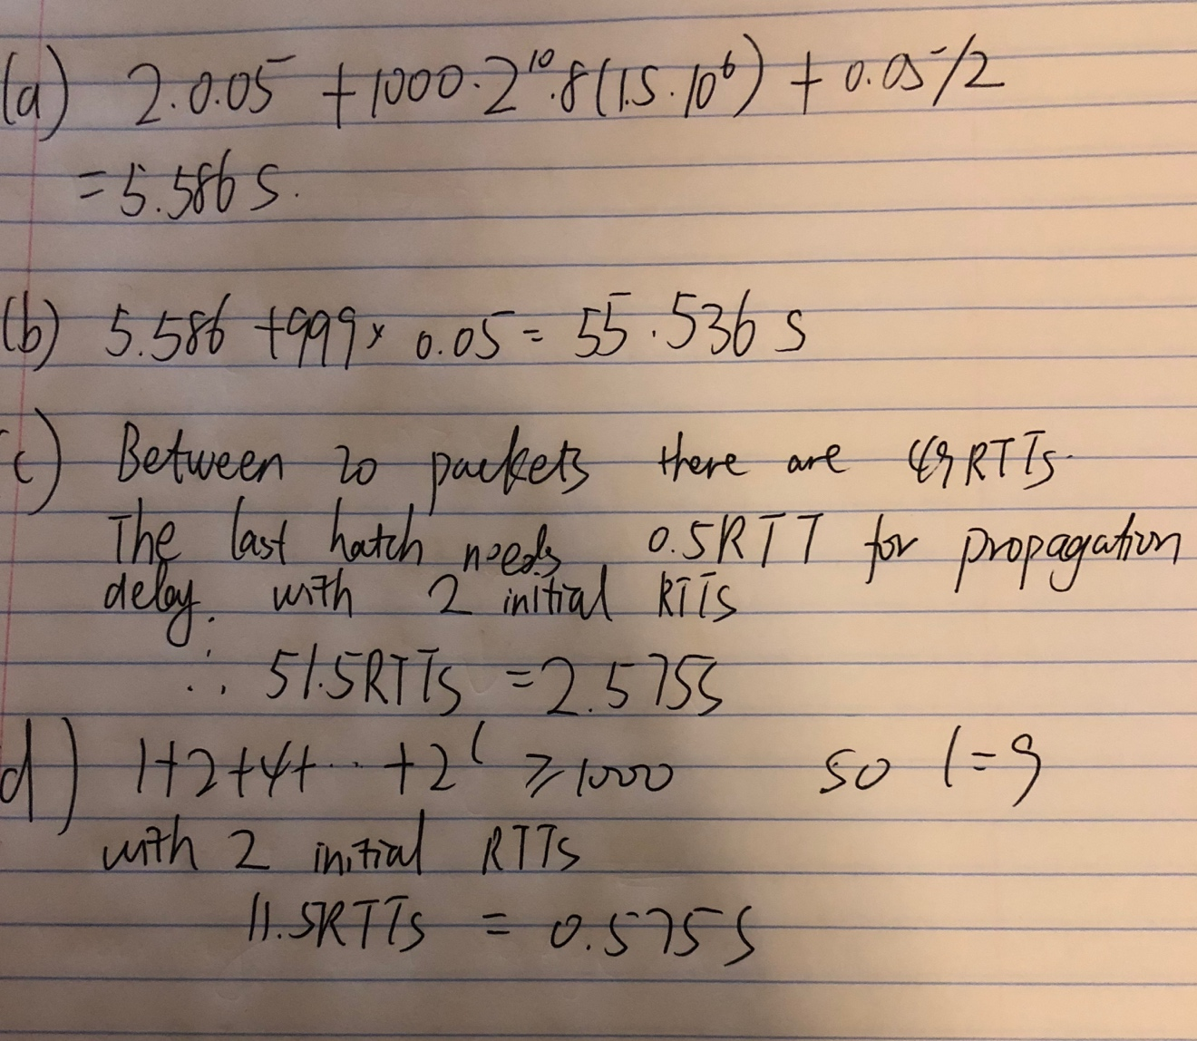

1.5



1.13

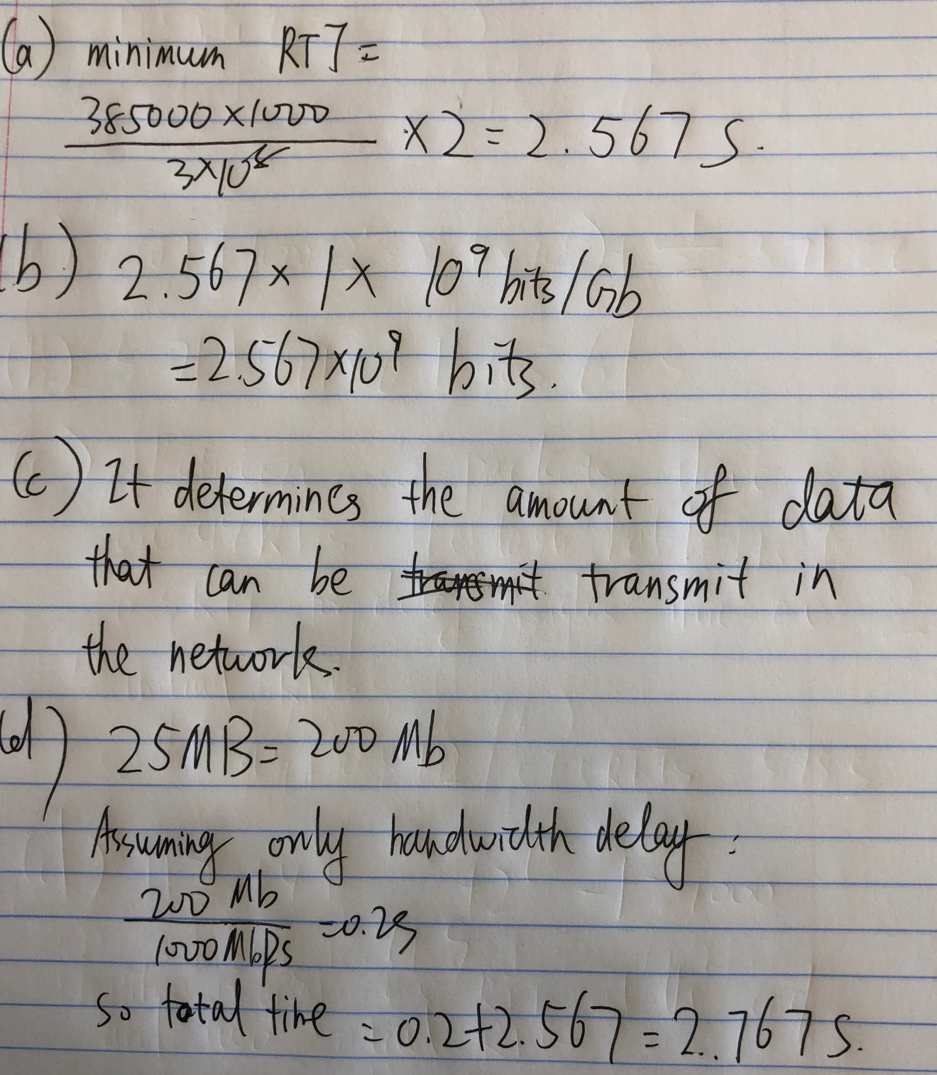

1.20

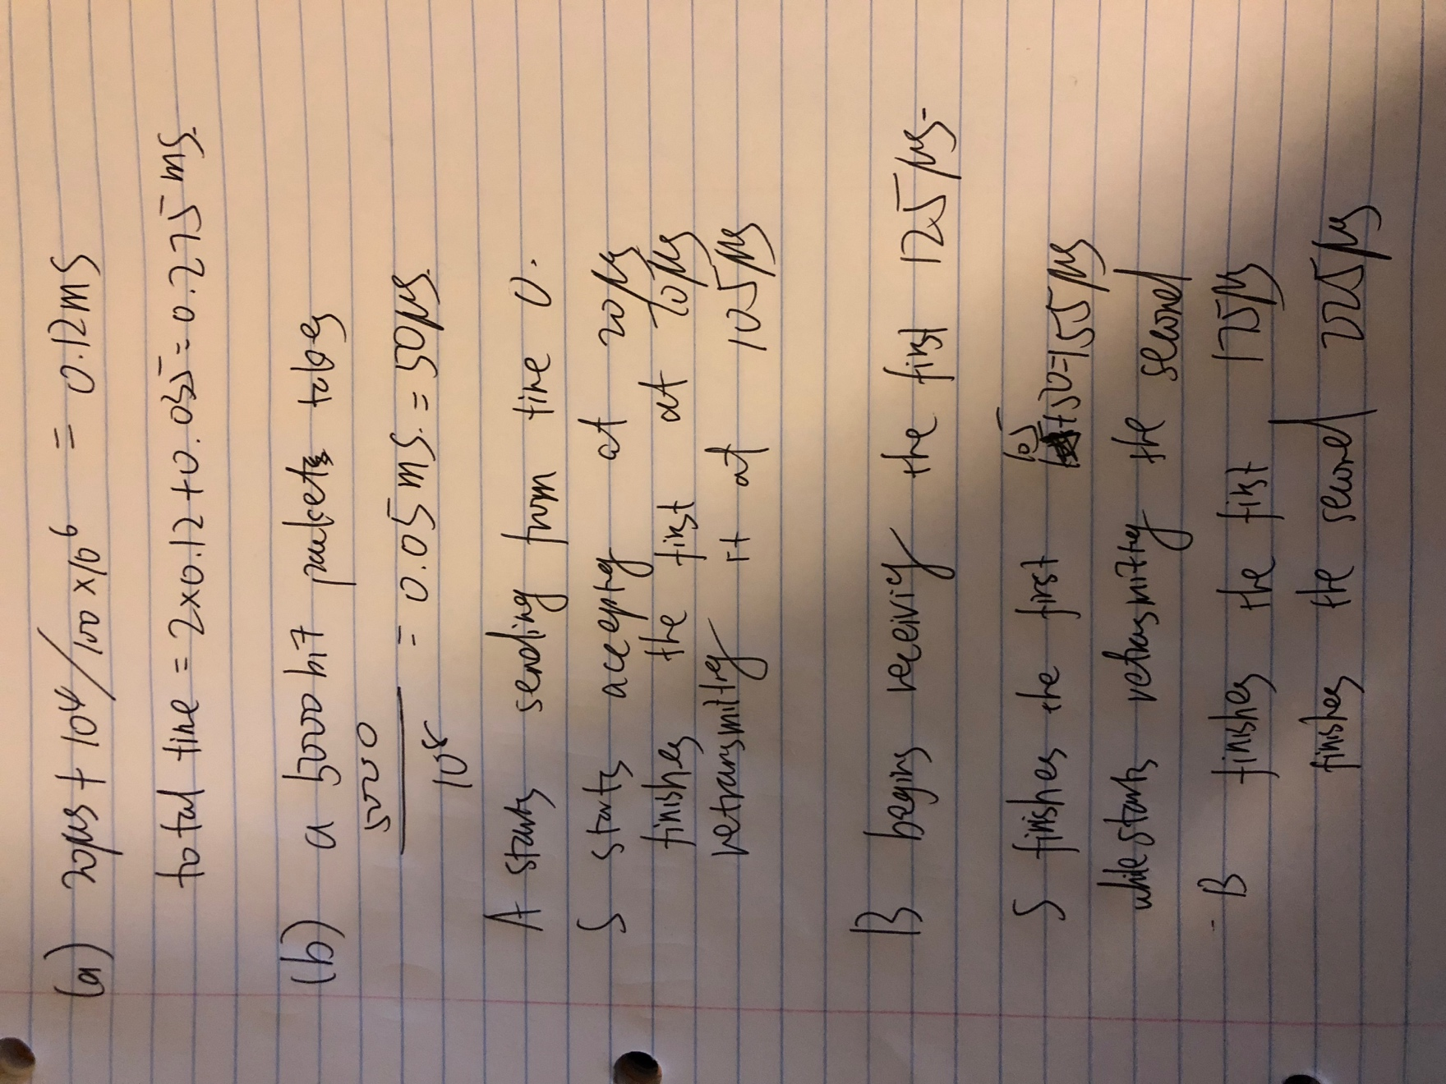

1.22

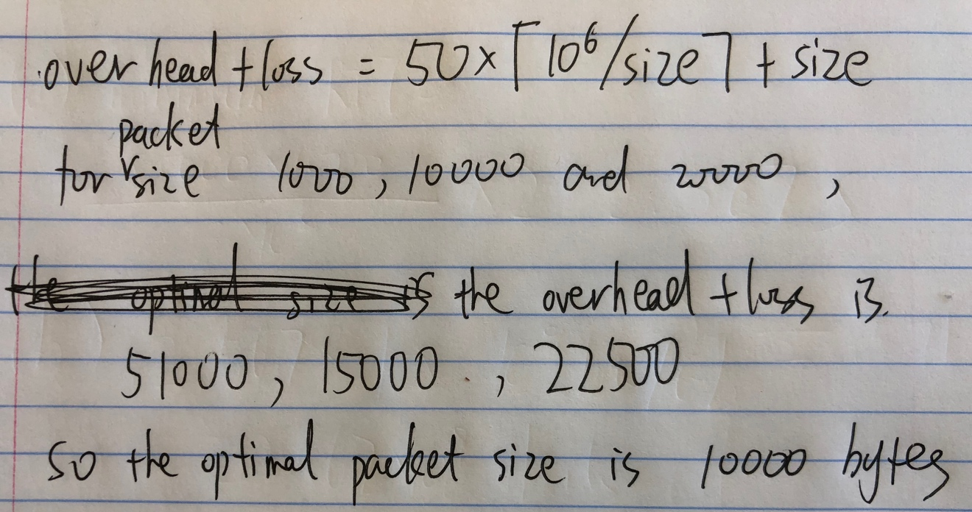

1.23

