🛡
ScamShield AI
AI for Digital Public Safety — Defeating Counterfeiting, Fraud & Digital Arrest Scams
Project Report
Economic Times AI Hackathon 2.0 — Phase 2
Problem Statement PS6
Submitted by:
2nd Year B.Tech CSE (Data Science) Student
Tech Stack: Python · Flask · HTML/CSS/JavaScript · SQLite/MySQL · Scikit-learn

Abstract
Digital fraud in India has evolved rapidly — from generic phishing SMS to the highly damaging "Digital Arrest" scam, where fraudsters impersonate police, CBI, or customs officials on video calls to extort money from panicked victims. ScamShield AI is a full-stack, AI-powered web application built to counter this threat at the point of contact: the message itself.
The system uses a TF-IDF + Logistic Regression machine learning model, layered with a transparent rule-based explainability engine, to classify SMS, email, and website URL content as Safe, Suspicious, or Fraud. A dedicated pattern detector identifies Digital Arrest scam language with a safety-first override, while separate modules validate UPI IDs and educate users on QR code fraud. The platform also includes user authentication, a personal analytics dashboard, a community scam-reporting module, and an administrator panel — built with Python, Flask, HTML/CSS/JavaScript, and scikit-learn, and designed to be understandable, extensible, and deployable by a student team within a hackathon timeframe.

Table of Contents
1. Introduction
2. Problem Statement (PS6)
3. Objectives
4. Proposed System Overview
5. System Architecture
6. Technology Stack
7. Module Description
8. Database Design (ER Diagram)
9. AI / ML Model Details & Workflow
10. Screenshots
11. Testing
12. Future Scope
13. Conclusion
References

1. Introduction
India has seen an unprecedented rise in digital fraud — lottery scams, fake KYC-update messages, phishing links impersonating banks, and most alarmingly, the "Digital Arrest" scam, where a caller poses as a law-enforcement officer and coerces the victim into transferring money while under psychological duress. The Indian Cyber Crime Coordination Centre (I4C) and RBI have repeatedly issued public advisories on this exact pattern, underlining the urgency of scalable, AI-assisted detection and awareness tools.
ScamShield AI directly addresses Problem Statement PS6 — "AI for Digital Public Safety: Defeating Counterfeiting, Fraud & Digital Arrest Scams" — by building an accessible, explainable, and practical web application that any citizen can use to check suspicious content before acting on it.

2. Problem Statement (PS6)
Design and build an AI-powered solution that helps citizens identify and defend against digital fraud, counterfeiting, and Digital Arrest scams — categories of crime that are growing rapidly and disproportionately affect people with limited digital literacy, including senior citizens.
Key challenges this project addresses:
- Victims often cannot tell a real government/bank message from a fraudulent one.
- Digital Arrest scams exploit fear and urgency, bypassing normal judgement.
- Fake UPI/QR code scams exploit a common misunderstanding — that scanning a QR code can receive money.
- There is no easy, free, one-stop tool for citizens to instantly verify suspicious content.

3. Objectives
- Build an ML-based text classifier that labels SMS/Email/URL content as Safe, Suspicious, or Fraud.
- Ensure every AI prediction is explainable — showing the user exactly why a verdict was given.
- Create a dedicated detection module for Digital Arrest scam patterns given their severity.
- Provide UPI ID validation and QR code fraud awareness content.
- Allow users to report scams, building a community-driven fraud database.
- Give users a personal dashboard to track their own scan history and exposure.
- Provide administrators a panel to monitor platform activity and triage reports.
- Keep the entire stack simple, well-documented, and beginner-friendly for a 2nd-year student team.

4. Proposed System Overview
ScamShield AI is a server-rendered Flask web application. Users register and log in via secure, hashed-password sessions. From their dashboard, they can paste any SMS, email, or URL into the AI Fraud Detector, which returns a verdict, confidence score, explanation, and prevention tips within under a second. A dedicated Digital Arrest page runs the same pipeline with an additional safety override specific to that scam type. A UPI/QR awareness page validates UPI ID formats and educates users on common QR-based fraud tricks. Users can also report scams via a structured form, which administrators review and triage through a dedicated Admin Panel.

5. System Architecture
The application follows a classic three-tier architecture: a browser-based client (HTML/CSS/JavaScript), a Flask application server handling routing, sessions, and business logic, and a SQLite data layer (with an optional MySQL schema for production deployments).
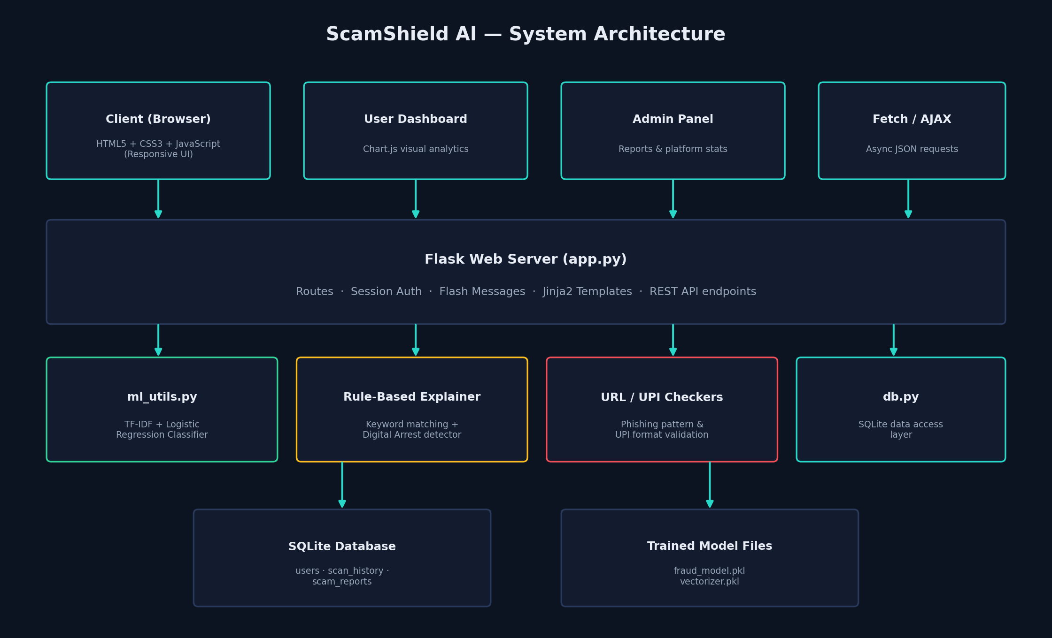
Figure 1: ScamShield AI System Architecture

6. Technology Stack
Layer | Technology | Purpose
Frontend | HTML5, CSS3, JavaScript | Responsive UI, AJAX calls to backend API
Backend | Python, Flask | Routing, session auth, REST API, template rendering
AI / ML | scikit-learn (TF-IDF + Logistic Regression) | Text classification into Safe/Suspicious/Fraud
Explainability | Custom rule-based keyword engine | Human-readable reasoning and Digital Arrest detection
Database | SQLite (default) / MySQL (optional) | Users, scan history, scam reports
Visualization | Chart.js | Dashboard analytics
Auth | Werkzeug security + Flask sessions | Password hashing, login sessions

7. Module Description

7.1 User Authentication
Registration and login with hashed passwords (Werkzeug), session-based auth, and role separation (user vs admin).

7.2 AI Fraud Detector (SMS / Email / URL)
Accepts free text or a URL, runs it through the ML model and/or rule-based URL checker, and returns a classification, confidence score, reasons, and tips.

7.3 Digital Arrest Scam Detector
A specialised page reusing the classification pipeline with a dedicated Digital-Arrest keyword bank and a safety override that force-flags fraud when strong patterns are detected.

7.4 Fake UPI & QR Awareness
Validates UPI ID format, flags lottery/prize-themed IDs, and educates users that QR scans can only authorize outgoing payments.

7.5 Scam Reporting Module
A structured form (scam type, description, contact info) that stores community reports for administrator review.

7.6 AI-Generated Safety Tips
A curated library of prevention guidance, contextually surfaced based on the type of scam detected.

7.7 Dashboard
Displays the logged-in user's scan history and a Chart.js doughnut chart summarizing their Safe/Suspicious/Fraud activity.

7.8 Admin Panel
Shows platform-wide statistics (total users, scans, fraud detected, reports) and lets admins triage scam reports by status.

8. Database Design (ER Diagram)
The schema consists of three core tables: users, scan_history, and scam_reports, related via foreign keys on user_id.
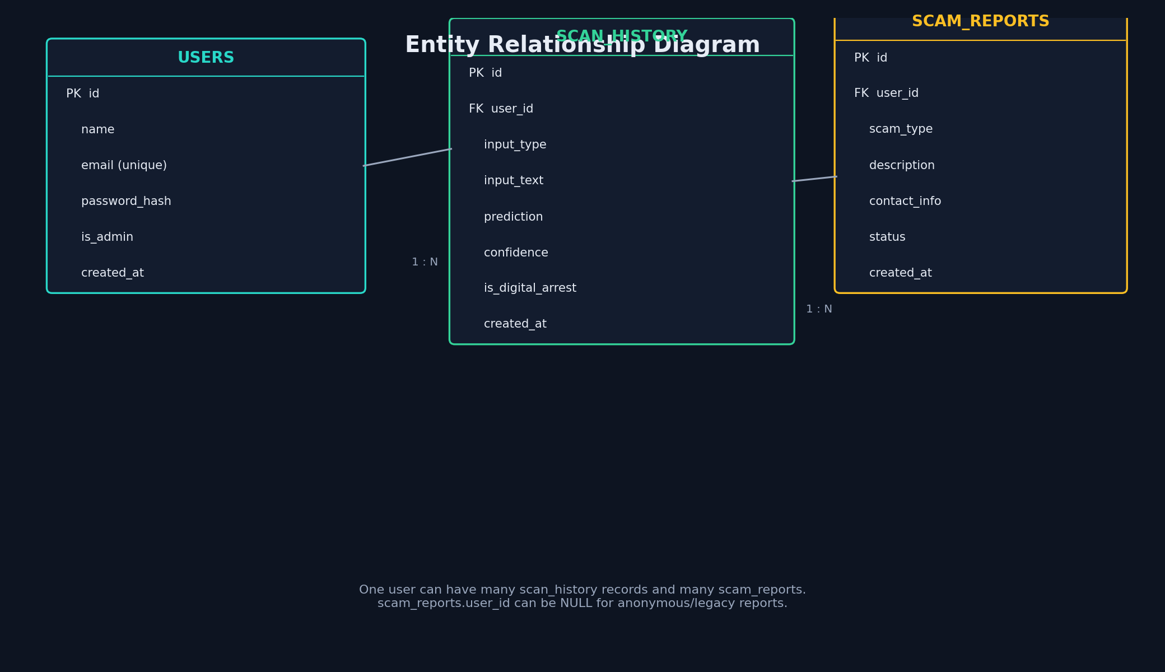
Figure 2: Entity Relationship Diagram

9. AI / ML Model Details & Workflow
The classifier pipeline is: raw text → TF-IDF vectorization (unigrams + bigrams, 3000 features) → Logistic Regression (multi-class, class-balanced). This was chosen over deep learning approaches for a hackathon MVP because it is fast to train, easy to explain in a viva, and performs well on small labeled datasets.
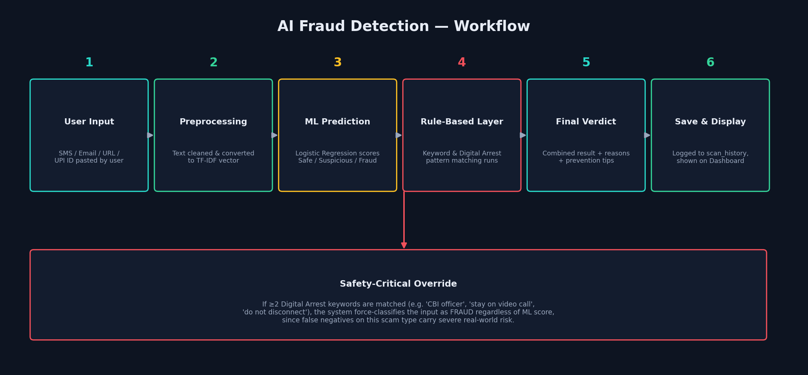
Figure 3: AI Fraud Detection Workflow

9.1 Model Performance
The model was trained on a curated sample dataset of 65 labeled SMS/email examples (models/dataset.csv) spanning fraud, suspicious, and safe categories, including several Digital Arrest style transcripts. 5-fold stratified cross-validation gives a mean accuracy of approximately 74% on this small dataset.
- Dataset size: 65 labeled samples (26 fraud, 26 safe, 13 suspicious)
- Vectorization: TF-IDF, unigrams + bigrams, max 3000 features
- Model: Logistic Regression, class_weight='balanced', max_iter=1000
- Mean 5-fold cross-validation accuracy: ~74%
Note: this is intentionally a small, hand-curated demo dataset appropriate for a hackathon MVP. Accuracy is expected to improve substantially with a larger, real-world labeled dataset (thousands of samples) — see Future Scope.

9.2 Explainability Layer
In parallel with the ML prediction, a curated keyword bank checks the input for known fraud, suspicious, and Digital-Arrest-specific phrases. Matches are surfaced directly to the user as the 'why' behind each verdict, and a safety override forces a Fraud classification whenever 2 or more Digital Arrest patterns are found — because under-flagging this specific scam type carries severe real-world consequences.

10. Screenshots
The following pages should be captured from a running instance of the application and inserted here for the final submission (see docs/SCREENSHOTS_GUIDE.md in the project repository for the full capture checklist):
- Home Page — hero section and feature overview
- Registration and Login pages
- AI Fraud Detector — input and result view (Fraud verdict with reasons/tips)
- Digital Arrest Detector — alert banner view
- UPI/QR Awareness — UPI ID check result
- Scam Reporting form
- User Dashboard — chart and scan history
- Admin Panel — stats and reports table

11. Testing
The application was tested end-to-end using Flask's test client, covering:
- User registration and login flows, including duplicate-email and weak-password rejections.
- AI detection API for fraud, suspicious, and safe SMS/email samples.
- URL phishing detection against known-bad and known-safe style URLs.
- UPI ID validation for both well-formed and lottery/prize-themed IDs.
- Scam report submission and persistence.
- Admin login, panel rendering, and report status updates.
All core flows returned expected HTTP status codes and correct classification results during testing.

12. Future Scope
- Train on a larger, real-world labeled dataset (thousands of samples) to improve accuracy and generalization.
- Upgrade to a deep learning model (LSTM/BERT-based) for nuanced language understanding.
- Add real QR code image upload and decoding (OpenCV/pyzbar) for literal QR scanning.
- Integrate with the National Cyber Crime Reporting Portal API for direct report submission.
- Build a browser extension for real-time link scanning outside the platform.
- Add multi-language support (Hindi and regional languages) to widen accessibility.
- Migrate to MySQL/PostgreSQL with the provided schema for production-scale deployment.

13. Conclusion
ScamShield AI demonstrates that a focused, explainable machine learning approach — combined with domain-specific rule-based detection — can meaningfully address a real, high-stakes public safety problem: digital fraud and Digital Arrest scams. By prioritizing transparency (every verdict comes with a reason and a concrete next step) over raw model complexity, the platform stays understandable to both its student developers and its end users, while remaining a solid foundation for future scaling.

References
- Reserve Bank of India — Public advisories on digital payment fraud (rbi.org.in)
- Indian Cyber Crime Coordination Centre (I4C) — Digital Arrest scam advisories (i4c.gov.in)
- National Cyber Crime Reporting Portal — cybercrime.gov.in
- scikit-learn documentation — TfidfVectorizer & LogisticRegression (scikit-learn.org)
- Flask documentation — flask.palletsprojects.com

