
Specializarea: Automatică și Informatică Aplicată

Optimization of interior thermal comfort through automatic control
Automatic Control of Home Automation Functions

Student Boșnegeanu Adrian Gabriel
Anul 3, Grupa 1

Cadru didactic îndrumător:
dr. ing. Georgian NECULOIU

Table of Contents
- Introduction....................................................................................................2
- Project theme.................................................................................................3
  - Theme description......................................................................................3
  - Technologies used......................................................................................4
- How it works.................................................................................................5
- Conclusions...................................................................................................13
- Bibliography.................................................................................................14

- Introduction

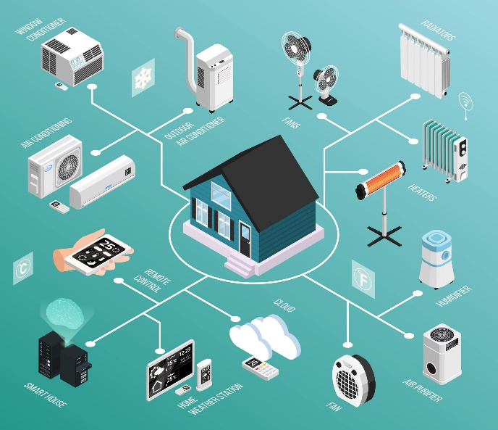
Automatic control of home automation functions refers to the ability of systems and devices in a smart home to autonomously act and react to different stimuli and commands, without the need for direct human intervention.
In the age of digital and advanced technology, the concept of the smart home has evolved beyond mere convenience to become a fundamental pillar of modern life. A smart home not only provides comfort and efficiency, but becomes an extension of our lifestyle, adapting and anticipating our needs in an unprecedented way. At the heart of this transformation is home automation, a discipline that integrates technology into the infrastructure of the home to improve and simplify everyday life.
At the heart of this home automation revolution is automatic control, a concept that transforms the home into a living and adaptable environment, capable of responding to user requirements without direct human intervention. Automatic control of home automation functions not only ensures optimal thermal comfort or adequate lighting, but also manages the entire smart home ecosystem, coordinating interactions between connected devices to create a harmonious and efficient environment.

- Project theme
  - Theme description
The theme of the project is automatic temperature control and aims to explore and implement a system to maintain the desired temperature inside a room and monitor humidity in real time.

The configuration of such a system not only provides comfort, but also helps to streamline energy consumption, a precious resource whose production involves the exploitation of natural resources and can have a negative impact on the environment. By implementing this automatic temperature control and humidity monitoring system, smarter management of energy resources can be achieved, reducing unnecessary consumption and minimizing carbon emissions associated with energy production.
Thus, in addition to the comfort and health offered to users, this project also has a positive impact on the environment, contributing to reducing the carbon footprint of the home and protecting natural resources for future generations. By integrating sustainable technologies and energy efficiency practices into the management of temperature and humidity inside buildings, this project represents an important step towards building a more sustainable and environmentally friendly future.


  - Technologies used
    - Raspberry Pi
The Raspberry Pi is a small small computer, originally developed in the UK by the Raspberry Pi Foundation. It was designed as an accessible and versatile tool designed to stimulate learning and innovation in the field of computer science and technology. Although its dimensions are comparable to those of a credit card, the Raspberry Pi has the processing power and ability to run various operating systems, including adapted versions of Linux.
Over time, the Raspberry Pi has become popular among technology enthusiasts, engineers, programmers, and DIY (Do It Yourself) enthusiasts, due to its versatility and usability. It can be used in a variety of projects, such as building a media center environment, creating a video monitoring system, developing solutions for home automation, building robots, or even learning programming and electronics concepts.
Thanks to its affordable price and extensive capabilities, the Raspberry Pi has become a popular platform for technology education, research and development, helping to democratize access to technology and foster creativity and innovation among the global community.
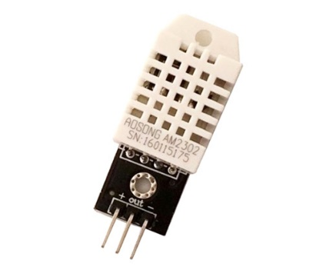
    - DHT21
DHT22, also known as AM2301, is a digital temperature and humidity sensor that can be used in various environmental monitoring applications. This sensor is designed to measure the temperature and relative humidity in a certain area. The DHT22 uses a synthetic polymer moisture sensor and a thermistor to measure temperature. It uses a single line of data to communicate with a microcontroller, thus facilitating its integration into various electronic designs.

    - Auxiliary
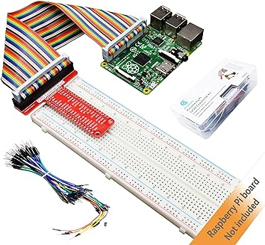
To simulate the functionality of such a system, we have chosen a series of auxiliary devices.
- GPIO Expansion T-Board , Breadboard and Jumper Cables
Ideal for experimenting with the Raspberry Pi without making permanent changes to it, the confifurcation in Fig. 5 allows for modular connection of sensors and other necessary devices

- LEDs
To mimic the functionality of the configuration, we used a red LED that replaces a heat generating device (heat pump, boiler, etc.) and a blue LED as a temperature reducing device.

- How it works
    - Configuring the relationship between the Raspberry Pi and the DHT22 temperature sensor
The DHT22 sensor, through the connection of its pin 2(DATA) to one of the GPIO pins of the Raspberry Pi, sends packets of 40 bytes of data at an interval of 40 microseconds. Each 5 bytes represents
First Byte: Integral Relative Humidity Data in %
Second byte: Decimal data of relative humidity in %
Third byte: Full temperature in degrees Celsius
Fourth byte: Decimal temperature data in degrees Celsius
Fifth Byte: Checksum (last 8 bits of the first byte + second byte + third byte + fourth byte)

Thus, with the help of the public library DHTXXD.h, we created a series of instructions in C to be able to interpret the received data.
To make the debugging and optimization process easier, we have integrated the possibility of executing a single read.
This subprogram (Fig. 6) is executed only if the command line does not specify a period of seconds at which to write the read data.
In case of specifying the interval at which the readings are performed, we have created a code sequence (Fig. 7) that performs readings at the desired interval.
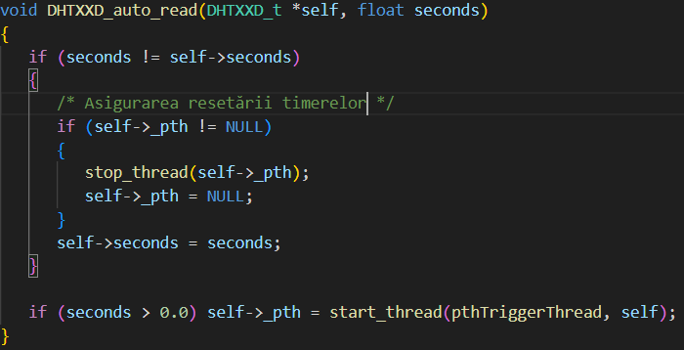

    - Processing of data received from the Raspberry Pi
We have established that after initiating the execution of the algorithm (Fig 8), all readings will be displayed in the command console in order to be able to detect future errors. In a "reqtemp" file we stored the temperature desired by the user and then compared it to the current temperature. We have established a range of 0.5 ^{oC} around the desired temperature where no signal is sent to the connected devices.

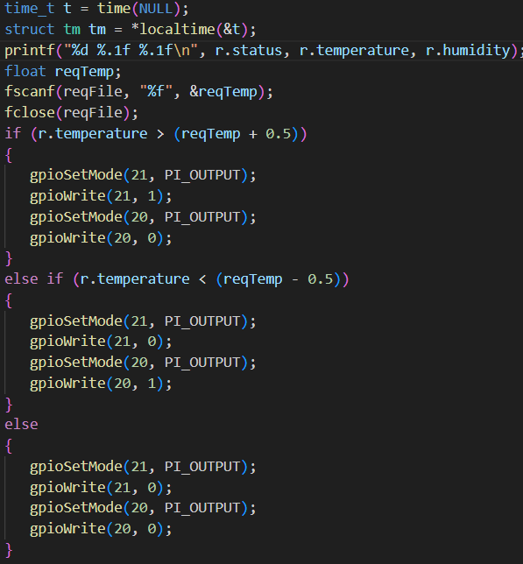

    - Preparing the Raspberry Pi for the User-Interface
We have chosen a web page as a way of communication between the user and the automatic ordering system so that the requirements can be ordered remotely from any device with an internet connection and a browser application.

Preparing the Raspberry Pi for this functionality involved installing the following programs:
- NGINX (pronounced "engine-x") is a high-performance web server and reversible proxy, used to handle heavy web traffic and improve the performance and security of web applications.
- PHP-FPM (PHP FastCGI Process Manager) is an improved alternative to running PHP as a FastCGI server, especially designed for high-traffic web applications. It is an optimized version of PHP that handles PHP processes to improve performance and the ability to handle a large number of concurrent requests.

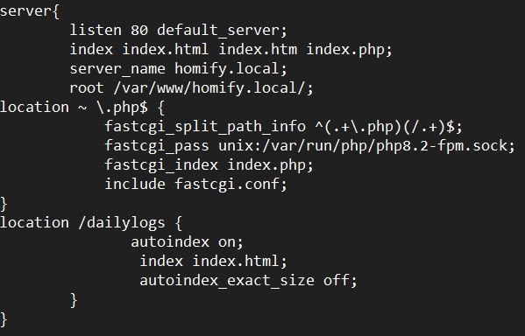
We then configured NGINX to create a web server and established PHP-FPM as a way to execute commands .php that would facilitate the connection between the previously written program and the web interface. We have also established a location at the root of the server, the "dailylogs" folder that will be accessible online and from where the user will be able to access the history of the indoor temperature.

    - Construirea User-Interface
Within the web page that serves as User-Interface we used the following elements:
- GAUGE dynamic display that displays the temperature graphically and induces the quality of thermal comfort through suggestive colors
- Current temperature and humidity text display
- Input-Box for setting the desired temperature
- Button to confirm the temperature order
- Links to temperature history

    - Making the connection between the UI and the automatic temperature control service

- Real-time temperature and humidity display

For this endeavour we used a JavaScript script that retrieves the data from a data.json file at an interval of 3 seconds. This script will also take care of positioning the GAUGE indicator according to the current temperature.

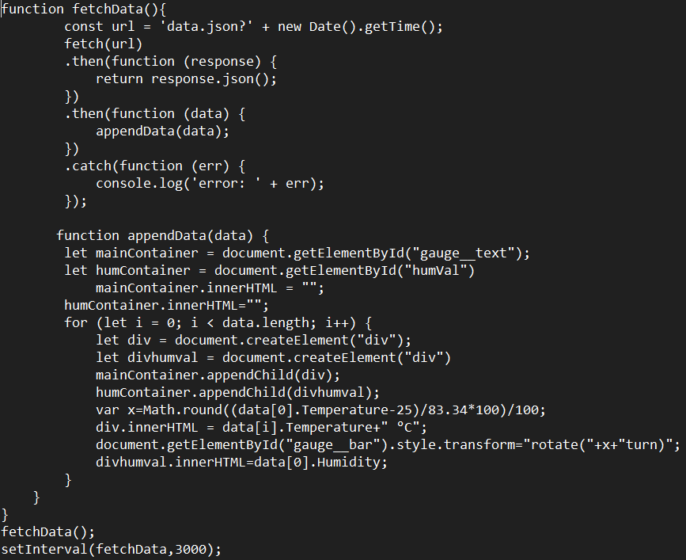
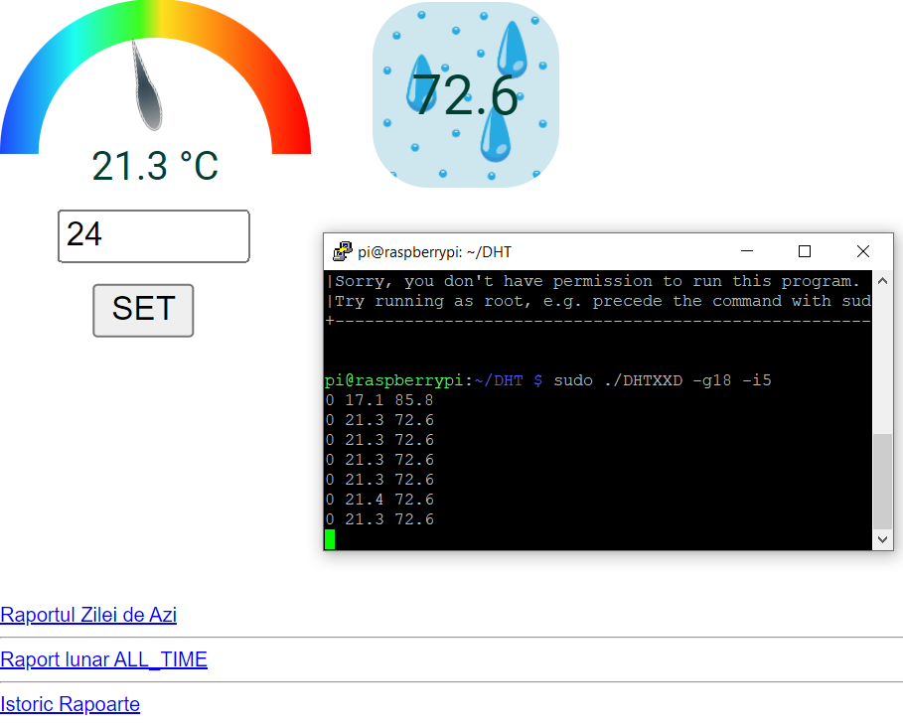

- Possibility to access the temperature history

In order to give the user the facility to access the temperature history, we decided to store the data, as it is read in a CSV file that can be processed later in Spreadsheet programs (Microsoft Excel, Google SpreadSheets).
Thus, we proceeded to design a new set of instructions within the C program to generate the "daylog.csv" file in which we will find the date and time of the reading followed by the actual reading.

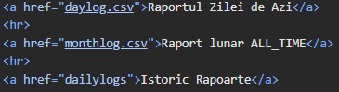

At the end of the day, the program will detect the date change and store the current day's data in a separate folder on the /dailylogs server, and the average of the temperatures recorded today will appear in the continuation of the "monthlog.csv”.
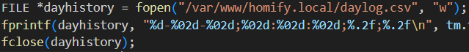

Subsequently, we made these files accessible on the web page dedicated to the system.

- Setting the temperature from the dedicated user interface

With the help of PHP and JavaScript we made the connection from the web page to the algorithm. When the user sets a temperature, it is written to a server file "reqtemp" which is then read into the control program.
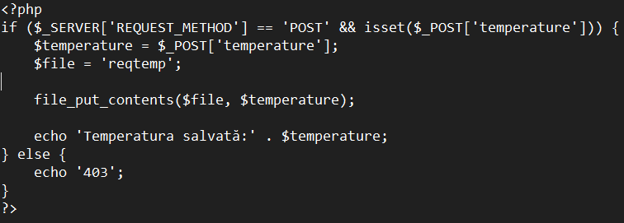
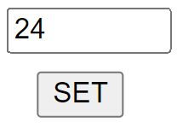

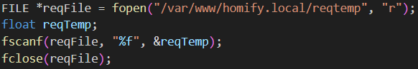

- Conclusions
The Automatic Control of Home Automation Functions is a module that has brought us real contributions to the horizon of knowledge and within which we have discovered the complexity of an automatic control system.
This project can be metaphorically summarized as a Smart-Puzzle, a set of pieces that put together brings you, in addition to the satisfaction of success, a real and functional home automation system that can be implemented.
The experience of carrying out this project certainly helped our evolution not only due to the brainstorming it imposed, but also to the multitude of new information it brought us. I deepened my knowledge in programming languages, web development, Linux.
The potential of the system we have chosen can be reduced, there are a multitude of such devices on the market that have entire development teams behind them, but with the help of the accumulated knowledge, the horizon of the development of automatic control devices of home automation functions has become much broader.
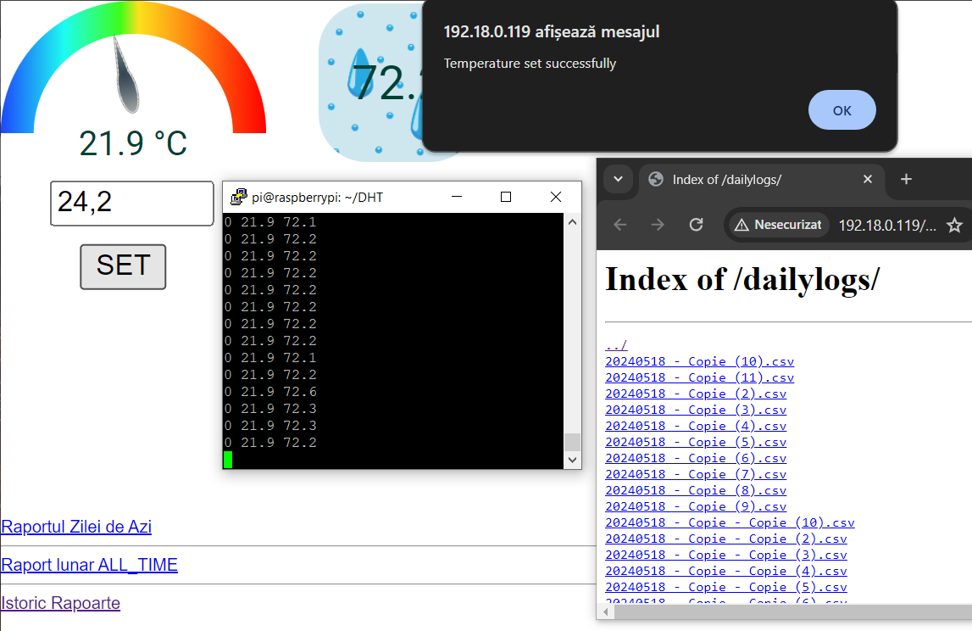

- Bibliography

- https://www.raspberrypi.com/
- https://github.com/nethoncho
- https://www.theserverside.com/
- https://www.digitalocean.com/
- https://askubuntu.com/
- https://www.youtube.com/@BrettInTech

