1. Install vs code
2. Install python 3.11 and later : https://www.python.org/downloads/release/python-31110/
3. Install PostgreSQL dabase

<https://drive.yipintsoi.com/apps/files/?dir=/ShareFile-Team/smartpp-Django-workshop&fileid=16866203>

|  |  |
| --- | --- |
|  |  |

<https://djecrety.ir/>

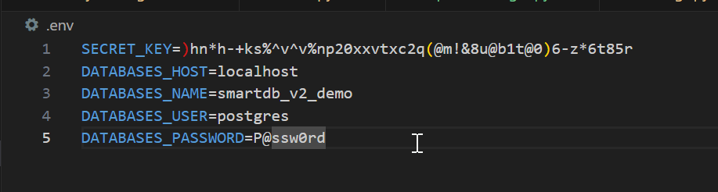

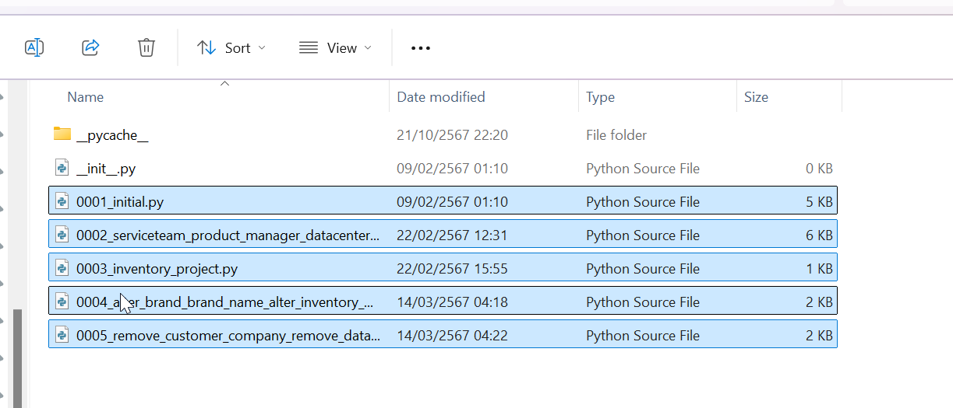

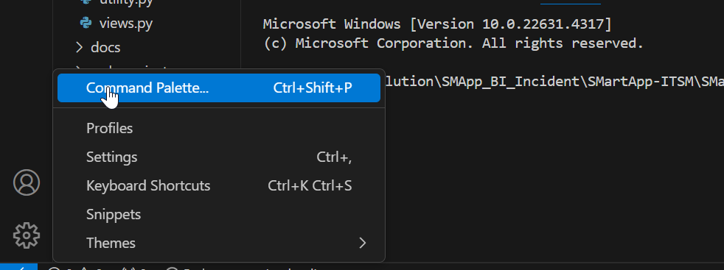

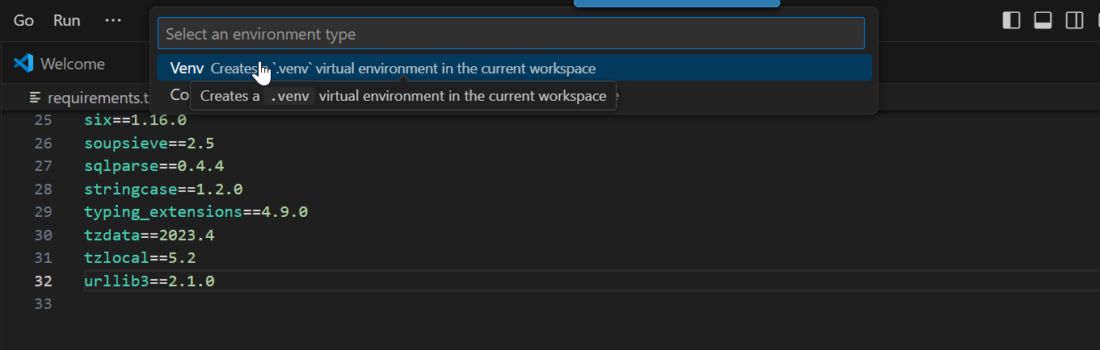

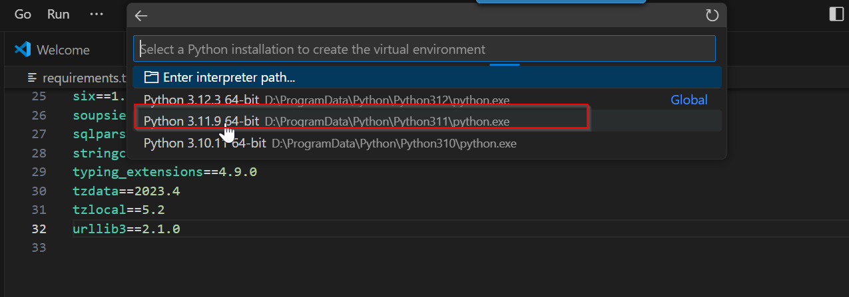

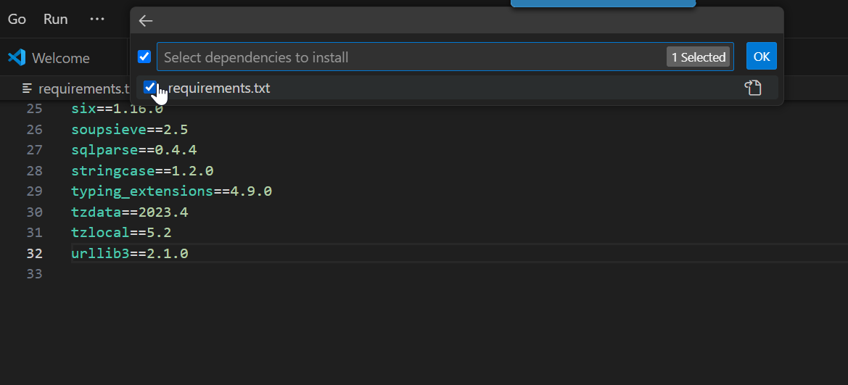

python manage.py startapp app

python manage.py makemigrations

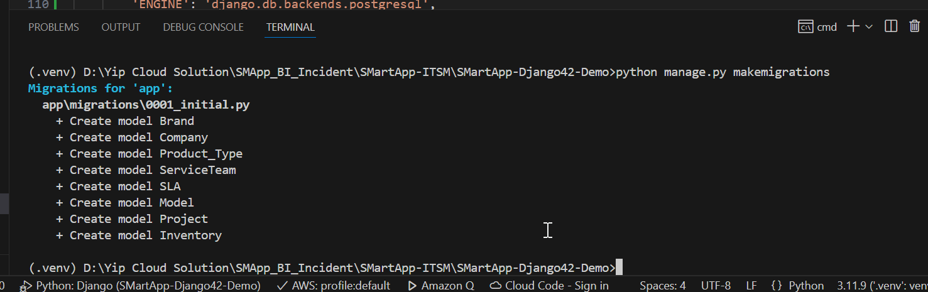

python manage.py migrate

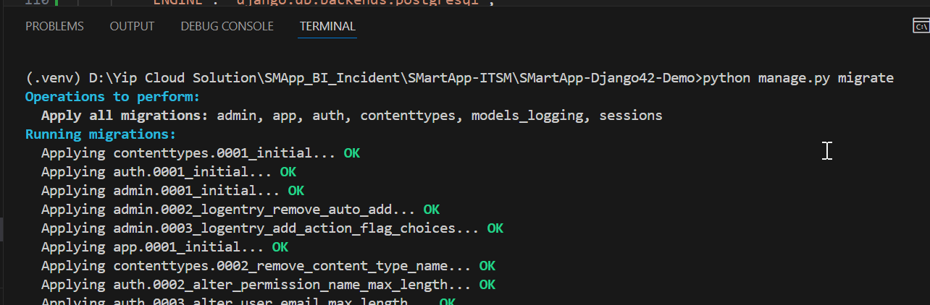

python manage.py createsuperuser

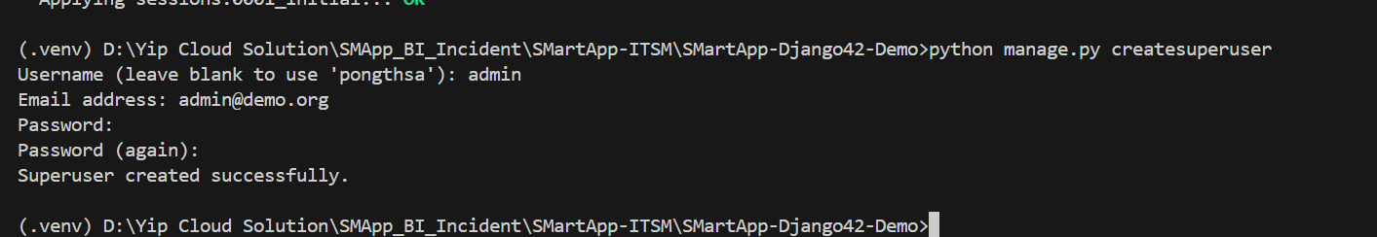

python manage.py runserver

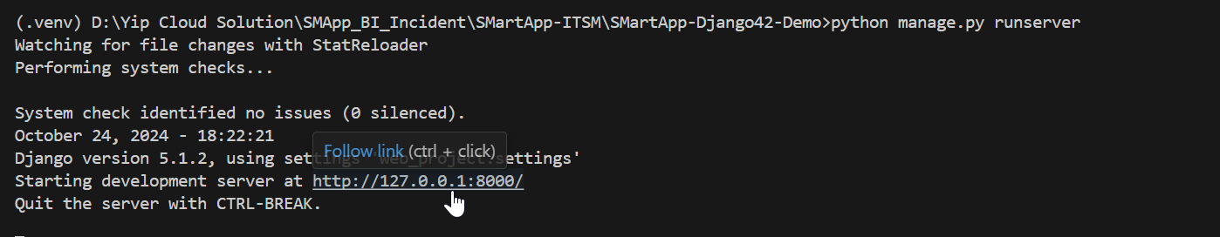

<http://127.0.0.1:8000/admin>

