

TRABAJO PRACTICO N1 - EXPRESIONES REGULARES - AUTÓMATAS Y GRAMÁTICA

Pardo Federico

Ascurra Daiana

AUTOMATAS FINITOS DETERMINISTAS Y NO DETERMINISTAS

Aplicando construcción de subconjuntos realice la conversión de los siguientes AFN en AFD

1) (a│b)\*

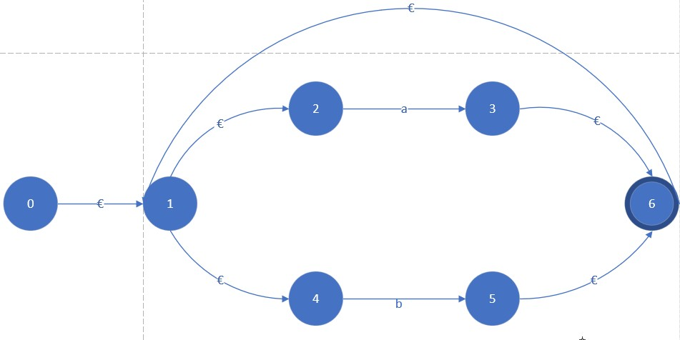

Cerradura - €(0) => {0,1,2,4,6} = A Mueve (A,a) = mueve ({0,1,2,4,6},a)={3}

Cerradura -€ (mueve (A,a))= {0,1,2,3,4,6} = B

Mueve (A,b) = mueve({0,1,2,4,6},b)={5}

Cerradura -€ (mueve(A,b))={0,1,2,4,5,6) = C

Mueve (B,a) = mueve ({0,1,2,3,4,6},a)={3}

Cerradura -€ (mueve(B,a))={0,1,2,3,4,6} = B

Mueve (B,b) = mueve ({0,1,2,3,4,6},b)={5}

Cerradura -€ (mueve (B,b))={0,1,2,3,4,5,6} =D

Mueve (C,a) = Mueve ({0,1,2,4,5,6},a)={3}

Cerradura -€ (mueve(C,a))={0,1,2,3,4,5,6} = D

Mueve (C,b) = Mueve ({0,1,2,4,5,6},b)={5}

Cerradura -€ (mueve (C,b))= {0,1,2,4,5,6} = C

Mueve (D,a) = Mueve ({0,1,2,3,4,5,6},a={3}

Cerradura -€ (mueve(D,a))={0,1,2,3,4,5,6} = D Mueve (D,b) = {5]

Cerradura -€ (mueve (D,b))={0,1,2,3,4,5,6} = D

2) (aa|b)\*(a|bb)\*

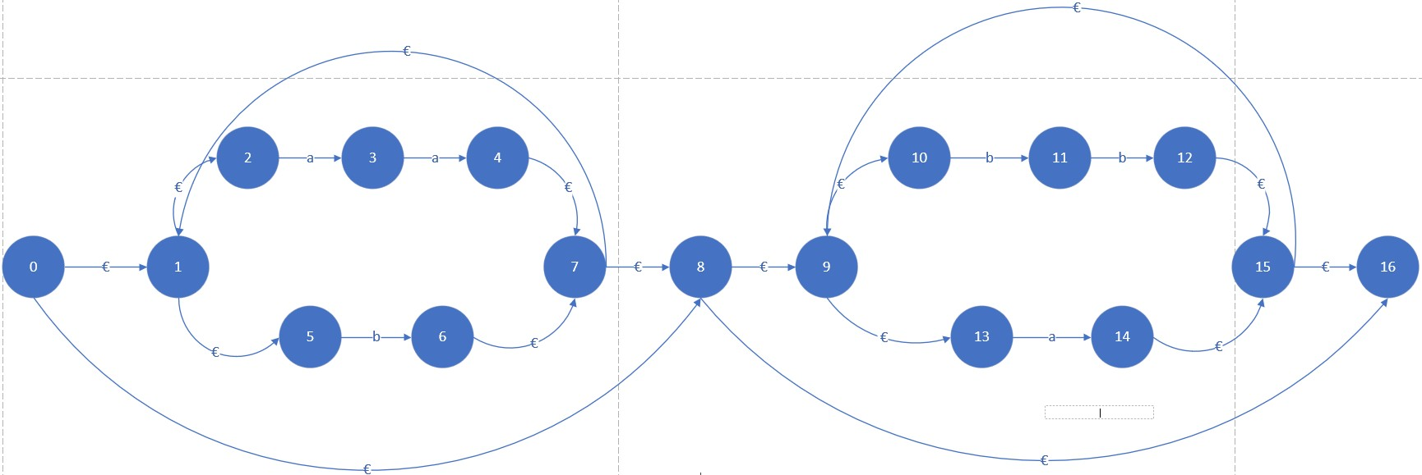

Cerradura -€(0) => {0,1,2,5,8,9,10,13,16} = A

Mueve (A,a) = mueve ({0,1,2,5,8,9,10,13,16},a)={3,4,14}

Cerradura -€ (mueve (A,a))={0,1,2,3,4,5,8,9,10,13,14,16} = B

Mueve (A,b) = mueve ({0,1,2,5,8,9,10,13,16}),b)={6,11,12}

Cerradura -€ (mueve(A,b))={0,1,2,5,6,8,9,10,12,13,16}= C

Mueve (B,a) = mueve ({0,1,2,3,4,5,8,9,10,13,14,16},a)={3,4,14}

Cerradura -€ (mueve(B,a))={0,1,2,3,4,5,8,9,10,13,14,16} = B

Mueve (B,b) = mueve ({0,1,2,3,4,5,8,9,10,13,14,16},b)={6,11,12}

Cerradura -€ (mueve(B,b)) = {0,1,2,3,4,5,6,8,9,10,11,12,13,14,16}= D

Mueve (C,a) = mueve{3,4,14}

Cerradura -€(mueve (C,a))= {0,1,2,3,4,5,6,8,9,10,12,13,14,16} = E

Mueve (C,b)=mueve {6,11,12}

Cerradura -€(mueve(C,b))= {0,1,2,5,6,8,9,10,11,12,13,16} = F

Mueve(D,a) = mueve{3,4,14}

Cerradura -€(mueve(D,a))= {0,1,2,3,4,5,6,8,9,10,11,12,13,14,16} = D

Mueve(D,b) = mueve{6,11,12}

Cerradura -€(mueve(D,b))= {0,1,2,3,4,5,6,8,9,10,11,12,13,14,16}= D

Mueve(E,a) = mueve {3,4,14}

Cerradura -€(mueve(E,a))= {0,1,2,3,4,5,6,8,9,10,12,13,14,16} = E

Mueve(E,b) = mueve {6,11,12}

Cerradura -€(mueve(E,d))= {0,1,2,3,4,5,6,8,9,10,11,12,13,14,16} = D

Mueve(F,a) = mueve {3,4,14}

Cerradura -€(mueve(F,a))= {0,1,2,3,4,5,6,8,9,10,11,12,13,14,16} = D

Mueve(F,b) = mueve {6,11,12}

Cerradura -€(mueve(F,b)) = {0,1,2,5,6,8,9,10,11,12,13,16} = F

3) (a|b)\*(a|b|є)

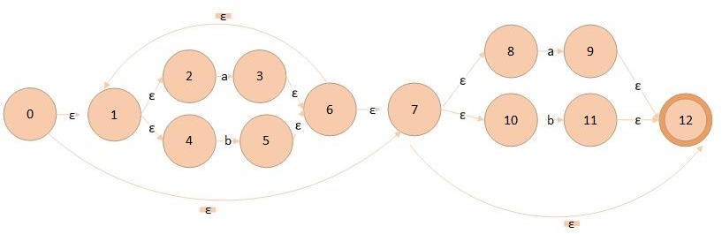

Cerradura -€(0) => {0,1,2,4,7,8,10,12} = A

Mueve(A,a) = mueve ({0,1,2,4,7,8,10,12},a)={3,9}

Cerradura -€(mueve(A,a))={0,1,2,3,4,7,8,9,10,12} = B

Mueve(A,b) = mueve({0,1,2,4,7,8,10,12},b)={5,11}

Cerradura -€(mueve(A,b))={0,1,2,4,5,7,8,10,11,12} = C

Mueve(B,a) =mueve({0,1,2,3,4,7,8,9,10,12},a)={3,9}

Cerradura -€(mueve(B,a))={0,1,2,3,4,7,8,9,10,12} = B

Mueve(B,b) = mueve({0,1,2,3,4,7,8,9,10,12},b)={5,11}

Cerradura -€(mueve(B,b)) ={0,1,2,3,4,5,7,8,9,10,11,12} = D

Mueve(C,a) = mueve({0,1,2,4,5,7,8,10,11,12},a)={3,9}

Cerradura -€(mueve(C,a))={0,1,2,3,4,5,7,8,9,10,11,12}= D

Mueve(C,b) = mueve({0,1,2,4,5,7,8,10,11,12},b)={5,11}

Cerradura -€(mueve(C,b))={0,1,2,4,5,7,8,10,11,12} = C

Mueve(D,a) = mueve({0,1,2,3,4,5,7,8,9,10,11,12},a)={3,9}

Cerradura -€(mueve(D,a))={0,1,2,3,4,5,7,8,9,10,11,12} = D

Mueve(D,b) = mueve({0,1,2,3,4,5,7,8,9,10,11,12},b)={5,11}

Cerradura -€(mueve(D,b))={0,1,2,3,4,5,7,8,9,10,11,12}= D