Mini Project 2
Mean Squared Error 3
Create Mean Plots 3
load('Spike_Events.mat');
load('templates.mat');
figure;
hold on;
for i = 1: size(SpikeEvents,2)
plot(SpikeEvents(:,i));
end
hold off;
SpikeEventsdemean = bsxfun(@minus,SpikeEvents',mean(SpikeEvents'));
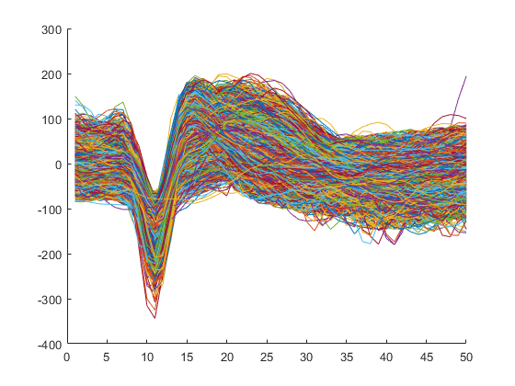
[coeff,score,latent] = pca(SpikeEvents','NumComponents',2);
% covarianceMat = cov(SpikeEventsdemean);
% [eigvec,eigvals] = eig(covarianceMat);
% figure;
% hold on;
% for i = 1:2
% plot(coeff(:,i));
% end
% hold off;
% legend('1','2');
% figure;
% biplot(coeff(:,1:2),'scores',score(:,1:2));
figure; hold on; scatter(score(:,1),score(:,2),'r.'); temp = SpikeEventsdemean*coeff; scatter(temp(:,1),temp(:,2),'b.'); hold off;
clear indeces;
numclusters = 5;
[idx,C,sumd,D] = kmeans(score(:,1:2),numclusters,'MaxIter',1000);
matrix = [score(:,1:2),idx];
figure;
hold on;
for i = 1:numclusters
indeces(1:length(find(matrix(:,3) == i)),i) = find(matrix(:,3) == i);
scatter(matrix(nonzeros(indeces(:,i)),1),...
matrix(nonzeros(indeces(:,i)),2),'.');
variances(i) = sum(pdist2(score(nonzeros(indeces(:,i)),:),C(i,:)).^2)...
/length(nonzeros(indeces(:,i)));
covariances(i) = sum((score(nonzeros(indeces(:,i)),1) - C(i,1)).*...
(score(nonzeros(indeces(:,i)),2) - C(i,2)))...
/length(nonzeros(indeces(:,i)));
end
legend('1','2','3','4','5');
scatter(score2(:,1),score2(:,2),'ko','DisplayName','Attempt Centroid');
scatter(C(:,1),C(:,2),'kx','DisplayName','Ground Truth Centroid');
hold off;
variances =
1×5 single row vector
1.0e+03 *
8.4691 3.5450 6.4448 3.4662 3.5445
covariances =
1×5 single row vector
592.1907 -193.9375 49.6907 -256.4259 -402.5603
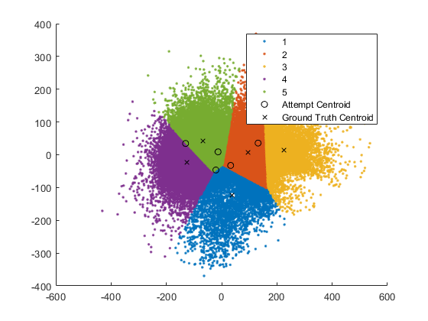

Mean Squared Error
groundtruth = sortrows(score2,1);
attempt = sortrows(C,1);
MSE = sum(diag(pdist2(attempt,groundtruth)).^2);

MSE =

4.8438e+04

Mean squared error is pretty high, however ground truth labels don’t seem to match clusters very well either.

Create Mean Plots
for i = 1:numclusters
figure;
hold on;
plot(SpikeEvents(:,nonzeros(indeces(:,i))));
plot(mean(SpikeEvents(:,nonzeros(indeces(:,i))),2),'k-','LineWidth',3);
title(['Cluster ' num2str(i)]);
hold off;
end
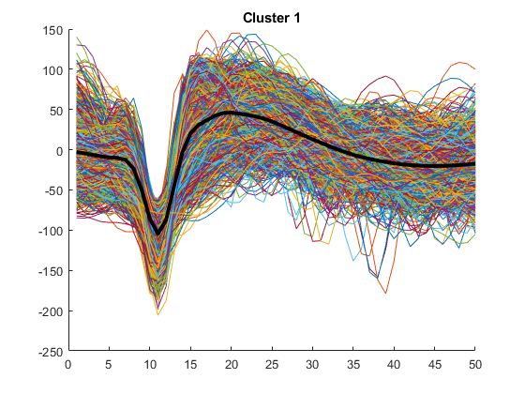
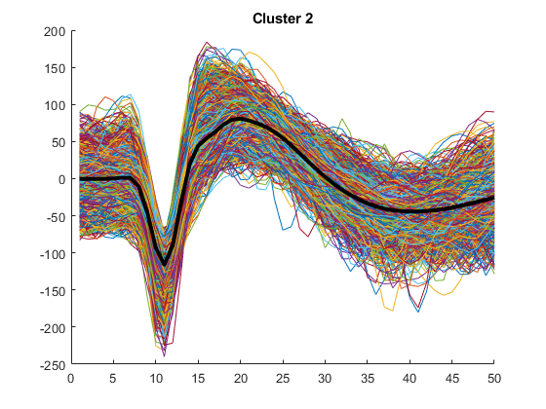
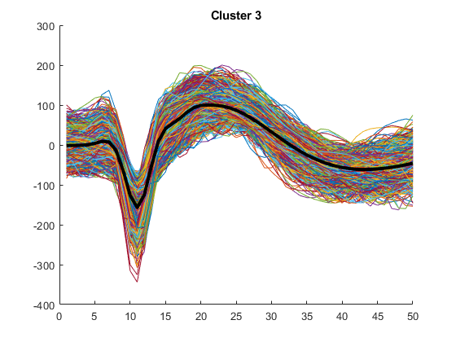
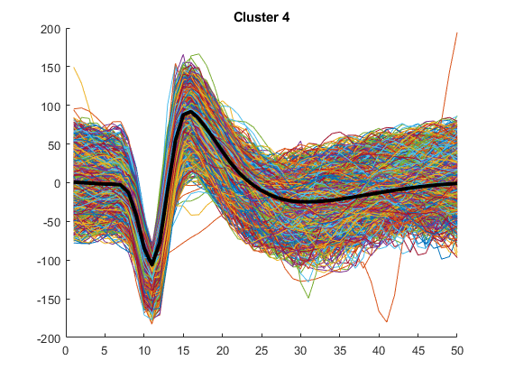
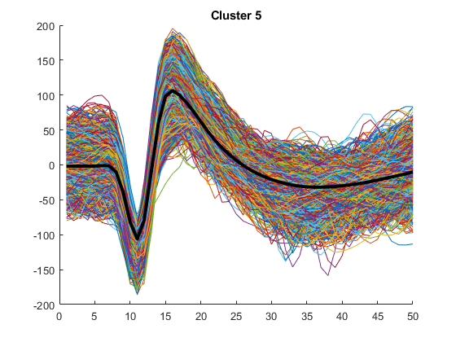
Published with MATLAB® R2017b
The optimal decision boundary does match the variances and the covariances well, the variances and the covariances are quite large, contributing to the decision boundaries squeezing up against each other to form straight lines.

