**High-level design approach**

**Problem statement**:

We began with the problem statement, as provided in the course syllabus:

**Project #2 – Personal Finance Management**

* Implement an optimization-based decision support system for individual asset-liability management based on the paper by Medova et al. in the journal Quantitative Finance.
* Core problem: integrate the assets and liabilities of an individual based on using optimization. This means finding the best investment strategies under uncertainty that meets liabilities and financial goals of an individual.
* This will be an important emerging functionality for FinTech.

The problem presented here is the following: create a tool to help design a financial strategy for an individual to optimally satisfy a set of customized financial goals, within a universe of uncertain financial assets. The functionality of the tool will then be similar to that which is currently provided by financial advisors to their clients, and by robo-advisor services available online (e.g. Wealthsimple, Wealthfront). To improve our problem statement, let’s start off by looking at the current solutions available for this problem.

**Current solutions**:

The traditional best solution to designing a financial strategy is to work with a professional financial advisor. The client will submit to an interview meeting with the advisor, who will attempt to ascertain information about important aspects of the client’s financial situation, including such items as assets, liabilities, income, financial goals, and level of risk aversion. The advisor will then consult their sales brochures for information about the available set of financial products (i.e. savings accounts, GICs, savings bonds, and mutual funds), information which is often highly qualitative (e.g. risk levels on a scale of 1 to 5, Morningstar ratings) or potentially irrelevant and misleading (e.g. past performance versus an index), or otherwise incomplete (e.g. beta to the market is given, but not correlation with other assets). Combining the set of information about their client and the set of information about available products, they will then apply their own rudimentary algorithm (e.g. stock/bond proportioning dependent on age, equal-weighted sub-portfolios for diversification) in order to arrive at a final portfolio that they will then implement for the client.

The traditional approach can lead to sub-optimal outcomes for many reasons, two of which are a lack of accounting for fine-level correlation between assets, and a bias towards actively-managed mutual funds with high fees (a portion of which often kicks back to the advisor!). In recent years, companies such as Weathfront and Wealthsimple have come to market with a quantitative, passive-focused ETF approach that addresses these two problems, and have managed to make progress in convincing the investing public of the value of this approach. They have also managed to reduce the cost to the end-user by removing paid advisors from the process of investing.

However, a major drawback in these new, automated modes of investing is that they target a very narrow range of use cases. As representative examples for the industry-standard offering, let’s examine Wealthsimple (Canada) and Wealthfront (U.S.).

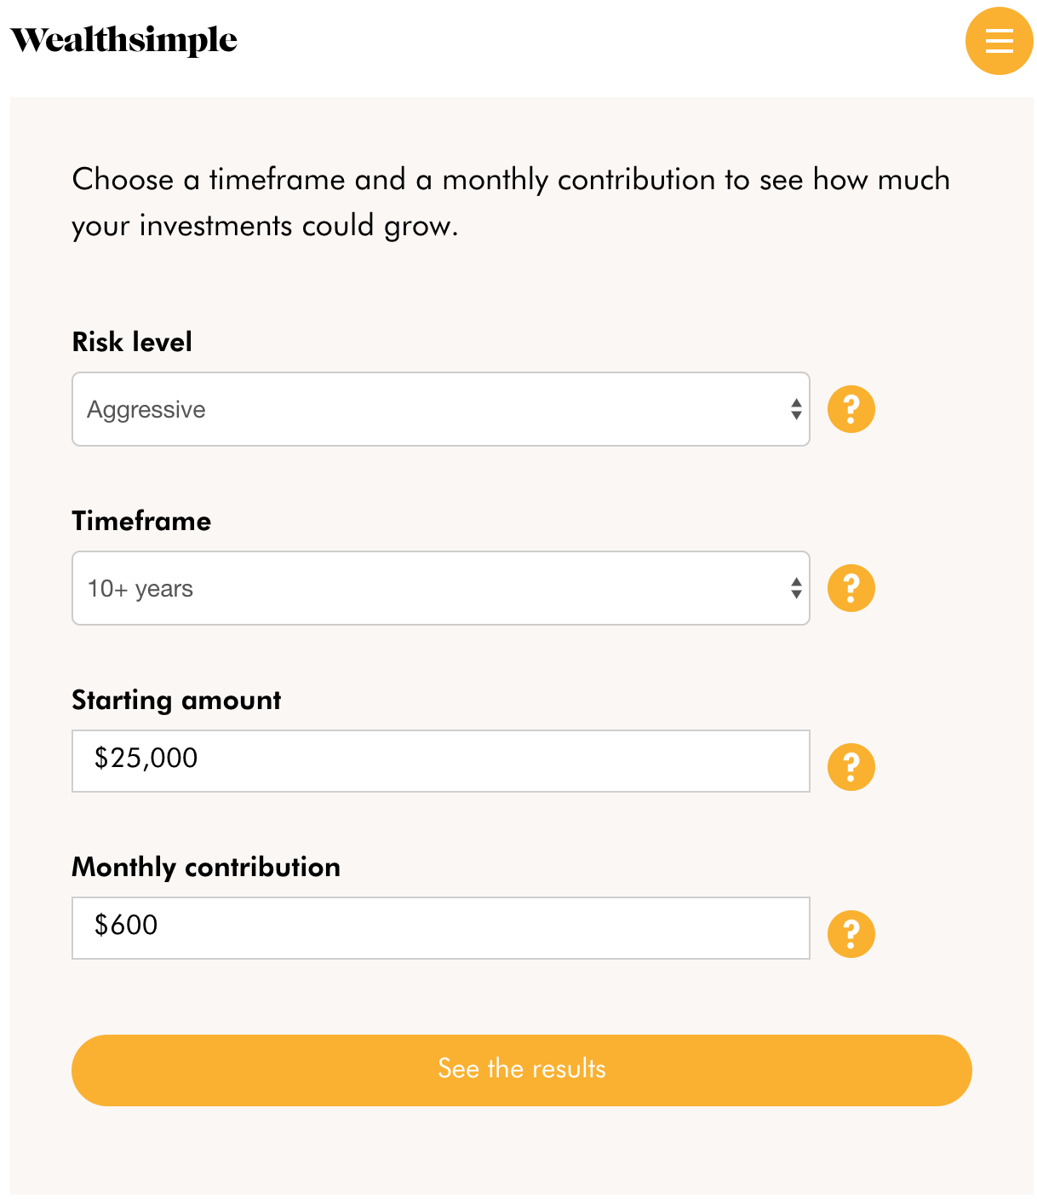

Wealthsimple starts by asking its user how much money they have to invest, and can incorporate a level of risk aversion in order to optimize return over a fixed length of time. Wealthfront offers a similar service, but geared towards generating retirement income.

So what if the user is a single mom with two children who wants to generate a plan to send her kids to university in 15 years? Neither service offers the ability to input cash outflow-related goals. The user could probably adjust her contribution levels and try to generate an expected portfolio value equal to 8 years of university tuition in the year 2030 (ouch! looks like we may have to forget about putting kid 2 in hockey). But what if the market goes down? And what happens afterwards? Does she still have any money left for retirement? Clearly, the current offering of robo-advisor services leaves a lot to be desired in terms of incorporating customized liability and cash outflow considerations for an individual.

**Improving on current solutions:**

So how can our tool be better than currently available solutions for designing financial strategies? As per the previous section, the identified area of improvement is in handling customized liability considerations. The problem of incorporating such considerations is addressed in Medova et al., which looks at a solution (iALM) that optimizes a set of asset allocations for an individualized utility function under uncertainty using dynamic stochastic programming (see the literature review for more information). By incorporating considerations about an individual’s specific financial goals into its core optimization problem, the tool will have the ability to design financial strategies that better satisfy an individual’s lifetime utility function under uncertainty (and isn’t that what happiness is all about?).

We also recognize that the success of online robo-advisor services demonstrates the potential for a paid financial advisor to be replaced by a well-designed user experience. An important aspect of the user experience of these websites is that it is geared towards users with low-to-middle levels of financial literacy, who would otherwise rely on their financial advisors to help them navigate the world of available financial products. So an effective tool should ideally cut out the need for a skilled operator (i.e. a financial advisor) by presenting a simple and self-explanatory user interface that aims to educate the user as well as to facilitate their immediate financial planning needs.

With these insights in mind, let’s revisit the problem statement.

**A reframed problem statement:**

* Implement an optimization-based decision support system for ~~individual asset-liability management~~ individual financial planning, which improves on existing decision support systems by incorporating individualized asset and liability considerations into optimal asset allocations through utility functions (based on the paper by Medova et al. in the journal Quantitative Finance,), and which presents itself in a way that is highly accessible to the broad investing public.