**User interface wireframes (web version, 1920 resolution):**

**Splash (when the app is first opened):**



* Changes to Wizard 1 when finished
* This is not what it will actually look like!

**Wizard 1:**

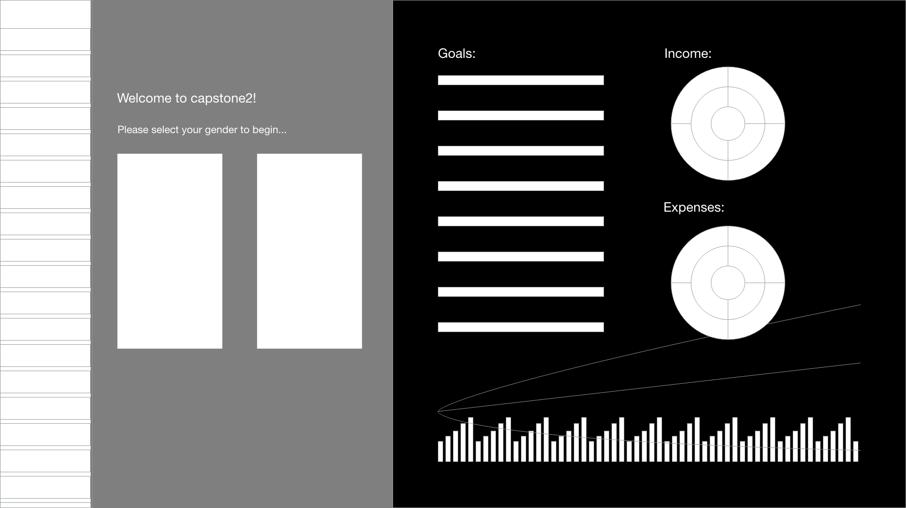

* Questionnaire/wizard mode available on the left
* Example financial strategy available on the right to explore
* Selecting a gender goes to Wizard 2
* Clicking in the right pane goes to Explore

**Wizard 2:**

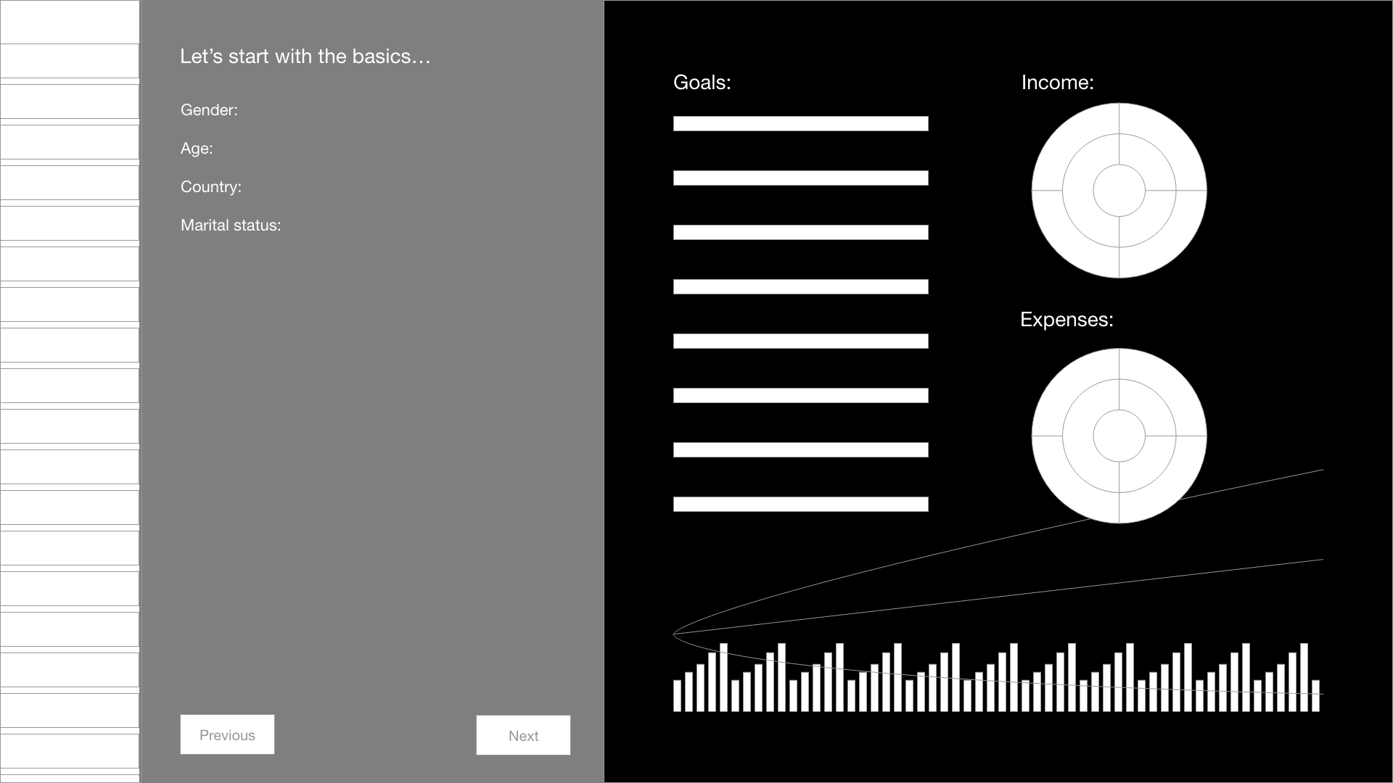

* Basic questions in order to project life expectancy, establish asset/tax universe, etc.
* Clicking in the right pane goes to Explore
* Clicking next goes to Wizard 3
* Clicking previous goes to Wizard 1
* Shows wizard progress on the left, click in left bar at any time to navigate wizard

**Wizard 3:**

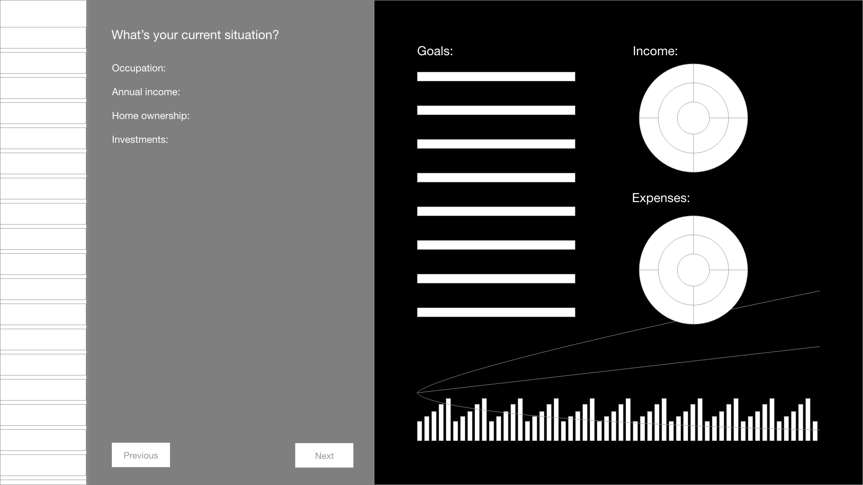

* Continuation of Wizard 2
* Questions focus on establishing current situation

**Wizard 4:**

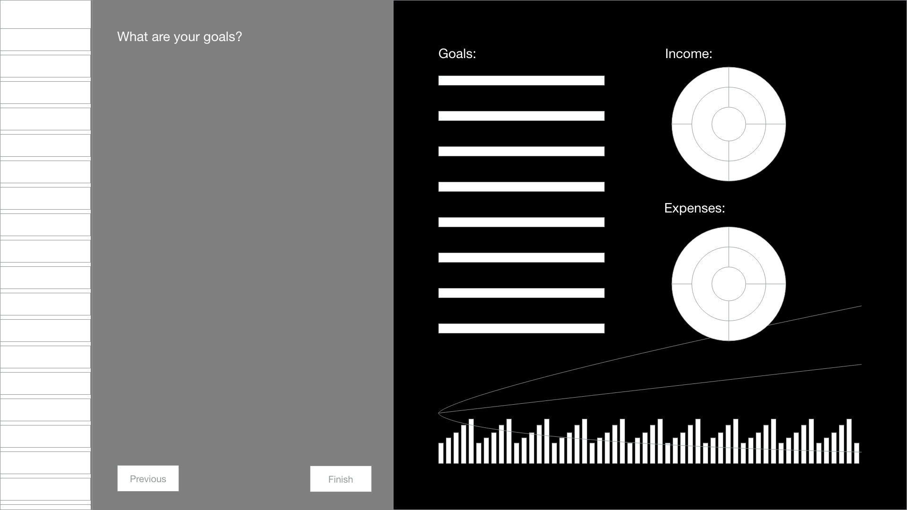

* Questions focus on establishing goals, risk aversion, etc.
* Clicking finish triggers a re-optimization and goes to Explore

**Explore:**

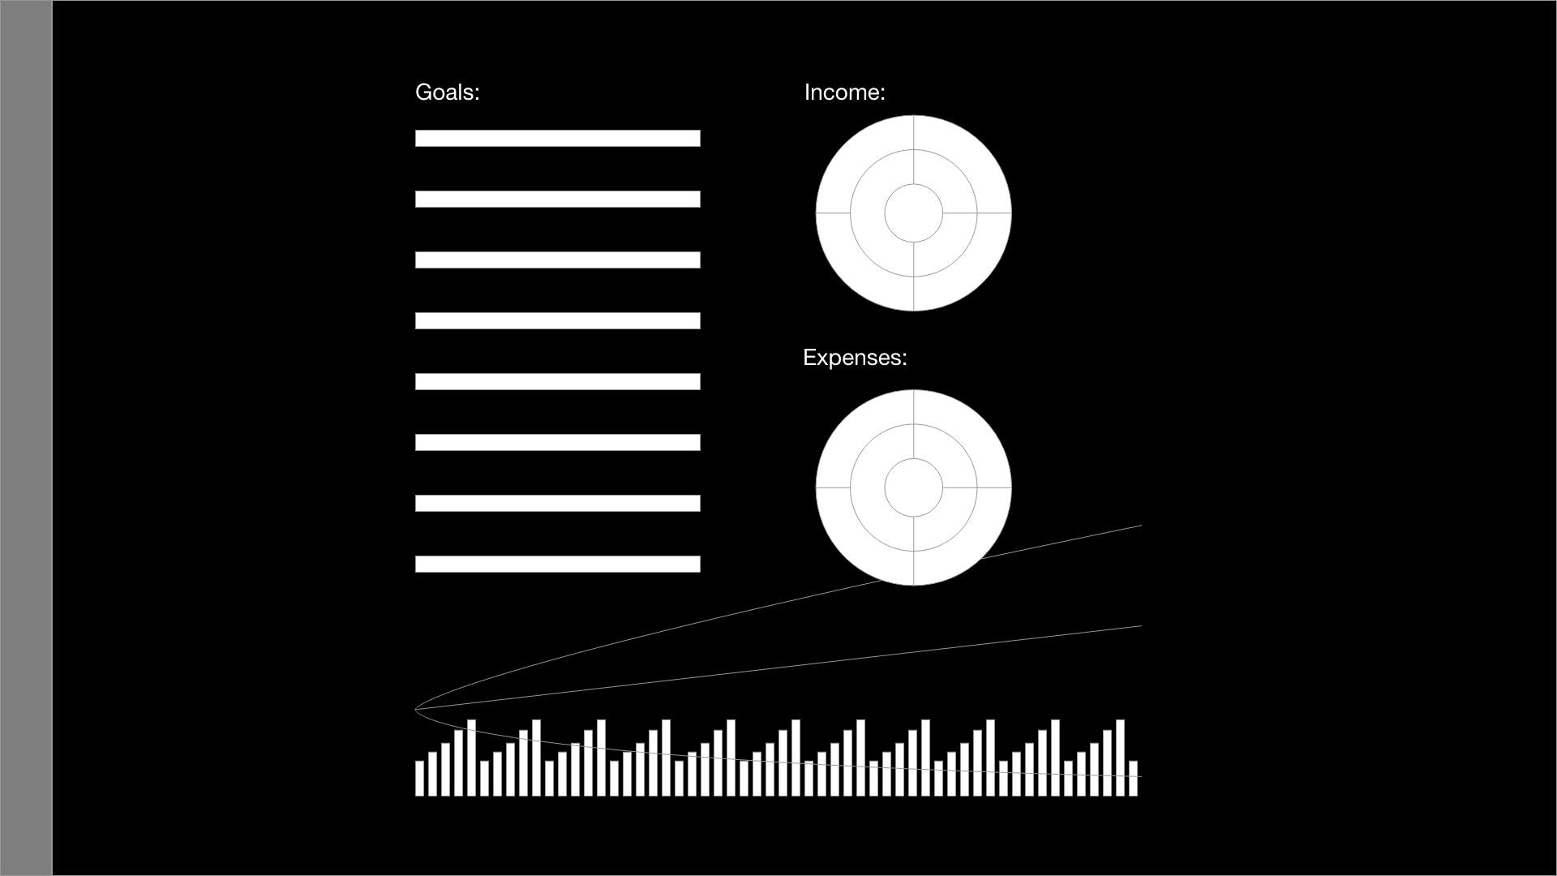

* Lists current goals, shows probability of meeting/distribution
* Click in goals area goes to Add Goal
* Shows projected total lifetime income/expenses, categorized and subdivided by area
* Click in income/expenses goes to Edit Income/Expense Item
* Shows projected asset allocations by year as time series stacked bar chart, overlaying lines representing expectation and uncertainty range for total wealth over time
* Clicking in bar chart goes to Cross Section
* Clicking in bar on left goes to Wizard

**Add Goal:**

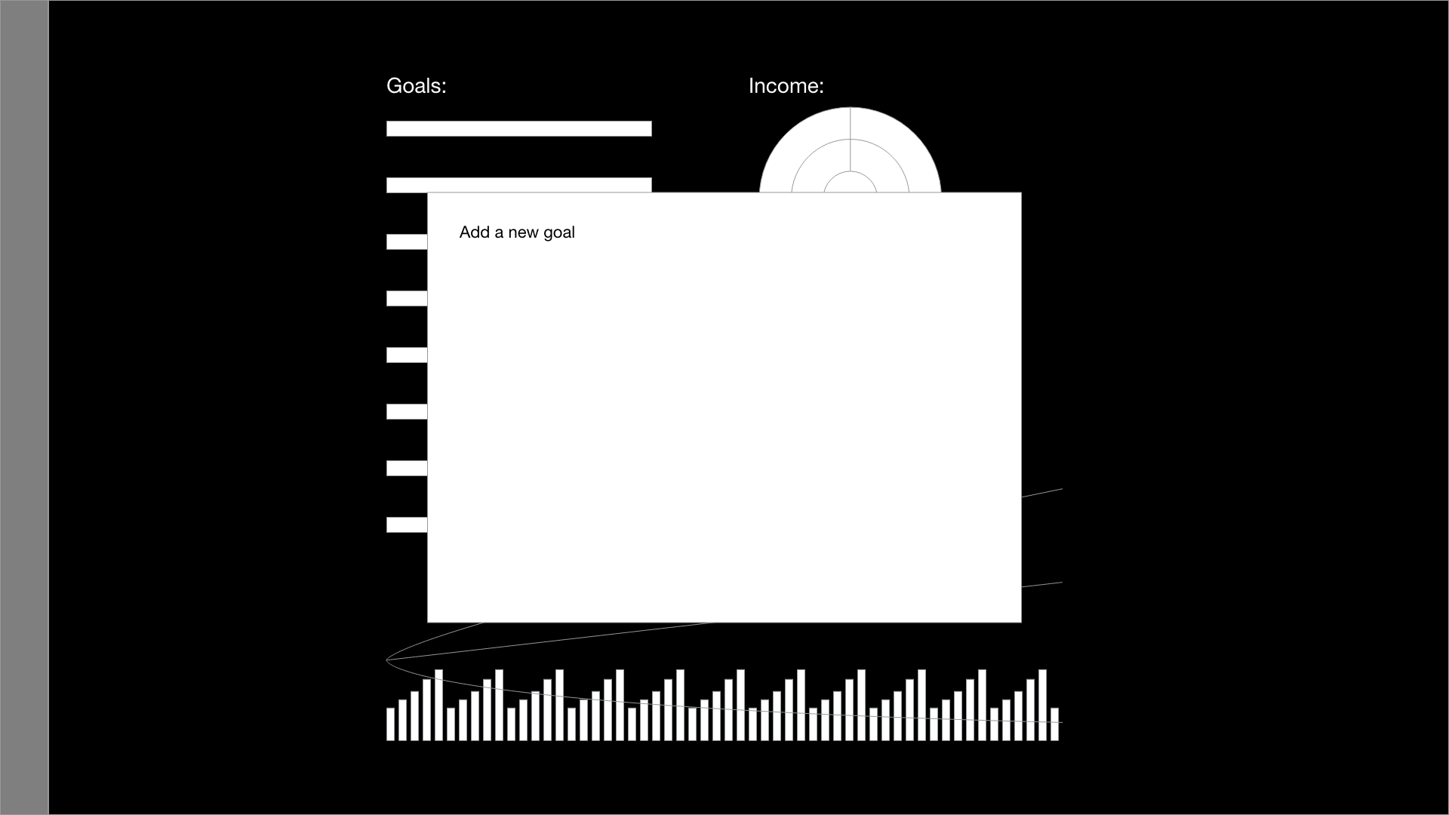

* Interface for adding a new goal
* User can select from and customize pre-defined goals, or input their own

**Edit Income/Expense Item:**

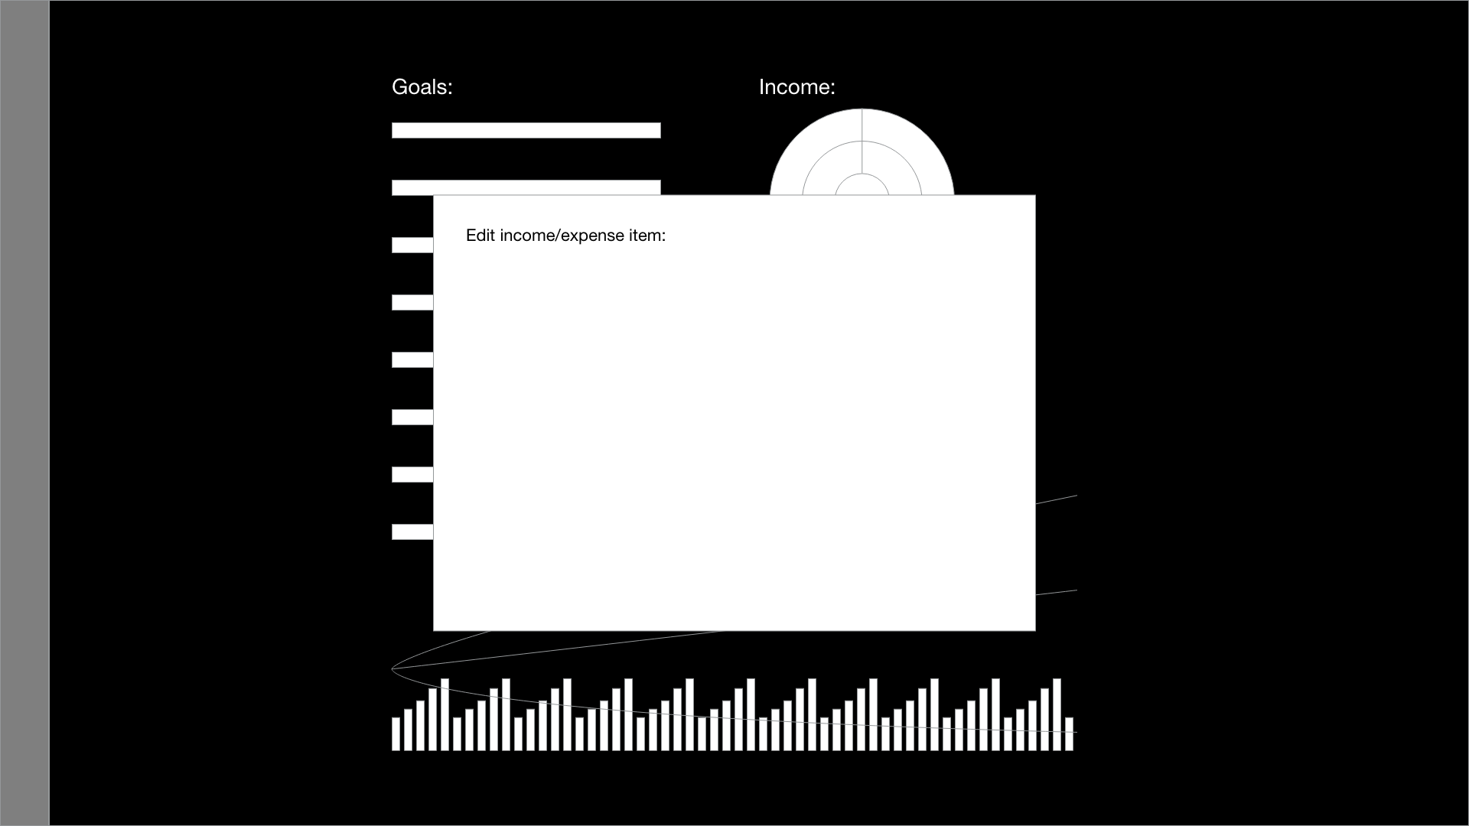

* Change amounts projected for selected income/expense

**Cross Section:**

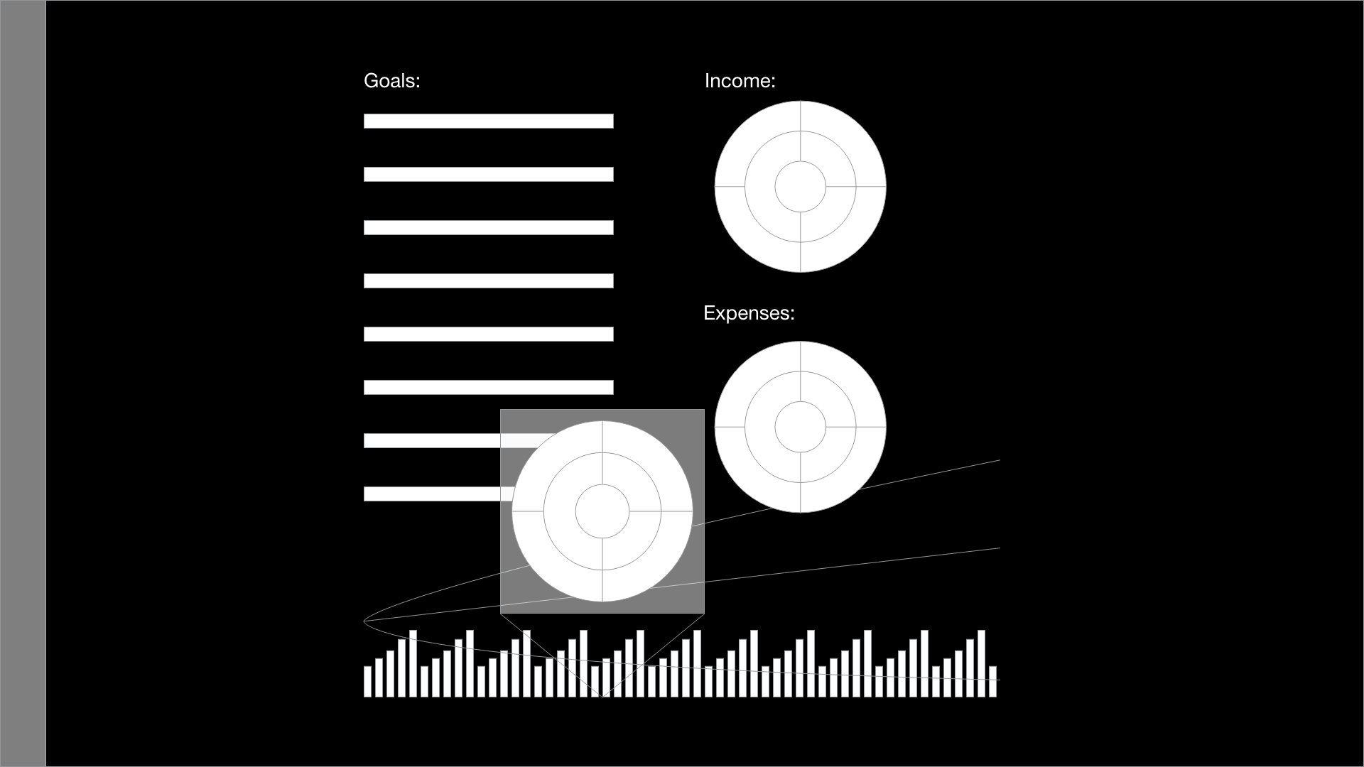

* Categorized/subdivided cross section of asset allocations for a given year