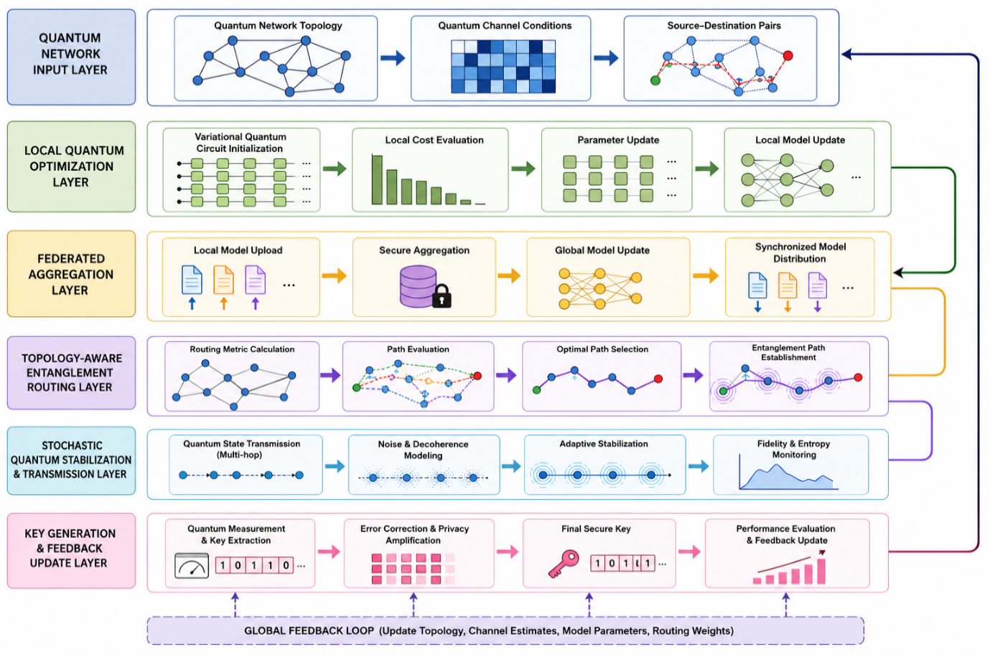
Figure 1: Federated Variational Quantum Optimization with Topology-Aware Routing
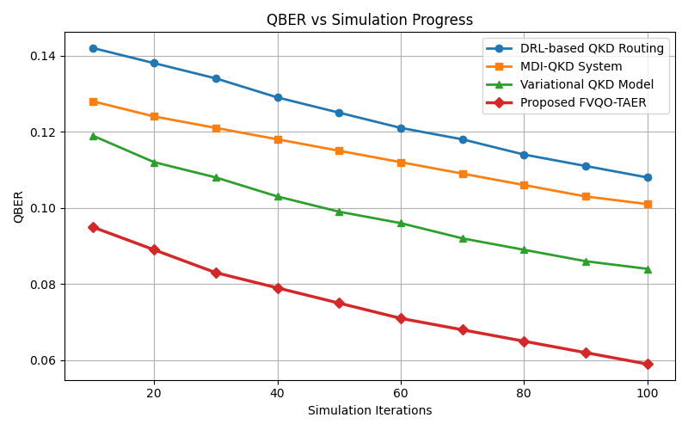
Figure 2: QBER across the simulation runs
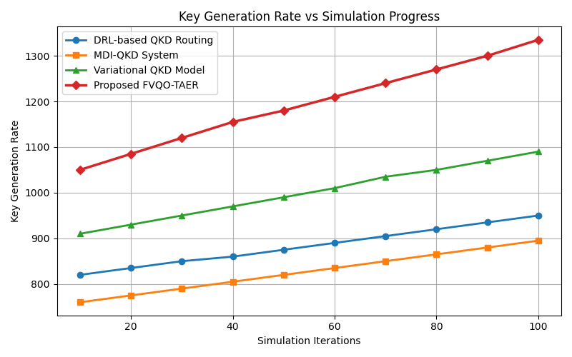
Figure 3: KGR across the simulation runs
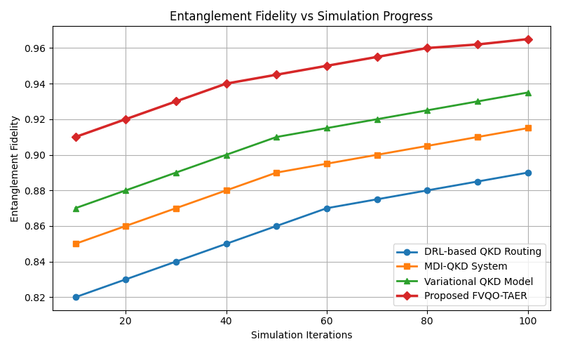
Figure 4: EF across the simulation runs
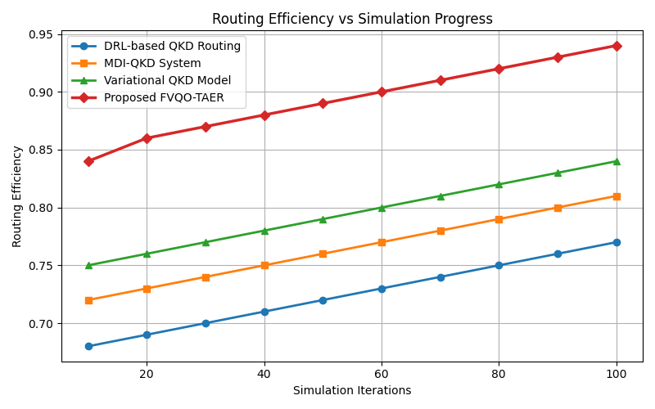
Figure 5: RE across the simulation runs
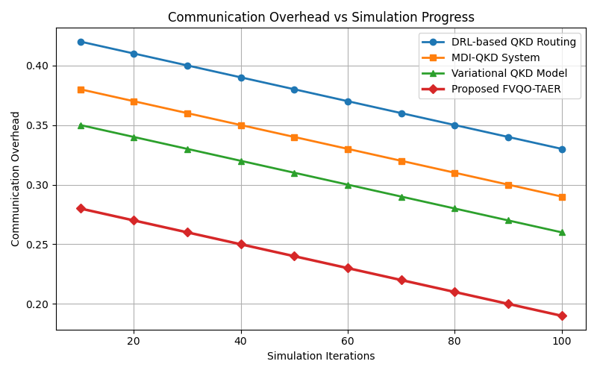
Figure 6: CO across the simulation runs

