Midas_V2 Scenarios: B, C, D, E

Abbreviations
To make this document clear, here are the abbreviations used throughout:
- TP = Take-Profit (the percentage gain target at which a trade is closed in profit).
- SL = Stop-Loss (the percentage loss at which a trade is closed to limit risk).
- EMA = Exponential Moving Average (a moving average that gives more weight to recent prices).
- VWAP = Volume-Weighted Average Price (average price weighted by trading volume).
- MACD = Moving Average Convergence Divergence (a momentum indicator that compares two moving averages).

Moving Average vs MACD
Although both are technical indicators, Moving Averages (MAs) and MACD serve different purposes:
• Moving Average (MA): A smoothed line showing the average price over a period (e.g., 9-day EMA, 200-day SMA). It indicates trend direction and can act as support or resistance.
• MACD (Moving Average Convergence Divergence): A momentum indicator built from two EMAs (typically 12-EMA and 26-EMA). It measures the difference between them, and adds a signal line (9-EMA of the MACD line) plus a histogram.
Key differences:
- MA shows trend; MACD shows momentum (acceleration/deceleration).
- MA is a direct price average; MACD is derived from the relationship between two MAs.
Analogy: A Moving Average is like a car’s speedometer (how fast you are going). MACD is like the accelerator pedal (are you speeding up or slowing down?).

Midas_V2 Scenarios – Moving Average vs MACD (Visual)
The chart below shows the difference between Moving Averages and MACD in practice:
- Top panel: Price with EMA lines (blue = 9-EMA, red = 26-EMA).
- Bottom panel: MACD indicator with MACD line (green), Signal line (orange), and Histogram (grey).
This illustrates how EMAs track trend, while MACD captures momentum and changes in acceleration.
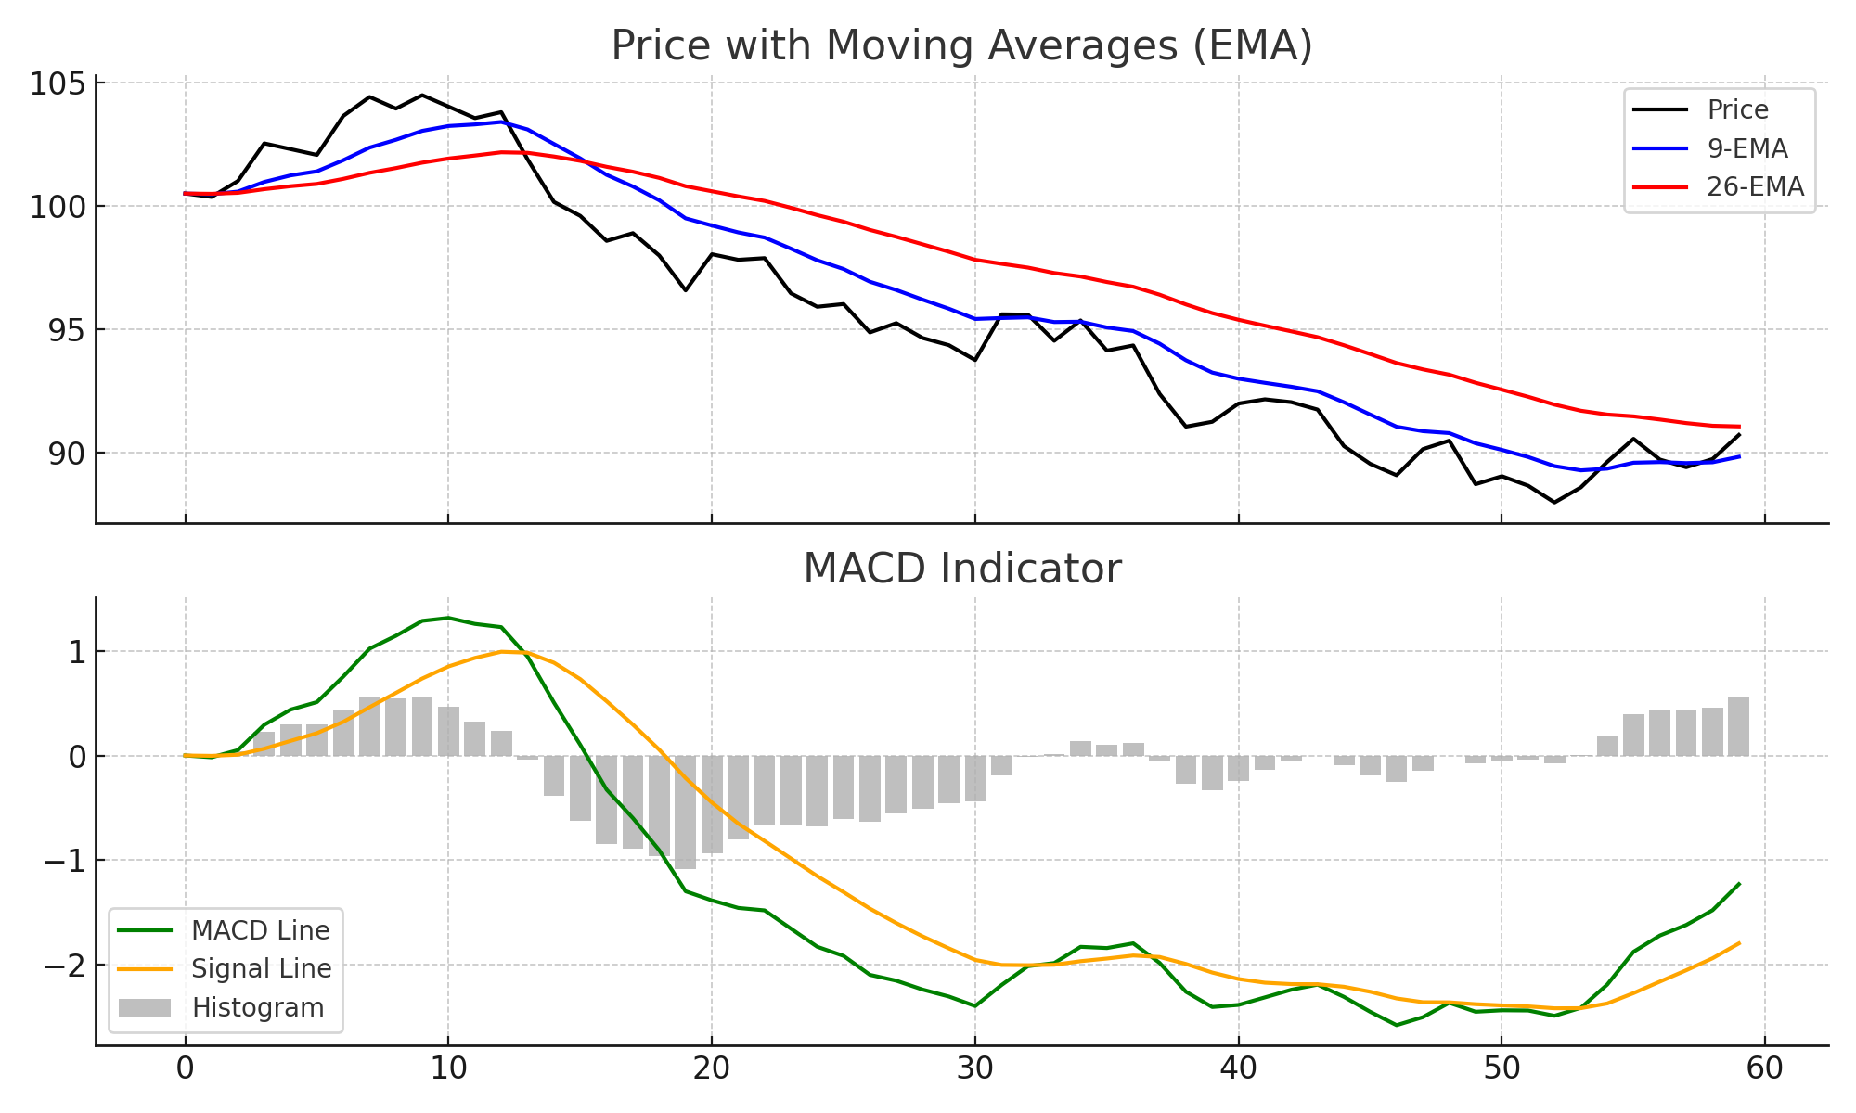

Midas_V2 Scenarios: B, C, D, E
This document explains the meaning of Scenarios B, C, D, and E in the Midas_V2 backtesting framework. Each scenario represents a different set of trading parameters designed to test profitability under varying conditions.

Scenario B – Baseline (Conservative Profit-Taking)
Scenario B is the baseline strategy. It represents a conservative, high-win-rate approach that aims for smaller, safer profits per trade. Key aspects:
- Take-profit (TP) around +2% per trade.
- Stop-loss (SL) around -4%.
- EMA confirmation ON.
- VWAP confirmation ON.
- MACD confirmation OFF.
Goal: Generate many small winners with high consistency. Works best when market conditions favor quick scalps.

Scenario C – VWAP Off (More Aggressive Entries)
Scenario C removes the VWAP confirmation filter, allowing more trades to trigger. Key aspects:
- TP and SL similar to Scenario B (≈ +2% / -4%).
- EMA confirmation ON.
- VWAP confirmation OFF.
- MACD confirmation optional depending on config.
Goal: Capture more opportunities, even if they are riskier, by not requiring price to align with VWAP before entry.

Scenario D – Larger Profit Targets
Scenario D is designed to test larger profit targets, aiming to capture extended runs. Key aspects:
- Take-profit (TP) raised to ~5–10% or more.
- Stop-loss slightly widened (e.g., -5% to -8%).
- EMA confirmation ON.
- VWAP confirmation ON.
- MACD confirmation OFF (fewer filters, looser entries).
Goal: Trade less frequently but capture bigger wins when momentum is strong. Useful for testing high-reward setups at the cost of lower win rate.

Scenario E – Dip Reclaim Strategy
Scenario E implements a dip-reclaim strategy, entering after a pullback when price reclaims a key level. Key aspects:
- Entry triggered by reclaiming VWAP or EMA after a dip.
- TP around +2% to +4% depending on config.
- SL wider (e.g., -4% or more) to allow room for dip.
- EMA + VWAP confirmation ON.
- MACD confirmation ON for momentum confirmation.
Goal: Buy dips and catch the rebound, similar to Ross Cameron’s ‘dip-trading’ style. This scenario focuses on second-chance entries rather than pure breakouts.

