**Third Year B. Tech., Sem V 2021-22**

**Programming Lab 3**

**Practical No- 3**

**PRN/ Roll No: 2019BTECS00070**

**Full name: Killedar Prathmesh Basaweshwar**

**Batch: T2**

**Title:Practical 5a**

**Code:-**

**1)**

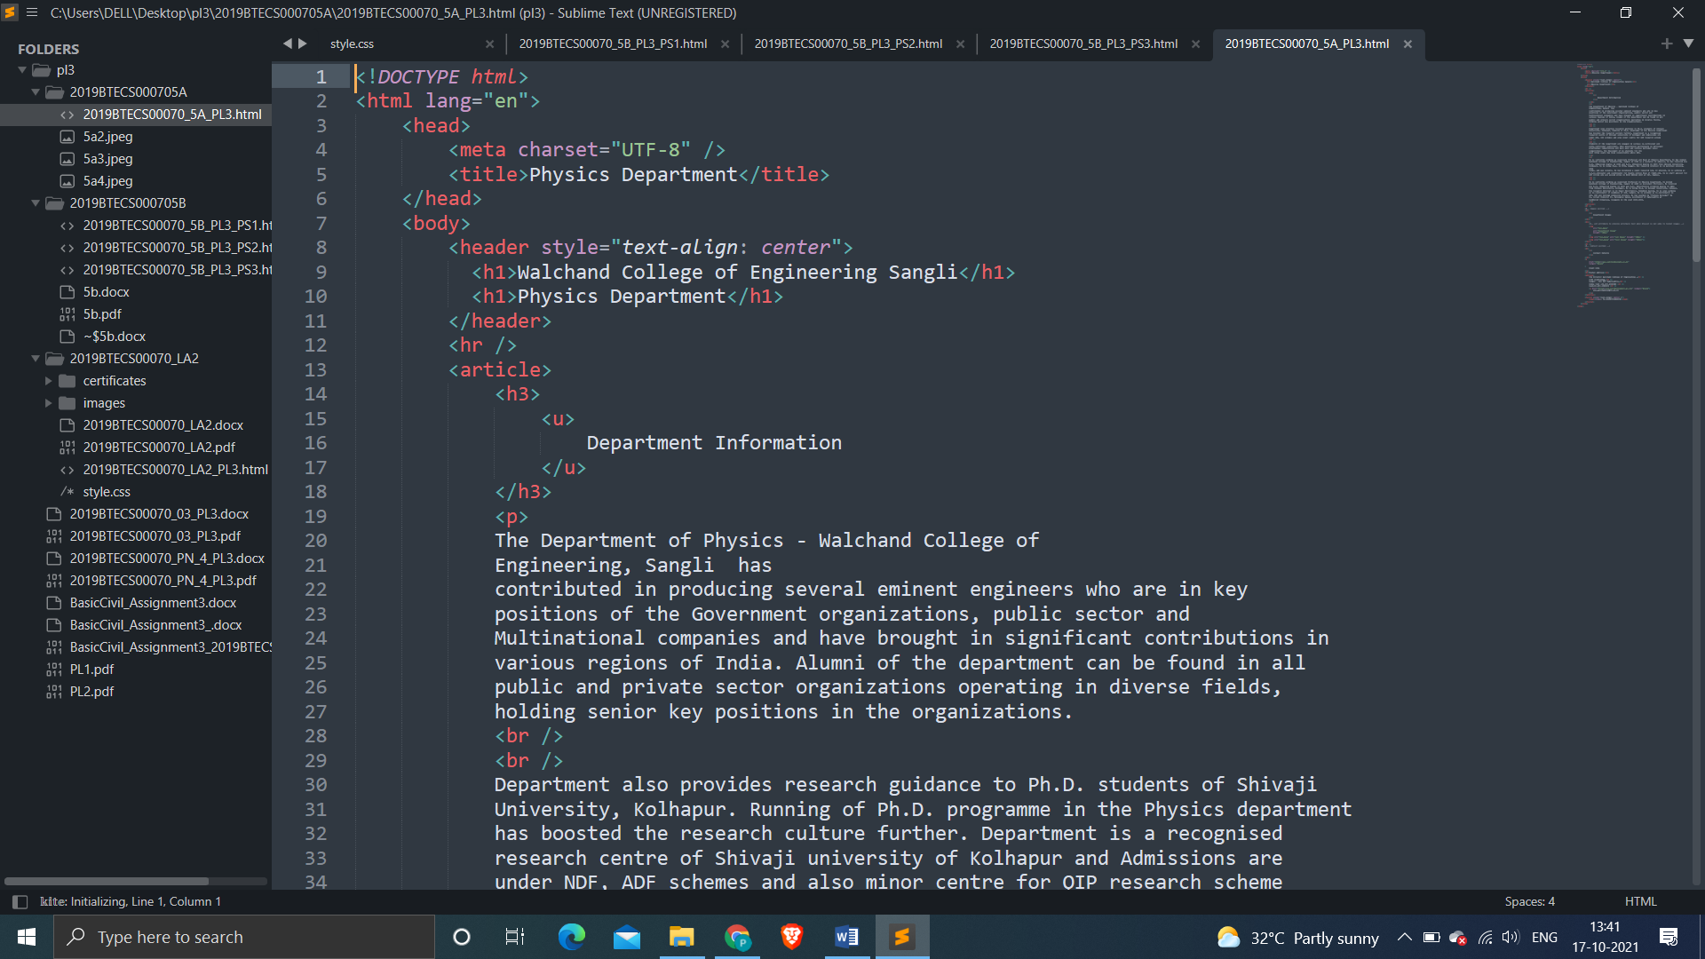

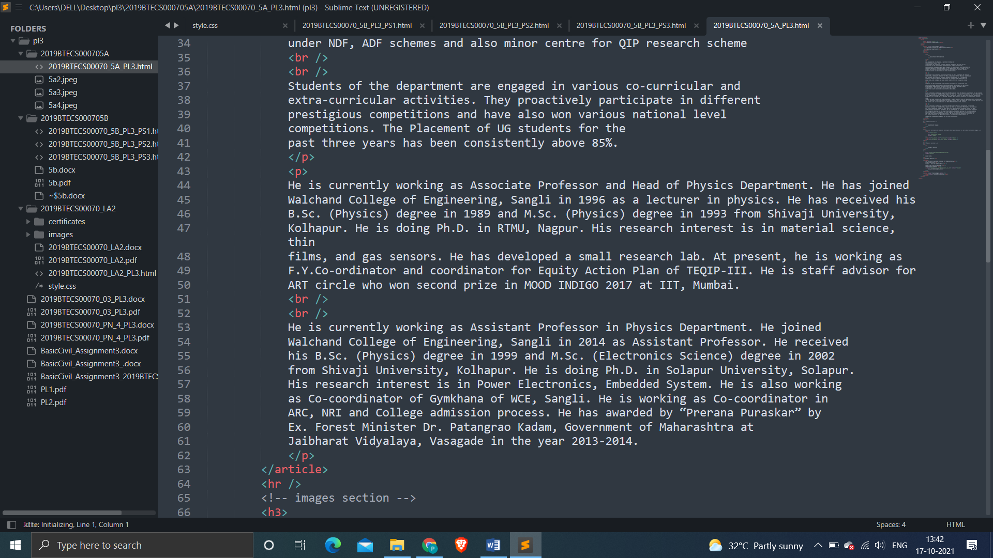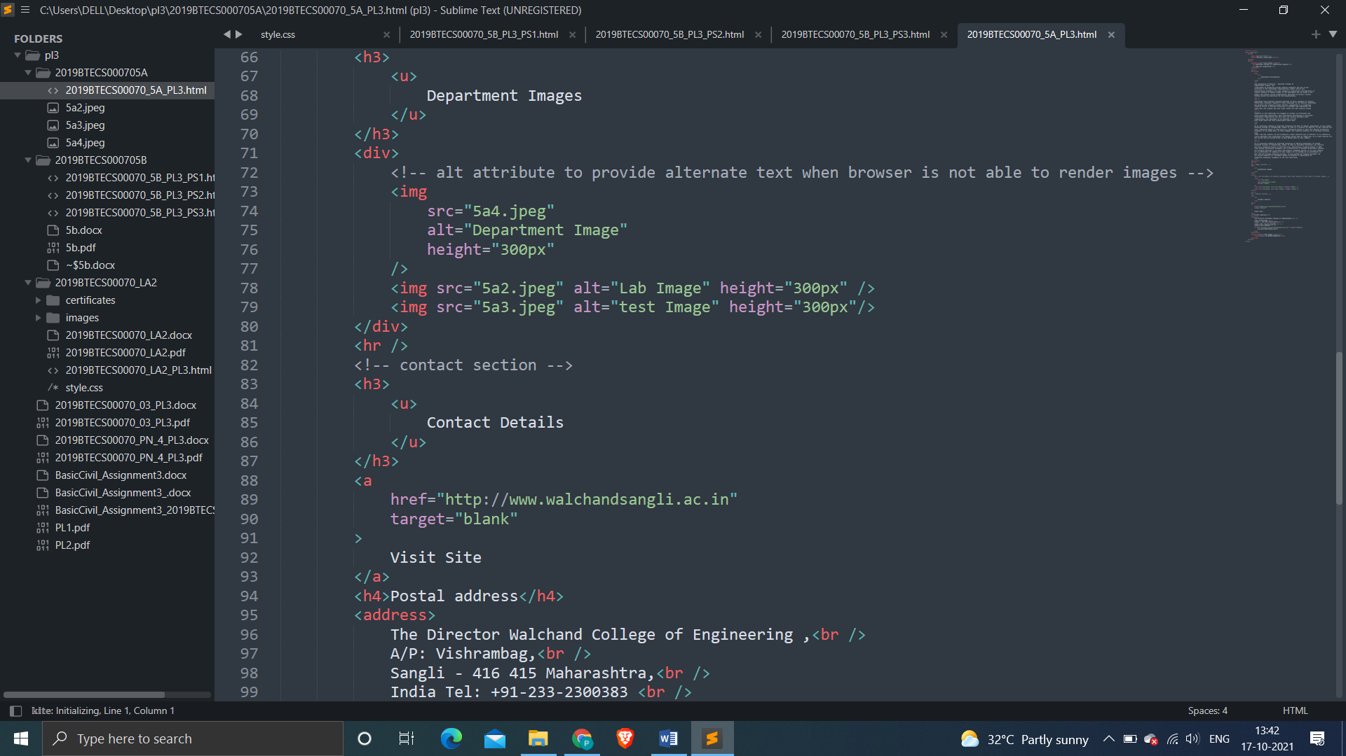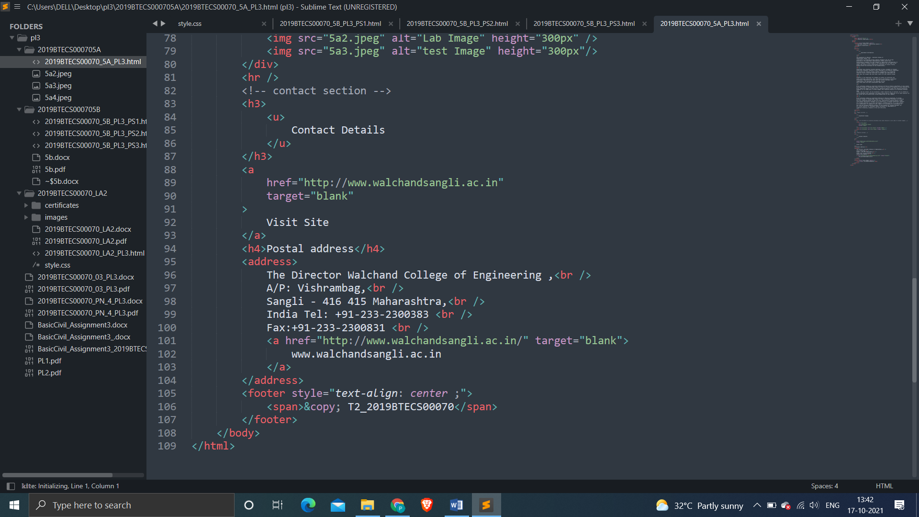

**Output:-**

