目录
目录 1
1.特殊字符 2
Backslash \ 2
Character $ 2
Character ^ and _ 2
Character % 2
Character # 3
Character & 3
2.Producing a Latex input file 3
3.Quatation Marks and Dashes 3
4.Section Heading 4
5.Text模式下改变字体大小 4
6.Greek Letters 5
7.公式中嵌入文字 8
8.分数 9
9.三个省略号 9
10.矩阵 9
11.微分和积分 10
12.List 列表 10
13.插入代码或者预先定义的格式的文本 10
14.插入表格 11
15.定义你自己的控制序列 11

1.特殊字符
\ { } $ ^ _ % ~ # &

Backslash \
Mathematical documents often contain arrays of numbers or symbols (matrices) and other complicated expressions. These are produced in LaTeX using control sequences.
Most control sequences consist of a backslash \ followed by a string of (upper or lower case) letters. For example, \delta, \emph and \to are control sequences:
the control sequence \delta produces the greek letter ,
the control sequence \emph, when followed by text enclosed within braces, will cause that text to be emphasized (usually by typesetting it in an italic font), and the control sequence \to (or \rightarrow) produces the arrow.

Character $
The special character $ is used when embedding mathematical expressions in paragraphs of ordinary text in order to change into and out of `mathematics mode'.

Character ^ and _
The special characters ^ and _ are used in mathematical expressions to produce superscripts and subscripts respectively.

Character %
The special character % is used to introduce `comments' into the input file that do not appear in the final document: all characters occuring after % on any line of the input file are ignored by LaTeX.

Character #
The special character # is used to specify arguments in definitions of control sequences.

Character &
The special character & is used when typesetting tables in order to separate entries in different columns.

2.Producing a Latex input file

\documentclass[a4paper,12pt]{article}
After the \documentclass command and these other optional commands, we place the command
\begin{document}
\end{document}

3.Quatation Marks and Dashes
'Single Quatation'
``double Quatation''
'dashes 1 -- '
'dashes 2 --- '

4.Section Heading
\section{}
\subsection{}
\subsubsection{}

5.Text模式下改变字体大小

\emph{text}

\tiny
\scriptsize
\footnotesize
\small
\normalsize
\large
\Large
\LARGE
\huge
\HUGE

6.Greek Letters
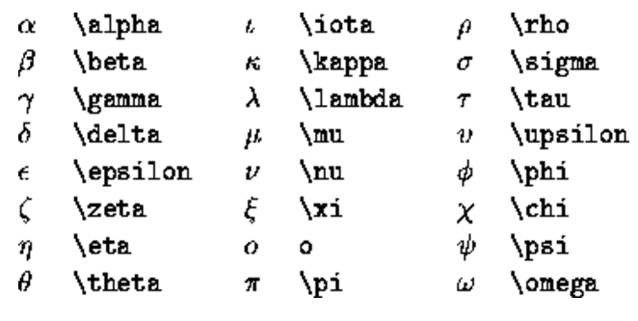
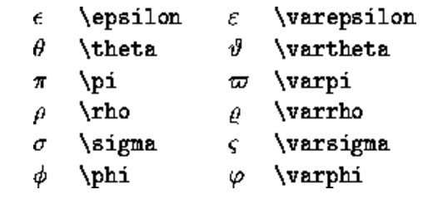
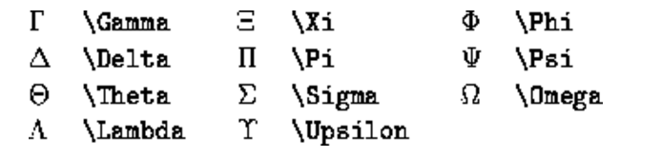

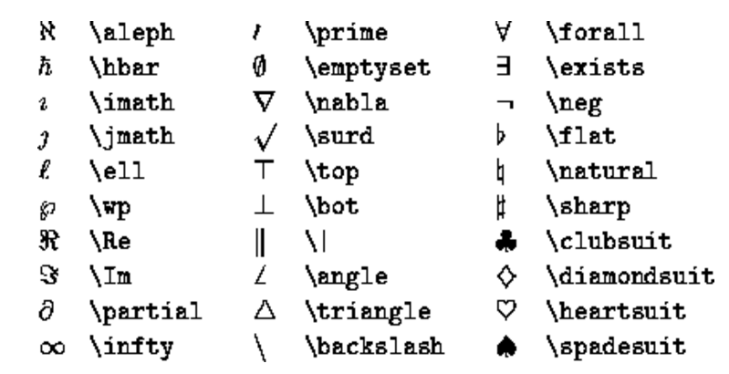
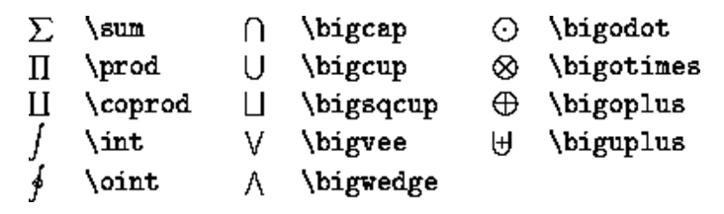
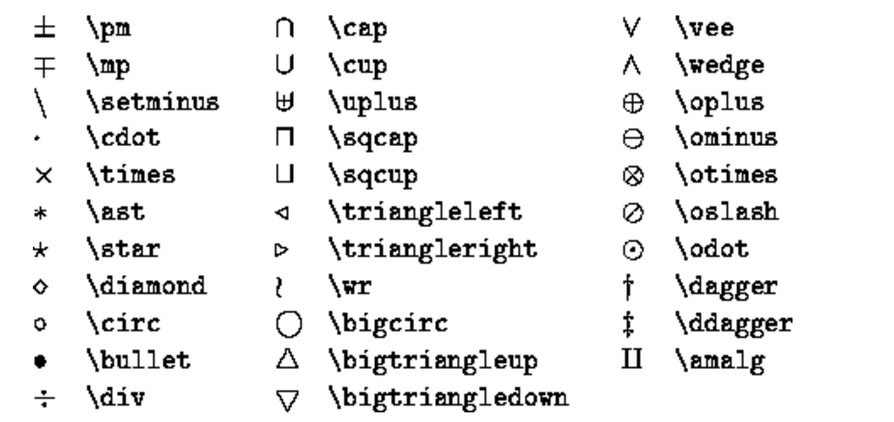
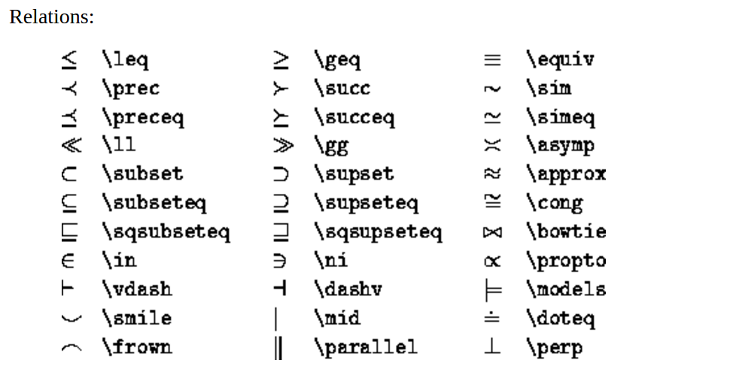
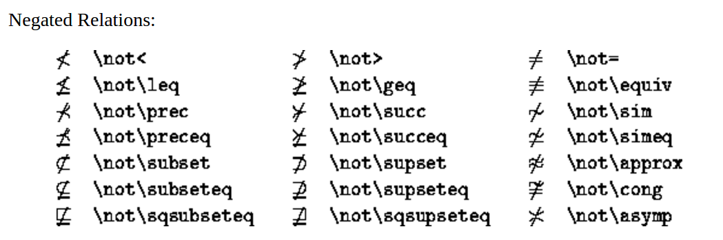
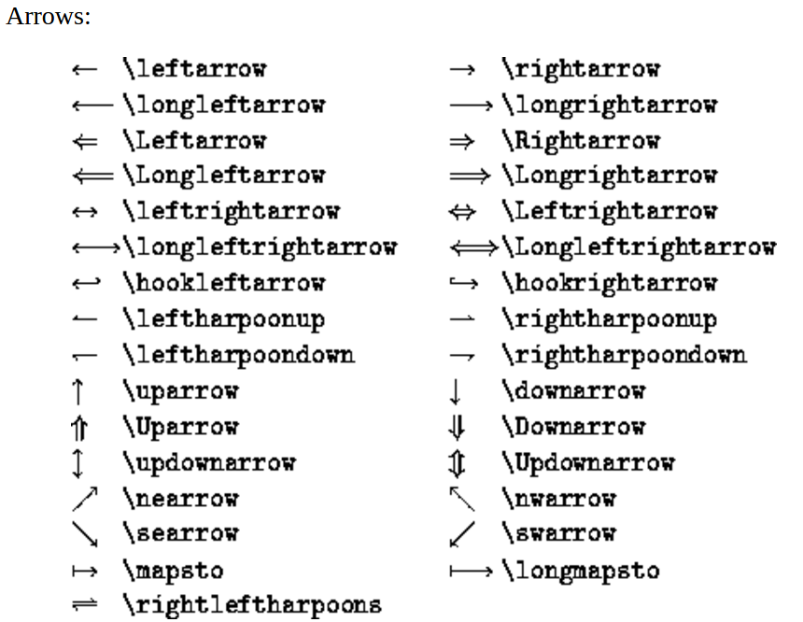
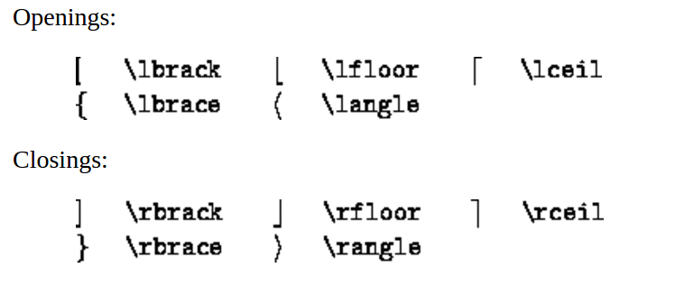
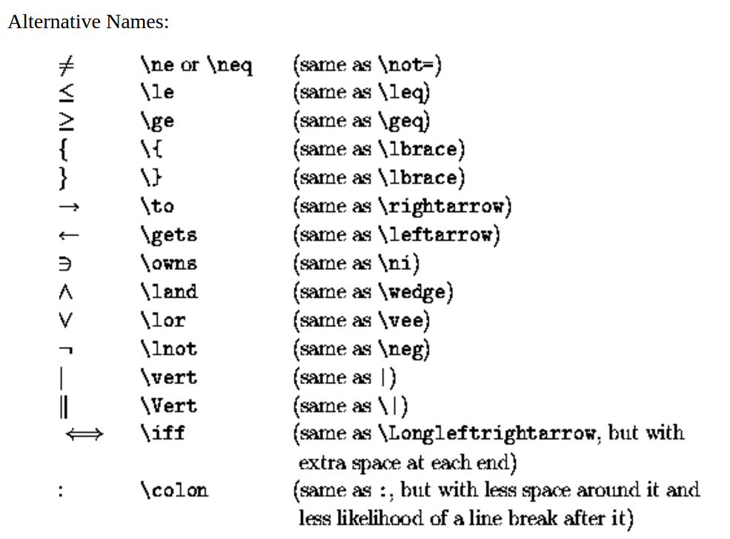

7.公式中嵌入文字
\mbox{embeded text}

Text can be embedded in displayed equations (in LaTeX) by using \mbox{embedded text}. For example, one obtains
by typing
\[ M^\bot = \{ f \in V' : f(m) = 0 \mbox{ for all } m \in M \}.\]
Note the blank spaces before and after the words `for all' in the above example.

8.分数
\frac{text1}{text2}

9.三个省略号
\cdots

10.矩阵
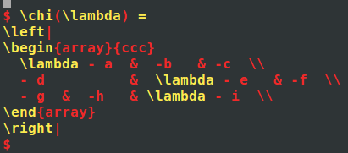

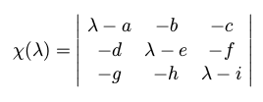
\left| 与 \right| 配对
\begin{array}{ccc}与\end{array}配对

11.微分和积分
\partial
\int

12.List 列表
enumerate
itemize
description

\begin{enumerate}
\item
Text
\item
text
\end{enumerate}

\begin{itemize}
\end{itemize}

\begin{description}
\end{description}

13.插入代码或者预先定义的格式的文本
\begin{verbatim}

\end{verbatim}

14.插入表格
\begin{tabular}{|r|r|}
\hline
A & b \\
C & d \\
\hline
\end{tabular}

15.定义你自己的控制序列
\newcommand{新定义的序列}[这里可以加参数]{现有的序列组合 #引用参数}

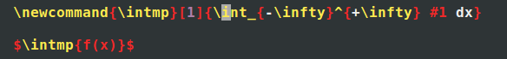
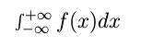

Latex beamer 制作幻灯片

三步骤：
1. Vim命令模式： \ll 进行编译，将tex格式转为dvi格式
2. Dvi 工具转为将dvi转为ps格式
Dvips xxx.dvi
- Ps2pdf工具转为pdf格式
Ps2pdf xxx.ps

